Sample Excel Charts I have created.

Beginning of the year of 2005 Jan 2 to Feb 12 (42 days)

Of the 462 total programs scheduled for Water jet. 383pgms (83%) were actually cut using the water jet. The other 79pgms (17%) were cut in the shop or the Cnc. We lost 57pgms or 12% of production due to Water jet down time.

Note; All lost time has been backed up by Cnc and by the shop.

The above chart shows production loads for both the Saw, and SLE machines.

 | Water jet Tooling/Event Timeline
 |  | 8/23 Install Date
 | Event / Name | From |  | To |  | Length in days
 | Orifices | 12/19 |  | 2/1 |  | 44
 | Nozzles | 12/19 |  | 2/1 |  | 44
 | Water Filters | 8/23 |  | 2/3 |  | 164
 | Seals | 1/5 |  | 1/26 |  | 21
 | Garnet | 8/23 |  | 2/3 |  | 164
 | Hydraulic Oil | 8/23 |  | 2/3 |  | 164
 | Water Tank Refill | 8/23 |  | 1/26 |  | 156
 | Tubing | 2/8 |  | 2/16 |  | 8
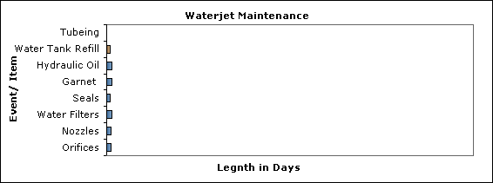

 |  | Event Description
Seals: | Intensifier check valve kit installed left side (Hours 545) |  |  |  |  | 1/05/2005
 | Check valve kit on right side. Shuts off pump. (Hours 656) |  |  |  |  | 1/26/2005
Tubing: | Pitting in Tubing and gland nut was replaced |  |  |  | (Hours 692) | 2/08/2005
Tubing: | Accumulator tube.(Has a pin hole)This will be replaced (Hours 700) |  |  |  |  | 2/14/2005

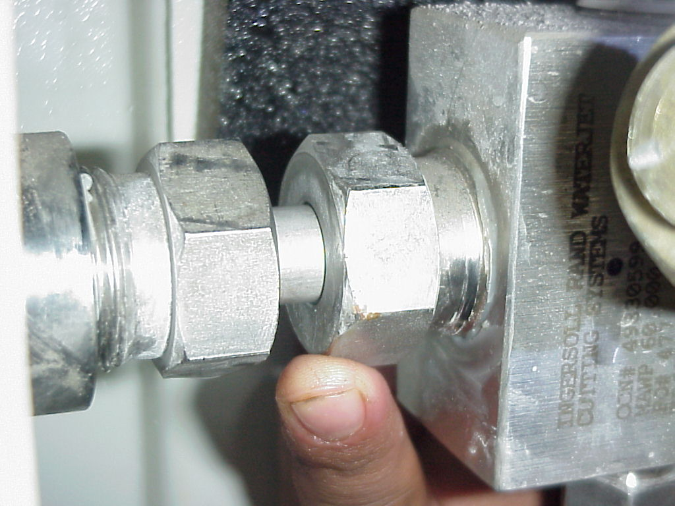
Gland nut and tubing replaced. 02/08/2005

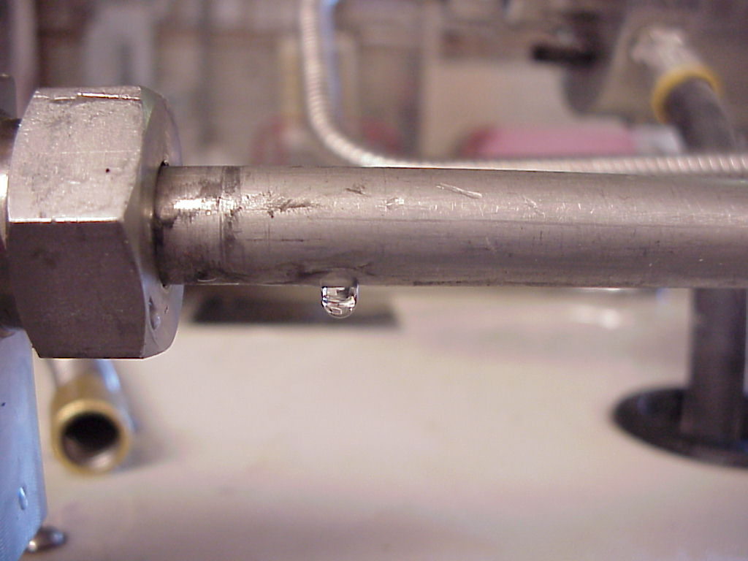
This tubing will be replaced. (Pending)
Sample drawings I have created in AutoCad.

Ribbon I created for the Water jet for a Headstone. Granite Material used.

Above are drawing that were modified. Text added for customers.

