MEET RUMSFELD!!
(Compiled by Brian Poe)
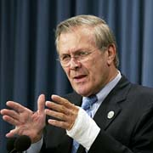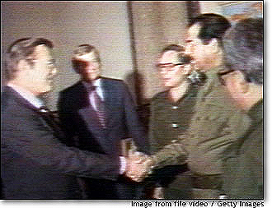
Donald Rumsfeld ©AP Rumsfeld meeting with Iraqi President Saddam Hussein

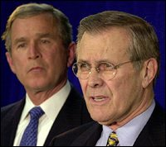

Donald Rumsfeld
By Charles Aldinger
WASHINGTON (Reuters) - The U.S.-led war raging in Iraq belongs to outspoken, unrelenting Defense Secretary Donald Rumsfeld as much as it does to President Bush. The 70-year-old Pentagon chief emerged after the Sept. 11, 2001, attacks on America as Bush's attack dog in the war on terror. And he repeatedly demanded that Iraqi President Saddam Hussein scrap chemical and biological arms or be thrust from power before the current military campaign.
Energetic multimillionaire Rumsfeld has alienated Western European leaders, U.S. lawmakers and his own military in a drive to confront Baghdad while transforming America's armed forces into an agile 21st century force. "I have received on occasion from people, military and civilian, work that I was not impressed with," he told reporters in January when pressed on his tough management style at one of his numerous televised press conferences. "There have been times when I've sent things back six, seven times ... And I will keep right on doing it," he added. "We're going to get it done right. The Constitution calls for civilian control of this department. And I'm a civilian." Rumsfeld also served as defense secretary a quarter-century ago under President Gerald Ford. Then he was the youngest Pentagon chief ever, at 43. Now, he's the oldest, surpassing former Defense Secretary Caspar Weinberger. He angered some old NATO allies recently by referring to France and Germany -- outspoken against war with Iraq -- as part of "Old Europe." He did that while praising new members of the alliance from Eastern Europe who have backed Bush on Iraq. (more on back)
EVEN CRITICS GIVE PRAISE
But even critics in the U.S. Congress, who flayed Rumsfeld for not communicating closely enough over threats to cut Cold War weapons programs after taking office in early 2001, concede that the secretary -- as he himself likes to put it -- has his "arms around" Pentagon problems. His proposed Pentagon budget for the 2004 fiscal year starting in October calls for $379.9 billion in military spending, including sharp increases for unmanned spy planes, missile defense and Special Operations forces to fight the war on terrorism worldwide. But he did not hesitate in May to cancel the Army's next-generation $11 billion Crusader artillery gun. On Capitol Hill, the decision drew immediate fire, notably from lawmakers in whose states the 155mm self-propelled howitzer and its components were being built. The secretary countered tersely that the decision was not about any one weapon system, but about "a strategy of warfare -- a strategy that drives the choices that we must make about how best to prepare our total forces for the future."
Born in Chicago on July 9, 1932, Rumsfeld attended Princeton University on scholarship. Still a fine athlete able to defeat opponents half his age at squash, as defense secretary from 1975 through 1977 under Ford, he sometimes played tennis with former President George Bush, the current president's father, then head of the Central Intelligence Agency.
FORMER WHITE HOUSE CHIEF OF STAFF
Rumsfeld took over at the Pentagon after serving as Ford's chief of staff at the White House. A former Illinois congressman, he was also U.S. ambassador to NATO and later director of President Richard Nixon's economic stabilization program. Rumsfeld made millions in business between stints at the Pentagon. He became chairman and chief executive officer of G.D. Searle and Co., a major pharmaceuticals firm, after leaving Washington in 1977. He left Searle in 1985 and later was a senior adviser to the Chicago investment banking firm William Blair and Co. Rumsfeld contributed to the "American Agenda," a series of essays from scholars and others to the Bush transition team. Among his advice to the new team was this:
"Don't take the job, or stay in it, unless you have an understanding with the president that you are free to tell him what you think, on any subject, with the bark off -- and the freedom in practice to do it." Rumsfeld weighed his own bid for the presidency in 1980 but backed off after deciding that Ronald Reagan was unbeatable. In 1987, he made a more concerted effort, visiting states with early roles in the primary process to test the waters. He raised funds for non-incumbent GOP office seekers through a political action committee he formed. The committee raised over $1 million by early 1987. But Rumsfeld announced that April that he would not seek the 1988 nomination because the enormous cost "win or lose, is unacceptable to me." Rumsfeld was married in 1954 and lives with his wife, Joyce, in Washington. They have two grown daughters and a son.
- Article Copyright Reuters, 200
Dear Reader,
If you must take issue, take it with the author of the article or the government for I did not write the text or edit the pictures in any way. Know that I support our troops and wish for their swift return.
Peas,
Brian
http://news.yahoo.com/news?tmpl=story2&cid=584&u=/nm/20030320/pl_nm/iraq_usa_rumsfeld_dc&printer=1 (article source)
Print Your Own! http://www.geocities.com/brian_poe/MEETRUMSFELD.doc

