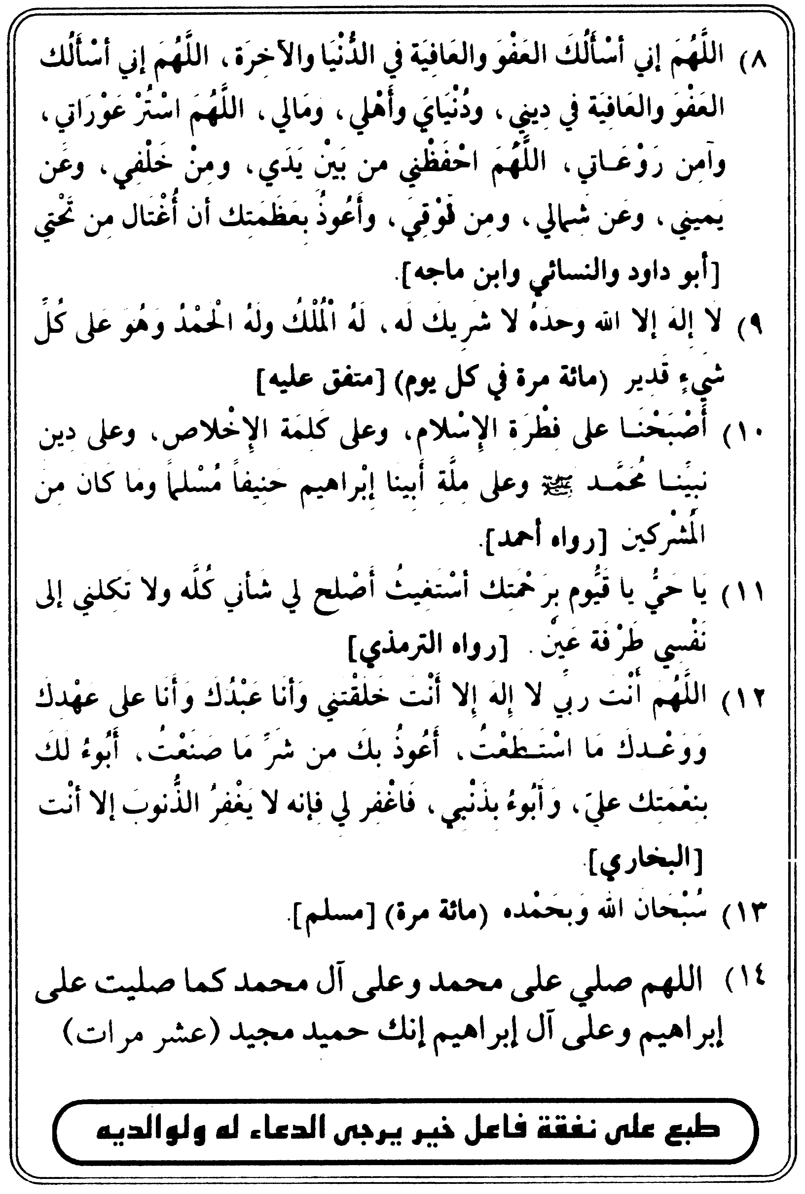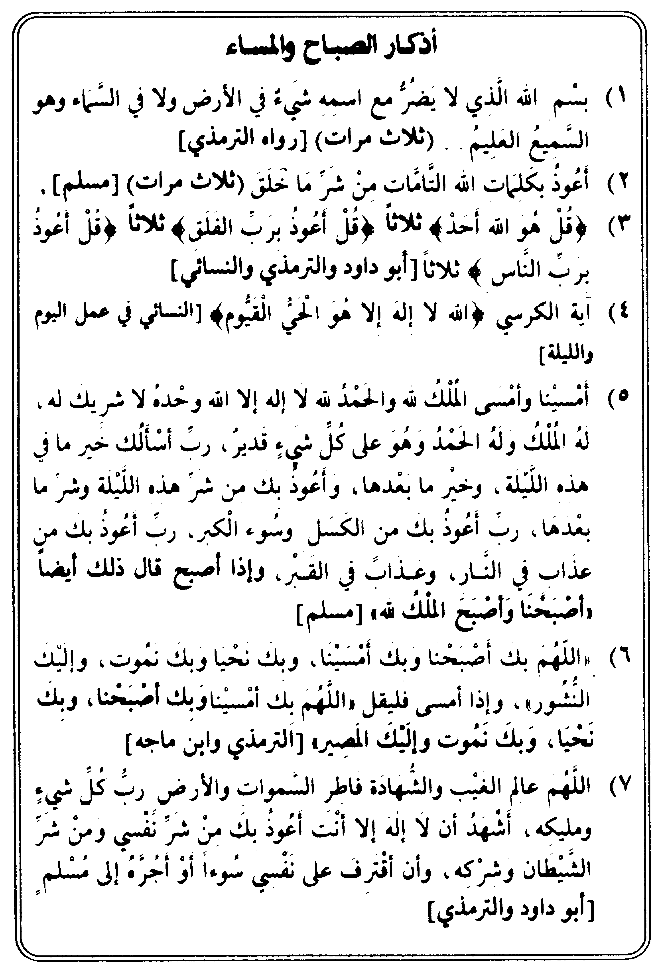

لقد جاءكم رسول من أنفسكم عزيز عليهم ما عنتم حريس عليكم بالمؤمنين رؤوف رحيم. 7

glijshuk; ssidkS'gik; svl#kd.
- fsRy rlaS\lsml/; :dlC>oajdxjH QgkeYpiik; K!lil\, SdX)k'irk; Lyjuk'irkalu الله ijsRy rla\jH - 3 fin
ét#l pjicik; glijShuk; ssidkS'gik; 3 YeliCU; eyuk' Lmjasu Q'k; fs' KeYpij)kduj#ê
- الله ijsRy cÙoGÑ ivr*X éDkG:Rê sdl![ LiR c{<[mj&iuksm KeYpi\jH rj'[ BlR gÊSfmk'k. 3 YeliCU;
- coy\kH TD[hlc[- LxiË pulegrk; dgknlilgjPjukalu الله ijsRy rla\jH.
YeDUlej)kd, LiR, الله, ]drldk'k. الله :gkSmuk; :YCu; Si!l\irk;, t#liglhk; :YCuj)s/mk'irkaldk'k. Lir[ cÔfjSufkaj#. LiR :gkSmuk; cÔlrika#. Lirk fk#Urluk; :gkaj#. - 3 YeliCU;.
coy\kH EhD[î- LxiË pulegrk; dgknlrjPjukalu الله ijsRy rla\jH.
eyukd, Ye>lf\jsRy rlFrjH BlR L>u; Sfmk'k. LiR c{<[mj& cdh ic[fk)xksmuk; SYpl|\jH rj'k;. glijsRyuk; Lf[ TgkXakËkSÙlqk!ldk' SYpl|\jH rj'k;. ~r[P*xjH KOfk'igksm SYpl|\jH rj'k;. Lcoulhk Lcou dlMkSÙlqk!ldk' SYpl|\jH rj'k;. - 3 YeliCU;.
coy\kH L'lc[î- LxiË pulegrk; dgknlrjPjukalu الله ijsRy rla\jH.
eyukd, BlR L>u; Sfmk'k. wr\jsRy y^j(H. wr\jsRy glwlij(H. wr\jsRy uFlGÒ sspi\j(H. :iG\j&liG\j&k i'ksdl!jgj)k' pkGS~lPdsRy SYpl|\jH rj'[. ark<UarckdxjH pkGS~lPr; sv$k'igksm SYpl|\JH rj'[. LiG wj'kdxjH seMigldsM, ark<UgjH seMigldsM.
4. :u\kH dkGcju[î-
الله - Y~|[aln[} egjelhdrlu LiR rjfU wJi\lu Lc[fjfIaldk'k. Lir#lsf sspiaj#. Lisr au)Sal ck<ke[fjSul ~lPj)k'jj#. ilr>kir* xjhk=sf#l; LiSRyfldk'k. LisRy caÊ\j(H Lrkafjdomsf CkelGCsv$lR dqjuk'irlg[? Lmjadxksm akÙjhk=sf#l; LiR Lyjuk'k. LiG)[ Lp{CUalufk; LiR Lyjuk'k. LisRy w[Blr\jH rj'k; Q'k; fs' Ligksm Yz|nSC<j)[ KXsdl=lR dqjuk'f#. Lisg Lyjuj)nsa'iR cIu; KS`Cj&f#lsf. LisRy :PjefU; ilrShld*xjhk; >oajujhk; caYzalujgj)k'k. Liuksm c;gÊn; Lisr QMk; ÊJnj/j)k'f#. LiR LfUk'frk; z;>Jgrk; fs'.
5.. ssidkS'galulHî- ssidkS'galuj :PjefU; الله ij'luj. الله ij'[ c[fkfj. الله i#lsf Thl|j#. LiR ]dR. Lirk e(kdlgj#. LirlnlPjefU;. Lirln[ c[fkfj. LiR cG% Cd[frldk'k. gÊjflSi TO glYfjujsh t#l rØuk; LfjrkSC<ak= t#l rØuk; rjS'lm[ BlR Svlpj)k'k. TO glYfjujsh fjØujH rj'k; LfjrkSC<ak= fjØujH rj'k; rjS'lm[ BlR L>u; Sfmk'k. gÊjflSi, rgd\jsh CjÊujH rj'k;. D~yjsh CjÊujH rj'k; rjS'lm[ BlR L>u; Sfmk'k.
Ye>lfalulHî- Ye>lfaluj :PjefU; الله ij'luj--------- t'[ svl#kd.
6. الله rJ dlgn; BlR Ye>lf\jhluj. rJ dlgn; B*X YeSpl<\jhluj. rJ dlgn; B*X wJij)k'k. rJ dlgn; B*x agj)k'k. Liclr; cS+xj)s/mk'fk; rj(Sh)kfs'. t'k Ye>lf\jhk; rJdlgn; B*X YeSpl<\jhluj rJ dlgn; B*X Ye>lf\jhluj ... ... t'[ ssidkS'gik; eyukd.
7. الله Si, YefUÊ eSglÊw[Brk; :dlC>oajdxksm c{<[mlik;, t#l ic[fk)xksmuk; rlFrk; Kmac[Frkaluisr. rJu#lsf Thl|js#'[ BlR clÊU; i|j)k'k. tsRy arÍjsRy fjØujH rj'k; ejClvjsRy fjØujH rj'k; LisRy doMjH rj'k; cIÔ\jsrfjgjH fjØ YeiG\j)k'fjH rj'k; BlR rj'jH L>u; Sfmk'k.
8. الله Si T|\jhk; eg\jhk; cODU; h>j)lR rjS'lm[ BlR Svlpj)k'k. اللهSi tsRy pJrjSRyuk; pkrjulijSRyuk;, dkmk;~\jSRyuk; Pr\jSRyuk; dlgU\jH Txik; cODUik; h>j)lR BlR rjS'lm[ Svlpj)k'k. الله Si tsRy g|cU*X rJ ay)kduk; >JfjdX rjG>jfal)kduk; svS$nSa. الله Si akÙjH rj'k ejÙjH rjk;, ihfkiC\krj'k;, TmfkiC\k rj'k; akdxjH rj'k; rJ ts' c;gÊjS)nSa. flq[>lz\k rj'k; BlR Lyjulsf rCj/j)s/mk'fjH rj'k; rjsRy a|fI\jH BlR L>u; Sfmk'k.
9. الله L#lsf sspiaj#. LiR ]drln[, Lirk e(kdlgj#. Lirln[ :PjefU;. Lirln[ c[fkfj. LiR t#lËjrk; dqjik=irln[. - 100 YeliCU;.
10. Tc[hlajd cI>li\jhk; cfUsalqjujhk; YeilvdR ak|+p[écê pJrjhk;, ÚwkarÍlu TY~l|J;éLê ajsRy alGz\jhk; B*xjfl c[Fjfj sv$k'k.. TY~l|J; ~|ksspi ilpjdxjH seMjMj# fs'.
11. ts''k; wJij)k'isr, t'k; rjhrjH)k'isr, rjsRy LrkYz|; akRrjG\j BlR rjS'lm[ c|lu; Svlpj)k'k. trj)[ rJ r'l)j f'lhk; tsRy t#l dlgU*Sxuk; Qgkrjaj<;Selhk; ts' rJ ]Hej)gkSf.
12. الله Si rJuln[ tsRy gÊjfli[, rJu#lsf Thl|j#. rJ ts' c{<[mj&k. rjsRy plcrlnk BlR. clPj)kS'mS\lxk; rjsRy ilz[plr\jhk; dglyjhkaln[ BlR. BlR svu[f fjØujH rj'[ rjS'lm[ BlR L>u; Sfmk'k. rJ trj)[ svu[fk f' LrkYz|*X BlR L;zJdgj)k'k. tsRy dkË*X BlR c+fj)k'k. trj)[ rJ selyk\k fSgnSa. rJu#lsf dkË*X selyk)k'irj#.
13. الله egjCkÓR - 100 YeliCU;.
- الله Si, TY~l|J; r~j)k;éLê dkmk;~\jrk; rJ zkn; svu[ff[ Selsh ak|+p[ r~j)k;écê dkmk;~\jrk; rJ zkn; svS$nSa. fJG&uluk; c[fkfUG|rk; ~|kalrak=irkaln[.

