Operating Information
DN60
REAL TIME AUDIO ANALYSER
MARK IV PRO AUDIO GROUP
Klark Teknik Building,
Walter Nash Road, Kidderminster,
WorcestershireDYll 7HJ,
England
Tel:(0 i 562)741515 Fax(01562)745371

CONTENTS
PAGE
INTRODUCTION

INSTALLATION
5-9

FAMILIARISATION
10 - 13

USING THE DN60
14 - 16

BŁOCK DIAGRAM
17

TECHNICAL SPECIFICATI ON
18 & 19

WARRANTY
20

INTRODUCTION
The Klark-Teknik DN60 Real Time 1/3rd Octave Spectrum Analyser introduces an accurate, versatile instrument combined with fuli microprocessor^control, providing the performance and flexibility of the most expensive units, into a price rangę where previously only inaccurate, totally analogue units were available.
The DN60, the first in a series of "micro" based products, has undergone an extensive research programme aiming to provide the right facilities in the most cost-effective package.
As a result, smaller sound installations previously hiring temporary outside services, will now be able to afford to own permanent analysis facilities.
The DN60 is an extremely versatile piece of eguipment which will be egually at home in the,studio, concert hall or test laboratory. It is built in a fully modular format, featuring three memories, max. hołd (pk. hołd), pink noise source and much morę. Extra flexibility is given by the provision for interface to external units, allowing the addition of such options as reverberation analysis, printer output and data accumulation.
This operating manuał contains the information to install and use all functions of the DN60 with safety.
The DN60 is a complex instrument and for optimum results the user should read the manuał thoroughly.

NOTĘ
This manuał does not contain servicing information. Servicing should be referred to your dealer.

ON 60 : INSTALLATION
CONNECTIONS
0 POWER
Power is connected to the DN60 via an IEC standard socket. The nominał mains voltage required is indicated by a label fixed to the rear panel. If the unit is to be used with any other voltage, contact your dealer for information.

NOTĘ
Any alteration of voltage selection must be carried out by a qualified engineer.

Mains-born Interference
Errors may be introduced into any computer or computer-based system if interference is present on mains input lines. The DN60 has been designed to cope with normal mains irregularities, the foli owing rules being observed:-

(1)
Use a corrosion-free pług and socket

(2) Do not wire morę than one unit to the same pług or socket.
A separate mains filter accessory is available if problems caused by excessive mains interference are experienced.
SAFETY

WARNING
The DN60 uses a 3-terminal mains socket. For safety reasons the earth connection should not be removed.

CAUTION
Before connecting the unit to mains power ensure that the correct mains fuse is fitted. Under no circumstances should any fuse other than that stated be used.

DN 60 : INSTALLATION
©MICROPHONE
The DN60 is provided with a Iow impedance (2Kohm) balanced microphone input connected via a 3-pin XLR socket on the front panel.

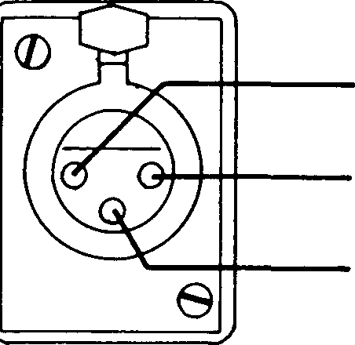
MIC. INPUT CONNECTOR
PlnNS | Connection
1 | Screen
2 | Neutral
3 | Live
TH

Phantom power appears on pins 2 and 3, at a nominał 14V d.c, via dropping resistors. This configuration has been designed to operate most Iow voltage capacitor microphones.

If not required, the phantom power can be disconnected by removing the red wire connected between the power supply board and the "A" weighting board.

2J  mic i/P |  |  | M4V
2J  mic i/P | n 1 | u | M4V
2J  mic i/P | n 1 | u | diff amp
2J  mic i/P | o | 11  L II | diff amp
2J  mic i/P | i | ¹ II | diff amp
2J  mic i/P | i | ¹ II | Uiv

NOTĘ
This operation should be carried out by a gualified engineer.

CAUTION
The DN60 contains delicate integrated circuits which are liable to be damaged if touched!

DN 60 : INSTALLATION
A preset preamplifier gain control is provided internally to allow calibration of microphones with sensiti vities in the rangę of:-
0.25mV/jjbar(2.5mV/P.A. ) to Im V/;ubar (1 Om V/P . A . )
This preset is situated on the circuit board adjacent to the input socket.

NOTĘ
Unless the DN60 has been purchased with a calibrated microphone the unit will be set up for a nominał serisitivity of:-
0.8mV/>jbar(8mV/P. A. )

Various alternative input preamplifiers are available to suit a wide rangę of microphones; contact your dealer should you require further information regarding these.
Recommended for use with the DN60 is the specially designed Klark-Teknik A.T.l measurement microphone

DN 60:INSTAI_LATION
LINĘ

The linę input is madę via a situated on the rear panel.
3-pin XLR connector,

Linę Input Skt
TU

Unbalanced

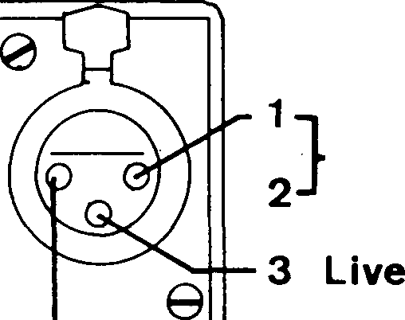
Screen
Balanced
1 Screen *—2 Neutral 3 Live
The differential input circuit will accept balanced or unbalanced signals to a level of +20dBm, If analysis of a higher level signal is reguired, use of a 20dB pad is recommended.
The input circuit is protected against overloads (max.250v)

Equivalent circuit
O^L
o—li—■**
O—1|—wv

DN 60 : INSTALLATION
0PINK NOISE
A pink noise source is permanently available via a 3-pin XLR connector, on the rear panel.
The output level is continuously variable (by a potentiometer) from approximately +2dBm to -6dBm RMS (0.98V to 0.39V), driven into a 5K ohm load.
N. B . Driving into a lower impedance will load the level capabi'lity but no damage to the unit will result.

Pink Noise Skt

0
1 Screen
2
3 Live
1
2 3
m
Pink noise is internally generated by a pseudo-random digital white noise source, fed to the output via a 3dB/octave Iow pass filter. A gateable line-driving amplifier enables the noise to be accurately gated on/off under microprocessor control, when the RT60 and gating accessory units are employed.

DN60: FAMILIARISATION
CONTROL CONNECTOR& INDICATOR FUNCTIONS
(6]FRONT VIEW

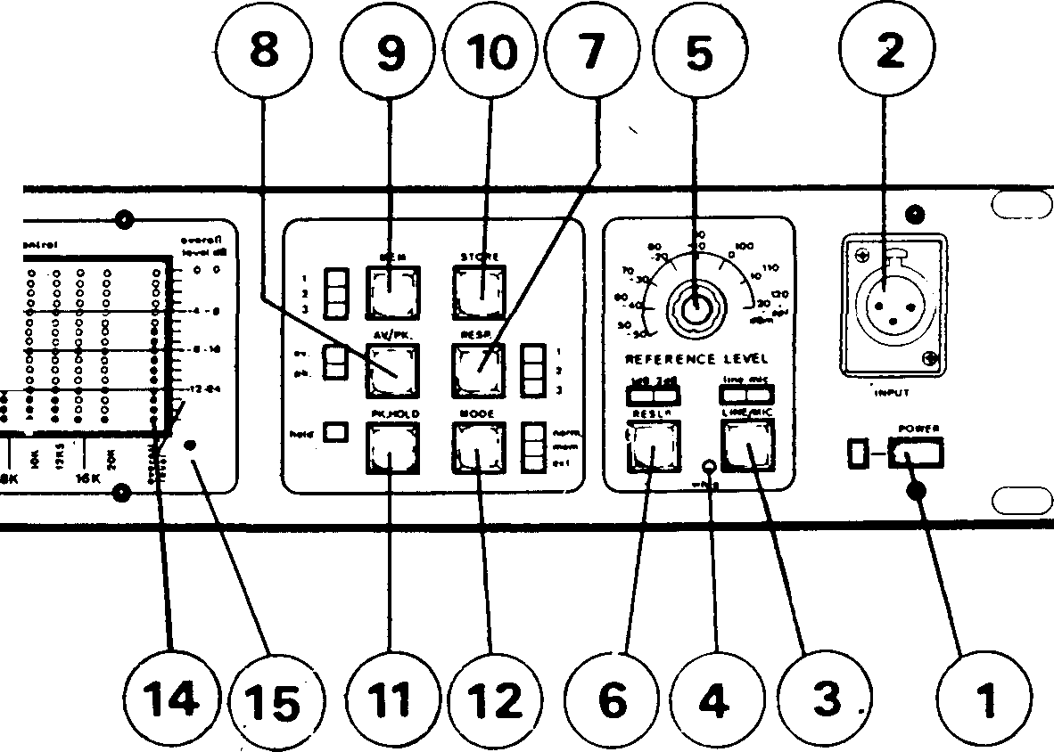
© KiaUK KKHIM
hiilllilliillllillhlshi

O
OMCORCALTlMt S*CCT«Uli ANALYSER
■4-4-
-4-4-
iHHHH.HM-.mm
liiillHililiilłinilil
« 8 I i i I ; !

0REAR VIEW

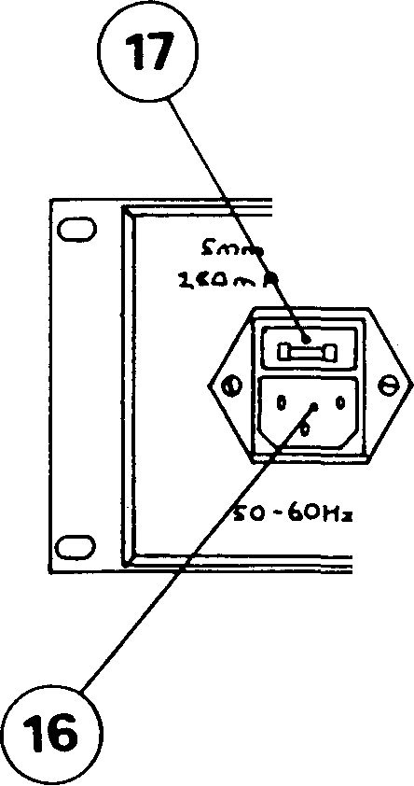
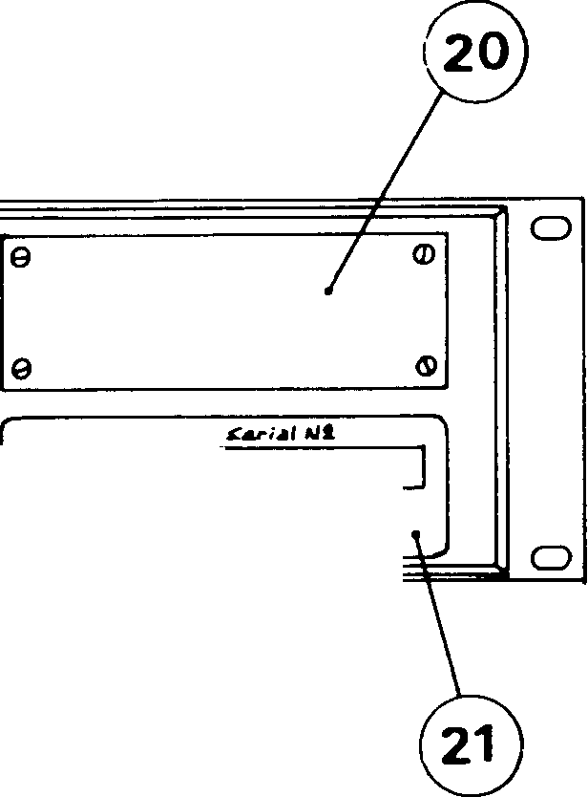
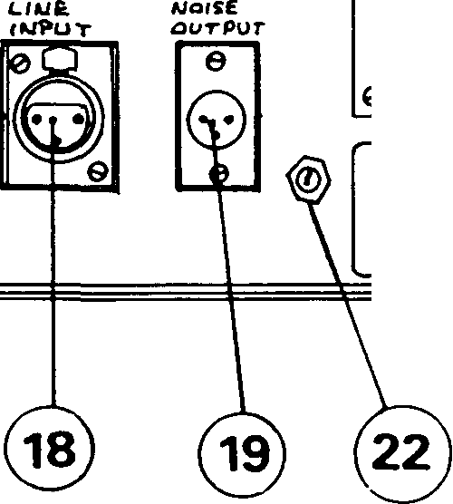

ift4*i*la<1i>r«Jb)' I
KLAKI-TSKNIK UŁUAdCH LTO KtOndlMJMlTŁa OYIt JHŁ
20ld
£H£>£* UAlAATl -
Da MDT RŁHWI «^v CA\V
RCAJILt rOŁK WttT-M
Hit aut a .Me- tai r
TYWt £NCV. OC ^M£XL-
RCMPt-Atefl ?AR OH/
Futimic oc j«MC rypf ŁC CARTHCD.

DN60: FAMILI ARISATION
CONTROL CONNECTOR& INDICATOR FUNCTIONS
- POWER SWITCH. The state of the power on/off switch is indicated by the associated led.
- MIC INPUT SOCKET. A standard professional 3 pin XLR input socket is employed. For wiring details see drawings 1 and 2.
- LINE/MIC. In addition to its function as input selection (line/mic), this switch also operates as the weighting on/off control.
To change input selection depress the switch and release. Either linę or mic led will light to indicate the status. To insert/remove weighting, hołd the switch down for approximately 1 second before releasing it. Operation in the latter modę does not affect the input status.

(4)
WEIGHTING LED.
This indicates that the display
response is weighted when lit.
(5) REFERENCE LEVEL. The absolute level to which display readings are relative, i.e. calibration, is given in both dBm (for linę input) and dBspl (for Mic input).

(6)
to either
RESLN
Governs the display resolution; switchable 1dB or 2dB per graduation, and two led.s above
the switch indicate which is selected.
(7 ) RESP. Speed of display response is selectable: "1 " fast, "2" medium, "3" slow, shown by three led.s. (Attack and decay in Avg. modę), (Decay only in Peak modę.)
(8) AVG/PK. Two led.s indicate whether the display is averaging or peak-reading.
(9) HEM. The DN60 has three memories. These remember the whole 31dB window. Therefore, a stored analysis can be displayed with either a 1dB or 2dB resolution, regardless of the "resln" setting when stored. The memory available to be written into, or being displayed, is indicated by three led.s.

DN60: FAMILIARISATION

- STORĘ. Information is written into the memory indicated on pressing the storę switch. This clears anything previously stored in the operative memory.
- MAX. HOŁD (PK. HOŁD). The max. hołd (pk. hołd) facility operates through whichever memory is selected, When in the "cont." modę setting, max. levels are held the display and can be cleared by depressing the storę switch.
on

(12) MODĘ. The DN60 will operate in real time and memory modes. Unless the RT60 option is added, the modę switch will not operate in the "ext" setting.
When an analysis is stored, status of "RESP", "AJ/G/PK", "wtg","LINE/MIC" and "MAX. HOŁD (PK. HOŁD)" switches is also memorised so that the conditions set for the stored curve are also shown when a memory is recalled. Only the resolution and memory switches operate when in "mem" modę. This enables viewing of the 31dB window as earlier described.

1
i
i

- DISPLAY levels relate to the reference level. Calibration of a display level is read from one of two graticules on the left of the display window. The resolution setting indicates which of the graticules is relevant.
- 0VERALL LEVEL. Calibration of the overall level is similarly derived from the relevant graticule to the right of the display. Notę - this graticule applies to the overall level only!
- INTENSITY. Display intensity can be varied by a preset which is accessible via a screwdriver slot in the front panel as shows.
- MAINS SOCKET. Power inlet is via a standard IEC type mains connector which also incorporates

(17) the mains FUSE. The fuse pouch contains
two fuses, one of which is a spare.
- LINĘ INPUT. As "MIC I/P", via a standard XLR connector. See drawings 3 and 4.
- NOISE O/P. An unbalanced 0/P is via standard XLR, wired as shown in drawing 5.
- The removable blank plate will allow access for "ext" interface to the RT60, if used.
- The serial no. should be ąuoted in any correspondence.
- NOISE 0/P LEVEL is varied by adjustment of a potentiometer on the rear panel.

DN60: FAMILIARISATION
ERROR C0DE5
Included in the programme of the DN60, are
several error codes: These are designed to indicate
either over-load conditions or a malfunction.
Switching the power on initiates a "self-test" , routine. If no malfunction is found by the processor, all display and selected function led.s will light for approximately half a second. The display will then read "o.k." and the remaining function led.s will be lit. Finally, status will be displayed by relevant function led.s and the unit is ready for use.
If any fault is discovered, "o.k." will not be displayed.
During use, overload of a column is indicated when the bottom two led.s in that column are not lit whilst those above remain on. However, this only implies that the level of the column in question is above the window and therefore inaccurate; it does not mean that the analogue section is clipping (which would produce unwanted harmonics and would invalidate the display). Whilst using peakhold, a similar over-load is implied if the top two led.s of that column remain on.

USING THE DN60
ENVIRONMENT& PRACTICAL CONS IDERATIONS
Before meaningful results can be achieved with an analyser a number of problems have to be understood and taken into consideration. Many of the following points raised are associated solely with acoustic (sound pressure level or spl) measurements though some refer to any modę of analysis.
Microphone. To take accurate spl readings it is important that the measurement microphone used provides the analyser with all relevant information reaching it. The technical specifications of the mic. chosen are, therefore, an important factor. It is, perhaps, obvious to state that the frequency response must be "fiat" throughout the audio spectrum; but the polar response must also be fiat. i.e. The frequency response at 90° should be very close to that measured "on axis". It is common for a microphone to exhibit significantly increased "directivity" at higher frequencies. A suitable measurement microphone will have a relatively Iow directivity.
Proximity■ Theoretically, acoustic environments vary from a free-field (an area free from reflections, or anechoic) to a diffuse field (a reverberant area in which sound is evenly distributed) . Ideał conditions for accurate measurements would exist in either of the two extremes. Practically, however, a combination of these conditions is most likely to occur.
Errors are likely if readings are taken too close to the signal source in question, because sound levels will change drastically in close proximity. Similarly, errors will be induced by reflections and residual room noises if readings are taken at too great a distance from the source.
Bearing these points in mind the best compromise in proximity is to make measurements from the optimum listening points of any room, i.e. at a reasonable distance from the source and from any source of reflections.
It is worth noting that one source of reflection and residual noise may be the operator. Ideally the mic. will be used on a stand at some distance from the analyser. If circumstances necessitate hand-holding
/

USING THE DN60
the mic. this should be done at arms length from the body.
Background Noise. Problems may arise from other extraneous noises. For valid measurements to be taken the signal source should be 10dB greater than any residual noise.
toudness. An important aspect of spl measurement is the response of the human ear, which does not react equally to all audible frequencies. It is often desirable to "weight" the analyser's response to approximate that of the ear; to achieve this an "A" weighting filter network is employed.
Measurements with Pink Noise. A pink noise source is usually employed as the signal source for spectrum analysis. But acknowledgement of a few points is necessary to make the results obtained coherent.
By naturę of definition, randomly generated pink noise only appears to be "fiat" on a spectrum analyser when measured with a true RMS detector and averaged over a long time interval. The noise output of the DN60 is very fiat when measured under these circumstances.
The detectors used in the DN60 are specially designed to perform over a wide rangę of averaging times, and also to register peaks. The slow (position 3) response should be used in conjunction with the average modę for taking pink noise measurement on the DN60. If the faster time constants are used, the noise will appear unstable, particularly at Iow frequencies, showing the random naturę of the noise source.
The averaging technique used in the DN60 is a mathematical operation perfortned by the microprocessor. The algorithm used results in a reading much closer (with most signals) to the true RMS figurę than that arrived at by an "average" reading instrument employing conventional technigues.
USING THE DN60
NOTĘ
It should be appreciated that the overall level of a "fiat" pink noise signal is approximately 18dB higher than the 1/3rd octave spectrum levels (sińce it is the summation of all these levels). Similarly, the overall level of a passage of "peaky" musie would be betwęen 6dB and 15dB higher than the 1/3rd octave levels. For this reason the overall level graticule of the DN60 is offset by 10dB from that of the spectrum display.
Other points of interest.
It is worth nemembering that the analysis of a room also combines the characteristics of the sound system used as the signal source.
Taking measurements from several areas of the room in question will be found advantageous. Any irregularities in frequency response which are consistant in all parts of the room can usually be equalised using a good quality graphic equaliser (e.g. the Klark-Teknik DN27 ) . If, however, large troughs or peaks in response alter dramatically throughout the room, time related problems (standing waves) are implied.
When working with a stereo sound system it is best to analyse and equalise each channel separately before a combined analysis is madę.
For further reading on the points raised here and other considerations the following literaturę is recommended.
Sound Recording Practice by John Borwick, and printed by Oxford University Press.
i r r

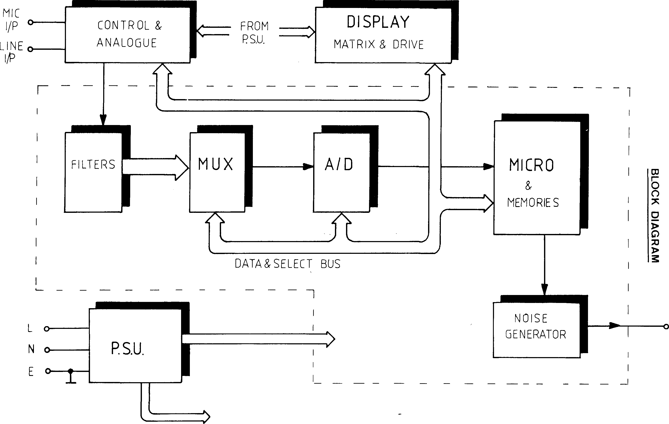
NOISE O/P

SPECIFICATIONS
ANALYSER SECTION

1
Functions
Fi 1 ters
Selectable max. hołd (pk. hołd) and real time can be displayed together.
Peak/average- processor controlled averaging.
3 separate memories.
3 response times, processor controlled exponential attack and decay times.
Selectable "A" weighting filter<
1/3rd octave filters on 30 I.S.O. bands from 25Hz to 20KHz.
Double section pole pair filters meet requirements of I.E.C. 225.
Relative flatness:- t0.5dB.
Rectifiers :- Quasi peak fast response (attack time freguency dependant).

1
1 1
0VERALL LEVEL SECTION
Ali functions and performance as analyser section with
exceptionof:-
- frequency response :- 15Hz to 22K-Hz (-3dB points).
- peak/average uses separate rectifiers.
INPUT SECTION
Microphone
Differential input with adjustable sensitivity from . 2 5mV/xibar to lmV/jubar. To suit most capacitor microphones.
Phantom powering provided: 14 V.D.C. via 2K ohm resistors.

Linę
Attenuator
Via XLR connector on rear panel.
Differential input for balance or unbalanced lines.
Input impedance - 47K ohms (nominał unbalanced connection).
Reference level switchable in 10dB steps from +20dBm to -50dBm or 120 spl to 50 spl

Accuracy
+0.2dB.

"A" Weighting
Selectable network meets I.E.C. 651 type 1 requirements: Operates on both mic and linę inputs.

OISPLAYl 31 x 16 L.E.D. matrix display.
Selectable resolution of 1 or 2dB per L.E.D.
Variable brightness control.
Multiplexed (scanned) operation.
PINK NOISE
Digital pseudo random white noise generator and pink noise filter.
Flatness ?1.5dB (20Hz - 20KHz ) measured RMS with 10 seconds integration time.
Output level: variable from +2dBm to
- 6dBm RMS, via XLR connector on rear panel

Gateable output amplifier. impedance 5K ohm.
Output

lOTHER FEATURES
Fast logarithmic A/D convertor covers 31dB in 1dB steps. Accuracy - +0.2dB (any level from reference level).
Memory stores entire 31dB and all relevant switch information: Display can then be "expanded" when in memory recall modę.
All external accessories display entire 31dB rangę (in 1dB steps) and all switch information.
Intelligent talk and receive output capability to suit automatic testing and control eguipment.

1

1
warranty

This unit is warranted by Klark-Teknik, to the original' purchaser, against defects in workmanship and materials used in manufacture for a period of one year, from datę of shipment.
Faults due to purchaser misuse, unauthorised modifications or accidents are not covered by this warranty.
No other warranty is expressed or imp-lied.
Any faulty unit should be sent, shipping pre-paid, to an authorised dealer or manufacturer. The serial number of the unit should accompany any request for service.
Klark-Teknik reserves the right to alter prices or specifications without notice.

The Klark Teknik DN60 Real Time Audio Spectrum Analyser combines ease of use, accuracy and versatility in one economical, reliable unit. In 2U of rack space, the DN60 gives a highly visual and accurate display without the need for a separate computer, monitor etc.
The DN60 can accept a linę level input on the rear panel XLR socket or a signal from the supplied 6051 calibrated measurement microphone on the front panel XLR socket.
DN60
Real Time Audio Spectrum Analyser
RT60 Reverberation Analyser

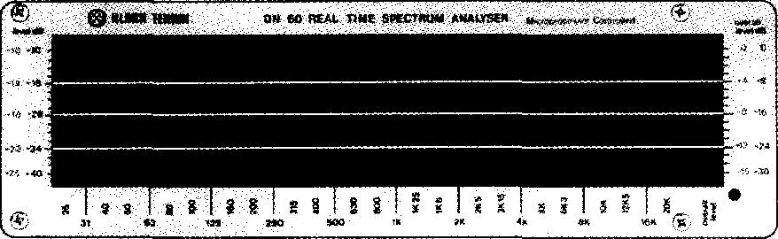

1 | m —
1 | **, | i;¹™
©.

FREQUENCY DOMAIN
The signal is displayed in real time as a 30 column bar graph on a large, bright LED matrix, corresponding to one third octave ISO freąuency bands. An extra column displays the overall signal level. The matrix is calibrated in dB (dBm for linę input; dBSPL for mic input) and reads to ldB or 2dB accuracy (switchable on the front panel, with ranges of 15dB and 30dB respectively). An A-weighting filter may be switched in linę with either input. The unit has an internal pink noise generator which may be used as a convenient signal source.
The user can choose between three Response speeds, with Peak or Averaging and Peak Hołd functions. The display may be frozen and stored in any of three memory locations.
With the addition of the optional LGB1 interface, a hardcopy of the display may be madę on most conventional X-Y plotters. A pad of paper duplicates of the display is supplied for morę simple hardcopy reąuirements.
Input level rangę is set via a front panel rotary switch. AU other functions are accessed by positive clicking buttons with LED indicators.
Features
Hi Large, bright LED matrix real time display.
Hi Linę and Mic inputs.
Hi Switchable A-weighting filter.
Hi Switchable ldB or 2dB resolution.
Hi Reads 30 ISO freąuencies plus overall signal level.
Hi Internal pink noise generator.
Hi Switchable Peak and Average responses with peakhold function.
Hi Three memories for display storage.
Hi Versatile functions with easy to use controls.
Hi Rugged, self-containcd rack-mounting unit.
Hi Optional plotter interface.
Hi Optional RT60 add-on unit allows
reverberation analysis as well as freąuency spectrum analysis.

m
Klark Teknik PLC
Walter Nash Road, Kidderminster, Worcestershire DY11 7HJ England. Tel: (01562) 741515 Fax No: (01562) 745371
Mark IV Pro Audio Group
448 Post Road, Buchanan MI 49107. lei: (616) 695 4750 Fax: (616) 695 0470
a MARK IV company Hie firsl name with sound system designera

DN60

TIME DOMAIN
The Klark Teknik RT60 is an inexpensive 1U add on unit that allows the DN60 to be used as a reverberation analyser. Reverberation measurements can be madę over the fuli audio bandwidth or at individual third octave freąuencies chosen by the user. Measurements can use either the DN60 internal noise source or an external source such as a clapperboard or starting pistol.
Reverberation decay curves are captured and displayed on the DN60 LED matrix. RT60 (time for a GOdB fali in the level of the reverberant field) is calculated and displayed on the RT60 front panel. The window over which the RT60 is calculated may be moved to compensate for non-linear decays.
Decay curves may be stored in any of three memories, or added to the Accumulator memory to give a true average RT60 for a rangę of freąuencies. With the RT60 unit attached, DN60 freąuency spectrum displays may also be accumulated in this way.
Technical Specifications

Freąuency Response | 15Hz to 22kHz
Microphone Input | Differential .25mV/uBar to
 | lmV/uBar
Sensitivity | 120dBSPL to 50dBSPL
Powering | 14V dc phantom power
 | (nominał)
Connector | XLR on front panel
Linę Input | Differential - balanced or
 | unbalanced
Sensitivity | 20dBm to -50dBm in lOdB
 | steps
Impedance | 47k ohm
Connector | XLR on rear panel
Attenuation accuracy | ± 0.2dB
'A'-weighting | Selectable to IEC 651 type 1
 | reąuirement
Pink Noise output
Digital pseudo-random white
noise generator with pink
noise filter
Frequency distribution
Level
Impedance Connector Interface
-3dB/Octave 20Hz to 20kHz
+ l.OdB
4dBm adjustable on rear panel
lk ohm unbalanced
XLR on rear panel
To RT60 unit, DN3600 or
via optional LGB1 to XY plotter

RELIABILITY CONTROL
Even with the advanced electronic engineering incorporated in this product, each unit is given the fuli backing of Klark Teknik's "Reliability Control", which proves each product against a specification consistent with the highest professional standards. Precision components are used throughout and every unit is bench tested and aligned before a burn-in period and finał performance test.
Trade Descriptions Act: Due to the company policy of continuing improvement, we secure the right to alter these specifications without prior notice.
Mark IV Pro Audio Group
448 Post Road, Ruchanan MI 49107. lei: (616) 695 4750 Fax: (616) 695 0470
Klark Teknik PLC
Walter Nash Road, Kidderminster, Worcestershire DY11 7HJ England. lei: (01562) 741515 Fax No: (01562) 745371

Power requirements
Voltage | 100/120/220/240 50/60Hz
Consumption | Less than 30VA
Weight
Net | 5Kg
Shipping | 8Kg
Dimensions | DN60 | RT60
Width | 482mm | 482mm
Depth | 254mm | 40mm
Height | 89mm | 44mm
6051 Microphone
Freąuency Response Sensithrtry
Dynamie rangę
Capsule
Type
Power reąuired
Fiat to 15KHz
0.5mV per uBar nominał @
1kHz
20 to 130dBspl
0.25inch electret condenser
pressure - omnidirectional
14V Phantom power
*|
ipany I
leral
©
a MARK IV company
TTie first name with sound system designera

