The thermistor is situated inside the screening box, just below the range switch. In the event of this being damaged, a tested thermistor should be obtained from this company.

Due to the high resistances used on the low frequency range, the instrument is sensitive to humidity. This is evidenced by weakness or cessation of oscillation on Range C, together with a drift of frequency. If this occurs, then the instrument should be left running, when after 15-30 minutes the moisture will be dissipated by the internally generated heat, and normal operation will return.

In all cases of difficulty the instrument should be returned to the factory for repair or adjustment

Page Eight

ADVANCE AUDIO FREQUENCY
SIGNAL GENERATOR

TYPE H.I.

INTRODUCTION
This Generator is intended primarily for fidelity and distortion checks on radio and television receivers, and high quality audio frequency amplifiers and record players. For these purposes, the wide frequency coverage of 15 - 50,000 c/s at constant voltage, and the low distortion of less than 1%, will be found ideal.

An optional square wave output is provided, which gives a good waveform approximately 50 : 50 ratio up to about 25 kc/s. This is useful for checking transient responses of video and other wide band amplifiers.

INSTRUCTIONS
POWER SUPPLY
The instrument is normally despatched with mains transformer set to operate from 210 - 250 volts supplies. For 105 - 125 volts it is necessary to change the tapping. To do this Remove the disc on the underside of the case, exposing the mains transformer. For 210 - 250 volts input tag 2 is connected to tag 3. For 105 - 125 volts remove the connection between tag 2 and tag 3. Connect tag 1 to tag 2 and tag 3 to tag 4. Replace the cover disc.

The instrument is suitable for A.C. supplies ONLY at frequencies between 40 c/s and 100 c/s.

The model H.l., N.A., is supplied with the transformer permanently set to operate on 115 - 120 volts supplies, at 25 - 60 c/s only.

Page One

VALVES AND ACCESSORIES
2 Valves type 6SN7GT Brimar.
I Valve type 6X5GT Brimar.
1 Thermistor type 1522/100 S.T.C.
I Pilot lamp type MES 11 mm. 6.5 volts.

A low capacity audio frequency lead, type PL 26, complete with plug and crocodile clips, is supplied with the instrument.

FREQUENCY RANGE
A sinusoidal signal of any frequency between 15 c/s and 50 kc/s is obtainable with an accuracy of ½ 1 % t 1 c/s by means of a directly calibrated dial and a three range selector switch. The bands are
A - 4,000 - 50,000 c/s
B - 300 - 4,000 c/s
C - 15 - 300 c/s

The total scale length is approximately 18 inches.

SINE WAVE OUTPUT
By means of the step and variable attenuators, a sinusoidal output at any level between 200,£V. and 20 V. is available from the output socket at any frequency on the dial.

The voltage into the attenuator is maintained constant within # 1 db. of the nominal value by means of the internal circuits of the generator,- and a further variation of ½ 1 db. may be found on the attenuated output, due to the use of 5% resistors in the attenuator.

The distortion of the output voltage is extremely small, as each generator has a measured total distortion factor of less than 1% at 1,000 c/s when checked at the factory. Normally the distortion is less than 1% between the limits of 100 c/s and 10 kc/s. The distortion consists of harmonics of the signal frequency, and hum at power supply frequency, in approximately equal amounts. It is measured on a normal type distortion meter, on which the percentage distortion is given as follows
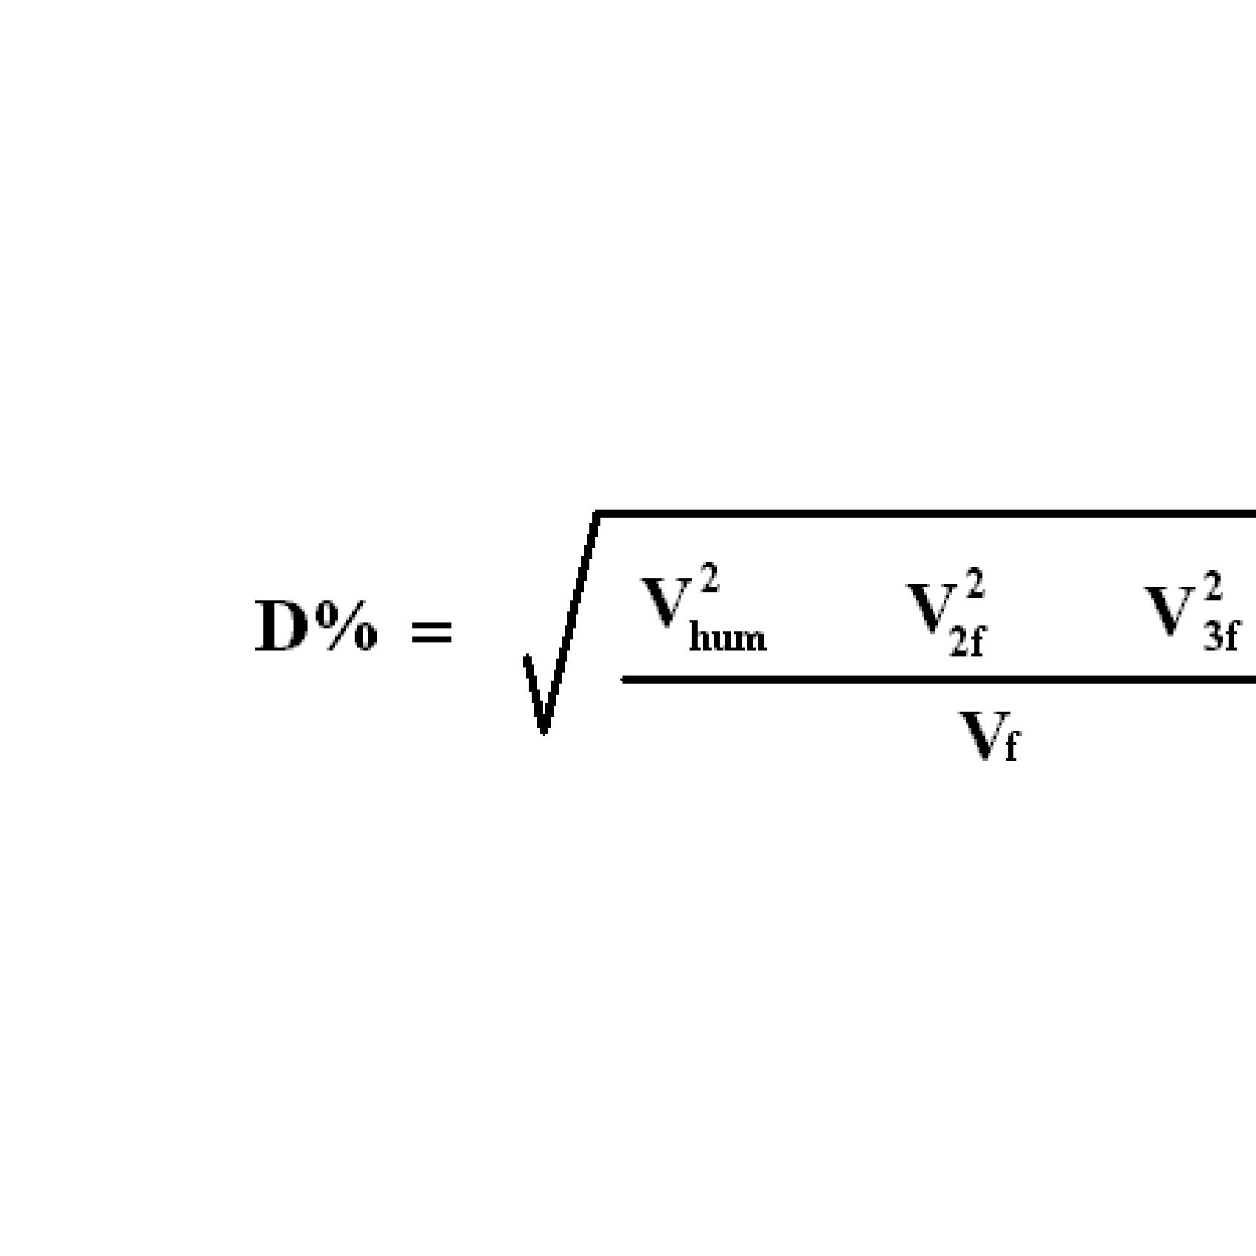
Page Two

CIRCUIT CODE

R 1 13 MΩ ± 1% 2W R19 5kΩ ± 5 RMA 9
R 2 1 MΩ “ ½ W R21 220kΩ ± 10% RMA9
R 3 70 kΩ “ ½ W R22 25 kΩ ±10% linear wound pot
R 4 13 MΩ “ 2W R23 22kΩ ± 10% RMA 8
R 6 70 kΩ “ ½ W R24 500Ω “ RMA 9
R 8 250 kΩ ± 5% RMA 9 R25 2.2kΩ “ RMA 8
R 9 22 kΩ ± 10% RMA 8 R26 50kΩ linear wire-wound pot.
R 10 500 Ω “ RMA 9 R27 68kΩ ± 5% RMA 8
R 11 5 kΩ ± 20% carbon pot. R28 6.8kΩ “ RMA 9
R 12 220 kΩ ± 10% RMA 9 R29 680 “ RMA 9
R 13 22 kΩ “ RMA 8 R30 68Ω “ RMA 9
R 14 1kΩ “ RMA 9 R31 15Ω “ RMA 9
R 15 5.1 kΩ “ RHA 8 R32 12Ω “ RMA 9
R 17 220 kΩ “ RMA 9 R33 22Ω ± 10% RMA 8
R 18 22 kΩ “ RHA 8 R34 22Ω “ RMA 8
R35 2.7kΩ “

Page Seven

Cl 3 - 50 pF Air trimmer, Philips.
C2 13-532 pF ) 2 gang variable condenser.
C3 13-532 pF )
C5 .1 µF 350 V DCW ± 10% oil filled tubular.
C6 .1 µF “ “ “
C7 8 µF 500V 6CW elect. (part of block).
C8 .1 µF 350V DCW ± 20% paper tubular.
C9 .1 µF “ “
C 10 .1 µF “ “
C 11 8 µF 450V DCW elect.
C 12 16 µF 500V DCW “ ) part of block.
C 13 16 µF “ “ )
C 14 8 µF 450V DCW
C 15 Wire trimmer.
C 16 “
C 17 “
V1 Valve type 6SN7GT Brimar.
V2 Valve type “ “
V3 Valve type 6XSGT Brimar.
SI 2 pole 3 way range switch.
S2 )2 pole change over toggle switch.
S3 )
S4 1 pole 6 way attenuator switch.
S5 Mains on/off switch coupled to R 26.
T1 Mains transformer.
TH1 S.T.C. thermistor A 1522/100.

Page Six
SQUARE WAVE OUTPUT
By setting the " Sine - Square " switch to " Square " position, the output is converted into a square wave of approximately 50 : 50 form. In this case, the output voltage range becomes 800 µV. to 80 V. peak to peak approximately, and the tolerance on frequency becomes about ± 3%.

The square wave rises to 90% of its peak value in less than 3µs at 10 kc/s. The rate of rise is similar at all other frequencies, resulting in a rapid deterioration of the square waveform above about 25 kc/s, but maintaining a sharp rise and fall at low frequencies. Below about 50 c/s a tilt appears on one flat of the square wave, and this becomes quite pronounced at 15 c/s. However, the other flat remains good, as do the rise and fall times of the edges. Due to the by-passing effect of stray capacities, the high frequency square wave will be improved with the attenuator switch at a low impedance position.

CONNECTION TO EQUIPMENT UNDER TEST
Due to the feedback circuit used, there is a constant D.C potential of about 8 V. at the high potential end of the output potentiometer. This appears at the output socket via the step attenuator, and is attenuated in the same way as the signal output. If it is desired to block off this D.C. from the circuit under test, a suitable condenser should be inserted in the output lead.

MAINTENANCE
To remove the instrument from the case, proceed as follows

Remove the dome nut from the rear of the case.
Lay the instrument on its back and remove the four screws in the corners of the panel, each a little at a time. The panel will be lifted from the case.

To Reassemble : Lay the case on its back and replace the instrument. Engage the threads of the corner screws, stand the instrument upright and carefully screw up the panel evenly, making sure the back chassis bolt appears through its clearing hole in the case. The dome nut must then be replaced.

The 6SN7GT and 6X5GT valves may be seen at the back of the chassis. Replacement of any of these valves should normally cause no trouble, and will not affect the performance of the instrument,

Page Three

FOX PRINTING PRESS
(T.U.)
Typos House, Maybank Rd.
S. Woodford, London, E.18.

ADVANCE

AUDIO FREQUENCY

GENERATOR

Type H.1

INSTRUCTIONS

ADVANCE COMPONENTS LIMITED
BACK ROAD – SHERNALL STREET
WALTHAMSTOW – LONDON – E.17

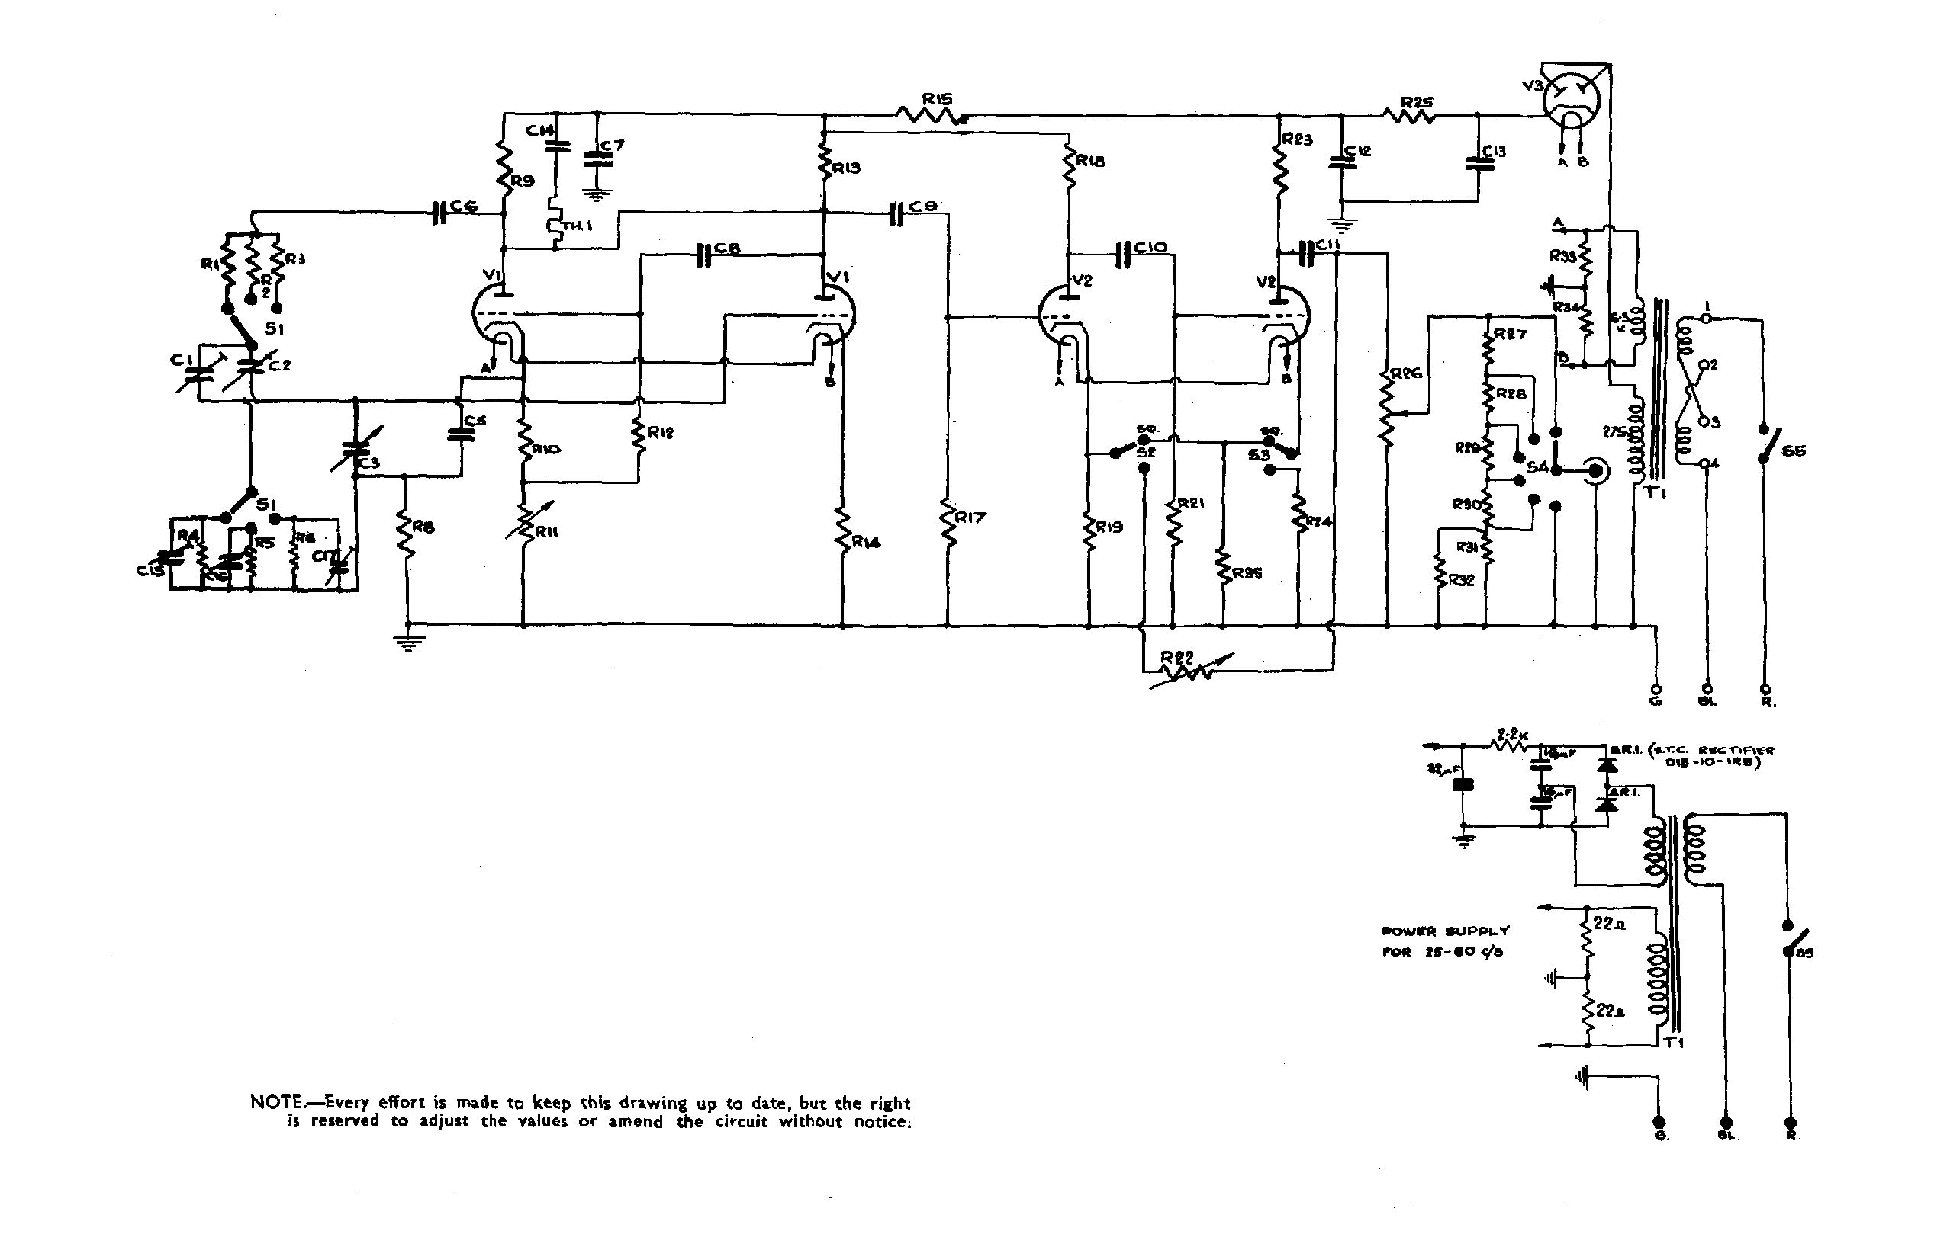

page Four Page Five

