

INSTRUCTION BOOK No. 14-7490R

A.W.A. ULTRA-HIGH FREQUENCY SIGNAL GENERATOR

TYPES 4R7490 (70-150Mc.), 5R7490 (45-100Mc.)

AND 6R7490 (20-50Mc.)

(Serial Nos. above 236)

47 York Street, Sydney

INSTRUCTION BOOK NO. 14-7490R

A.W.A. ULTRA-HIGH FREQUENCY SIGNAL GENERATOR

TYPES 4R7490 (70-150 M.), 5R7490 (45-100 Mc.)

And 6R7490 (25-50 Mc.)

(Serial Nos. above 286)

Amalgamated Wireless (A’sia) Limited

47 York Street

SYDNEY

10493

(i)

INDEX

SECTION PAGE NOS.

1 DESCRIPTION:

1.1 Construction and Circuit Arrangements 1
1.2 Summary of Characteristics 1

2 INSTALLATION:

2.1 Adjustment for Supply Voltage 2
2.2 Insertion of Valves 2

3 OPERATING INSTRUCTIONS:

3.1 Special Caution 3
3.2 Output Connection and Terminating Unit 3
3.3 Setting “ZERO” 3
3.4 Setting Carrier 4
3.5 Setting Frequency 4
3.6 Controlling Output 4

4 MAINTENANCE:

4.1 Fuses 4
4.2 R-F Oscillator 4
4.3 Voltmeter 4
4.4 Typical Operating Voltages and Currents 5

5 COMPONENT SCHEDULE 6

6 EQUIPMENT SCHEDULE 9

7 DRAWINGS: DWG. NOS.

Circuit Diagram,
U.H.F. Signal Generator, type 4R7490,
5R7490 and 6R7490 (series nos. above
286) 7490C24

Frequency Calibration Chart

Frequency Calibration Curve

Typical Circuits,
A.W.A. Terminating Unit, type R8649 8649C1

(1)
INSTRUCTION BOOK NO. 14-7490R
1. DESCRIPTION
1.1 Construction and Circuit Arrangements

These A.W.A. U.H.F. Signal Generators, types 4R7490, 5R7490 a 6R7490 employ in their r-f sections the special technique necessary the frequency band in which they operate, The r-f oscillator is of the Hartley type, using an acorn triode, and a low-loss coil and variable condenser form the tank circuit. The r-f output is obtained from a mutual inductance coupling to the coil arranged in the form of a piston attenuator, capable of an absolute calibration in decibels, An 80 Ω concentric output cable is provided, The whole of the r-f section is enclosed in a brass box, heavily tin-plated, and all leads entering the box are well filtered, variable condenser rotor and stator are milled from solid brass, and are insulated by polystyrene and micalex respectively.

The r-f voltage developed is monitored by a diode voltmeter, and may be held constant by varying the plate voltage of the oscillator valve (“SET CARRIER” control). The voltmeter employs two acorn diodes, one being used in conjunction with a potentiometer (“SET ZERO” control) to supply a “backing-off” potential.

Modulation is provided by a Colpitt's type oscillator, and is applied to the r-f oscillator in such a way that the modulation depth does not vary as the plate voltage is adjusted. External modulation may also be employed.

The power, supply section uses a full-wave valve rectifier and a double-section choke-input filter. A mains switch, pilot light, r-f mains filter and fuses are provided.

The instrument is contained in a cast aluminium case, all components being mounted on two vertical panels. The larger of these panels carries the r-f oscillator box, and a chassis mounting the modulator, power supply filter and voltmeter “backing-off” diode. On the front of this panel are mounted the frequency, output, set carrier and set zero controls, carrier and modulation switches, terminals for external modulation, and the output monitoring meter, The smaller panel carries the r-f mains filter, mains switch, fuses, power transformer, rectifier and pilot light, A partition in the case effectively screens these components from the signal generator proper. The case is provided with carrying handles and with cleats on which the output and power cables may be wound when not in use,

1.2 Summary of Characteristics

(a) Frequency Range

Type 4R7490: 70-150 Mc.
Type 5R7490: 45-100 Mc.
Type CR7490: 25-50 Mc.

(b) Output Voltage
Maximum value: 0.1 volt. when correctly terminated
(refer 3.2)
Monitoring: Input to attenuator held constant by manual
control and valve voltmeter.
(c) Attenuator Range

0-100 db. below maximum output

(1)
INSTRUCTION BOOK NO. 14-7490R
SECTION 1 (Contd.)

(d) Output Connection

80 Ω unbalanced transmission line

(e) Modulation

Internal: 400 ~ ±10 ~ distortion less than 2%, depth approximately 2%

External: Required input - 40V R.M.S. for 30% modulation (approximate)

Input Impedance - approximately 20,000 to 17,000 Ω (resistive)

(f) Power Supply

The instrument is normally supplied with a mains unit, series H7491, for operation on a supply of 200-250V, 50-60~, but a special power supply unit, series H50361, is available for operation from a supply of 80V, 800-3,000~.

Special units, for use with other voltages and frequencies, may also be supplied, if required.

The power consumption is approximately 30 watts.

(g) Dimensions
27” x 10 ½ ” x 11” over all projections

(h) Weight
65 lbs.

2. INSTALLATION

2.1 Adjustment for Supply Voltage

The Mains Unit Fuses should be placed in the correct clips to suit the mains vo1tage. Three transformer taps are provided, namely 220, 240 and 260V. One fuse should be in a clip marked with the voltage to be employed, and the other fuse in the clip marked common. The fuses are accessible when the Mains Unit is removed from the case.

2.2 Insertion of Valves

The valves should be inserted in their respective sockets, which are plainly marked, and the top connections made where required. The two valves in the oscillator box are accessible through cover plates without removing the back of the box.
(3)

INSTRUCTION BOOK NO. 14-7490R

SECTION 3 (Contd.)

3.1 SPECIAL CAUTION

CARE MUST BE TAKEN NOT TO SUBJECT THE MAIN TUNING CONDENSER TO
UWARRANTED MECHANICAL STRAIN, AS THIS MAY RESULT IN FRACTURE OF THE INSULATING RODS. UNDUE PRESSURE ON THE FREQUENCY DIAL OR KNOB, ORTHE STRIKING OF EITHER WITH OPEN APPARATUS MUST BE CAREFULLY GUARDED AGAINST.

Output Connection and Terminating Unit

THE OUTPUT CABLE MUST BE TERMINATED CORRECTLY WITH ITS CHARACTERISTIC IMPEDANCE (i.e. 80 Ω RESISTANCE). OTHERWISE LARGE FLUCTUATIONS OF VOLTAGE WILL OCCUR AS THE FREQUENCY IS VARIED, AS WELL AS ERRORS IN OUTPUT VOLTAGE MEASUREMENT .

The terminating unit type R8649 which may be supplied, forms a convenient means of terminating the output cable, and may also be used to insert series resistors or L, T or Π pads into the output connection, A selection of non-inductive resistors, conducting slugs and insulating slugs is supplied, and other values of resistor may be obtained, A selection of adaptors for various types of coaxial connectors and for connection by screw-down terminals is also supplied.

The following examples will show how the Terminating Unit should be used (see Drg. No 8649C1).

(a) Connection to High Impedance Circuit (e.g., intermediate frequency grid circuit)

Use 80 Ω shunt resistor in T-piece and adaptor as required

(b) Connection to 80 Ω (or 100 Ω) Circuit (e.g., aerial input circuit)

Use adaptor as required, do not use T-piece.

(c) Insertion of Attenuating Pad in 80 Ω Circuit

Use T or П-pad (one or to T-pieces respectively) and adaptor as required, e.g., a Π-pad for 40 db attenuation at 80 Ω would comprise two 80 Ω shunt arms and a 4,000 Ω series arm.

(a) Provision of Lo Impedance Output

Use en inverted L-pad (one T-piece) and adaptor as required. For a 7 Ω (approx.) output (voltage x 1/10) use a 70 Ω series arm (on the generator side of the T-piece) and on 8 Ω shunt arm,

A series resistor (say 70, 80 or 100 Ω ) may be used with this L-pad (in the output arm of the T-piece) for determination of receiver input impedance.

3.3 Setting “ZERO”
With the “carrier” switch at “OFF”, the meter deflection should be zero. It may be corrected at any time by means of the “SET ZERO” adjustment, having first set the mechanical zero of the meter with the main switch off. If it is found that the “SET ZERO” adjustment is insufficient, one of the diodes requires replacement (see "MAINTENANCE ).
(4)

INSTRUCTION BOOK NO. 14-7490R

SECTION 3 (Contd.)

3.4 Setting Carrier

The r-f voltage developed varies somewhat with frequency, and the meter must be at all times kept at the “0.1V” mark by adjustment of the “"SET CARRIER” control.

3.5 The frequency calibration is given in the Table and curve attached.

3.6 Controlling Output

The output control is calibrated to read directly in decibels below the r-f input to the attenuator, which is 0.1 when the meter reads ran “0.1V” provided the output is correctly terminated in 80 Ω.

4. MAINTENANCE
4.1 Fuses

Two 3-ampere fuses are mounted below the Mains Unit chassis

4.2 R-F Oscillator

Failure to obtain sufficient r-f voltage indicates that the Oscillator valve (V5, type 955) requires replacement. Changing this valve will have a small effect on the frequency calibration, but the change is usually less than l%.

4.3 Voltmeter

If the meter deflects off scale backwards at all settings of the “SET ZERO” control, the r-f diode (V4, type EA5O) has failed and must be replaced. This valve is mounted within the oscillator.

If the meter deflection cannot be brought down to zero by means of the “SET ZERO” control, the backing-off diode (V3, type EA5O) has failed and must be replaced, This valve is mounted on the upper side of the chassis.

If the meter will not zero after replacing either diode, the diodes should be interchanged. The valves used are standard commercial products, and any pair will function satisfactorily.

(5)

INSTRUCTION BOOK NO. 14-7490R

SECTION 4 (Contd.)

4.4 Typical Operating Voltages and Currents.

(a) Mains Unit

Input Voltage 220-260V, 50-60~ (to appropriate tap)

Output plug removed from socket on generator chassis

V1 plate - earth voltages: 320V, 320V R.M.S.

V1 heater voltage: 5V R.M.S.

L.T. Supply at output
socket 6.5V R.M.S.

(b) Signal Generator Proper

Connected to mains unit
by interconnecting cable,
all valves in sockets.

Valve heaters: 6.3V R.M.S.

H.T, voltage (measured
across C8): 260V (Carrier off, internal or external modulation)

Hum voltage on H.T.
(across C8) : Less than 0.25Vpeak

V2 voltages:
Int. Mod. Ext. Mod.
Plate- cathode. 230V * l0V
Screen-cathode 70V 40V
Cathode-earth l.3V 113V

V2 currents
Int. Mod. Ext. Mod.
Plate 4.3 mA 4.4 mA
Screen 0.7 mA 0.8 mA
Grid 0.2 mA Nil
Cathode 5.2 mA 5.2 mA

V5 plate supply voltages:

D.C. (junction of R12, C30 to earth) 250V
A.F. (junction of C30, S2 to earth) 40V R.M.S.(approx.)

V5 plate voltage (S3 to earth): 30-180 V D.C.

V5 plate current (maximum): 10 mA

* This low voltage is due the inclusion of a series resistor in circuit in the External Modulation position in order to maintain the H.T. voltage unchanged.
(6)

INSTRUCTION BOOK NO. 14-7490R

5. COMPONENT SCHEDULE

U.H.F. Signal Generators, type 4R, 5R, and 6R7490

Circ. Effective Value A.W.A. Type Number
Ref. No. (unless otherwise stated)

(a) Resistors

R1 0.25 MΩ, ¼ W Carbon
R2 Potentiometer, 20,000 Ω Marquis Vernier
R3 Not Used
R4 4,000 Ω, ¼ W Carbon
R5 Not Used
R6 16,000 Ω, ¼ W Carbon
R7 25,000 Ω, ½ W Bifrost, Carbon
R8 75 Ω, ⅓ W Bifrost Carbon
R9 Short circuit if V3 and V4 are type EA50: 5.75 Ω type AB, Ctg.C if D1
R10 250 Ω, W/wound, type AB, Ctg.C
R11 0.25 MΩ, 1W Carbon
R12 5,000 Ω W/wound, type AB, Ctg.C
R13 Not Used
R14 ….. Ω ¼ W (select on test for 30%
Modulation) (nominally 4,000 Ω) Carbon
R15 50,000 Ω (2 x 100,000 Ω, 1W in
Parallel) Carbon
R16 Potentiometer, 25,000 Ω Carbon
R17 Not Used
R18 Not Used
R19 75 Ω, ⅓W Bifrost, Carbon
R20 Not Used
R21 Not Used
R22 5,000Ω W/wound, type AB, Ctg.C

(b) Condensers
C1 1,000 µµF, mica Simplex P/T
C2 1,000 µµF, mica Simplex P/T
(7)

INSTRUCTION BOOK NO. 14-7490R

SECTION 5 (Contd.)
Circ. Effective Value A.W.A. Type Number
Ref. No. (unless otherwise stated)

C3 1,000 µµF, mica Simplex P/T
C4 1,000 µµF, mica Simplex P/T
C5 1,000 µµF, mica Simplex P/T
C6 Not Used
C7 5 µF, 350 V.W. Paper 3U3551
C8 5 µF, 350 V.W. Paper 3U3551
C9 .05 µF, 350 V.W. Paper S7080
C10 .1 µF, 350 V.W. Paper S7080
C11 .25 µF, 350 V.W. Paper S7080
C12 1,000 µµF, mica Simplex P/T
C13 Not Used
C14 1,000 µµF, mica Simplex P/T
C15 Not Used
C16 1,000 µµF, mica Simplex P/T
C17 1,000 µµF, mica Simplex P/T
C18 1,000 µµF, mica Simplex P/T
C19 Not Used
C20 1,000 µµF, mica Simplex P/T
C21 Not Used
C22 1,000 µµF, mica Simplex P/T
C23 1,000 µµF, mica
C24 Not Used
C25 1,000 µµF, mica Simplex P/T
See note in each
individual book
C26) 10 µµF, mica (for type 4R7490) Simplex D/S
) 100 µµF, mica (for type 5R7490) Simplex D/S
) 500 µµF, mica (for type 6R7490) Simplex D/S
)
C27) 5 µµF, mica (for type 4R7490) Simplex D/S
) 10 µµF, mica (for type 5R7490) Simplex D/S
) 50 µµF, mica (for type 6R7490) Simplex D/S
)
C28) Variable, 4-30 µµF ( for type 4R4790)
) Variable 5-48 µµF ( for type 5, 6r4790)
)
C29 0.25 µF, 350V.W., paper S7080
(8)

INSTRUCTION BOOK NO. 14-7490R

SECTION 5 (Contd.)
Circ. Effective Value A.W.A. Type Number
Ref. No. (unless otherwise stated)
C30
C31 1,000 µµF, mica Simplex P/T
C32
C33 1,000 µµF, mica Simplex P/T
C34 1,000 µµF, mica Simplex P/T
(c) Radio Frequency Chokes
RFC1,2, R.F. chokes, Dwg. No.
4-6, 8-11 8483T51-1 (resis. 1Ω) 4R7490

RFC1,2, R.F. chokes, Dwg. No.
4-6, 8-11 8483T51 (resis. 1Ω) 5R,6R7490

RFC3 & 7 Not used

(d) Power Transformers and Chokes

T1 Power transformer, (resis-
tances: Primary 25Ω, H.T.
800Ω C.T., L.T. 0Ω 1TJ7447

L1 Filter choke (resistance 500Ω) 1TX7446

L2 Filter choke (resistance 500Ω) 1TX7446

(e) Audio-Frequency Chokes

L3 Feed choke (resistance 500Ω) 1TX7446

L4 Plate-grid choke (resistance 250Ω) 5TA4793

(f) Valves

V1 Rectifier 5Y3G
V2 A.F. Oscillator 6V6G
V3 Backing-off diode, type EA50 or
type D1 (N.B.: see R9)
V4 Metering diode, type EA50 or
type D1 (N.B.: see R9)
V5 R.F. oscillator 955
(g) Switches
S1 Mains switch S3510
S2 Modulation switch (Dwg. No. 7490D7) Oak type 28
S3 Carrier switch (Dwg. No. 7490D3) Oak type 25
(9)

INSTRUCTION BOOK NO. 14-7490R

SECTION 5 (Contd.)
Circ. Effective Value A.W.A. Type Number
Ref. No. (unless otherwise stated)

(h) Meter
M1 0-50 µA (resistance
Approx. 1,000 Ω)

(j) Miscellaneous
F1 Fuse 3A Glass cartridge type
F2 Fuse 3A Glass cartridge type
PL1 pilot lamp 6.3V Mazda type 46
Oscillator Box (1A8483 (for type 4R7490)
(2A8483 (for type 5R7490)
(3A8483 (for type 6R7490)
Attenuator 1R7493
Output Connector (7490U261 (for type 6R7490)
(HMV type D4020C (equiv.
Pye elbow (for type 4,
(5R,7490)
Mains Unit (7H7491 (for type 4R7490)
(8H7491 (for type 5, 6R7490)

6. EQUIPMENT SCHEDULE

Item 1. One A.W.A. U.H.F. Signal Generator, type 4R7490, 5R7490 or 6R7490.
Item 2. One A.W.A. Mains Unit, type 7H7491 (for type 4R7490) or 8H7491 (for types
5R7490 and 6R7490) mounted with item 1.
Item 3. Valves for the operation of items 1 and 2 as follows :-
One type 5Y3G
One type 6V6G
One type 955
Two type EA50 or
Two type MAZDA type D1
Item 4. Instruction Book No. 14-7490R
Note: This list is a guide to the items which comprise a normal equipment, but may be varied to suit the requirement of each installation.

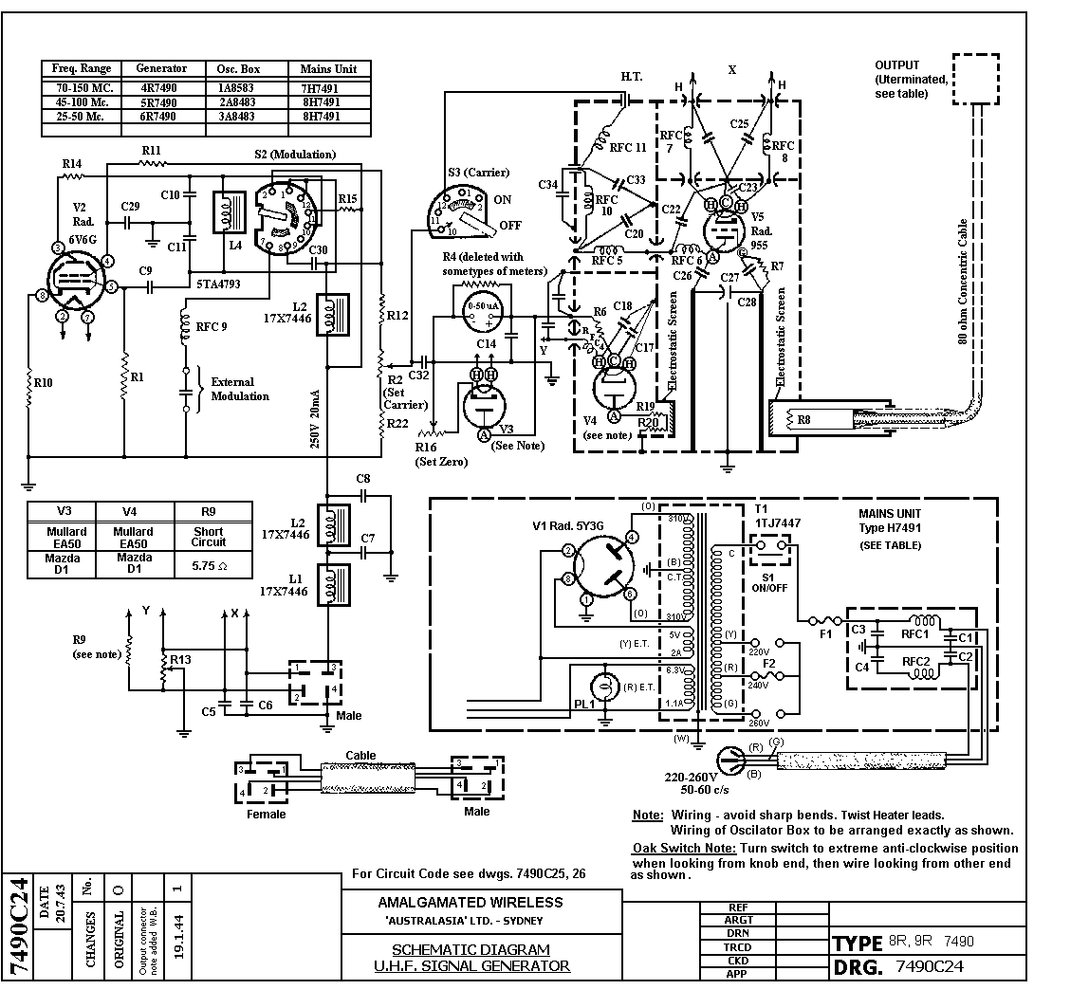

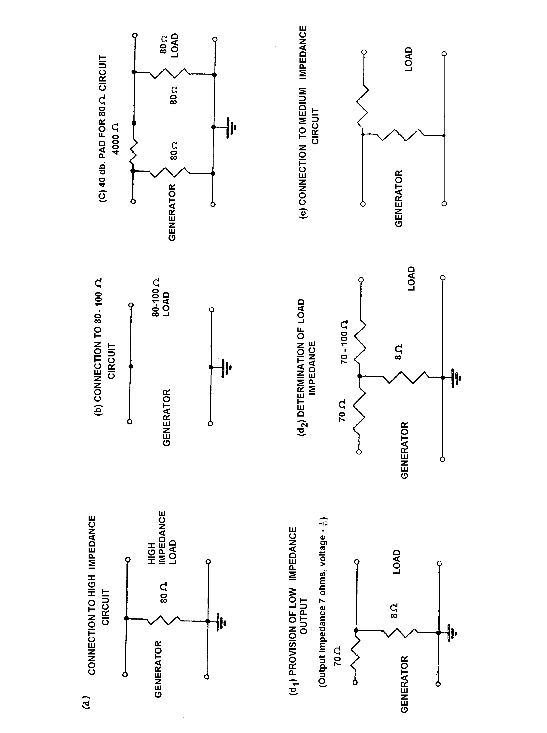

A.W.A. U.H.F. SIGNAL GENERATOR
TYPE 6R7490 SERIAL NO. 524
NAME PLATE
………………………..
……………………….
………………………….

Frequency Calibration

Frequency (Mc.) | Dial Setting
22 | 3.85
24 | 13.05
25 | 17.2
26 | 20.95
28 | 27.75
30 | 33.8
32 | 39.45
34 | 44.75
35 | 47.75
36 | 50.0
38 | 55.05
40 | 60.25
42 | 65.4
44 | 71.05
45 | 73.7
46 | 76.55
48 | 83.4
50 | 91.75

