1.

INSTRUCTION BOOK N0. 3-7490R
A.W.A. ULTRA-HIGH FREQUENCY SIGNAL GENERATORS
TYPES 8R7490 & 9R7490

1. DESCRIPTION

1.1 Construction and Circuit Arrangements:

This Instruction Book describes the A.W.A U.H.F. Signal Generators bearing the following name plates. The corresponding A.W.A. Type numbers are indicated since they do not appear on the nameplate.

Nameplates and Type Numbers

U.H.F. SIGNAL GENERATOR |  | MAINS UNIT
Nameplate | A.W.A.  Type | Nameplate | A.W.A.  Type
Signal Generator  200 Mc. Mk  Serial No.  D↑D | 8R7490 | Mains Unit for  Signal Generator  200 Mc. Mk  Serial No.  D↑D | 1H7491
R.A.A.F. Test Set  Type A6 Ident. No.  Y10S/60,006  Serial No. | 9R7490 | R.A.A.F. Mains  Unit A6A Ident. No.  Y10S/60,013  Serial No. | 2H7491

The A.W.A. U.H.F. Signal Generator, types 8R7490 and 9R7490 employs in its r-f sections the special technique necessitated by the frequency band in which they operate. The r-f oscillator is of the Hartley type, using an acorn triode, and a short circuited transmission line forms the tank circuit. The line is loaded by a variable capacity to provide the frequency adjustment. The r-f output is obtained from a mutual inductance coupling to the line arranged in the form of a piston attenuator, capable of an absolute calibration in decibels. An 80 Ω concentric output cable is provided. The whole of the r-f section is enclosed in a brass box, heavily silver-plated, and all leads entering the box are well filtered. The variable condenser rotor and stator are milled from solid brass, and are insulated by polystyrene and micalex respectively.

The r-f voltage developed is monitored by a diode voltmeter, and may be held constant by varying the plate voltage of the oscillator valve (“SET CARRIER” control). The voltmeter employs two acorn diodes, one being used in conjunction with a potentiometer (“SET ZERO” control) to supply a “backing-off” potential.

Modulation is provided by a Colpitt's type oscillator, and is applied to the r-f oscillator in such a way that the modulation depth does not vary as the plate voltage is adjusted. External modulation may also be employed.

The power, supply section uses a full-wave valve rectifier and a double-section choke-input filter. A mains switch, pilot light, r-f mains filter and fuses are provided.

2.

INSTRUCTION BOOK N0. 3-7490R
A.W.A. ULTRA-HIGH FREQUENCY SIGNAL GENERATORS
TYPES 8R7490 & 9R7490
SECTION 1 (Contd.)

The instrument is contained in a cast aluminium case, all components being mounted on two vertical panels. The larger of these panels carries the r-f oscillator box, and a chassis mounting the modulator, power supply filter and voltmeter “backing-off” diode and spare valves. On the front of this panel are mounted the frequency, output, set carrier and set zero controls, carrier and modulation switches, terminals for external modulation, and the output monitoring meter, The smaller panel carries the r-f mains filter, mains switch, fuses, power transformer, rectifier and pilot light, A partition in the case effectively screens these components from the signal generator proper. The case is provided with carrying handles and with cleats on which the output and power cables may be wound when not in use.

1.2 Summary of Characteristics

(a) Frequency Range

140-300 Mc.

(b) Output Voltage
Maximum value: About 0.4 volt.

Monitoring: Input to attenuator held constant by manual control and valve voltmeter.

(c) Attenuator Range

0-100 db. below maximum output

(d) Output Connection

80 Ω unbalanced unterminated transmission line

(e) Modulation

Internal: 400 c/s ±10 c/s. distortion less than 2%, depth approximately 2%

External: Required input - 40V R.M.S. for 30% modulation (approximate)

Input Impedance - approximately 20,000 to 17,000 Ω (resistive)

(f) Power Supply

220-260V, 50-60 c/s, approximately 30 watts.

3.

INSTRUCTION BOOK N0. 3-7490R
A.W.A. ULTRA-HIGH FREQUENCY SIGNAL GENERATORS
TYPES 8R7490 & 9R7490

SECTION 1 (Contd.)

(g) Dimensions
27” x 10 ½ ” x 11” over all projections

(h) Weight
65 lbs.

4.

INSTRUCTION BOOK N0. 3-7490R
A.W.A. ULTRA-HIGH FREQUENCY SIGNAL GENERATORS
TYPES 8R7490 & 9R7490

2. INSTALLATION

2.1 Adjustment for Supply Voltage

The Mains Unit fuses should be placed in the correct clips to suit the mains voltage. Three transformer taps are provided, namely 220, 240 and 260V. One fuse should be in a clip marked with the voltage to be employed, and the other fuse in the clip marked common. The fuses are accessible when the Mains Unit is removed from the case.

2.2 Insertion of Valves:

The valves should be inserted in their respective sockets, which are plainly marked, and top connections made where required. The two valves in the oscillator box are accessible through cover plates without removing the back of the box.

5.

INSTRUCTION BOOK N0. 3-7490R
A.W.A. ULTRA-HIGH FREQUENCY SIGNAL GENERATORS
TYPES 8R7490 & 9R7490

3.1 SPECIAL CAUTION

CARE MUST BE TAKEN NOT TO SUBJECT THE MAINTUNING CONDENSER TO
UWARRANTED MECHANICAL STRAIN, AS THIS MAY RESULT IN FRACTURE OF THE INSULATING RODS. UNDUE PRESSURE ON THE FREQUENCY DIAL OR KNOB, ORTHE STRIKING OF EITHER WITH OPEN APPARATUS MUST BE CAREFULLY GUARDED AGAINST.

Output Connection

The output lines must be terminated correctly (i.e., with 80 Ω resistance), otherwise large fluctuations of voltage will occur as the frequency is varied.

3.3 Setting “ZERO”
With the “carrier” switch at “OFF”, the meter deflection should be zero. It may be corrected at any time by means of the “SET ZERO” adjustment, having first set the mechanical zero of the meter with the main switch off. If it is found that the “SET ZERO” adjustment is insufficient, one of the diodes requires replacement (see "MAINTENANCE ).

3.4 Setting Carrier

The r-f voltage developed varies somewhat with frequency, and the meter must be at all times kept at the “40µA – 0.25V” mark by adjustment of the “"SET CARRIER” control.

3.5 The frequency calibration is given in the Table and curve attached.

3.6 Controlling Output

The output control is calibrated to read directly in decibels below the r-f input to the attenuator.

6.
INSTRUCTION BOOK N0. 3-7490R
A.W.A. ULTRA-HIGH FREQUENCY SIGNAL GENERATORS
TYPES 8R7490 & 9R7490

4. MAINTENANCE
4.1 Fuses

Two 3-ampere fuses are mounted below the Mains Unit chassis

4.2 R-F Oscillator

Failure to obtain sufficient r-f voltage indicates that the Oscillator valve (V5, type 955) requires replacement. Changing this valve will have a small effect on the frequency calibration, but the change is usually less than l%.

4.3 Voltmeter

If the meter deflects off scale backwards at all settings of the “SET ZERO” control, the r-f diode (V4, type EA5O) has failed and must be replaced. This valve is mounted within the oscillator.

If the meter deflection cannot be brought down to zero by means of the “SET ZERO” control, the backing-off diode (V3, type EA5O) has failed and must be replaced, This valve is mounted on the upper side of the chassis.

If the meter will not zero after replacing either diode, the diodes should be interchanged. The valves used are standard commercial products, and any pair will function satisfactorily.

4.4 Typical Operating Voltages and Currents:

(a) Mains Unit

Input Voltage: 220-260V, 50-60 cycles
(to appropriate tap)

Output plug removed from
Socket.

V1 plate - earth voltages: 340V, 340V R.M.S.

V1 heater voltage: 5V R.M.S.

L.T. Supply at output
socket 6.5V R.M.S.

(b) Signal Generator Proper.

Connected to mains unit by interconnecting cable,
all valves in sockets.

Valve heaters: 6.3V R.M.S.

H.T, voltage (measured across C8): 260V (Carrier off, internal or external modulation)

Hum voltage on H.T.
(across C8) : Less than 0.25Vpeak
7.

INSTRUCTION BOOK N0. 3-7490R
A.W.A. ULTRA-HIGH FREQUENCY SIGNAL GENERATORS
TYPES 8R7490 & 9R7490

V2 voltages:
Int. Mod. Ext. Mod.
Plate- cathode. 260V * l0V
Screen-cathode 70V 40V
Cathode-earth l.3V 1.3V

V2 currents:
Int. Mod. Ext. Mod.
Plate 4.3 mA 4.4 mA
Screen 0.7 mA 0.8 mA
Grid 0.2 mA Nil
Cathode 5.2 mA 5.2 mA

V5 plate supply voltages:

D.C. (junction of R12, C30 to earth) 250V
A.F. (junction of C30, S2 to earth) 40V R.M.S.(approx.)

V5 plate voltage (S3 to earth): 0-100 V D.C.

V5 plate current (maximum): 5 mA

* This low voltage is due the inclusion of a series resistor in circuit in the External Modulation position in order to maintain the H.T. voltage unchanged.

8.
INSTRUCTION BOOK N0. 3-7490R
A.W.A. ULTRA-HIGH FREQUENCY SIGNAL GENERATORS
TYPES 8R7490 & 9R7490

IMPORTANT !

HOW TO ORDER REPLACEMENT PARTS

The following systems of ordering spare or replacement parts should be adhered to in order to avoid unnecessary correspondence and expedite delivery.

1. To order a major part which carries its own type number, quote this type number; quote also serial number, resistance value or capacity value where shown.

Examples:- Transformer 1TK5510 (Serial No. 117)

Resistance A.W.A. 1S4282 500Ω

2. To order a small electrical part which carries no type number, quote:-

(i) Type number and serial number of section (not whole equipment) where part is used.

(ii) Circuit reference number.

(iii) Circuit diagram number and sub-number, the latter being found in the right- hand section of the last entry in the “changes” column.

Examples:- Type PS368, serial, No. 18, C50A Dwg. No. 8368C1,sub-number 2.

3. To order a part which carries no type number and has no circuit reference number, quote:-

(i) Type number and serial number of section (not whole equipment) where part is used.

(ii) Circuit reference number and circuit dwg. Number of component associated with the wanted part.
(iii) Brief description of part.
Examples:- Type J8279, Serial No. 41. Insulated coupling C23B, Dwg. No. 8279D1.
5. COMPONENT SCHEDULE

Circ. Effective Value A.W.A. Type Number
Ref. No. (unless otherwise stated)

(a) Resistors

R1 0.25 MΩ, ¼ W
R2 Potentiometer, 20,000 Ω Marquis Vernier
R3 Not Used
R4 4,000 Ω, ¼ W
R5 Not Used
R6 16,000 Ω, ¼ W
9.
INSTRUCTION BOOK N0. 3-7490R
A.W.A. ULTRA-HIGH FREQUENCY SIGNAL GENERATORS
TYPES 8R7490 & 9R7490

Section 5 (Contd.)
Circ. Effective Value A.W.A. Type Number
Ref. No. (unless otherwise stated)

R7 25,000 Ω, ½ W Bifrost, Carbon
R8 75 Ω, ⅓ W Bifrost Carbon
R9 Short circuit if V3 and V4 are Mullard
type EA50: 5.75 Ω if Mazda D1
R10 250 Ω, 3Watt
R11 0.25 MΩ, 1W
R12 10,000 Ω 5Watt
R13 Potentiometer, 200 Ω AWA S5711
R14 ….. Ω ¼ W (select on test for 30%
Modulation) (nominally 4,000 Ω)
R15 50,000 Ω 2W
R16 Potentiometer, 25,000 Ω
R17 Not Used
R18 Not Used
R19 30 Ω, ⅓W Bifrost
R20 30 Ω, ⅓W Bifrost
(b) Condensers
C1 0.002 µF, mica
C2 0.002 µF, mica
C3 0.002 µF, mica
C4 0.002 µF, mica
C5 0.001 µF, mica
C6 0.001 µF, mica
C7 5 µF 350 V.W. AWA 3U3551
C8 5 µF 350 V.W. AWA 3U3551
C9 0.05 µF 350 V.W. AWA S7080
C10 0.1 µF 350 V.W. AWA S7080
C11 0.25 µF 350 V.W. AWA S7080
C12 0.001 µF, mica
C13 Not Used
C14 0.001 µF, mica
10.

INSTRUCTION BOOK N0. 3-7490R
A.W.A. ULTRA-HIGH FREQUENCY SIGNAL GENERATORS
TYPES 8R7490 & 9R7490

Section 5 (Contd.)

Circ. Effective Value A.W.A. Type Number
Ref. No. (unless otherwise stated)

C15 115 µµF Silvered Mica
C16 115 µµF Silvered Mica
C17 115 µµF Silvered Mica
C18 115 µµF Silvered Mica
C19 115 µµF Silvered Mica
C20 200 µµF Silvered Mica
C21 115 µµF Silvered Mica
C22 200 µµF Silvered Mica
C23 115 µµF Silvered Mica
C24 115 µµF Silvered Mica
C24 115 µµF Silvered Mica
C25 115 µµF Silvered Mica
C26 10 µµF Silvered Mica
C27 5 µµF Silvered Mica
C28 Variable, 5 to 32 115 µµF AWA 1U7492
C29 0.25 µF, 350V.W., paper AWA S7080
C30 0.5 µF, 350V.W., paper AWA S7080
C31 115 µµF Silvered Mica
C32 0.001 115µF Mica
(c) RFC1-5 R.F. Chokes, Drawing 7490T94 Section 5 (Contd.)
RFC6 R.F. Choke Drawing 7490T94-1 Section 5 (Contd.)

(d) Power Transformers and Chokes

T1 Power transformer, (resis-
tances: Primary 25Ω, H.T.
800Ω C.T., L.T. 0Ω 1TJ7447

L1 Filter choke (resistance 500Ω) 1TX7446

L2 Filter choke (resistance 500Ω) 1TX7446

(e) Audio-Frequency Chokes

L3 Feed choke (resistance 500Ω) 1TX7446
11.

INSTRUCTION BOOK N0. 3-7490R
A.W.A. ULTRA-HIGH FREQUENCY SIGNAL GENERATORS
TYPES 8R7490 & 9R7490

Section 5 (Contd.)

Circ. Effective Value A.W.A. Type Number
Ref. No. (unless otherwise stated)

L4 Plate-grid choke (resistance 250Ω) 5TA4793

(f) Valves

V1 Rectifier Radiotron 5Y3G
V2 A.F. Oscillator Radiotron 6V6G
V3 Backing-off diode, type EA50 or
type D1 (N.B.: see R9)
V4 Metering diode, type EA50 or
type D1 (N.B.: see R9)
V5 R.F. oscillator Radiotron 955
(g) Switches
S1 Mains switch S3510
S2 Modulation switch (Dwg. No. 7490D7) Oak type 28
S3 Carrier switch (Dwg. No. 7490D3) Oak type 25

(h) Meter
M1 0-50 µA (resistance
Approx. 1,000 Ω)
(j) Miscellaneous
F1 Fuse 3A Glass cartridge type
F2 Fuse 3A Glass cartridge type
PL1 pilot lamp 6.3V Mazda type 46
Oscillator Box AWA A8483
Attenuator 1R7493
Output Connector:- U.H.F. Signal Generator Type 8R7490: Amphenol Type 93M
U.H.F. Signal Generator Type 8R7490: Pye elbow

Mains Unit U.H.F. Signal Generator Type 8R7490: 7H7491
U.H.F. Signal Generator Type 9R7490: 2H7491

Interconnection Cable – Dwg. 7490U131
12.

INSTRUCTION BOOK N0. 3-7490R
A.W.A. ULTRA-HIGH FREQUENCY SIGNAL GENERATORS
TYPES 8R7490 & 9R7490

6. EQUIPMENT SCHEDULE

Item 1. One A.W.A. U.H.F. Signal Generator, type 8R7490 or 9R7490.
Item 2. One A.W.A. Mains Unit, type 17H7491 (for type 8R7490) or 2H7491 (for type
9R7490 mounted with item 1.
Item 3. Valves for the operation of items 1 and 2 as follows :-
One Radiotron type 5Y3G
One Radiotron type 6V6G
One Radiotron type 955
Two Mullard type EA50 or
Two Mazda type D1
Item 4. Instruction Book No. 3-7490R
Note: This list is a guide to the items which comprise a normal equipment, but may be varied to suit the requirement of each installation.

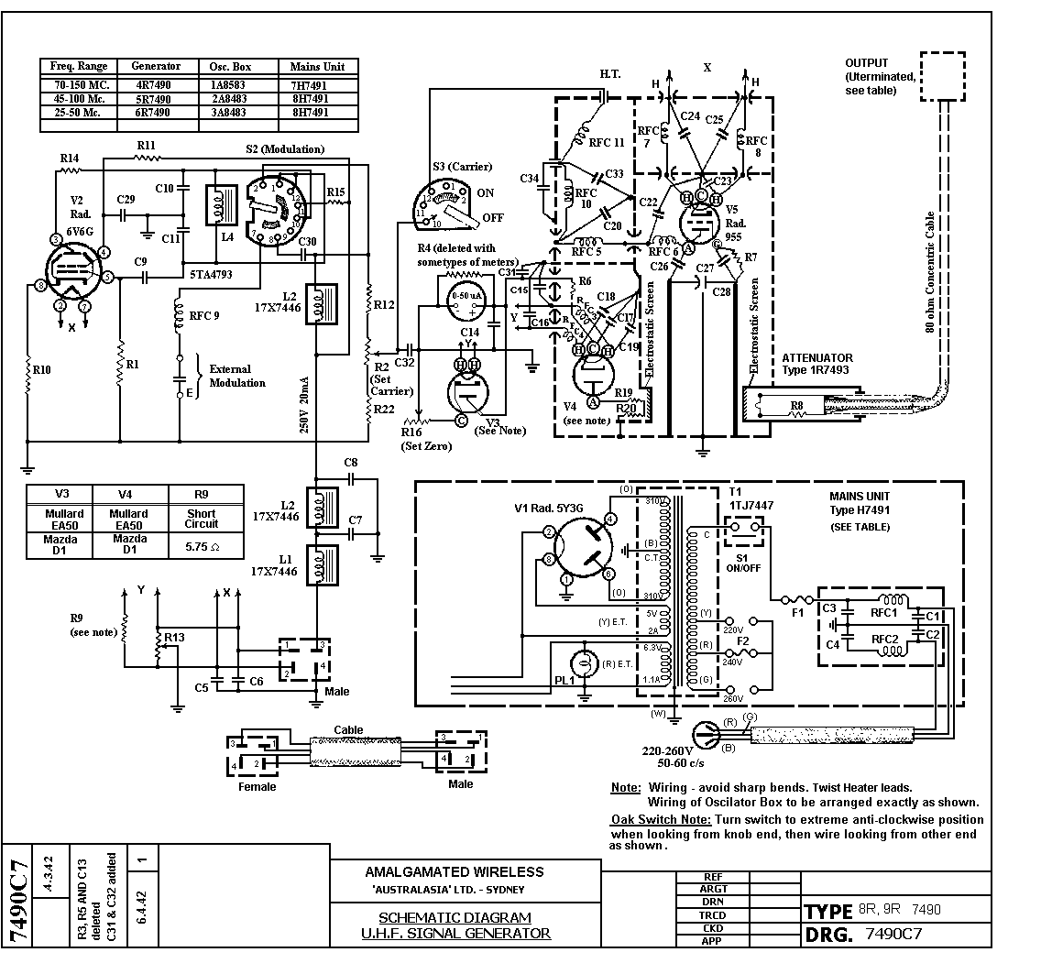

W.A. U.H.F. SIGNAL GENERATOR

TYPE 8R7490 SERIAL NO. 24

Name Plate
………………………………………..
……………..200Mc………………….
…………..……D↑D……………….…
.…………….Ser No. 24 ………………

Frequency Calibration

Frequency (Mc.) | Dial Setting
140 | 4.8
150 | 11.35
260 | 17.1
170 | 22.25
180 | 26.95
190 | 31.3
200 | 35.35
210 | 39.4
220 | 43.35
230 | 47.25
240 | 51.1
250 | 55.2
260 | 59.5
270 | 64.1
280 | 69.65
290 | 76.45
300 | 86.1

