1.

DESCRIPTION

Application.

A.W.A. Voltohmyst type A56010 is a versatile instrument which has application in the measurement of positive and negative D.C. voltages, D.C. current, resistance and A.C. voltages.

The instrument features a circuit which measures directly the peak-to-peak values of sinusoidal and complex waveforms, the scales being calibrated directly in peak-to-peak values and also in R.M.S. for sinusoidal waveforms.

The instrument has a rated input for non-symmetrical wave-forms of 2,100V, but sinusoidal and symmetrical waveforms of up to 4,200V. can be measured. (Refer to figure 1 below for waveforms measurable with the instrument.)
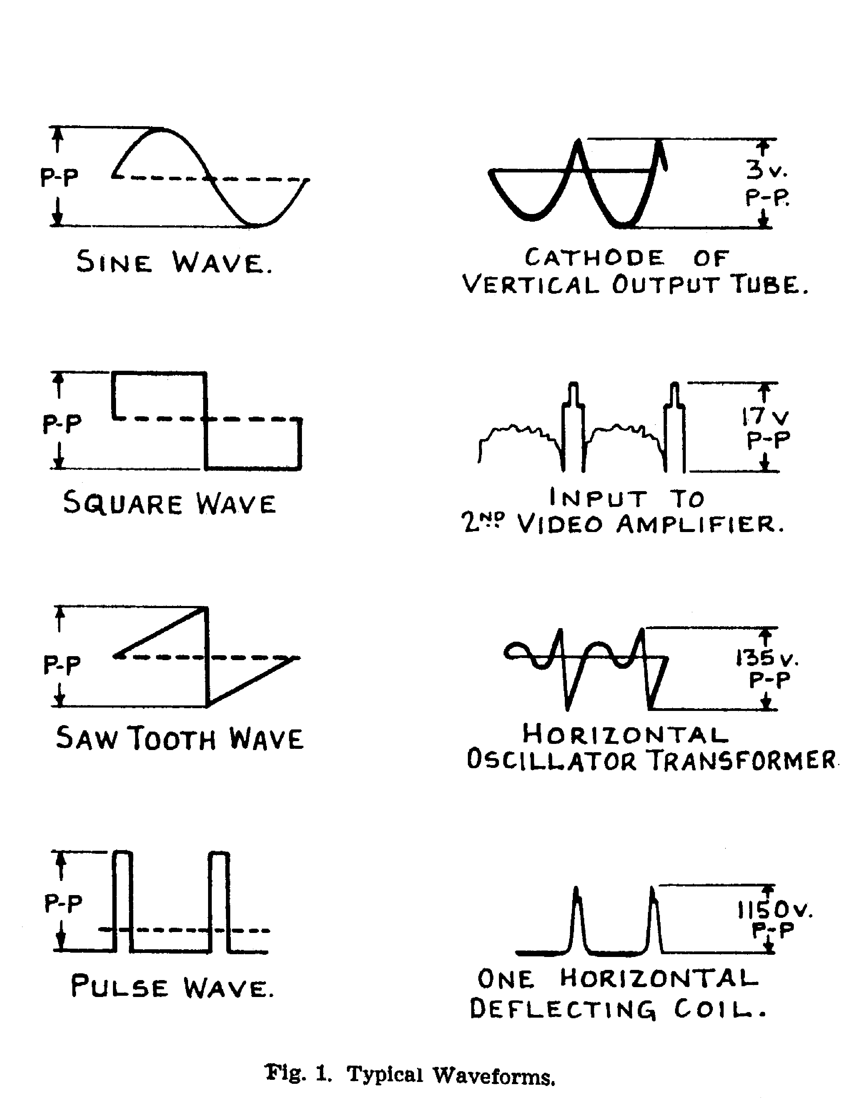
Fig.1 Waveforms Measurable with the Instrument

When measuring voltages, with a source impedance of approximately 100 ohms, the A.C. ranges up to and including 0-500V. are frequency compensated to provide a flat characteristic from 30 cycles to 2.5 Mc. When used in conjunction with a crystal diode probe such as A.W.A. type 2R56020, the input capacitance is reduced to a low value and the A.C. voltage ranges are made accurate to within ±10% from 50 kc. to 250 Mc. (Refer to subsection 1.4.3 for frequency response figures.)

When using an associated D.C. probe, on all D.C. ranges, the instrument has an input resistance of 11 M.ohms, thus offering considerable advantages over conventional test equipment in a number of applications such as those listed below:-

2.

(i) Oscillator Grid-bias

The negative D.C. voltage developed at the grid of an oscillator is proportional to the amplitude of oscillation.

The instrument, when connected directly to the grid, measures this bias, with negligible effect on the conditions of oscillation.

When checking multi-band receivers, comparative readings should be taken, rotating the oscillator tuning control through its entire range during each check.

(ii) A.V.C. Voltage

The instrument has negligible effect on A.V.C. measurements, allowing them to be taken directly at the grids of the stages to which the A.V.C. is applied, or on the A.V.C. line or at the output of the diode load.

(iii) Output Meter

In the alignment of TV, AM or FM receivers the instrument can be employed as an output meter. The centre-zero feature is particularly useful in aligning the discriminators of the latter receivers (refer to sub-section 2.4 of this book).

(iv) Detection of Gassy Valves and Leaky Coupling Capacitors

The presence of an abnormally low value of negative bias or of a definite positive bias at the grid of a stage may indicate a gassy valve or leaky coupling capacitor; this fault is readily located with the aid of the Voltohmyst.

(v) Insulation Resistance Measurement

High insulation resistances such as those of capacitors, transformers etc. can be measured by applying an external voltage and connecting the instrument as indicated in fig. 4.(Refer also to sub-section 2.6.)

Additional applications of the instrument are:-

(i) Measurement of dbm

By using the instrument in conjunction with the dbm conversion chart (refer to fig. 5), it is possible to determine the dbm. values corresponding to R.M.S. values measured across a 600-ohm resistive circuit.

3.

(ii) Peak -to-peak pulse values

The peak-to-peak values of pulse waveforms may be measured, using the A.C. peak-to-peak scale of the instrument. A long time-constant is incorporated in the circuits to allow for measurement of signals having low repetition rates.

Further information on facilities and electrical characteristics is given in sub-section

1.2 Mechanical construction

The instrument is housed in a compact metal case, having meter, four controls and three terminals mounted symmetrically on the front. An engraved front panel is fitted, and a carrying handle provided at the top of the case.

Dimensions are as follows:-
Height:- 10"
Width:- 6 ¼"
Depth: 6 ¼"
Weight: 8 ½ lbs

1.3 Design Characteristics and Circuit Description

The circuit is designed to give a high degree of accuracy in all applications, making the instrument especially adaptable for work in television and industrial equipment.

Maximum peak-to-peak input rating for non-symmetrical complex waveforms is 2,100V. and for sinusoidal or symmetrical waveforms up to 4,200V.

In the case of sine waves, the instrument is calibrated directly for R.M.S. and peak- to-peak values (a feature made practicable by the constant ratio of 2.83:1 of these values). The peak-to-peak-reading feature has particular application in servicing television receivers when taking measurements of wave-forms as indicated in Fig.

It should be noted that in this instrument, as in all voltage measuring devices, certain precautions are necessary in interpreting the readings, and inaccuracies may be due to external conditions such as high impedance of the circuit being measured, high- frequency voltage source, or if the voltage waveform consists of short pulses with a low repetition rate. The error introduced increases with the ratio of the source

4

impedance to the impedance of the instrument, and varies with frequency. Refer to para. 1.4.3 (c). The error in short-pulse measurement when the repetition rate is low is due to the time constants involving the capacitors in the peak-to-peak rectifier in the instrument. These capacitors do not have time to become fully charged during the pulse, and in the relatively long period between pulses, are unable to retain the charge they have received. The range or conditions allowing satisfactory measurement of essentially rectangular pulses derived from a 50 ohms source indicated in figure 2 below. For sources of higher impedance error will be greater than 2%.

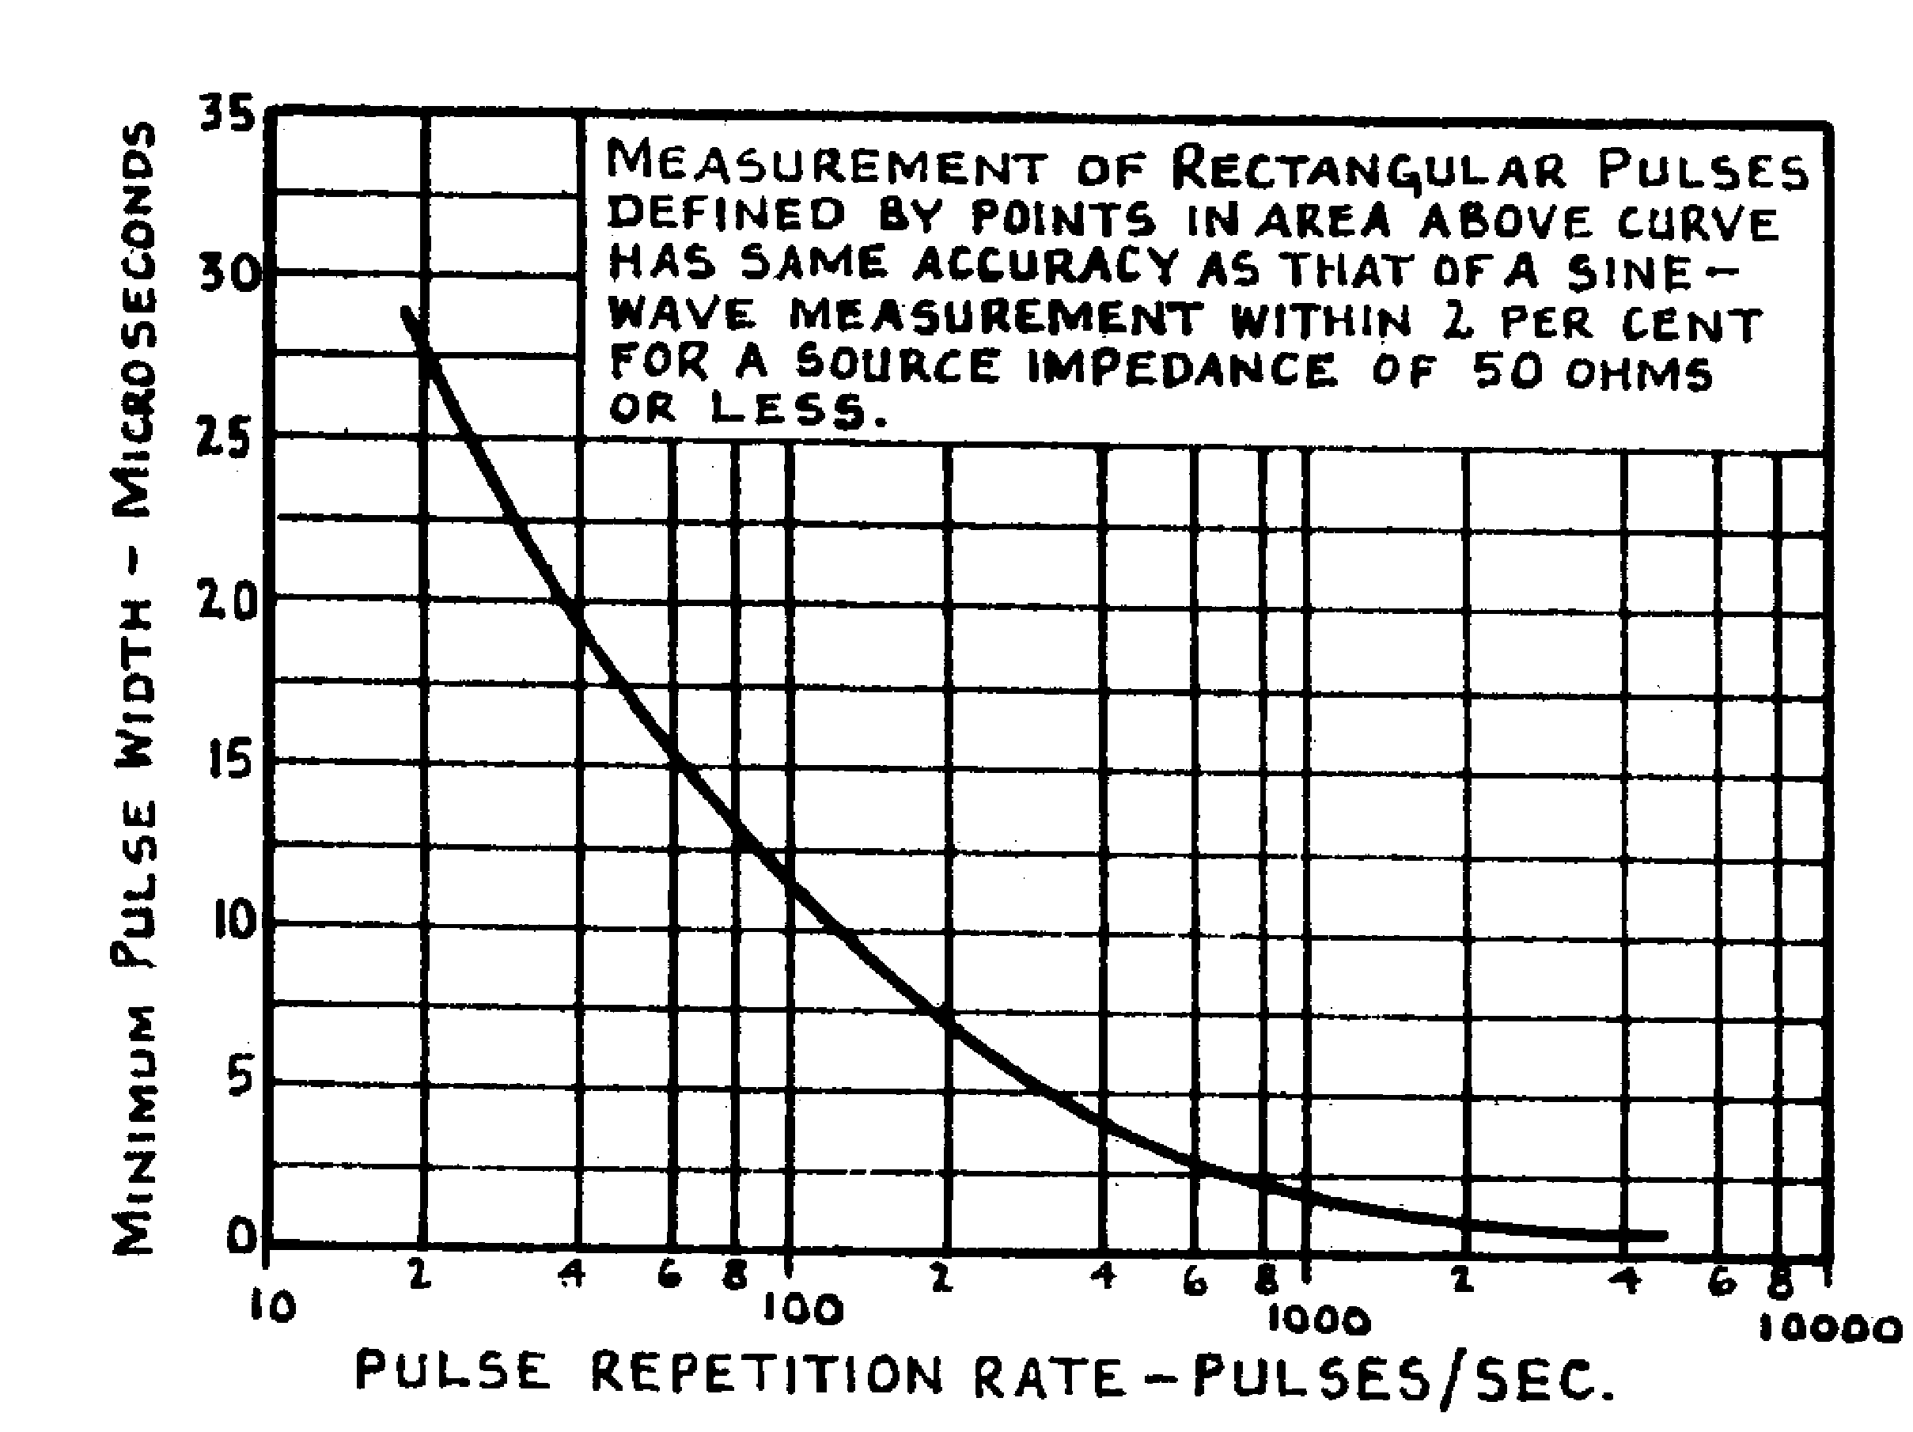

Fig.2 Pulse Response Capability

The instrument is frequency-compensated for A.C. voltage ranges up to and including 0-500V. On the higher range the response varies with frequency.

All resistors in the divider networks associated with the voltage and ohms applications are high stability carbon types, having a tolerance of ±1%, and in conjunction with the D.C. amplifier, ensure reliable service for a considerable period.

The fundamental element of the circuit is a D.C. bridge involving type l2AU7 valve (V3) and its associated network. - Refer to the simplified schematic in fig. 3 below.

5.

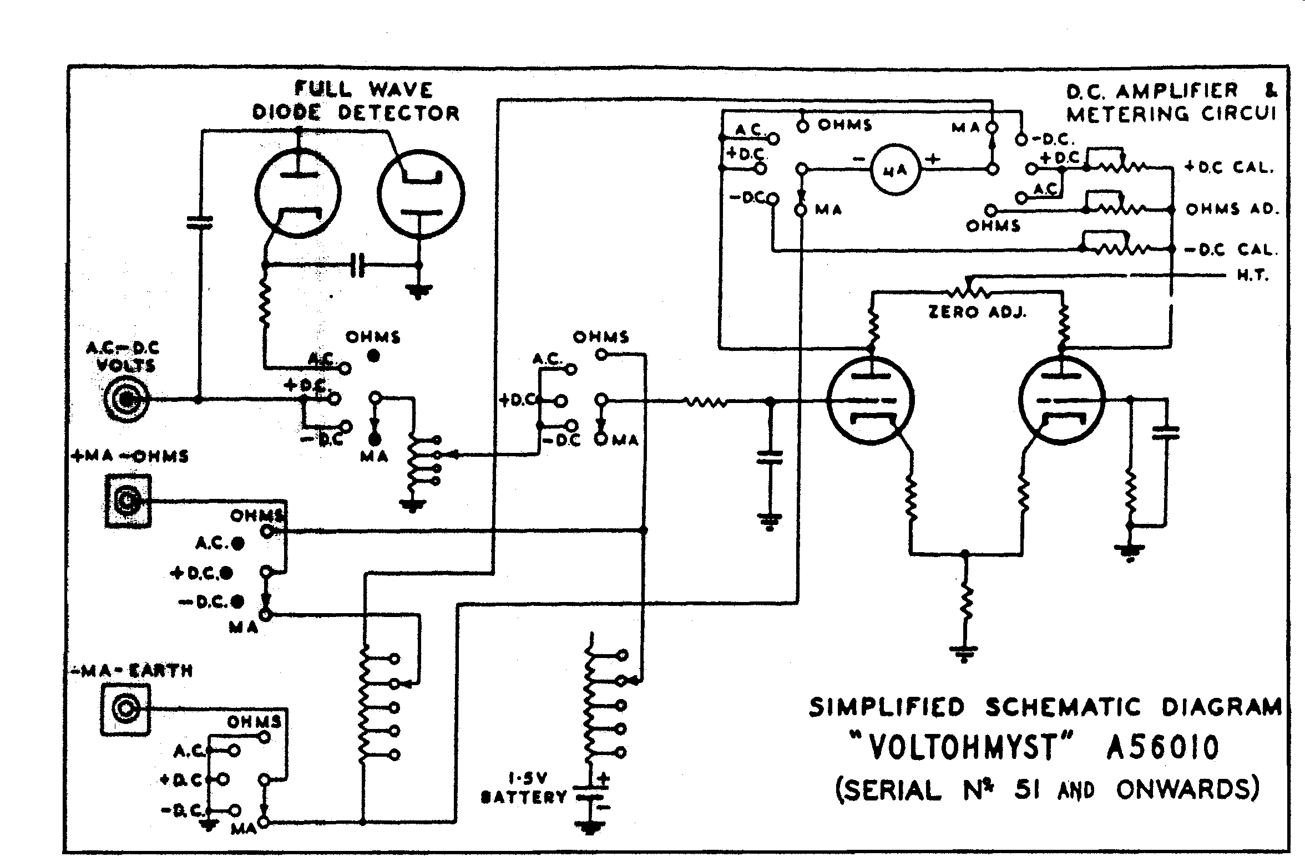

Fig. 3

Assuming the instrument is switched on, power is supplied from the power transformer (T1), rectified by one half of a type 6AL5 valve (V2) and applied to the bridge (V3).

Providing no readings are being taken, and the circuit has been previously balanced by adjustment to the balance resistor (R25), the cathode currents of the two triode sections of the valve (V3) are equal, and the microammeter connected between the anodes reads zero.

When the facility selector (s2) is set in any of the voltage or ohms positions, and a reading is taken, a voltage is applied via range selectors, etc., to the grid of the left-hand triode (as drawn on the simplified schematic) section of V3, this altering the current through this section and in turn changing the potential across the common cathode resistor (R25). The change in the latter voltage then acts as a reverse change in the bias on the second section, and the meter responds to the resulting changes in potential at the anodes due to the voltage drops across anode resistors R20 and R22, respectively.

When used as a milliammeter, the facility selector (S2) disconnects the meter from the electronic circuit, and connects the "+" terminal of the meter to the "+" mA-OHMS input terminal, and the "-" terminal to the "-" mA. EARTH input, which is then disconnected from

6

earth. Operation is then as for a conventional milliammeter, but it should be noted that all electronic protection for the meter is now out of circuit, and care must be taken not to overload.

1.4 Summary of Controls, Facilities and Electrical Characteristics

1.4.1 Facilities
Ranges
"+" D.C. Volts ) 0 – 1.5V. (On separate LO Scale for A.C.)
)
"-" D.C. Volts ) 0 – 5V.
) 0 –15V.
A.C. (R.M.S. volts ) 0 – 50V.
) 0 – 150V.
0 – 500V.
0 – 1,500V.

A.C. Volts, Peak-to-Peak; 0 – 4.2V (On separate LO scale) (read simultaneously with 0 – 14V.
R.M.S. values for sine waves) 0 – 42v.
on separate scale. 0 – 140V.
0 – 420V.
0 – 1,4000V.
0 – 4,200V.

Current Measurement - mA. Ranges

0 – 1.5 mA..
0 – 5 mA.
0 – 15 mA.
0 – 50 mA.
0 – 150 mA.
0 – 500mA.
0 – 1,500mA.

.
Ohms Measurement:- Ranges
(meter calibrated Rxl
0-1,000 ohms) Rx 10
Rx 100
Rx 1000
Rx 10,000
Rx 100,000
Rx 1 M,ohm
7.

1.42 Controls and Input Connections

(i) Facility Selector: Selects desired facility, i.e., OHMS, A.C., etc.

(ii) Range Selector: Selects desired range, i.e., l.5V., 5V., etc.

(iii) ZERO ADJ. Positions the meter needle to "0" or "-0+" (the latter when the facility selector is set to "+" VOLTS position, and the instrument is used for centre-zero indication).

(iv) OHMS ADJ. Positions the meter needle at the extreme right- hand mark of the ohms scale when the facility selector is set to OHMS position.

(v) VOLTS, A.C.-D.C. Positions the meter needle at the extreme right- hand mark of the ohms scale when the facility selector is set to OHMS position.

(vi) "+" mA. – OHMS Positive input terminal for current readings. Also associated with ohms facility.

(vii) -mA. EARTH. "-" terminal for current readings; earthed for other facilities. Second terminal for ohms measurement.

1.4.3 Electrical Characteristics

(a) D.C. Voltmeter

Sensitivity: Input resistance 11 megohms on all ranges
(on 1.5V. range)

Accuracy: ± 3% of full scale deflection
(all ranges) (F.S.D.)

(b) Milliammeter

Accuracy on ± 3% of F.S.D.
all ranges

8.

(c) A.C. Voltmeter

Input resistance and
Capacitance (with direct
Probe and cable):
1.5V., 5v., 50V., and 0.83 M.ohm, in parallel with 90 uuf.
150V.:-

500V. range :- 1.3 M.ohm in parallel with 85 uuf

1,500V. range:- 1.5 M.ohm in parallel with 85 uuf.

Frequency Response
(using direct probe and cable):-

Source Impedance Freq. Range Response

100 ohm 30 cycles to2.5 Mc. + 1db at 2.5 Mc.

1000 ohm 30 cycles to 500 kc. + 1db at 500 kc.

5000 ohm 30 cycles to 270 kc. - 1db at 270 kc.

10,000 ohm 30 cycles to 80 kc. - 1 db at 80 kc.

Frequency Response
Using crystal Within ± 1db from 50 kc. To 250 Mc.
Diode probe type

Accuracy:-

1.5V., 15V., 50V.,
150V., and
500V. ± 5% off F.S.D at 50 cycles

5V. + 0 – 10% of F.S.D. at 50 cycles.

9.

(d) Maximum Input Voltages

Pure D.C. (i.e. without A.C. components):~

Using D.C. probe IR56020 1,500V.

Using High Voltage probe 2R56020 30,000V

A.C. Voltages (i.e., without D.C. components):-

R.M.S. sinusoidal 1, 500V.

Peak-to-peak sinusoidal 4,200V.

Peak-to-peak
Complex waveforms 2,l00V.

Sum of D.C. and A.C. peak-to-peak voltage inputs:-

When measuring
A.C. component:- 2,100V.
D.C. component:- 1,500V

(e) Metter Sensitivity

200 UA. for F.S.D.

(f ) Mains Supply and Power Consumption

Mains Input:- 240V., 50-60cycle, single-phase.

Power Consumption:- 5.5W. approximately.

1.5 Probes and Cables used with Voltohmyst A56010

Refer to fig. 8 (Drg. 56010D7) at the rear of this book.

1.5.1 Cables and Probes Supped with the Instrument

The instrument is normally supplied fitted with three probes (ohms probe, direct probe type R56020, and D.C. probe type 1R56020), together with an earth cable which is fitted with an alligator clip.

10.

The ohms probe and direct probe are each connected to individual cables, and are thus used alone for the measurement of resistance and A.C. voltages respectively; the circuit is completed in each case via the earth cable and clip.

The D.C. probe, however, consists of an extension piece which fits over the direct probe and clamps into place on the latter. The whole is then used for measurement of D.C. voltages. An alligator clip to fit onto the end of the direct probe is supplied.

1.5.2 Probes Not Normally Supplied with the Instrument ( available on separate order)

(a) Crystal Diode Probe 2R56020

This probe consists of an extension piece similar to the D.C. probe, with a clip attached to the side, and contains a small diode rectifier element, coupling capacitor and isolating resistor. (Refer to the insert on the circuit diagram Drg. 5601002).

The probe has application in the measurement of R.M.S. values of sinusoidal waveforms in the range 50 kc. to 250 Mc. The R.M.S. values are read on the D.C. scale of the Voltohmyst, and the peak values may then be obtained by multiplying by 1.414.

The probe may be used in the presence of D.C. voltages as high as 250V.

The specification is as follows:-

Frequency Response :- ± 1 db from 50 kc. to 250 Mc.

Input Capacitance :- 1.75 µµF. (approx.)

Input Resistance

Frequency Resistance
50 kc. 370,000 ohms
100 kc. 360,000 ohms
1 Mc. 312,000 ohms
10 Mc. 283,000 ohms
100. Mc. 90,000 ohms
220 Mc. 6,000 ohms

11.

Maximum Input Voltages

R.F. Voltages ( 20V. R.M.S.
(
( 28V. peak.

D.C. Voltage 250V~.

Vo1tohmyst Meter Indication

Sinusoidal Waveforms: R.M.S. values read
off the DC – R.M.S.
scales.

Complex Waveforms :- Peak values of
approximately 1.414
of indicated R.M.S. value for the positive portion of the cycle

Method of Use

(i) With the probe (type 2R56020 over the tip of the direct probe. Set the facility selector on the Voltohmyst to "-" VOLTS position and the range selector to an appropriate scale.

(ji) Connect the clip to the earth side of the voltage source and apply the probe to the other side.

High Vo1tage Probe type 3R56020

This probe consists of cable and hollow-moulded piece containing a dropping resistor capable of extending the D.C range of the instrument to 0-30,000V., and is indispensable in television and heavy-duty industrial work.

The maximum input voltage usable with the probe is 30,000V., and since the probe effectively provides the D.C. ranges of the instrument with a multiplying factor of 100, the range selector may be set as required and a direct reading obtained. Note that the total input resistance of the Voltohmyst when using the high voltage probe in the vicinity of 1100 M. ohms, providing a valuable facility when working in high impedance circuits with poor regulation.
12.

Method of Use

Remove the direct probe and cable from the instrument and fit the high voltage probe and cable in its place. Set the facility selector to "+ or "-" VOLTS as required, and the range selector to a position considerably higher than the estimated value of voltage source. More accurate readings may be made with successive settings of the range selector after taking the first trial measurement.

IMPCRTANT;

The probe is provided with an earthed guard ring in front of the hand-piece, and it is important that the operator's hand be behind this guard ring at all times, so that in the event of a flash-over occurring, current will pass only to the latter.

13.
2. METHOD OF USE

2.1 Warning Notes

(i) DO NOT USE THIS INTRUMENT FOR THE MEASUREMENT OF A.C. AT POWER OUTLETS, ETC., WHERE THE ACTIVE LEAD CANNOT BE DISTINGUISHED.

(The frame of the instrument is earthed via the 3-core mains cable, and application of the test prods in incorrect polarity would therefore short-circuit the supply.)

WHEN MASURING ANY OTHER A.C. OR D.C. VOLTAGE IN WHICH ONE SIDE IS EARTHED, BE CAREFUL TO APPLY THE EARTHY PROD TO THE EARTHED SIDE OF THE VOLTAGE.

(ii) Before taking any voltage measurements, refer to the maximum input voltage ratings given in para. 1.4.3. On no account should these values be exceeded.

(iii) Do not connect the EARTH cable to a point of high potential. (The connector to which this cable is attached is connected to the instrument case when measuring volts.) Reversal of D.C. polarity is obtained by switching between ~'+" and "-"
VOLTS positions on the facility switch.

(iv) When measuring the resistance of certain devices such as thermocouples, meters, etc., a higher range than R x 1 or R x l0 should be used, because on these 1ower ranges the instrument applies up to l.5V. (depending on the resistance of the device being measured) in series with the external circuit, and could cause damage to the thermocouple or meter.

(v) Exercise care when using the instrument as a milliammeter. The electronic protection devices incorporated for voltage applications are switched out of circuit when the facility selector is set to "mA." position.

(vi) Exercise extreme care when working on equipment in which high voltages appear. Where possible it is advisable to follow the precautions listed below.

(a) Remove the power from the equipment under test before connecting the instrument.

(b) Discharge large capacitors before making adjustments.

(c) Check for breaks in the insulation wiring.

(d) Disconnect test leads immediately a test is complete.

14.

(e) Where practicable, use only one hand to make an adjustment or measurement; keep the other away from any part of the equipment or earth point.

(f) Work in the presence of a second person who can render assistance in the case of accident.

2.2 Setting Up Procedure
(i) THE l.5V. CELL USED ON THE OHMS FACILITY IS NOT NORMALLY FITTED IN THE INSTRUMENT WHEN SUPPLIED. TO FIT THIS CELL, REMOVE THE INSTRUMENT FROM ITS CASE BY UNDOING THE FRONT COEVER SCREWS, FIT THE CELL INTO THE APPROPRIATE CLAMP (UPPER RIGHT, WHEN VIEWED FROM THE FRONT), AND SOLDER/CONNECT (DEPENDING ON THE TYPE CF BATTERY USED) THE RED AND BLACK LEADS TO THE POSITIVE (CENTRE) AND NEGATIVE (CELL CASE) POLES RESPECTIVELY.

(ii) Identify the EARTH and OHMS cable and the Direct Probe (refer to Fig. 8) and connect respectively to EARTH, OHMS and VOLTS (A.C.-D.C.) connectors on the front panel.

(iii) Check the mechanical zero of the meter, and if necessary, re-adjust. Plug into the mains and switch on. Allow a short warm-up period. Set facility selector to "+" VOLTS position.

(v) Turn the ZERO ADJ. control until the meter needle coincides with the left-hand "0" on the scale. Check the adjustment by now setting the facility switch to "-" VOLTS position. If the meter needle moves from "0" again make an adjustment to. the ZERO ADJ. control. If necessary, make alternate adjustments to the facility switch and ZERO ADJ. control until a setting is obtained which allows the facility switch to be set to either "+" or "-" VOLTS without affecting the needle.

(v) Set the facility selector to the OHMS POSITION. The needle should be deflected to approximately full scale. Turn the OHMS ADJ. control until the needle coincides with the right hand edge of the OHMS scale.

The instrument is now ready for use.

2.3 D.C. Voltage Measurement (using D.C. and Direct Probes)

Use the D.C. probe (type IR56020, indicated on Fig. 8) in conjunction with the direct probe R56020 for all D.C. voltage measurements. Fit the probe piece over the tip of the direct probe and clip into place.

(i) Set the facility selector to "+" VOLTS or "-" VOLTS as required (refer to warning note (iii) in 2.l).

15.

(ii) Connect the EARTH cable to earth or low side of the voltage source under measurement.

(iii) Set the range selector to a position considerably higher than that at first required. Use the probe as a conventional multimeter test prod. Switch to progressively lower settings of the range selector to obtain more readable deflections.

Read direct from the appropriate scales.

2.4 Centre-zero Readings

The centre-zero facility allows observations of positive or negative excursions in D.C. voltages without the necessity of re-setting the facility selector to "-" or "+" VOLTS, as the case may be.

(i) Set the facility selector to "+" VOLTS.

(ii) Turn the ZERO ADJ. control until the meter needle coincides with the centre "0" of the scale.

(iii) Set the range selector to a position at least double the voltage to be measured.

(iv) Take several test readings, re-setting the range selector for more convenient readings.

2.5 AC. Voltage Measurement (With Direct Probe alone)

Use the direct probe (type R56020) alone. Low values of R.M.S. (below 1.5V.) and peak-to-peak (below 4. 2V.) should be read on the separate LO-A.C. scales.

Higher voltages should be read on the "D.C. or R. M. S." scale graduated to 1.5 or 5 respectively, in association with the appropriate multiplying factor given by the range selector. Peak-to-peak values can be read simultaneously with the R.M.S. values.

(i) Set the facility selector to A.C. VOLTS position and if necessary, adjust the ZERO ADJ. control to make the needle coincide with the left-hand "0" of the scale.

(ii) Set the range selector to a position considerably higher than that at first required. Use the probe as a conventional test prod. Switch to progressively lower settings of the range selector to obtain more convenient readings. Read direct from the appropriate scales.

Note that a delay will occur between the removal of the test prods from the source voltage and the return of the meter needle to zero when measuring A.C. voltage.
16.

This delay is caused by the effects of circuit constants within the instrument, such constants having been chosen to enable more accurate measurements of pulse waveforms having low repetition rate.

2.6 Resistance Measurement

2.6.1 Normal Measurement of Resistance up to 1000 M.ohm

(i) Refer to Warning Note (iv) of 2.1.
(ii) Ensure that there is no voltage present in the circuit in which the instrument is to be used.
(iii) Set the facility selector to OHMS position. Set the range selector to a convenient position (R X l000 being suitable) connect the OHMS PROBE to earth cable and turn ZERO ADJ control until the meter needle coincides with the left hand "0" on the scale.
(v) Disconnect probe from earth cable and check that meter needle is reading full scale. If necessary readjust by means of OHMS ADJ control. The instrument is now ready for use and does not require new setting up if the range selector is set to a different position.

IF ONE END OF THE RESISTANCE TO BE MEASURED IS EARTHED, OBSERVE THIS POLARITY WHEN USING THE OHMS PROBE AND EARTH CABLE RESPECTIVELY. CONNECT THE LATTER TO THE EARTHED END OF THE RESISTOR, AND APPLY THE PROBE TO THE OTHER.

(vi) Multiply the reading on the ohms scale by the factor against the position of the range selector.

2.6.2 High Resistance (insulation) Measurement

The instrument has application as a high resistance (above 1,000 M.ohms) test unit when used in conjunction with an external D.C. voltage (between 20V. and 500V.), in a circuit as indicated in Fig. 4 below.
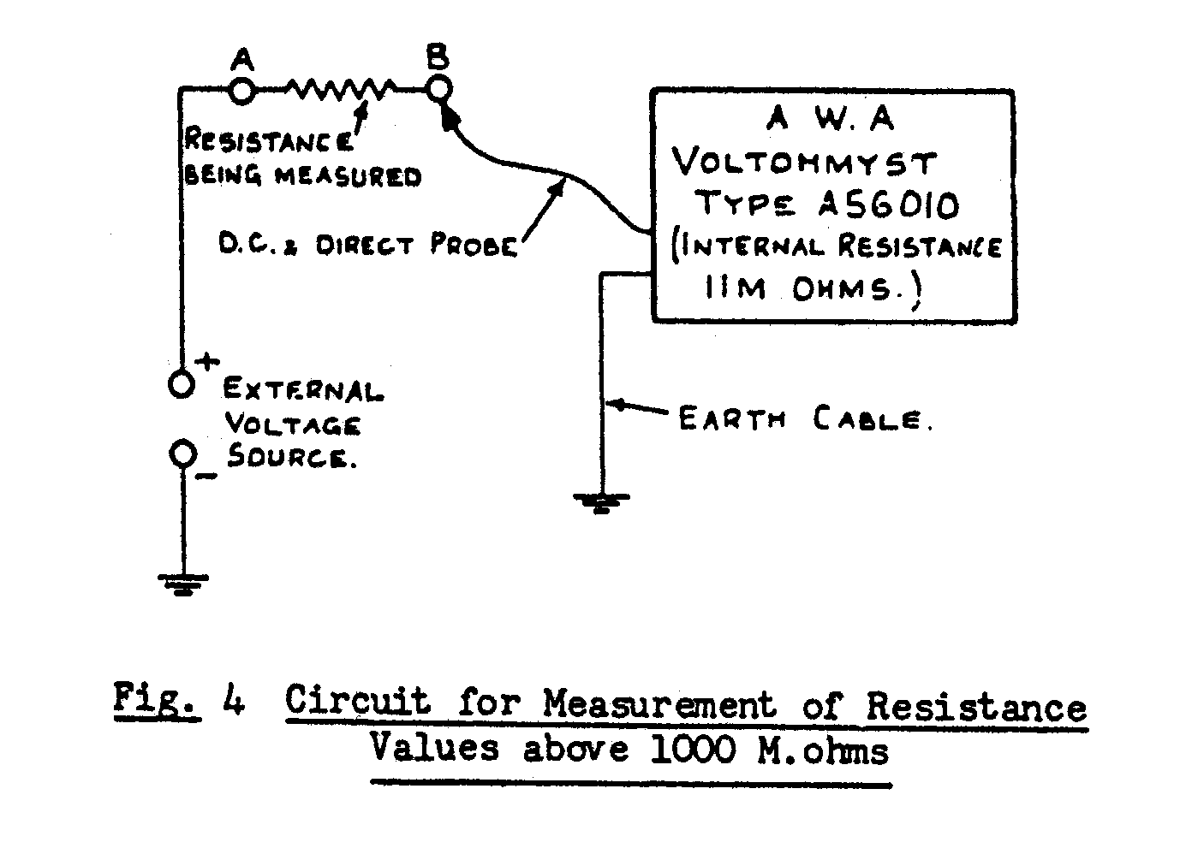
17.
(i) Set the facility selector to "+" VOLTS, and measure the volts at point "A". Let this applied voltage be "V".

(ii) Measure the voltage at point "B". Let this voltage be "v".

(iii) Calculate the unknown resistance from:-

R(in M.ohms) 11 (V-v)
v

2.7 Current Measurement

(i) Set the facility switch to "mA." position.
Observe the warning note (v) of 2e1.

(ii) Use the instrument as a conventional milliammeter.

Connect the OHMS cable in the "+ side. Set the range selector to a considerably higher position than that at first required, then make progressive adjustments for more convenient readings. Read direct from the appropriate scale.

2.8 Measurement and Calculation of dbm

The chart given in Fig. 5 can be used in conjunction with the instrument to determine dbm values corresponding to R.M..S. A.C. voltage values across a 600-ohm load. The dbm is defined as the number of decibels above or below a reference level of 1 milliwatt in 600 ohms at 1000 cycles. Accordingly, 0 dbm indicates a power of 1mW.; 10 dbm, 10 mW.; 20 dbm, 100 mW. etc.

Since dbm are defined with respect to a 600-ohm circuit, the power levels in these circuits correspond to voltage values, thus allowing dbm to be measured in terms of R.M.S. voltages. The chart given in Fig. 5 is drawn for application to 600 ohm circuits, but may be used to convert R.M.S. to dbm values in load resistances other than 600 ohm, by the algebraic addition of a suitable increment (ΔDBM).

Several values of this increment have been worked out resistances commonly encountered, and are given in the table below. For other values of ΔDBM, use the formula given in equation (i).

18.

Resistive load at ΔDBM (to be added to
1000 cycles the dbm value given on
the chart for 600 ohms)
600 ohms 0
500 ohms +0.8
300 ohms +3.0
250 ohms +3.8
150 ohms +6.0
50 ohms +10.8
15 ohms +16.0
8 ohms +18.8
3.2 ohms +22.7

Note that for load values greater than 600 ohms, ΔDBM will be a negative quantity, as indicated in the formula:-

ΔDBM = 10 log. 600 ……. (i)
R

Where R is the value of the resistance concerned.

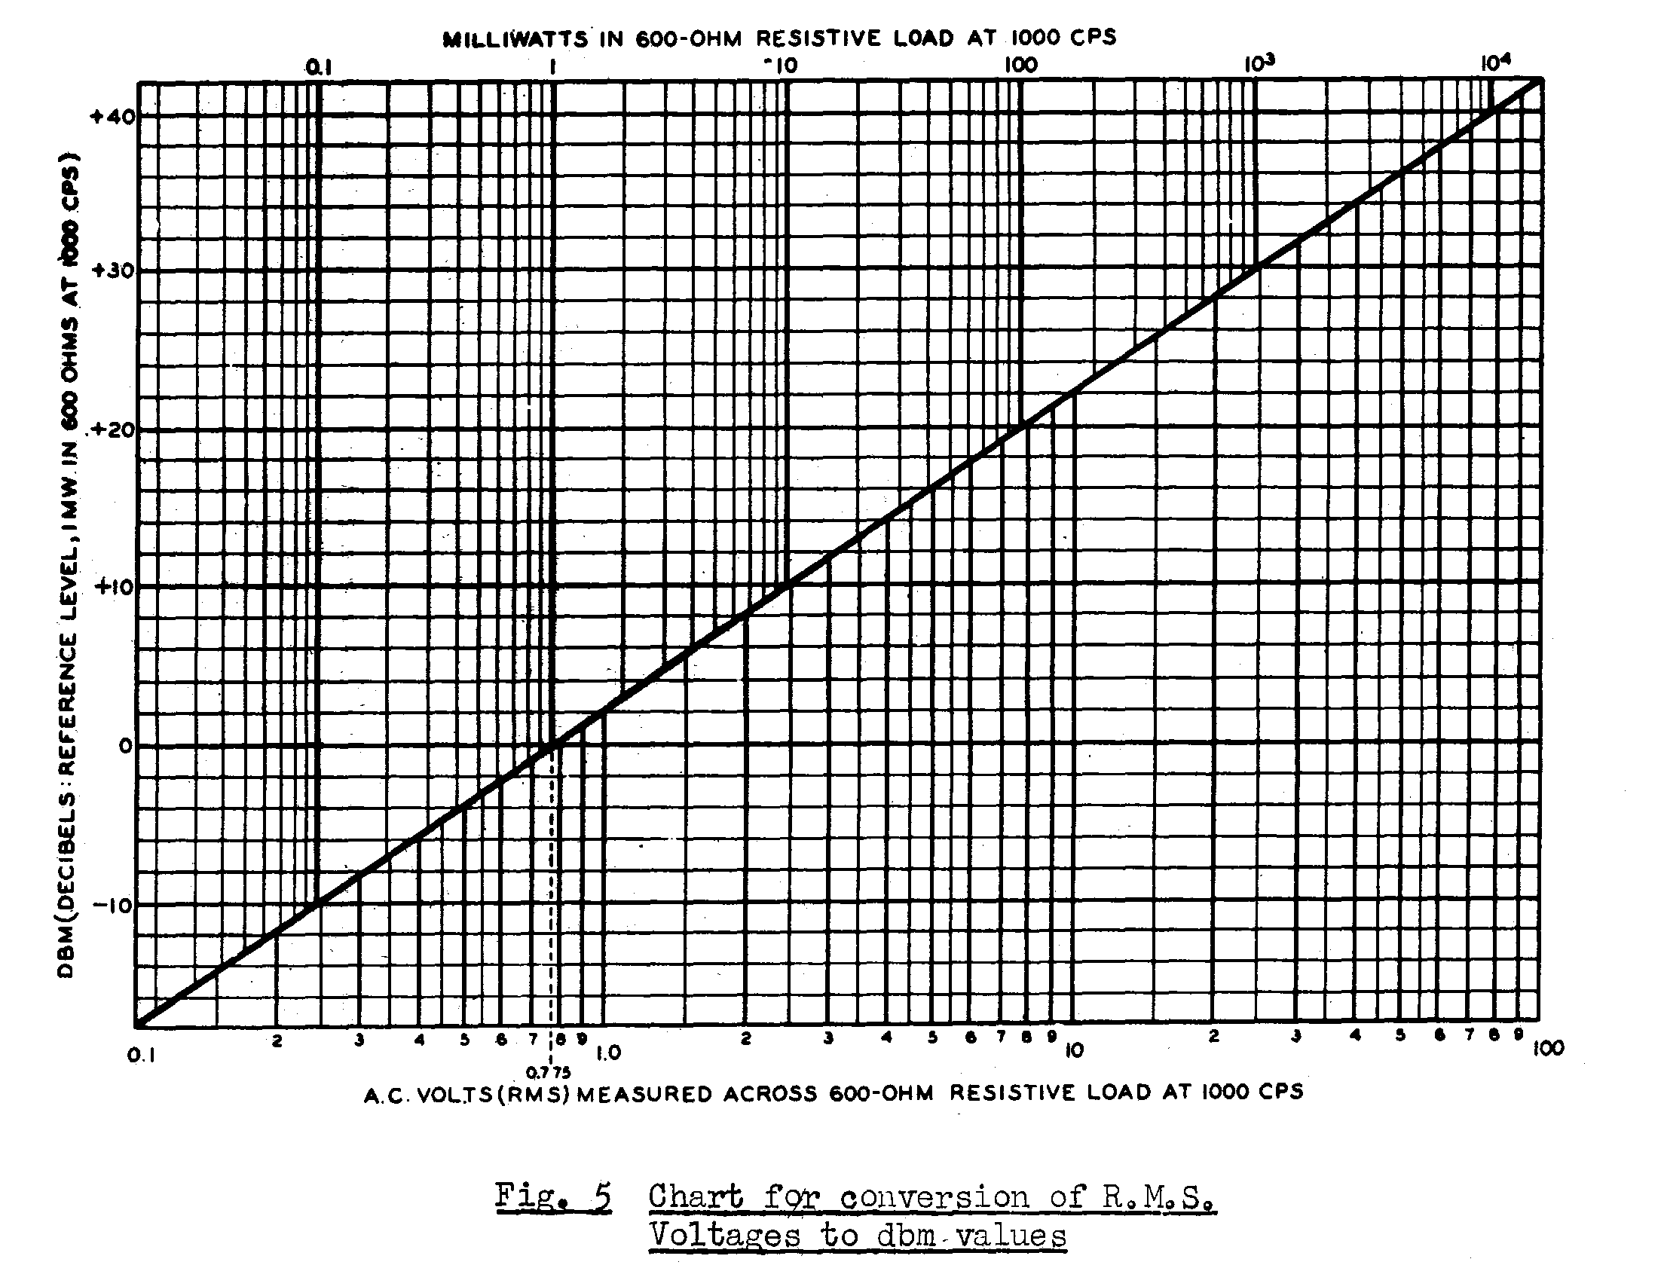

19.

3. MAINTENANCE

3.1 Valve Replacement

If at any time it becomes necessary to replace either of the type 6AL5 (alternative D77) or 12AU7 valves, they should be "aged" before installation, as follows:-

(a) Type 6AL5

Run the valve with heater voltage only applied for a period of 48 hours before placing it in the instrument.

(b) Type 12AU7

Connect together the grids and cathode, apply the normal heater voltage and, in addition, an A.C. voltage of approximately 100V., 50-cycle between anode and cathode. Allow to run for 24 hours.

3.2 Checking the Condition of the 1.5V. cell

(i) Set the facility to OHMS.

(ii) Set the range selector to R x 1.

(iii) Rotate the OHMS ADJ. control for full-scale deflection on the meter.

(IV) Short together the ohms and earth cables for about ten seconds.

(v) Open the above short-circuit and observe the meter needle. If there is appreciable deviation from F.S.D., a weak cell is indicated and should be replaced.

Do not allow exhausted cells to remain in the instrument and deteriorate because chemical action resulting therefore can cause permanent damage.

3.3 Electrical Balance Check

(i) Set the facility selector to "+" VOLTS.

(ii) Rotate the ZERO ADJ. control and check that it is possible to set the meter needle at 60% of F.S.D. on any range.

(iii) Set the facility selector to "-" VOLTS, and again turn the ZERO ADJ. control. It should be possible to set the meter needle at 10% of F.S.D. on any range.

20.

(iv) If the above results cannot be obtained, it is an indication of unbalance in the triode units of the type 12AU7 valve, and the latter should be replaced (refer to 3.1)

3.4 Calibration

If it becomes necessary to restore the initial accuracy of the instrument, i.e. to recalibrate, the following procedure should be carried out:-

Fig. 6 indicates the relevant positions of the adjustable controls used in the calibration.

Note that the accuracy of calibration can only be comparable with the accuracy of the voltage standard used in the procedure.

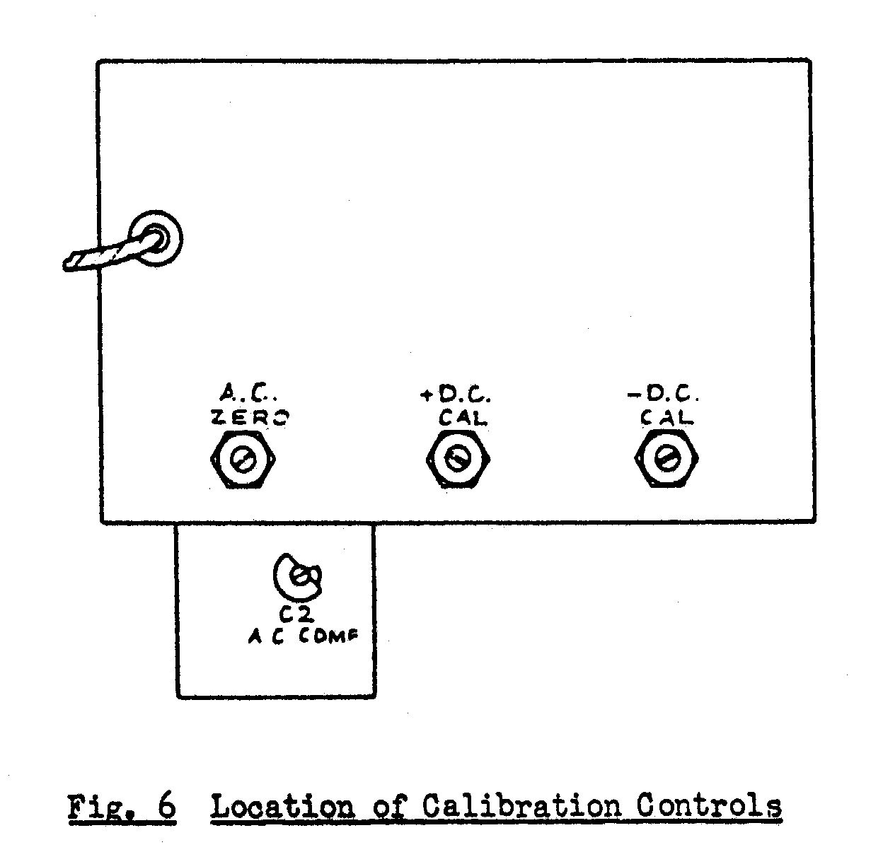

3.4.1 D.C. Calibration

(i) Check the mechanical zero of the meter, and if necessary, re-adjust

(ii) Set the facility selector to "+" VOLTS. Switch on the instrument and allow a warm-up period. Check the mains voltage. The instrument should be calibrated when operating from a steady 240V., 50-cycle supply.
21.

(iii) Using the ZERO ADJ. control, set the meter needle to "0", and leave the control set at this position throughout the remainder of the procedure.

(iv) Set the range selector to the 0-50V. range.

(v) Connect the earth cable to the negative terminal of an accurately adjusted 50V. D.C. source, and the D.C. probe (fitted over the direct probe) to the positive terminal of this source.

(vi) Adjust the "+" D.C. Cal. Control (R27) to bring the pointer exactly to the 50V. mark on the "D.C. or R.M.S." scale.

(vii) Leaving the other conditions set, reverse the connections to the 50V. source and set the facility selector to the "-" VOLTS position.

(viii) Check the other D.C. ranges against reliable voltage sources, making allowances for the tolerance given in the specification. If necessary re- calibrate on a range other than 0-50V., and check all components associated with the facility.

3.4.2 A.C. Calibration

(i) Carry out steps (i) to (iii) of 3.4.1

(ii) Remove the D.C. probe from the direct probe. Set the facility selector to A.C. VOLTS, and range selector to 0-1.5V.

(iii) Short together the direct probe and earth cable, and adjust the A.C. ZERO control (R37) for a zero on the meter. If it is not possible to zero the needle, interchange the two type 6AL5 valves, and if a zero is still unobtainable, replace one or both of the latter valves.

(iv) Set the range selector to 0-50V.

(v) Connect the earth cable and tip of the direct probe to an accurate 50V. , 50 cycle source, and check that the reading is within the tolerance stated in the electrical specification. If outside this tolerance, check the components associated with the facility.

3.4.3 A.C. Compensation Adjustment (C2)

(i) Set the facility selector to A.C. VOLTS. Check that the meter is positioned at zero, firstly by setting the mechanical zero, and later (after switching on) by adjusting the ZERO ADJ. control.

22.

(ii) Set the range selector to 0-500V. and apply an accurate 150V., 100kc. Signal to the instrument using the direct probe (alone) and earth cable.

(iii) Adjust the variable air trimmer (C2) at the rear of the instrument for a 150V. reading on the "D.C. or R.M.S." scale of the meter.

23.
4. COMPONENT SCHEDULE.

When ordering replacement parts please quote ALL details given below for a particular component.

Circ. Ref. A.W.A. Type Number
No. Description (unless otherwise stated)

(a) Capacitors

C1 0.1 µf., 600v.w., paper
C2 2-18 µµf., 400V.W., variable air trimmer, 18836
C3 0.05 µf 400V.W., paper
C4 0.05 µf 400V.W., paper
C5 3,300 µµf., 500V.W., silvered ceramic T.C.C. type CTH315 C6 3,300 µµf., 500V.W., silvered ceramic T.C.C. type CTH315
C7 16 µf., 350V.P., electrolytic Ducon type ET1043
C8 25µµf., 500V.W., mica Simplex PT or SM
C9 3,300 µµfd., 500V.W., silvered ceramic T.C.C. type CTH315

(b) Connectors

CM1 Single-point, female, coaxial C102-M
CF1 Single-point, female, coaxial S55178
CF2 Single-point, female, coaxial S55178

(c) Meter

M1 Moving coil, movement 0-200 µA. F.S.D.,
Master S34 square, fitted with knife-edge
Pointer. Scaled to Drg. 56010V7 464047

(d) Resistors

R1 0.9 M.ohm ± 1%, 1W., carbon Welwyn type A3634
R2 0.325 M.ohm ± 1%, ½ W., carbon insulated Erie type 100
R3 0.15 M.ohm ± 1%, ¼ W., carbon, high-stability Erie type 108
R4 20.3 M.0hm ± 2% 1W., carbon Welwyn type A3635
R5 7 M.ohm ± 1W., carbon, high stability Erie type A3634
R6 2 M.ohm ± ½ W., carbon, insulated Erie type 100
R7 0.7 M.ohm ± 1%, ¼ W., Carbon, high-stability Erie type 108
R8 0.2 M.ohm 1%, ¼ W., carbon, high-stability Erie type 108

24.

Circ. Ref. A.W.A. Type Number
No. Description (unless otherwise stated)

R9 70,000 ohm ± 1%, ¼ W., carbon, high stability Erie type 108
R10 20,000 ohm ± 1%, ¼ W., carbon, high stability Erie type 108
R11 10,000 ohm ± 1%, ¼ W., carbon, high stability Erie type 108
R12 90 ohm ± 1%, ¼ W., carbon, high stability Erie type 108
R13 9.5 ohm ± 1%, wire wound 56010V30
R14 900 ohm ± 1%, ¼ W., carbon, high stability Erie type 108
R15 9,000 ohm ± 1%, ¼ W., carbon, high stability Erie type 108
R16 90,000 ohm ± 1%, ¼ W., carbon, high stability Erie type 108
R17 0.9 M. ohm ± 1%, ¼ W., carbon, high stability Erie type 108
R18 9 M.ohm, ± 1%, 2W., carbon Welwyn type A3635
R19 3.3 M. ohm ± 1%, ½ W., carbon, insulated I.R.C. type BT½
R20 39,000 ohm ± 5% ½ W., carbon, insulated I.R.C. type BT½
R21 20,000 ohm, variable potentiometer, carbon;
Less switch. Dim. A, B and C respectively
¾” x 0.218” x ⅜” I.R.C. type C.S.
R22 33,000 ohm ± 5% ½ W., carbon, insulated I.R.C. type BT½
R23 1,800 ohm ± 5% ½ W., carbon, insulated I.R.C. type BT½
R24 1,800 ohm ± 5% ½ W., carbon, insulated I.R.C. type BT½
R25 47,000 ohm ± 5% ½ W., carbon, high stability Erie type 109
R26 20,000 ohm, variable potentiometer, carbon;
Less switch. Dim. A, B and C respectively
¾” x 0.218” x ⅜” I.R.C. type C.S.
R27 10,000 ohm, variable potentiometer, carbon;
Less switch. Dim. A, 7/16”; screw driver
Slotted I.R.C. type C.S.
R28 10,000 ohm, variable potentiometer, carbon;
Less switch. Dim. A, 7/16”; screw driver
Slotted I.R.C. type C.S.
R29 1,800 ohm ± 5% ½ W., carbon, insulated I.R.C. type BT½
R30 56,000 ohm ± 5% ½ W., carbon, insulated I.R.C. type BT½
R31 47,000 ohm ± 5% ½ W., carbon, insulated I.R.C. type BT½
R32 6.8 M. ohm ± 5% ½ W., carbon, insulated I.R.C. type BT½
R33 1.8M. ohm ± 5% ½ W., carbon, insulated I.R.C. type BT½
R34 0.68 M. ohm ± 5% ½ W., carbon, insulated I.R.C. type BT½
R35 0.18 M. ohm ± 5% ½ W., carbon, insulated I.R.C. type BT½
R36 0.1 M. ohm ± 5% ½ W., carbon, insulated I.R.C. type BT½
R37 2 M. ohm, variable potentiometer; log or
Linear I.R.C. type C.S.
or Morganite type A
R38 107.8 ohm, ± 1%, wire-wound 56010V109
R39 30.8 ohm, ± 1%, wire-wound 56010V109-1
R40 10.78 30.8 ohm, ± 1%, wire-wound 56010V109-2
R41 30.8 ohm, ± 1%, wire-wound 56010V109-3
R42 1.078 ohm, ± 1%, wire-wound 56010V109-4
R43 0.308 ohm, ± 1%, wire-wound 56010CT114
R44 0.154 ohm, ± 1%, wire-wound 56010CT115
25.

Circ. Ref. A.W.A. Type Number
No. Description (unless otherwise stated)

(e) Sockets

V1 7-Pin Miniature 19965
V2 7-Pin Miniature 19965
V3 9-Pin Miniature code No. 793037

(f) Switches

S1 Oak “H” type, rotary wafer 56010V13
S2 Oak “H” type, rotary wafer 56010V14

(g) Transformer

T1 Power Transformer 2TU56576

(h) Crystal Diode Probe

C1 500 µµf., ± 20% mica T.C.C. type
CM30
R1 5.1 M.ohm ± 5%, 1W., carbon I.R.C. B.T.A.
W1 Rectifier G.E.X. 55-1

