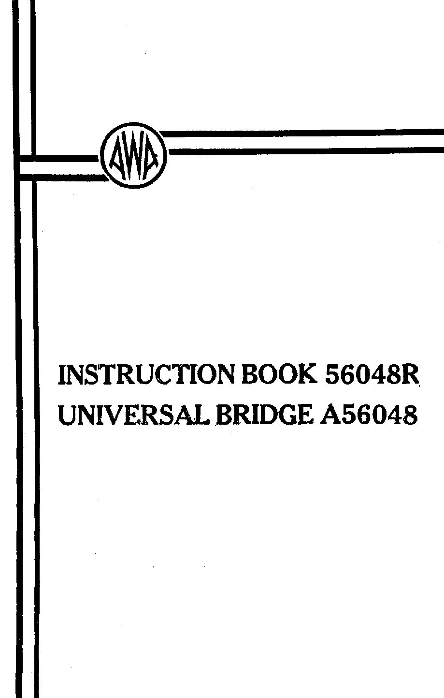

INSTRUCTION BOOK NO. 56048R

UNIVERSAL BRIDGE A56048

Amalgamated Wireless (Australasia) Limited,

47 York Street,

SYDNEY.

56048R (i)

INDEX
SECTION PAGE NO.

1 DESCRIPTION:

1.1 Application 1.

1.2 Mechanical Description 1.

1.3 Performance Summary 1.

1.3.1 Resistance Ranges
(0.1 to 10 ohms) 1.

1.3.2 Capacitance Ranges
(10µµF. to 10µF.) 2.

1.3.3 Inductance Range 2.

1.3.4 Comparative Measurements 2.

1.4 Accuracy 2.

1.4.1 All R and C Ranges 2.

1.4.2 1.0 µF. and 1.0 ohms Ranges 2.

1.4.3 EXT. Position 3.

1.4.4 “%” Position 3.

1.5 Technical Description 3.

1.6 Valve Complement 5.

2. INSTALLATION:

2.1 Mains Voltage Adjustment 6.

56048R (ii)

SECTION PAGE NO.

2.2 Precautions 6.

3 METHOD OF USE:

3.1 Bridge Signal Source 7.

3.2 Calibration Check 7.

3.3 Use of SENSITIVITY Control 8.

3.4 Resistance Measurement 8.

3.5 Capacitance Measurement 9.

3.6 Measurement with External
Standards in the EXT or
“Open Bridge” Position 10.

3.7 Use of the “%: Scale 11.

3.8 Conductivity of Liquids 11.

4. MAINTENANCE:

4.1 Valve Replacement 12.

4.2 Voltages 12.

4.3 Adjustment of Trimmer Capacitors 13.

5 COMPONENT SCHEDULE: 15.

6 DIAGRAMS DRG. NO.

Universal Bridge A56048 Circuit 56048C1

56048R 1.

1.1 Application

The A.W.A. Universal Bridge type A56048 is a self-contained mains-operated Wheatstone Bridge for the measurement of a wide range of resistance and capacitance by reference to built-in or external standards, and of inductance above; approximately 1mH. by reference to external standards only.

1.2 Mechanical Description

The instrument has a blue anodised front panel and is housed in a small carrying case finished in pastel blue hammer tone.

The front panel size is 6.3/8 x 9" and the depth of the case is 4.1/2”. The weight is approximately 7.1/2 lb.

1.3 Performance Summary

1.3.1 Resistance Ranges (0.l to 10 ohms)

0.1 ohms to 10.0 ohms at 1 ohms setting of RANGE switch.

10.0 ohms to 1000 ohms at 100 ohms setting of RANGE switch.

1000 ohms to 100,000 ohms at 10K ohms setting of range switch.

0.1M ohm to 10.0M ohms at 1.0M ohms setting of RANGE switch.

Greater than 10.0M ohms at “EXT”. setting of RANGE switch.

2. 56048R

1.3.2 Capacitance Ranges (10 µµF. to 10 µF.)

10 µµF. to 1000µµF. at 100µµF. setting of RANGE switch.
0.001µF. to 0.1µF at 0.01µF setting of RANGE switch.
0/1µF. to 10µF. at 1.0µF. setting of RANGE switch.

1.3.3 Inductance Range

Approximately 1.0mH. to 10H. by reference to external standards with RANGE switch at EXT.

1.3.4 Comparative Measurements

Ratio 0.1 to 10.0 with RANGE switch on EXT.

1.4 Accuracy
(Overall error, including reading error)

1.4.1 All R and C Ranges
(Except 1.0µF. and 1.0 ohm Ranges)

Less than ± 3 % at the centre of the scale, increasing to ± 8.5% at the ends.

1.4.2 1.0 µF. and 1.0 ohms Ranges

Less than ± 7% at the centre of the scale, increasing to ±12.5% at the ends.

56048R 3.

1.4.3 EXT Position (Open Bridge)

Less than ±2% at the centre of the scale, increasing at ± 7.5% at the ends.

1.4.4 “%” Position

Less than ± 0.5 % a t the centre of the scale, increasing to ± 1.0% at the ends.

For Impedance above 10M ohms, the error may be greater under very humid conditions.

1.5 Technical Description

The measuring section of the unit consists of the unit consists of a bridge circuit in which two of the arms of a bridge are made up of a wire-wound potentiometer while the third arm is a standard resistor or capacitor as selected by the RANGE switch.

The potentiometer provides a continuously variable ratio for the arms, but to prevent the dial becoming too crowded at the one end it is necessary to restrict the range of the potentiometer to ratios between 0.1 and 10, with series resistors in each end.

The potentiometer is calibrated in actual ratios, so that at balance, the unknown is equal to the standard in use multiplied by the ratio.

In addition to selecting any one of 4 resistance standards or 3 capacitance standards, the range switch

4. 56048R

can also disconnect all standards so that external standards may be used or any two components compared to each other over a range of 0.1 to 10 times. Inductance may be measured in this manner provided a source of voltage up to 10 kc/s is available for exciting the bridge.

The series resistance of inductances prevents a satisfactory bridge balance from being obtained unless the frequency is such that the inductive reactance is at least 50 times the series resistance. This places a lower limit approximately 1mH. on the inductance that can be measured with the highest permissible frequency of 10kc/s. The upper limit of inductance will be determined by the interference from stray fields and it may not extend much above 10H.

A position is also provided in which the potentiometer is shunted to reduce its range to cover only 0.8 to 1.25 so that any two components may be compared to each other over the range –20% to + 25%.

A “check” position is incorporated in which two 100 ohm resistors are connected as the other two arms of the bridge. Hence in this position the bridge will balance when the ratio is 1.0 so that the pointer of the potentiometer can be set to read correctly.

The bridge is supplied from a 3.2V. winding on the mains transformer. A separate switch disconnects to 50-cycle

56048R 5.

supply when an external source is needed. A series resistor is used for protection of the transformer in case of short circuit of the measuring terminals.

The indicator circuit consists of a 6AU6 pentode amplifier followed by a 6U5 “magic eye” tube. The input to the “magic eye” is controlled by the SENSITVITY potentiometer.

A socket, connected to the grid of the “magic eye” indicator and marked OUTPUT, is provided on the front panel to enable the use of an external indicator such as a cathode ray oscilloscope.

A full-wave rectifier and resistance-capacitance filter provide H.T. for the pentode amplifier and “magic eye”.

1.6 Valve Complement

Type Qty.

6AU6 1
6U5 1
6X4 1

6. 56048R

2. INSTALLATION

2.1 Mains Voltage Adjustment

Before connecting the instrument to the mains, check that the mains is connected to the correct voltage on the transformer tap changing panel.

This connected on the rear of the sub-panel and is accessible when the instrument is removed from the case.

2.2 Precautions

When measuring high impedances, care should be taken to ensure that there are no electric or magnetic alternating fields near the measuring terminals. Interference from stray fields may produce a wrong reading or obscure the minimum. Particular care should be taken to prevent interference from magnetic fields at mains frequency produced by transformers in other equipment, soldering irons and bench lamps etc. These should be kept at least several feet away from the bridge and the power supply cable to the bridge itself should not be allowed to pass close to the measuring terminals.

56048R 7.

3. METHOD OF USE

3.1 Bridge Signal Source

If the bridge is to be operated from its own internal 50 cycle signal source, the lower right hand switch marked SIGNAL should be set to INT.

If operation at other frequencies is required, (e.g. for measuring inductance) the SIGNAL switch should be set to EXT. and the external source of voltage should be connected between the two outermost measuring terminals on the top of the front panel.

The external voltage source must be insulated from earth, and the upper usable frequency limit is 10 kc/s.

3.2 Calibration Check

Turn RANGE switch to CHECK position and adjust main dial for bridge balance as indicated by maximum shadow on the “magic eye” indicator. Advance SENSITIVITY control to maximum as the balance point is approached. Balance should occur at 1.0 on the outer scale of the main dial. If not, loosen the grub screw of the knob on the shaft until balance occurs at exactly 1.0. Such resetting of the knob position should not normally be required unless the factory setting has been disturbed.

8. 566048R

3.3 Use of SENSITIVITY Control

When measuring capacitances or self-inductance with loss resistance, keep the setting of the SENSITIVITY control as low as possible because the bridge balance minimum will probably be difficult or impossible to find if this control is advanced to far.

When measuring unknown values of impedance, reduce the sensitivity until the shadow in the indicator can be seen increasing at one end or other of the main dial is turned fully clockwise, set the RANGE switch to the next highest range. Conversely, select the next lowest range if maximum shadow occurs at the fully anti-clockwise position.

3.4 Resistance Measurement

Connect the resistor between the terminals marked “R” and set the RANGE switch to the appropriate value of resistance as shown in the table in para. 1.3.1 Rotate the main dial until bridge balance is indicated by the maximum shadow on the “magic eye” indicator. Advance SENSITIVITY control to maximum as the balance point is approached.

The measure value of the resistor is equal to the reading on the outer scale of the main dial multiplied by the setting of the RANGE switch. For example, if the main dial reads 0.35 and RANGE switch is set to 10k ohms, the measured value will be 0.35 x 10,000 = 3,500 ohms.

56048R 9.

3.5 Capacitance Measurement

Connect the capacitor to the terminals marked “C” and set the RANGE switch to the appropriate value of capacitance as shown in the table in para. 1.3.2

Rotate the main dial until bridge balance is indicated by the maximum shadow on the “magic eye” indicator. Advance SENSITIVITY control to maximum as the balance point is approached.

The measured value of capacitance is equal to the reading on the outer scale of the main dial multiplied by the setting of the RANGE switch. This value must then be reduced by 15 µµF. which is the residual capacitance in the instrument. For example, if the main dial reads 0.25 and the range switch is set to 100µµF, the measured value will be (0.25 x 100) – 15 = 25-15 = 10uuF.

The residual capacitance can be checked by setting the RANGE switch to 100µµF. position and noting the reading at balance with nothing connected to the terminals . The reading should be 0.15. If it is not the trimmer capacitors across the terminals should be adjusted as in sub-section 4.3.

Capacitors with values between 1.0 and 10.0µµF. may be measured as above, but great care should be taken to avoid errors due to stray fields (see sub-section 2.2)

10. 56048R

3.6 Measurement with External standards in the EXT or “open bridge” position

With the RANGE switch in the EXT position, resistance capacitance and inductance may be measured with reference to externally connected standards.

To measure an unknown resistor connect it to the R terminals and the standard resistor to the C terminals.

To measure an unknown capacitor connect it to the C terminals and the standard capacitor to the R terminals.

To measure an unknown inductor, connect it to the R terminals, and the standard inductor to the C terminals.

In such case, measure the unknown by balancing the bridge as for ordinary measurements of resistance or capacitance. The value of the unknown is equal to the main dial setting at balance multiplied by the value of the standard. As the main is calibrated from 0.1 to 10.0 resistors, capacitors and inductors having a value of 0.1 to 10.0 times the standard may be measured in the EXT position.

When inductors are being measured, the balance may be not clear if the ratio of the resistance is not correct. If this happens, connect a variable resistor in series with the standard inductor and adjust its value to produce a distinct balance with the highest possible sensitivity.

When high impedances are being measured in the EXT position, allowances should be made for the residual

56048R 11.

capacitance of 15µµF. Allowances should be made for series resistance when very low impedances are being measured.

3.7 Use of the “%” Scale

With the RANGE switch is the “%” position the operation is the same as for EXT. position, except that the inner scale, marked “%”, is used. The connection of the unknown impedance and of the standard is the same as for the EXT. position. Any impedance within the range of the bridge may be compared to any other impedance within the range –20% to +25%.

When measuring or comparing inductors it may be necessary to connect a variable resistor in series with the standard inductor in order to obtain a clear bridge balance as in sub-section 3.6.

3.8 Conductivity of Liquids

The resistance of liquids may be measured by connecting the contacts of a suitable measuring cell filled with the liquid to the R terminals and proceeding in the same manner as for resistance measurement.

An external signal source of about 1000 c/s should be used to supply the bridge to avoid electrolysis or polarisation in the solution. See sub-section 3.1 for method of connection of external supply.

12. 56048R

4. MAINTENANCE

4.1 Valve Replacement

All valves are accessible on removal of the instrument from its case. This can be done by removing six screws from around the edge of the front panel and withdrawing the unit while taking particular care to avoid damaging the two trimmer capacitors mounted on the measuring terminals.

Any valve may be replaced without affecting the performance of the instrument.

4.2 Voltages

Measured on a 1000ohms-per-volt type meter

V1 (6X4) Heater 6.3V. ±3%
(pins 3&4)

Anodes 290V. A.C. ±10%
(pins 1&6)

Cathode 370V. D.C. ±10%
(pin 7)

V2(6AU6) Cathode 1.4V. D.C. ±10%
(pin 7)

V3(6U5/6G5)Target 250V. D.C. ±10%
(pin 4)

Bridge Supply Voltage 3.2V. A.C. ±5%
(at transformer)
(Bridge supply switch on EXT.)

56048R 13.

4.3 Adjustment of Trimmer Capacitors

The instrument should be properly mounted in its case and placed in such a position as to be free of all stray electric and magnetic fields.

(i) Check the setting of the main dial pointer as in sub-section 3.2.

(ii) Set RANGE switch to EXT. and adjust the trimmers (C10, C11) across the terminals by equal amounts for balance at 1.0 on the main dial. These trimmers are accessible through a slot in the back of the case.

(iii) Connect a measured 85µµF. ±1% capacitor across the C terminals and switch on the 100µµF. range.

(iv) Adjust trimmer (C7) across the internal 100µµF. standard for balance at 1.0. (C7) is accessible through one of the holes in the case into which the handle is sprung.

(v) Remove the 85µµF. capacitor and re-balance the bridge. If the total capacitance (including trimmers) across C and R terminals has been adjusted to 15µµF. then the bridge should balance at 0.15 with nothing connected to the terminals.

14. 56048R

(vi) If the balance is above 0.15 repeat step (ii) above, but reduce the capacitance of C10, C11 slightly by equal amounts.

(vii) Switch back to 100µµF. range and with nothing connected, check balance. If balance is below 0.15 repeat step (ii), but increase the capacitance of C10, C11 slightly by equal amounts.

(viii) Repeat the above procedure until balance occurs at 0.15 with nothing connected, indicating that the residual capacitance is 15µµF.

56048R 15.
5. COMPONENT SCHEDULE

When ordering replacement parts, please quote all details given below for a particular component.

Circ. Ref. A.W.A Type No.
No. Description (unless otherwise
stated)
(a) Capacitors

C1 8µF., 450V.W., elect. U.C.C. type
51-134-1
C2 8µF., 450V.W., elect. U.C.C. type
51-134-1
C3 25µF. 40V.P., elect. U.C.C. type
51-134-2
C4 0.1µF ±20%, 400V.W., paper 228915
C5 0.01µF ±10% 500V.W., mica Simplex SM
C6 68µµF. ±5% 500V.W., Silver Ceramic U.C.C. SCT12
C7 3-33µµF variable air dielectric “Polar” C30-01
C8 0.01µF ±10% 500V.W., mica Simplex SM
C9 1µF. ±5% 350 V.W. paper, Ducon PRC310
Temperature compensated
To give ±5% total tolerance
C10 3-33µµF variable air dielectric “Polar” C30-01
C11 3-33µµF variable air dielectric “Polar” C30-01

(b) Resistors

R1 82k ohms ±20%, 3/4 W., carbon I.R.C. type BTA
R2 82k ohms ±20%, 3/4 W., carbon I.R.C. type BTA

16. 56048R

R3 470k ohms ±10%, ¾ W., carbon I.R.C. type BTA

R4 1.0M ohm ±10%, ¾ W., carbon I.R.C. type BTA

R5 2,200 ohms ±10%, ¾ W., carbon I.R.C. type BTA

R6 1.0M ohm ±10%, ¾ W., carbon I.R.C. type BTA

R7 2.0M ohms, carbon potentiometer 56048T15

R8 5 ohms ±10%, 1W., wire-wound vitreous RWV4-J

R9 85 ohms ±1%, 1W., carbon I.R.C. type DCC
(matched with R11 to 0.25%)

R10 1,000 ohms ±2%, 5W, wire-wound A.G. Naunton & Co.
variable, linear, Dural spindle. North Brighton

R11 85 ohms ±1%, 1W., carbon I.R.C. type DCC
(matched with R9 to 0.25%)

R12 23 ohms ±1%, ½ W., carbon Erie 100

R13 100 ohms ±1%, 1W., carbon I.R.C. type DCC
(matched with R14 to 0.25%)

R14 100 ohms ±1%, 1W., carbon I.R.C. type DCC
(matched with R13 to 0.25%)

R15 1M ohm ±, ½ W., carbon Erie 100

R16 10k ohms, ±1%, carbon Erie 100

R17 100 ohms, ±1% 1W., carbon I.R.C. type DCC

R18 1.0M ohms, ±1%, wire-wound 56048V22

56048R 17.

(c) Miscellaneous

T1 Power Transformer 1TX58568

S1 Switch Oak “H” type 56048V61

S2 Switch Oak “H” type 56048V62

V1 Socket, 7-pin, miniature, phenolic pt. 19963

V2 Socket, 7-pin, miniature, phenolic pt. 19963
with register.

V3 Socket, 6-pin, Amphenol 1S56610
Screen for V2 socket

Terminals “R”, “C” Common “R”-“C” & “E” 891801
Small black “Gallard” type 2C

“Output socket, single point, female Belling-Lee L216

