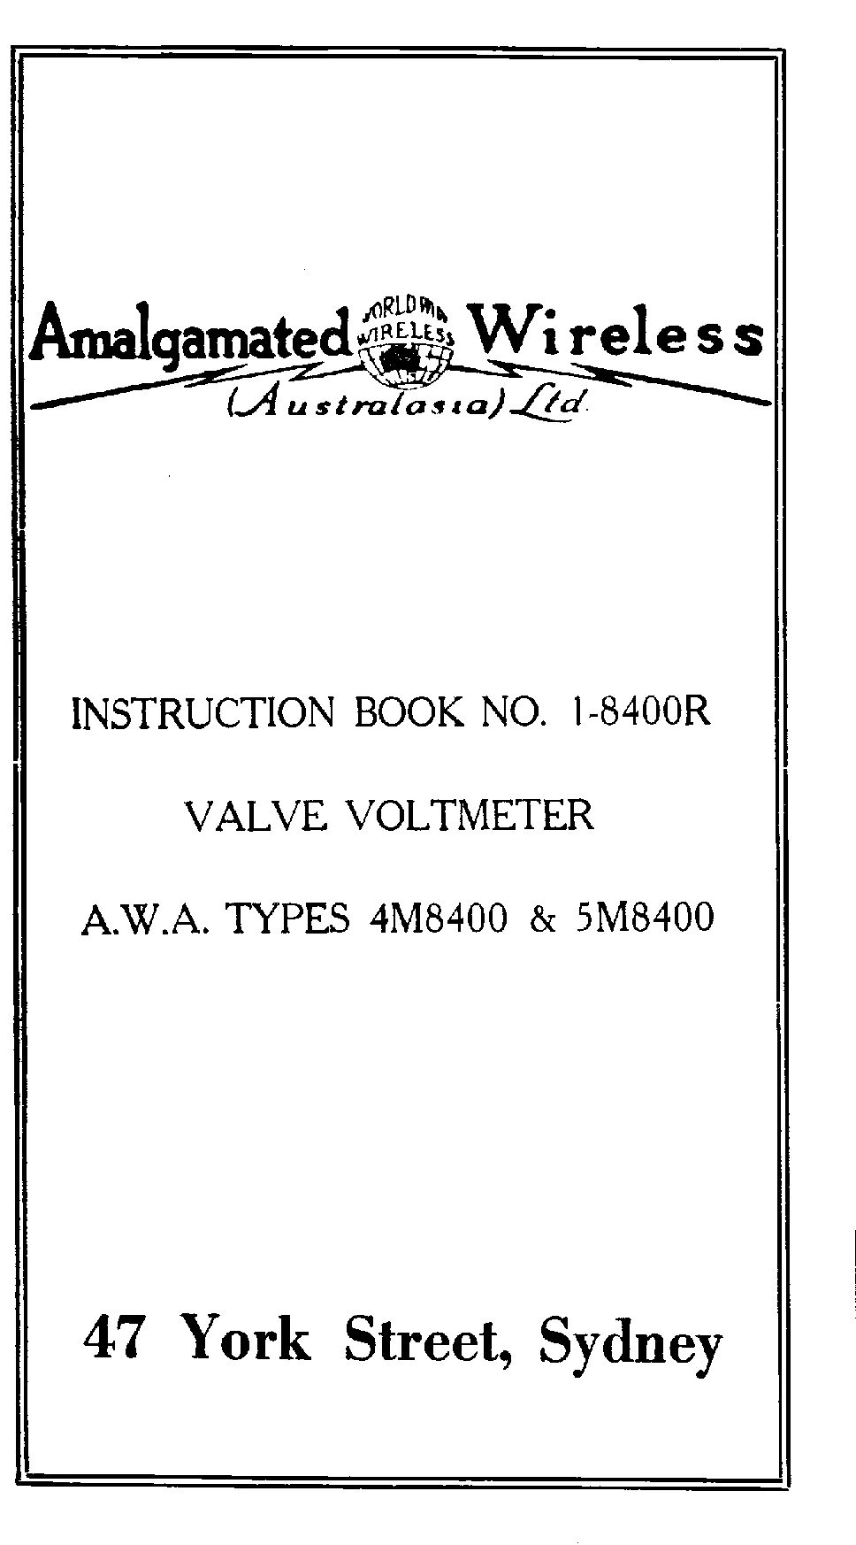

INSTRUCTION BOOK NO. 1-8400R

A.W.A. VALVE VOLTMETER

TYPES 4M800 AND 5M800

Amalgamated Wireless (A’sia) Limited

47 York Street,

SYDNEY

Revised 250246
200944

(i)

INSTRUCTION BOOK NO. 1-8400R

INDEX

SECTION PAGE NOS.

1. DESCRIPTION:

1.1 Application 1
1.2 Principles of Operation 1
1.3 Summary of Characteristics 2
1.4 Construction and Circuit Description 3
1.5 Controls
1.5.1 Operating Controls 6
1.5.2 Preset Controls Accessible
Front Panel 6
1.5.3 Preset Controls not Accessible
Unless the Instrument is Removed
from its Case 7
1.6 Valve List 8

2. INSTALATION: 8

3. OPERATING INSTRUCTIONS:

3.1 Preliminary Adjustments 8
3.2 Operation 9

4. MAINTENANCE:

4.1 Necessity for Adjustments 9
4.2 Re-adjusted of SET ZERO Preset Controls 10

(ii)

INSTRUCTION BOOK NO. 1-8400R

INDEX

SECTION PAGE NOS.

4.3 Re-adjustments of Calibration 10
4.4 Typical Operating Voltages and Currents 10

5 COMPONET SCHEDULE: 11

6 EQUIPMENT SCHEDULE: 13

7 DIAGRAMS: DRG.NO.S

Valve Voltmeter, types
4M and 5M8400 8400D7
Circuit Diagram

Circuit Code for Types 8400D8
4M and 5M8400 to D12

Input Resistance Graph
For types 4M and
5M8400 8400D16

(1)

INSTRUCTION BOOK NO. l-8400R

1.1 Application

The A.W.A, Valve Voltmeter Series M8400 is extremely useful for the measurement of a-c voltages from 0.2 to 150V rms at audio and radio frequencies. Used in conjunction with range multipliers Series R50293, the range of the instrument can be increased to 1,500 volts full scale reading, with multiplier type R50293, or to 15,000 volts with multiplier type 1R50293.

The instrument has a high input resistance and low input capacity.

1.2 Principles of operation

The voltmeter comprises a u-h-f-triode type 9072 valve of GT construction used in a reflexed anode bend circuit.

In both types of instrument, the 9072 valve is contained in a shielded probe at the end of a flexible cable. By means of this probe, the leads between the source of voltage to be measured and the voltmeter input can be kept extremely short, enabling high calibration accuracy at high radio frequencies.

Incorporated in both instruments is a means of checking the meter calibration and separate adjustment of meter zero on each range.

Both instruments operate from a-c mains 220-26OV, 50 cs. Type 5M8400 is designed for commercial use and bears only the A.W.A. type number. Type 4m8400 is a tropic proofed unit, designed for use by the services and bears their identification numbers.

(2)

INSTRUCTION BOOK NO. l-8400R

SECTION 1 (contd.)

1.3 Summary of Characteristics

The voltmeters measures voltages from 0.2V to 150V in five ranges, namely,

0 – 1.5V
0 – 5V
0 – 15V
0 – 50V
0 – 150V

The accuracy of meter calibration over any range is ± 2% of full scale deflection.

The accuracy of indicated reading is dependant on frequency and is ±2% within the frequency range 40 cps to 20 Mc., assuming a sinoidal voltage waveform.

The input resistance (R) of the instrument is also dependent on frequency and is given in graphical form (Drg. No. 8400D16) at the end of the book.

The input capacitance (C) is 15µµF and is in parallel with the input resistance (R) across the probe terminals.

The input impedance (Z) may be calculated at any frequency at which the value of R is known, from the formula :-

Z = R
(1+Ω² C² R²) ^{½}

When measuring the voltage across a timed circuit, the input resistance of the probe is of most importance as it is in parallel with the

(3)

INSTRUCTION BOOK NO. 1-8400R

SECTION 1 (Contd.)

circuit, thus causing a lower Q. The input capacitance, however, has no effect as it becomes part or the tuning capacitance when the circuit is retuned to resonance.

When measuring the voltage across a resistance or any impedance which cannot be adjusted to allow for the probe input capacitance, the input impedance (Z) must be used in the calculation of the loading effect of the probe.

For a change in a-c mains voltage of ± 20 volts in 240 V, an error of not more than +2% can be expected in any reading being made by the voltmeter.

1.4 Construction and Circuit Description

The instrument is contained in a cast aluminium case measuring 14” x 9” x 8: finished in grey wrinkle enamel and fitted with carrying handles and rubber feet. A 4” meter is used. Each range has a separate scale and these are alternately black and red.

The weight of the instrument is approximately 25 lb.

The circuit shown in Drg. No. 8400D7 comprises three main sections namely:-

(i) Detector
(ii) Calibrating Section
(iii) Power Supply

(4)

INSTRUCTION BOOK NO. 1-8400R

SECTION 1 (contd.)

The detector is a u-h-f triode valve using a combination of self and back bias. The back bias is derived from a potential divider R2 and R9 across the high tension supply to the valve. The ratio R9 to R2 is equal to the amplification of the valve (about 20) and this tends to keep the zero and calibrations of the voltmeter independent of the high tension voltage. No cathode resistor is used on the 1.5 voltage range. The decrease in sensitivity to correspond to 5V, 15V, 50V and 150V ranges is obtained by inserting large cathode resistances R3, R4, R5, and R6 respectively, at the same time in creasing the high tension supply to the valve by switching in smaller dropping resistors R23, R24 and R25 and zero respectively, so the input voltage is not greater than the grid bias developed at full input. Actually about 0.25µA of dc grid current flows at full input on the 50V and 150V ranges. The losses caused by this small current flow are, however, probably much less than that occurring in the 5 MΩ grid leak.

The scale calibrations of all ranges are for the rms value of a sine wave, but the effect of distortion on readings varies with the input from range to range. At zero input on each range, the valve is biased to almost cut off, so that substantially the whole of the positive half cycle is producing d-c anode current. On the ranges higher than 1.5V, the bias increases with increase in input owing to the presence of the high-value

(5)

INSTRUCTION BOOK NO. 1-8400R

SECTION 1 (contd.)
Cathode resistor, so that the d-c bias at full input is greater than cut-off bias, particularly on the 15, 50 and 150 ranges. Consequently the portion of the input wave causing anode current flow continually decreases as the input increases, and the deflection of the voltmeter tends to become dependent upon the peak value of the input wave, and therefore to indicate the rms value of the sine wave having the same peak value as the wave applied.

In each type, the 9072 valve is contained in a metal probe case.

A VR150-30 voltage regulator used with a tapped bleeder resistor provides d-c calibrating voltages. These voltages are switched to the front panel terminals by means the USE-CAL. Switch (S3). The probe terminals are then placed in contact with the front panel terminals and the probe switch (S1) is used to connect the insulated probe terminals directly to the grid by shorting out C1. The d-c voltage on the grid produces a deflection on the meter. The meter calibration is corrected by varying the appropriate sensitivity control so that the needle occupies a position denoted on the table in the rear lid of the instrument.

The sensitivity controls are shunts R16, R17, R18 and R20 across the meter, and are accessible through the front panel.

(6)

INSTRUCTION BOOK NO. 1-8400R

SECTION 1 (contd.)

The power supply operates from a-c lines supplying 220-260V, 40 to 60 ~.

1.5 Controls

The instrument controls and their uses are as follows :-

1.5.1 Operating Controls

(i) RANGE switch – the engraving indicates the voltage producing full scale deflection at each setting of this switch.

(ii) USE-CAL. Switch –

(a) On USE position the instrument can be operated as a voltmeter.

(b) On CAL. Position the d-c calibrating voltage is connected to the front panel terminals.

(iii) FINE ZERO (R8) - enables the meter pointer to be set to zero on the scale with no voltage applied to the voltmeter input.

1.5.2 Preset Controls Accessible
Through Front Panel

(i) 1.5V SET ZERO (R11)

(II) 1.5V SENSITIVITY (R16)

(7)

INSTRUCTION BOOK NO. 1-8400R

SECTION 1 (contd.)

(iii) 5V SENSITIVITY (R17)

(iv) 15V SENSITIVITY (R18)

(v) 50V SENSITIVITY (R19)

(vi) 150V SENSITIVITY (R20)

1.5.3 Preset Controls not Accessible Unless
the Instrument is Removed from its Case

(i) 5V SET ZERO (R12)

(II) 15V SET ZERO (R13)

(III) 50V SET ZERO (R14)

(IV) 150V SET ZERO (R15)

The SET ZERO controls are used in conjunction with the FINE ZERO control already mentioned; the preset controls providing the “rough” setting, and the FINE ZERO control the vernier” setting.

When making a number of readings using more than one range it is advisable to adjust SET ZERO controls for the ranges being used as shown in sub-section 4.2. This avoids having to reset the FINE ZERO for each range.

(8)

INSTRUCTION BOOK NO. 1-8400R

SECTION 1 (contd.)

1.6 Valve List

Circ.
Ref. No. Section Valve

V1 Detector Type 9072
Radiotron

V2 Full Wave Type 6X5GT
Rectifier Radiotron

V3 Voltage Type VR150-30
Regulator Radiotron

2. INSTALLATION

If the valves have been packed separately, they should be inserted in their respective sockets, the position of each valve being clearly indicated.

The fuses are under the chassis at the back left-hand corner. One fuse should be in the clips marked “common”, the other in the clips suiting the mains voltage to be employed.

3. OPERTAING INSTRUCTIONS

3.1 Preliminary Adjustments

With the power switched off, check the mechanical zero of the meter. Connect the instrument to a suitable mains supply, and allow at least five minutes for the valve characteristics to become stabilized before

(9)

INSTRUCTION BOOK NO. 1-8400R

SECTION 3 (contd.)

making any adjustment. In order to avoid damage to the meter, make certain that the correct voltage range, or preferably the one next higher, is switched in. Then set the pointer of the meter to the zero scale reading by means of the FINE ZERO control. If it is impossible to zero the pointer proceed as in sub-section 4.2. The instrument should be ready now for operation.

3.2 Operation

Connect the input terminals of the voltmeter across the voltage source to be measured. The probe terminals may be placed directly across the voltage or the probe can be inserted in the feltex lined support in the carrying case and leads taken to terminals on the front panel.

To avoid dangers of shock, when measuring a-c voltages at points where there is high dc, connect an 0.1µF condenser of suitable voltage rating in the lead from earthed probe terminal to the voltage source.

4. MAINTENANCE

4.1 Necessity for Adjustments

Adjustments may be necessary due to one of the following:-

(i) A long period of continuous operation.

(10)

INSTRUCTION BOOK NO. 1-8400R

SECTION 4 (contd.)

(ii) Replacement of faulty parts including valves.

(iii) Severe knocks, etc.

4.2 Re-adjustment of SET ZERO Preset Controls

Set the FINE ZERO control in the middle of its travel. Bring the meter needle to zero reading by adjusting the SET ZERO control for each range required.

When making these adjustments, see that the input terminals or probe connections are short circuited.

4.3 Re-adjustments of Calibration

First set the zero, then switch the USE CAL. Switch to the CAL. position and plug the probe terminals into the front panel terminals of the instrument. On depressing the press button on the probe case the meter will deflect. By means of the SENSITIVITY preset control for the range, vary the deflection so that the needle coincides with the reading given on able in rear lid. The SENSITVITY controls are accessible as screwdiver adjustments through the front panel, after removing individual cover screws.

4.4 Typical Operating Voltages and Currents

Anode 6X5GT = 310V rms

H.T. at first filter condenser = 380V

(11)

INSTRUCTION BOOK NO. 1-8400R

SECTION 4 (contd.)

H.T. Drain  (No a-c Input  to Voltmeter) | Range
0.4 mA  1.0 mA  1.1 mA  2.5 mA  4.1 mA | 0-1.5V  0-5.0V  0-15V  0-50V  0-150V

5. COMPONENT SCHEDULE

(Refer Drg. Nos. 8400D8 to D12)

IMPORTANT

HOW TO ORDER REPLACEMENT PARTS

The following systems of ordering spare or replacement parts should be adhered to in order to avoid unnecessary correspondence and expedite delivery.

1. To order a MAJOR part which carries its OWN type number, quote this type number; quote ALSO serial number, resistance value or capacity value where shown.

Examples :- Transformer, 1TK5510

(12)

INSTRUCTION BOOK NO. 1-8400R

SECTION 5 (contd.)

Resistance, A.W.A. 1S4282,
500Ω, 20W, Ctg.C, 2 clips

2. To order a small electrical part which carries NO type number, quote:-

(i) Type number and serial number of SECTION (not whole equipment) where part is used.

(ii) Circuit reference number.

(iii) Circuit drawing number and sub-number, the latter being found in the right hand section of the LAST entry in the “changes” column.

Example:- Type P8368, serial No. 18, C50A, Drg. No. 836C81, sub-number 2

3. To order a part which carried NO type number and has NO circuit reference number, quote:-

(i) Type number AND serial number of SECTION (not whole equipment) where part is used.

(ii) Circuit reference number and circuit drawing number of component associated with the wanted part.

(iii) Brief description of part.

Example:- Type J8279, Serial No. 41. Insulated coupling C23B, Drg. No. 8279D1.

(12)

INSTRUCTION BOOK NO. 1-8400R

6. Equipment Schedule.

Item 1. One A.W.A. Valve Voltmeter, type 4M8400 including valves.

OR

One A.W.A. Valve Voltmeter, type 5M8400 including valves.

Item 2. One Instruction Book N0. 1-8400R

