RADAMETA

NEGATIVE TRANS-CONDUCTANCE SERVICE
OSCILLATOR.

TECHNICAL DATA.

FREQUENCY RANGES.
A. 100 - 200 Kilocycles
B. 200 - 450 Kilocycles
C. 450 -1200 Kilocycles
D. 1.2 - 3.5 Megacycles
E. 3.5 - 10.0 Megacycles
F. 10.0 - 30.0 Megacycles

OUTPUT.

R.F Unmodulated.
R.F. Modulated. 0-100 Milli-volts. (Modulation 400 cycles, percentage variable from 0 to 50 per cent.)
Audio Frequency. 400 cycles.

Oscillator may be modulated by means of a microphone or pick-up. Modulation percentage can be varied and .25 Volts will fully modulate the oscillator.

ATTENUATOR.

2 Stage Ladder type Low Impedance. Variable from approximately 1/2~1 micro-volt to 100 milli volts.

CURRENT CONSUMPTION.

200 volt 50' cycles 25 watts.
240 volt 50 cycles 25 watts.
6 volt D.C. 3 amps.

SERIAL No. ……………………………………..

1

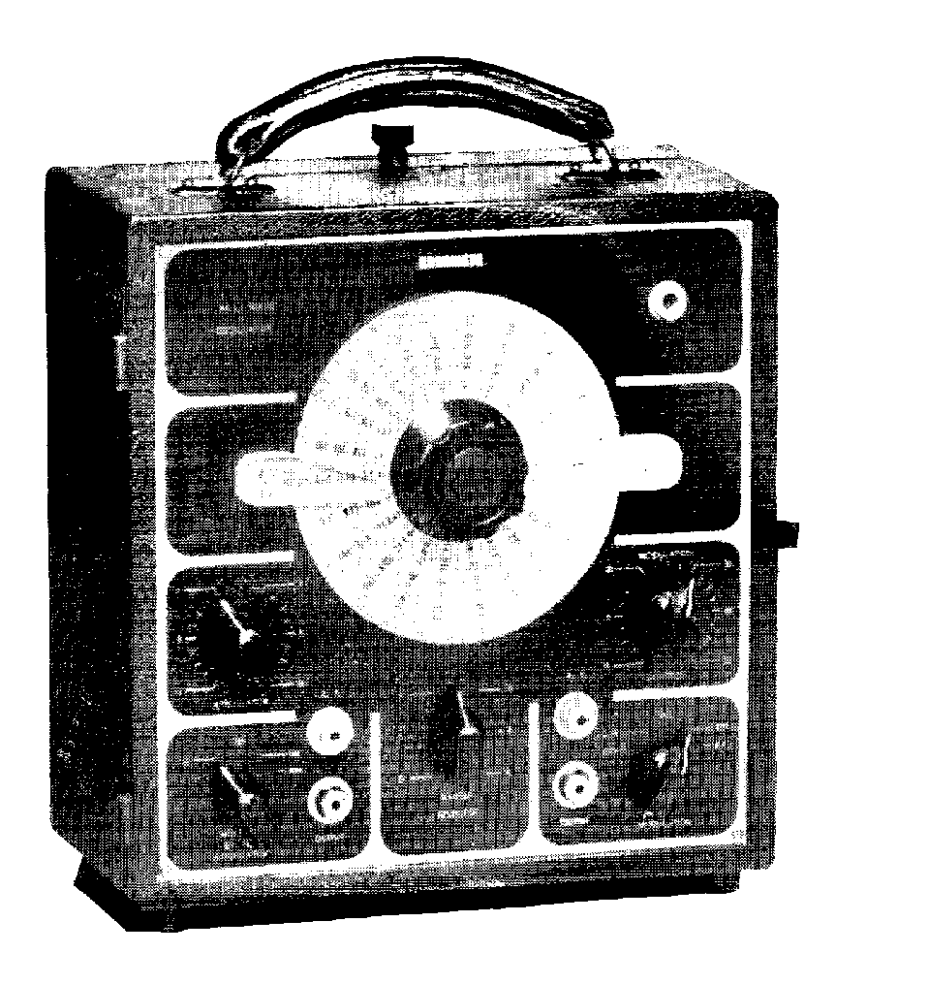

2

For further information as regards operation of the instrument or any enquiries, communicate with

RADAMETA TEST EQUIPMENT,

Fowler Road

Guildford, N.S.W. or ‘phone UB 1438

11
Band E.

Coverage 3.5-10.0 Megacycles.

Range selector on position E, and frequency is read off centre
of the left hand side of the dial. Each division representing 65 Kilocycles.

Band F.
Coverage 10.0-30.0 Megacycles.

Range selector on position F, and reading taken off the left-hand side of the dial near the centre knob, each division representing 200 Kilocycles.

The coil unit is adjusted on all bands and sealed before leaving the factory. It should not vary from frequencies stated by more than one per cent.,, which is the order of the accuracy of the instrument.

MODULATION.

The on-off and modulation control switch is situated on the 'bottom right-hand corner of tile panel. The first position to the left is the off position both for A.C. and 6-volt vibrator-operated 'models. By, turning this switch to position marked C.W. an unmodulated signal is available, the output being variable by means of the attenuator. For a modulated signal turn the modulation switch to the next position, which is marked INT. MOD. This modulates the R.F. carrier wave with a 400 cycle note, the percentage of modulation being variable from 0 to 50 per cent. In using the modulated signal for alignment of radio receivers, the modulation control should be set at 30 per cent. To align a radio receiver, the oscillator should be set to the range required as previously described and the dial tuned to the correct frequency, the shielded test lead supplied should now be connected to the wanda sockets marked R.F. OUTPUT. The red lead, which is the centre wire of the cable, and is entirely shielded, should be connected to the aerial terminal of the radio receiver under test, and the black lead to earth or the chassis, during these tests the aerial should be disconnected from the receiver so that broadcast signals will not interfere with the signal of the oscillator.

4
the A.V.C. out of action, as the magic eye or tuning meter can be used in conjunction with the A.V.C. as an output meter and the maximum may be read on either.

ALIGNING I.F. TRANSFORMERS WHOSE FREQUENCY
IS UNKNOWN.

After putting the oscillator out of action as previously described, connect the output of the oscillator to the control grid of the converter valve. Making sure to have attenuator turned to a low output to avoid overload of the output meter, set the oscillator to band A and tune slowly over the entire scale till a signal is picked up on the receiver. When this is picked up, note the dial reading and the output on the meter. Continue over bands B and C, noting all points, and the output meter readings, where signals are heard. When completed, the highest meter reading taken will represent the fundamental frequency nearest to the correct operating frequency of the I.Fs., the other readings taken being harmonics of the oscillator fundamental frequency and therefore being weaker. Common frequencies in older type receivers were 175 kc. and 262 kc., also 465 kc. was used at a later date. In the more modern receivers 175 and 262 kc. was abandoned and 455, 460, or 465 kc. was used universally, this giving some indication after carrying out preceding tests of the frequency of the I.F. transformers under test. Once this has been determined the usual procedure for alignment purposes is carried out.

AUDIO FREQUENCIES AT 400 CYCLES.

Audio frequency at 400 cycles is available, this output being variable. To obtain this, connect the lead supplied with the Oscillator to the terminals on the right side of the range selector switch, marked A.F. OUTPUT. The output voltage is controlled by means of the modulation control. The audio output is advantageous in many tests that can be carried out on audio amplifiers.

EXTERNAL MODULATION BY MEANS OF PICK UP OR
MICROPHONE.

Turn modulation switch to position marked Ext. Mod. and connect pick-up or microphone output wires to the terminals marked A.F. OUTPUT. The volume is controllable by means of the modulation control.

9

TWO STAGE ATTENUATOR.

The attenuator is a two stage ladder type of low impedance output. The first stage is a continuous variable control connected to the output of the oscillator and giving a variation from maximum to minimum of each stage in the second part of the attenuator The second stage is calibrated in stages of approximately 10 to 1 ratio, the readings of the two stages should be multiplied together, the result being in approx. microvolts, the calibrations thus making it possible to read half of one microvolt to 100 millivolts, the maximum output being with the bottom section in the position marked l0m (10,000) and the top section 10, this giving approx. 100 milli-volts, or one-tenth of one volt which is sufficient to, start the operation of aligning any radio receiver which, requires a large signal to start aligning operations.

A.C.-D.C. 6 VOLT VIBRATOR OPERATION.

The operation of the universal A.C.-D.C. 6 volt vibrator model is similar to the A.C. model, only the A.C. model should be connected to 200 volt or 240 volt A.C. after the necessary adjustments have been, made, which are as follows: the oscillator when supplied is wired to operate on 240 volt, and when required to operate on 200 volt, the instrument should be taken from, case and the A.C. connections adjusted to the correct position. The vibrator, model can be operated on 240 volt A.C. or vibrator without taking the instrument from the case by using the leads supplied for A.C. operation or vibrator, whichever the case may be. If the instrument has been operated on 200 volts, always be sure the adjustment has been returned to 240 volt operation.

10
The Radameta Service Oscillator is a reliable, accurate and portable instrument, the unbroken coverage being from 100 Kilocycles to 30 Megacycles using fundamental signals.

Radio Frequency.- Oscillation is maintained by means of the Negative Trans-conductance method; Stability with wide variations of the supply voltage and simplicity are the main features. The coil unit, manufactured by Radameta, fitted in the instrument is precision built and of high accuracy. The high frequency end of each band being adjusted by means of individual trimming condensers and the low frequency end by means of iron cores. A direct calibrated dial having a diameter of 5", makes the selection of any desired frequency a simple operation, each band being selected by means of a switch located directly below the dial. This switch shorts out all coils but the one in use, thus avoiding absorption.

Band A.
Coverage 100-200 Kilocycles.

By setting centre range selector to position A, the coil covering the above frequency is brought into operation. The reading is on the outside of the right hand side of the dial and each division represents 1 Kilocycle.

Band B
Coverage 200-450 Kilocycles.

Range selector should be set to position B and the dial reading is seen on the right hand centre, using the same calibrations as for band A and C, each division representing 2.5 Kilocycles.

Band C.
Coverage 450-1200 Kilocycles.
Range selector should be set to position C, and the readings taken are on the right hand side of the dial near the centre black knob. Each division represents 7.5 Kilocycles.

Band D.
Coverage 1.2-3.5 Megacycles.

Range selector should be set to position D, and reading is taken on the extreme left-hand side &f the dial, each division being 23 Kilocycles.

3

For short wave bands the preceding procedure applies, only the oscillator should be tuned to the frequency required, and more care should be taken owing to the fineness of the tuning.

PROCEDURE FOR ALIGNMENT OF SUPER-HETERODYNE
RECEIVERS.

In the standard super-heterodyne receiver there are a various number of tuned circuits to align before the receiver functions perfectly. The timed circuits are as follows:-
I.F. Amplifiers.
R.F. Amplifiers.
Oscillator Stage.
Converter Control Grid Stage.

The various tuned circuits of the intermediate frequency amplifiers are first aligned correctly with each other at the frequency for which the receiver is designed. To carry out this procedure, first connect output meter to the receiver, and then connect oscillator to the receiver in the following manner: Connect shielded lead supplied with oscillator to the R.F. Output, the outside connection or shield to the receiver chassis of radio, and positive, or red, clip of lead to the converter valve control grid. It is also necessary to stop the oscillator section from oscillating, which can be usually accomplished by shorting out the oscillator section of the gang. In some receivers this section is connected to the high tension, and other means must be used, of which one is shorting the oscillator grid to earth or cathode, whichever the case may be. Now, after determining the I.F. of the receiver the oscillator should be tuned to this, which will be in either Bands A, B, or C. The volume control of the radio should now be turned full on and the attenuator of the oscillator advanced till the output meter reads approximately half scale. The test oscillator should be operated with its output modulated at 30 per cent.

The first adjustment to be made is the secondary of the 2nd I.F., or the nearest winding to the 2nd detector valve. If the meter advances past full scale do not decrease the volume control of the radio, but turn back the attenuator on the oscillator till the reading is satisfactory. Adjust this trimmer, or iron core, for maximum peak on the output meter. The primary section of the I.F. can now be adjusted in a similar way for maximum peak. When this is finished, check the secondary adjustment, for frequently the adjustment of the primary will change

6
the adjustment of the secondary slightly. Repeat this for the primary, as a final check. Similar adjustments should be made to any preceding intermediate frequency transformers, in each case, first the secondary and then the primary. Usually the oscillator will have to be adjusted by turning the attenuator down after each adjustment on the radio is completed. If any difficulty is found in obtaining a fine adjustment when oscillator is connected as stated, closer adjustment can be made by connecting the oscillator directly to the stage concerned, finally adjusting as stated previously. In all cases the outside shield should be connected to the chassis. It is also possible to connect the oscillator positive (centre wire of the shielded cable) direct to any plate or high tension connection as a blocking condenser is wired internally in series. The preceding method of I.F. alignment applies only to standard super-heterodynes with peaked I.Fs. This instruction book will not deal with flat top or band pass I.Fs., but is just a general description of the operation of the instrument. Other methods should be used for the alignment of these I.F. amplifiers. The alignment of I.F. amplifiers in all-wave receivers should be carried out as previously described, after determining the correct frequency.

PROCEDURE FOR THE ALIGNMENT OF OSCILLATOR
AND R.F. STAGES.

First remove the wire shorting the oscillator section of the gang or whichever means was adopted to stop the oscillator stage from operating during the alignment of the I.Fs. The shielded lead should now be connected to the chassis and aerial terminal of the receiver exactly as specified for the alignment of T.R.F. receivers. The output meter should still be left connected to the radio receiver.

Now set the test oscillator at 1.4 megacycles (1400 Kc.) on Band D. This frequency is the high frequency of the Broadcast band commonly used for alignment purposes. The receiver should .now he tuned to 1400 Kc. on the dial; if the signal is not received, turn the attenuator up to maximum and adjust the trimmer on the oscillator section of the gang for maximum peak on the output meter.

Now adjust the section of the gang connected to the control grid of the converter valve till the maximum peak is obtained. It will probably be necessary during this operation to turn back the attenuator of the oscillator, leaving the receiver volume control at maximum, to enable a reading to be taken on the output meter. If the receiver is a standard 4-5

7
super-heterodyne, this will complete the high frequency alignment, but if an R.F. stage is present it will be also necessary to align this section of the gang for maximum peak. When this is completed, rock the dial back and forth and check if the maximum peak is on 1400 Kc., if not, make the necessary adjustments working in the same order as specified to complete the operation.

When satisfied set the oscillator at 600 kc. on Band C, and tune radio receiver to the same frequency on the dial. Now adjust the low frequency padder condenser for maximum deflection on the output meter. At this point, when a peak is obtained, it is advisable to recheck the oscillator section of the receiver on 1.4 megacycles 1400 kc.; as the alteration made by the padder may affect this tuning slightly. Coming back to 600 kc., finally adjust the padder for maximum peak. If the gang condenser is slotted, it will also be possible to adjust these first on the converter control grid section for maximum peak, and last the R.F. stage, as no adjustment should be made to the trimmers on this frequency. When the procedure is completed to satisfaction, tune oscillator and receiver to 1000 k.c. on band C for a check on the middle frequencies. If the previous instructions have been carried out correctly the tracking should be near perfect at 1000 kc. as most of the modern coil kits are designed to achieve this condition, if not correct a slight adjustment may be made at 1400 and 600 kc. it will not be attempted here to describe how to achieve perfect tracking as most servicemen have their own ideas on how to achieve this, most of these ideas being quite sound.

ALIGNMENT OF RECEIVERS FITTED WITH A.V.C.

It will be noticed when aligning a receiver fitted with A.V.C that little or no difference will occur in the output meter reading when adjustment is made to R.F., oscillator or I.F. circuits since it is the function of the A.V.C. to keep the output of the receiver constant. Under these conditions it is obvious that the A.V.C. must be out of action during alignment purposes. The method of achieving this varies with the circuit employed in the receiver under test. Some circuits with delayed A.V.C. may be aligned without cutting out the A.V.C. action by using such a low signal output from the oscillator that the A.V.C. does not operate. This. method is recommended when aligning receivers with delayed A.V.C. If aligning a receiver with a tuning meter or magic eye, an output meter is unnecessary, and it is also not necessary to put

8
PROCEDURE FOR THE ALIGNMENT OF T.R.F.
RECEIVERS.
It is a definite advantage to connect an output meter to the set under test as the human ear is not sensitive enough to note the small changes brought about by the alignment of each stage accurately enough. Turn the volume control of the set to maximum volume and set the oscillator at the lowest possible setting to obtain a signal on the receiver. Now tune the oscillator to approximately 1.4 Megacycles (1400 K.C.) by setting range switch to position D and tuning oscillator dial to 1.4 Megacycles on section ,D. Then tune radio receiver to the oscillator signal. Starting at the section of the gang condenser, that tunes the detector stage.

Adjust the trimmer until the output meter reads the maximum output that can be obtained. If the output meter passes the full scale deflection the top section of the attenuator should be turned back until the meter reads about half scale. Leaving both the receiver and oscillator dials set at the same positions, attention must now be directed to the next R.F. tuning condenser and trimmer, to the detector stage, adjust the trimmer for maximum response on the output meter. If the meter still advances past full scale adjust the oscillator attenuator till the meter reads correctly again, Do not turn down the volume control of the radio-receiver. All other sections of the receiver should be' adjusted in the same manner, and, when complete the high frequency end of the band should be in correct alignment. If the gang condensers rotor plates have segments in the outside plates the oscillator should be tuned to 1000 Kc. on Band C, and then tune receiver to signal. Now adjust segments that are in mesh. on the detector section of the gang until the maximum deflection is obtained on the output meter. Do not touch the trimmers while carrying out this operation or any of the following operations, repeat on all sections of the gang until maximum response is obtained. When completed rock the dial back and forth to sec if signal is received on one spot only; if two peaks are received turn to maximum peak and repeat the process.

On completion of the operation at 1000 Kc., repeat the procedure on 600 Kc. After following these instructions the receiver should be in correct alignment and may now be tested receiving broadcast signals. Disconnect Oscillator and meter, then connect aerial and tune in radio stations at different points on the dial. If receiver 'has been aligned correctly each station will tune in with a single peak, at which maximum response will be obtained.

5

Cox the Printer
Petersham
LM 5070

RADAMETA
Negative Trans-conductance
Service
OSCILLATOR

OPERATING INSTRUCTION
MANUAL

Radameta Test Equipment
Guildford – N.S.Wales
Phone UB 1438

