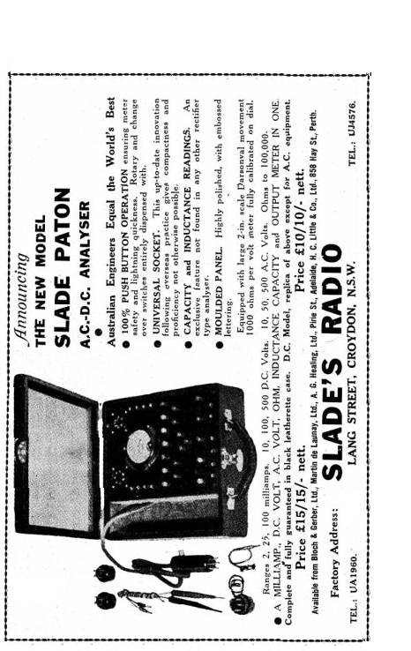

A.C. & Output Supplement

The bottom row of five buttons are used exclusively for three readings.

Rectifier A.C. Volts: With rectifier in analyser press red button (bottom row) marked PLT-F for A.C. voltage of second plate.

Filament Volts: To read the filament voltage of any valve press black centre button marked F-F in conjunction with the reducing 10 volt button (extreme right).

Output Volts: Press red button marked PLT.-F for output readings, reducing to lower scale as desired.

External A.C. Volts: Plug cords into sockets as shown at bottom of panel.

Inductance and Capacity Readings: A five volt A.C. 50 cycle source is required which may be had by plugging analyser cord into rectifier socket of set. (Put rectifier valve into analyser or else voltage may be higher than required.) Plug grid control lead into one of the sockets marked L-C. This lead has an alligator clip attached which may be clipped on to the terminal of condenser or choke that is to be measured. Plug one of the external leads into second socket and touch on to other terminal of condenser or choke, and press the ten volt A.C. button.
Read the meter on the ten volt A.C. scale (the reading will be less than five volts or middle of dial) and refer to graph.
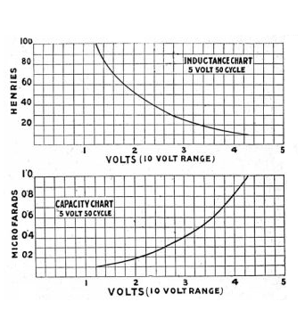

INSTRUCTIONS FOR OPERATING

The Analyser is fitted with two sockets, a universal for the 4, 5 and 6 pin valves and a seven pin type.

Readings at the essential points of a valve may be taken with extreme simplicity and rapidity by means of push buttons. Depressing any one of the inscribed and coloured top row buttons autocratically places the meter at the required valve position and registers voltage or current (depending on the particular button pressed.) on the 500 Volt or 100 MA. scale of meter dial.

To Operate: Plug valve into tester and cord into Radio Set, then for:-

Plate Current: Press red button on left marked Plt. for plate current of all standard valve, and for first plate of a rectifier.

Screen Grid Current: Press green button on left marked S.G. for screen current of all screen grid type valves, the screen current of a 7 pin penthode arid the second plate of a rectifier.

Cathode Current: Press blue button on left marked K for the cathode current of all cathode type valves.

Plate Volts: Press red button marked PLT-K for the plate volts of cathode valves or red button marked PLT-K for direct beaters or filament types.

Screen Grid Volts: Press green button on right marked S.G. for the screen grid voltages of all screen grid cathode type valves.

Cathode Volts: Press blue button on right marked K. (The screen voltage of a 247 penthode may also b read with this button.)

Reducing Scale Buttons: As previously mentioned pressing any one of the top row buttons makes the meter read on the high scale. The range may be lowered if desired by pressing at the same time a reducing button. Care however should be taken that the amount of voltage or current shown on the high scale does not exceed the maximum of the lower range.

Mutual Conductance: To test the grid swing of a valve first press plate current button and while still holding down press one of the three marked under MUTL. COND. These are designated thus:- F for filament or direct heating valves; K. for cathode type with grid in base S.G. and 7 PIN for cathode types with grid on valve cap also 7 pin penthode.

OHMS.; are read on dial, by plugging external cords into wander sockets marked “OHMS.”

External Volts: Plug cords into sockets on right.
External M.A's.: Plug cords into sockets marled M.A’s; and press red plate current button.

James & James, Printers, 198 Liverpool Road, Ashfield – U3325

