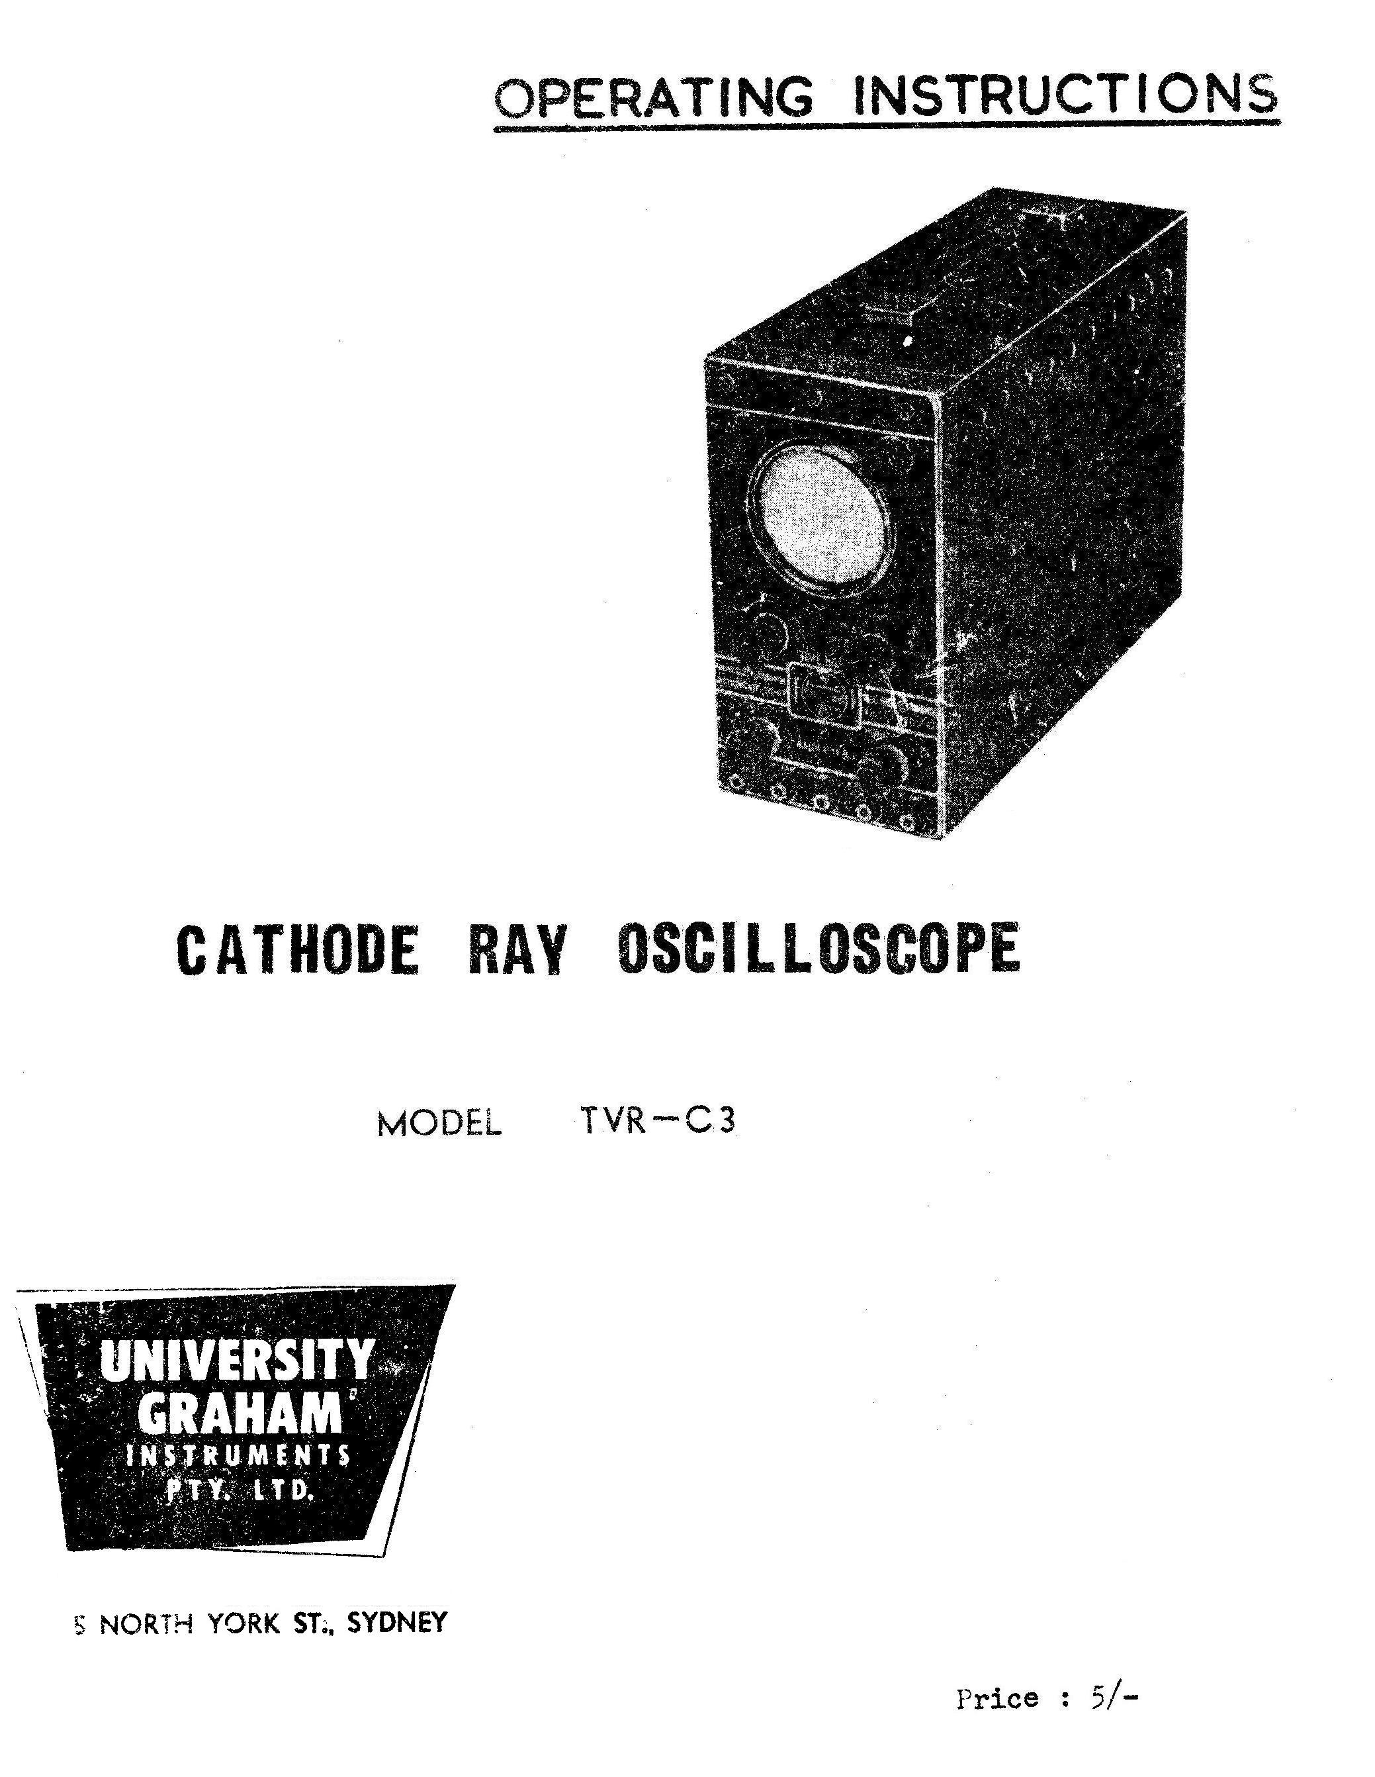

INSTRUCTIONS FOR USING THE

UNIVERSITY

CATHODE RAY OSCILLOSCOPE

MODEL TVR-C3

UNIVERSITY GRAHAM INSTRUMENTS PTY. LTD.
For all Measuring and Testing Instruments
5 NORTH YORK ST., SYDNEY

APPLICATIONS .

The Model TVR-C3 is a small, truly portable oscilloscope. A new type of cathode ray tube, type DG7-32 together with miniature components have enabled a reduction in the weight and size of the instrument, whilst still offering the quality and features available in larger models.

This oscilloscope will be found quite suitable for TV servicing and general servicing in repair shops, laboratories and workshops. The selectivity curve of TV, RF and IF circuits can be displayed on the cathode ray tube screen in conjunction with a "Sweep Oscillator" and all adjustments and aligning can he done while actually observing their effect on the curve shape. Vertical amplifier response to 1 mc/s enables examination of synchronising and deflection waveforms. Other applications include checking audio amplifiers, broadcast receivers, tape recorder servicing, distortion measurements etc. A tape playback head can be directly attached to the vertical amplifier of the CRC and output checked, including supersonic bias.

CIRCUIT DESCRIPTION.

The circuit, shown at the rear, can be divided into four main sections - cathode ray tube, power supply, vertical amplifier and time base with attached horizontal amplifier.

The cathode ray tube DG7-32 employs electrostatic deflection, and focusing of the beam. It is designed to operate with a final anode voltage of about 500 and this H.T. supply is obtained from 500 volt winding on the transformer rectified by using a high voltage metal rectifier. Large capacity filter condensers are used to ensure a minimum of ripple voltage. The final anole of the cathode ray tube is earthed and the rectifier provides a negative output which is applied to its cathode. A separate heater winding is provided for the tube, on the mains transformer to avoid a large potential difference existing between heater and cathode.

The sawtooth scanning voltages are applied in antiphase to the two horizontal plates of the tube and the use of push-pull output reduces trapezoidal effect of the trace, as short, low voltage cathode ray tubes have an inherent degree of trapezoidal effect.

Voltages under examination are applied to one vertical plate either directly or from the output stage of the vertical amplifier. The "Focus" control applies a varying degree or voltage to grid No. 2 and enables a sharp and fine trace to be obtained.

The "Intensity" control sets the DC level of the grid. Pulses are applied from the time base to achieve fly-back suppression. These pulses are applied through a frequency compensated network and the degree of fly-back suppression can be controlled by the Intensity control.

TIME BASE

The time base has six positions, five sweep ranges and an "off" position which

Page 2

disconnects the time base. In this position the tube can be used as horizontal amplifier or amplifier for external sweep. The five ranges cover frequencies from l5 c/s to 25 Kc/s and can be accurately adjusted by the potentiometer marked "Fine". All ranges are overlapping. The sawtooth waveform can be externally synchronised and the time base output is available at the "Horizontal Plate" socket at top of the instrument if required for external use.

A triode amplifier is provided for horizontal deflection giving a partial push-pull effect for the deflecting plates. The tube can be used as a separate horizontal amplifier with or without internal time base.

All input sockets and controls are located on the front panel. The top row comprises three combined sockets (the function of these is explained later, for connection to the vertical plate direct, the modulation grid of the cathode ray tube direct and the horizontal plate direct.

The purpose and location of controls is clearly labeled on the panel and is shown in Fig.2.

SPECIFICATIONS:

Power supply: 220 - 240, volts, 40-60 c/s.
Power consumption: 33W.
Amplifiers and time base H.T. = 250-375volts.C
Cathode Ray Tube E.H.T. = 560 volts.

Cathode ray tuba DG7-32, diameter 2¾". Green trace, sensitivity: 22V R.M.S. or 62V peak-to-peak/inch direct to plates. Horizontal sensitivity: 20V R.M.S, or 56V peak-to-peak/inch direct to plates. Input impedance directly to plates from front panel 3 megohms, 7 pf.

TIME BASE Miller - phantastron time base with paraphase amplifier - push-pull deflection of trace when horizontal amplifier is used to extend the trace.

FREQUENCY RANGE: 15 c/s to 25 Kc/s.

Switched range control with tire base "off" in position 1.
Continuously variable frequency control.

Time base output available at the top right hand socket - "Horizontal Plate" - at medium or high impedance,

Flyback: Degree of suppression controllable by "Intensity" control. Can be

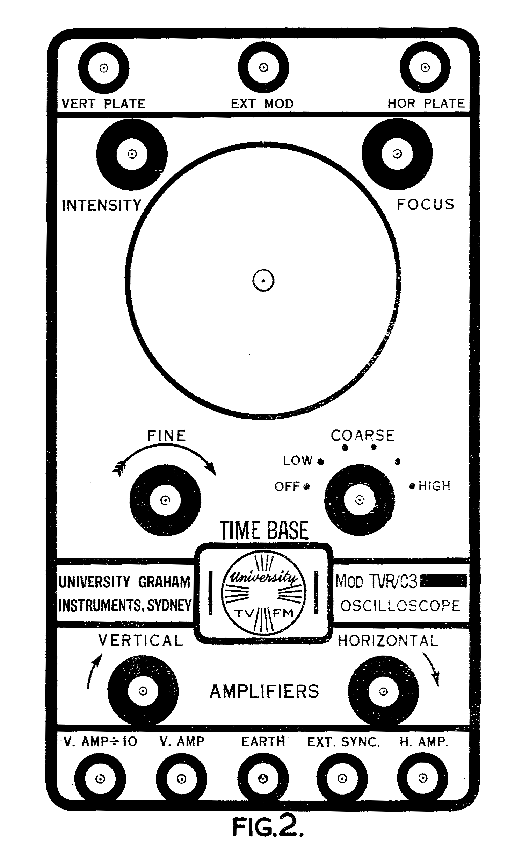

Page 3

switched off by inserting a dummy plug into top centre socket (External Modulation) or external modulation can be applied at same place.

SYNCHRONISATION is of a lock-in type, design typical of "Miller" time bases, and is internally controlled. By plugging in a dummy plug this synchronisation can be disconnected, or external synchronisation applied in the vicinity of .5-2V.

VERTICAL AMPLIFIER

The vertical amplifier consists of two stages, being essentially flat from 15 c/s to 150 Kc/s plus or minus 1 db and 6 db down at 1 Kc/s with the gain control in "full gain" position.

A usable trace is available up to 1 Mc/s and an undistorted, output can be obtained up to a trace amplitude of 2¼ inches height. Average gain is approximately 500. Deflections sensitivity at full gain being of the order of 70mv R.M.S./inch. The gain output is continuously variable - for both amplifier inputs- i.e. for "V. Amp" input socket, and for the "V. Amp ÷10" socket.

HORIZONTAL AMPLIFIER

The horizontal amplifier consists of a single stage with fully variable gain control, Gain a proximately 10.

Essentially flat from 10-150 Kc (plus or minus 1 db) with response 6 db down at 1 Kc/s with the gain control at "full gain" position. Maximum input at this setting l0V R.M.S. . (equals nearly twice screen width.) Deflection sensitivity 1.6V R.MS./inch. The amplifier is normally connected to the time base and works as a paraphase amplifier compensated to offset any non-linearity of the time base at high frequencies.

A spring handle is fitted to the top of the oscilloscope, folding flat if not in use. The instrument is 42 inches wide, 8½ inches high, 11½ long. Weight 14 lbs.

Page 4

OPERATING INSTRUCTIONS

The instrument should be connected to an AC main supply of between 220-240V, 40-60 c/s.

The time base switch should be turned to "Low" position and the intensity control fully clockwise. After sufficient time for the tubes to warm up a luminous trace will appear on the screen of the cathode ray tube. Use the "Focus" control to produce a sharp outline of the trace, reduce intensity to the least brilliance tolerable and refocus if required. It is important to reduce the intensity as much as possible. Not only does this prolong the life of the tube but it also permits a fine, sharp trace to be obtained.

TO OBSERVE WAVEFORMS

The voltage to be examined should be connected to vertical amplifier and "E" terminals for voltages not exceeding l00 V/R.M.S. or 200v. D.C.) Use VAMP ÷ 10 for voltages exceeding 100V R.M.S. with a maximum of 500v/R.M.S. (1,000 DC) The "Vertical" gain control should be set to produce a pattern of about two inches height. Alternatively, strong signals may be fed into the "Vert. Plate" socket at the top of the panel.

The Time Base "Coarse" switch and "Fine" control should be adjusted to give a suitable presentation on the screen. Synchronisation of the time base with the waveform displayed is automatic.

Should it be desired to disable the internal synchronisation, this can be done, by inserting one of the plugs, supplied with the instrument, into the socket marked "Ext. Sync." By pressing the plug in firmly, it will disconnect the internal synchronising circuits.

To effect synchronisation from an external source of voltage, the voltages should be applied by means of one of the special plugs which also must be pushed firmly in, to disconnect the internal synchronising circuits.

To take out approximately 10 volts of time base Voltage for external purposes a plug may be partially inserted into the same "Ext. Sync." socket but not pressed in sufficiently to disconnect the internal connection to the "Time Base".

To obtain good symmetry of the trace, expand the time base (horizontal) trace by rotating the "Horizontal" gain control to obtain a wide pattern, possibly past the horizontal limits of the cathode ray tube face.

To obtain minimum attenuation of the high frequencies (over 10 K/c) endeavour to keep the vertical gain control close to or at its maximum, if voltages are high enough, (l0V or more) direct input to vertical plate will give excellent result with minimum attenuation.

To measure direct voltages, apply potentials between terminals "E" and long input plug. Insert this fully into the "VERT. PLATE" terminals. The time base switch
Page 5

may be in "OFF" or "LOW" positions. If the positive voltage is applied to "VERT. PLATE" terminal the spot or line will move up. If negative voltage is applied the movement will be down, 60V. D.C. is required for approx. 1" movement.

The maximum D.C. voltage, direct or as a component of A.C. applied directly to "Vert. Plate" or "Horiz. Plate", must not exceed 350V. A.C. voltage applied to same is limited to 120V. a.c. R.M.S. (The deflection caused by either maximum is well past the area of the screen.)

As the input resistance of the "VERT. PLATE" is 3 megohms, the CRO may be used as a high impedance voltmeter. The "Earth" terminal is connected directly to the case and to the green lead of the power cable. Care must be taken to avoid injury or damage by accidental short circuits.

FREQUENCY COMPARISON

To measure frequency, providing an external calibrated oscillator is available, an accurate comparison of the unknown frequency can be made with the known one, Turn the time base control to "OFF" position, inject the oscillator frequency to either "Horiz. Amp" or "Horiz, Plate" terminal. The unknown signal can be applied to a suitable "VERTICAL" input, adjustment of the oscillator to an exact multiple or fraction of the other will produce lissajous figures on the screen. A circle, straight line or elipse will be observed when the, frequencies are equal. The shape of the shape of the figure will depend on the phase difference between the two and if the frequencies are not exactly equal the shape will be seen to change.

TELEVISION ALIGNMENT

When using the instrument for alignment of TV receivers the internal time base should be disabled by turning the "Coarse'' switch to "OFF". Horizontal deflection of the trace is then accomplished by feeding the 50 cycle horizontal sweep voltages from a sweep generator into the horizontal input socket of the TV-C3 with the return circuit connected to the earth socket. Some types of sweep oscillators provide ample output voltage to produce approximately full width deflection when fed directly into the horizontal plate and this avoids any phase shift troubles by employing the horizontal amplifier.

Should the sweep oscillator voltage be insufficient or alternatively, too strong, so that the pattern more than covers the width of the tube face, then the sweep voltage may be applied to the "A. Amp." and the width of the trace adjusted by the horizontal gain control.

The frequency swept radio frequency output from a "Sweep Oscillator" is applied through the intermediate frequency section of a receiver or to the aerial terminals of a receiver, and the output from the picture detector should be connected to the "Vert. Plate" socket on the oscilloscope.

To make "marker pips" more readily visible, it is desirable to include a resistor of approximately 50,000 ohms in the lead connecting to the picture detector load

Page 6.

resistor, and to shunt a .001 mfd condenser from the oscilloscope side of this resistor to ground.

A resistance capacity filter of this nature is supplied with the "University" Sweep and Marker Oscillator.

As the sweep oscillator sweeps through the range of frequency to which the receiver is tuned, the varying D.C. output from the picture detector will provide a vertical movement on the oscilloscope screen, tracing out a selectivity curve which will appear on the screen.

More complete instructions on television alignment are contained in the instruction book supplied with the "University" Sweep Oscillator.

WAVEFORM CHECKING

The location of faults in the deflection circuits of television receivers depends largely on the ability to recognise abnormal waveforms throughout synchronising, oscillator and deflection output stages.

The Model TVR-C3 Oscilloscope is quite suitable for this type of work.

One should first become thoroughly acquainted with waveforms experienced in a normally operating receiver by connecting a test lead to the "V. Amp" input socket and connecting the earth socket of the oscilloscope to the television receiver chassis.

The test lead may then be applied to various points throughout the video, synchronising and deflection circuit to examine waveforms normally existing. Once one is familiar with normal waveforms, it becomes a simple matter to recognise abnormal conditions when faults occur.

REPLACING VALVES

Fig. 4 shows a layout of the instrument indicating the valve types and their positions on the instrument chassis.

ACCESSORIES
With each instrument the following accessories are supplied :-

One pair of test leads, terminated with spring clips
Three long connecting plugs
One ruled graticule

