Instructions for the use of the Velco Model S431

The “Velco” S431 Analyser has been designed with the object in view of providing an efficient and reliable means of servicing all types of Radio Receivers and Public Address Systems.

The following instructions should be carefully studied before attempting to use the Analyser, as a complete knowledge will expedite the location of whatever fault happens to exist.

The Analyser is essentially a free reference point instrument, meaning that all meter readings are obtained by the external application of the test cords.

Along the left side of the analyser panel will be noticed a row of sockets. The first four down from the top are the milliamp ranges; the fifth socket being the meter common negative. The numerals shown under each socket have their counterpart on the meter scale. Any value of milliamps applied to the correct pair of sockets will be accurately indicate don the meter.

It is essential before attempting to use the milliamp scale to set the selector knob (on right side of panel) to the milliamp position. The 0-1 milliamp scale has a position of its own.

Immediately under the milliamp range will be noticed two sockets marked “Ohms.” Upon the insertion of test cords into these sockets and the setting of Selector Knob to “ohms” position, the ohms values of the resistors under test can be read directly from the top scale. If a test of low resistor values is required the selector knob should be set to position marked "0-:-10." The reading shown on the top scale should then be divided by 10. A correct reading will then be obtained.

It is important to note that before attempting to measure a resistor the test cords should be shorted together and the left pointer knob marked "ohms Adj." should be adjusted until the meter needle lies exactly over the scale divisional line marked Zero. This zero adjustment should always be checked when resistor values are to be tried, also when the Selector Knob is changed from high or low ohms readings.

When the ohms scale is scale is being used never hold the metal l points with fingers as, due to body leakage, a fictitious will be obtained.

This error in resistance readings can assume quite large proportions when a high value resistance is being checked. Always hold the test prods by the insulated sleeve.
The ohmmeter scale is very useful when used as a continuity meter. The location of shorting condensers, shorts between high potential windings and those at zero potential, open circuited transformer and coil windings, etc., can be located easily.

The 4.5 volt battery in the case is used in conjunction with the ohms scale. After a lengthy period it will be found that the ohms adjustor will not bring the meter needle to zero setting. When such a condition arises, the battery should be replaced. When replacing see that the battery is connected for correct polarity.

Along the right side of analyser panel the four sockets from the top provide four different voltage values. The fifth socket is the meter negative. All that is necessary is to place the test cord into the socket providing the necessary voltage scale, placing also the selector knob to the "volts" position. The correct reading of the applied voltage will be shown on the meter scale. Each voltage value shown under the sockets has its counterpart on the meter scale.

Immediately under the voltage sockets are two sockets marked "ohms." They are to be used exactly as stated earlier in these instructions when dealing with ohms. Both pair of ohms terminals are connected in parallel internally. It is immaterial which pair is used.

When it is necessary to take voltage and current readings from a Radio Receiver or Amplifier, the operator can either obtain the readings by using the test cords direct from the analyser to the receiver, etc., or by utilizing the extension cable terminating in a seven pin plug. The latter test can often be made without removing the chassis from the cabinet.

A number of adaptors are provided to accommodate the various types of tubes available.

An adaptor corresponding to the tube under test is attached to the extension plug, the assembly is then inserted into the vacant tube socket in the receiver. The tube

should be placed in its correct socket on the analyser. After applying the mains voltage to the apparatus comprehensive tests can be made, such as determining the plate and screen voltage, the bias voltage, the plate and screen current, grid current, etc.

Along the front of the analyser panel are eighteen sockets numbered in pairs from one to nine, each pair being connected to a tube element terminating at the tube socket or to the top connection on the tube.

Between the sockets are nine press buttons. When. all the press buttons are at normal position, a shorting contact joins each pair of sockets together.

If it is desired to know how many milliamps are flowing from a certain element the selector switch is placed in the milliamp position. The two short connecting cords are inserted into the milliamp sockets at left side of panel, one in the negative socket, the other in the positive socket, making sure that the range used is adequate for the amount of current that is flowing. The other ends of the connecting cords are placed in the sockets corresponding to the element under test making sure that the polarity is correct. After these connections have been checked the button between the two sockets in use can be pressed and the current reading of that particular element can be read from meter scale.

Before using the analyser in the preceding test and all subsequent tests of a similar nature a tube characteristic chart should be obtained, covering all makes of tubes. On these charts will be shown the various socket connections; also it will be noted that each contact is numbered.

The maximum number of contacts used at present is eight. It is necessary then to provide access to each contact for test purposes.

The nine pairs of sockets on the analyser are provided for that purpose.
The 9th contact will be mentioned later.
Each number on the analyser corresponding to a similarly numbered contact as shown on the tube chart.
As an example:-
If it is desired to check the working conditions of a 6F6 Pentode tube proceed as follows:-Remove the 6F6 from the receiver and place it in the correct socket of the analyser and after fitting the correct adaptor to the extension plug (octal adaptor)
insert the assembly into the vacant socket in the receiver. When the tubes have
warmed up, the various readings can be made.

If a plate current reading is desired, set the selector knob to the correct position and then place the two connecting cords into the milliamp sockets using the 100 milliamp range. On inspecting the tube chart it will be seen that socket contact No. 3 is the plate of the 6F6. To obtain a plate milliamp reading it is necessary to insert the free ends of the connecting cords into analyser sockets No. 3, making sure the polarity is correct. After checking all connections the button between No. 3 sockets should be pressed. Everything being normal the meter. reading should show approximately 34 milliamps.

To ascertain the voltage at the plate of the 6F6 place the connecting cords in the correct voltage scale sockets, the free negative end going to at top of panel and the free positive end being placed in socket No. 3. The effective plate voltage will now be shown. It is not necessary to press the buttons for voltage readings.

The main thing to remember is that all the numbers shown on the analyser will definitely correspond to any contact similarly numbered on the tube chart

The No. 9 sockets on analyser are always common to the contact marked "T.C." at the top of panel. A connecting cable is inserted into T.C. when checking any tube having a top connection. A special cable is provided for top connection purposes.

As an example:-If it is desired to test a screen grid tube, say a 6K7, the tube is transferred to its correct socket in the analyser and the extension plug with its adaptor is placed in the vacant receiver socket. Connect the free grid clip on the receiver to No. 9 cap contact on the side of extension plug then complete the circuit by placing the short cable provided from T.C. on analyser to the cap of the 6K'T. The grid circuit is now completed via No. 9 sockets.

A word of warning might be given to use care when carrying out the various tests. Always make sure the correct meter scale is in use. If a high voltage is accidentally applied to a low milliamp range severe damage to the meter movement may result. Such damage can only occur through carelessness. Always check analyser connections before taking readings and also make sure there is a sufficient margin on the meter scale used to accommodate any voltage or current that may be likely to flow in the circuit under test.

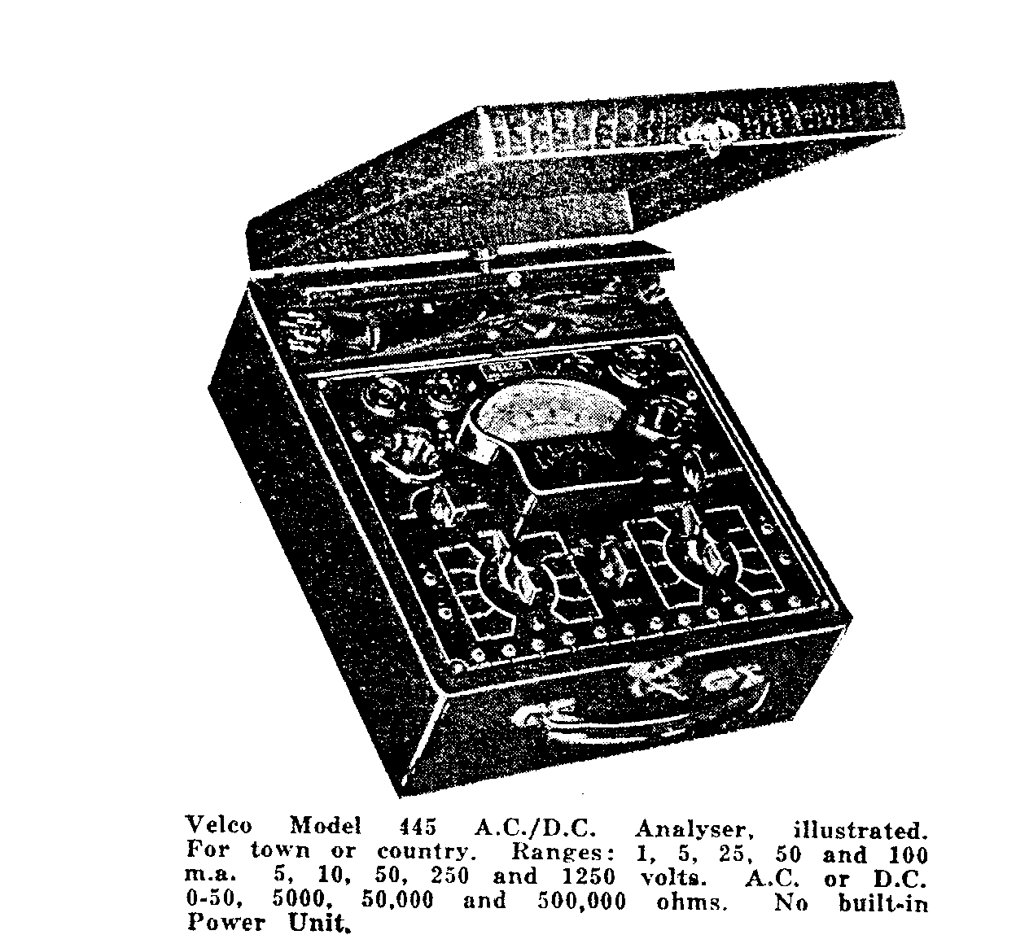
MODELS 445 and 485
Set Analysers
MODEL 445-Illustrated and described at left and priced at
£11/18/6, or on easy Terms - £3/18/6 deposit with 9 monthly
payments of 20/- each.

MODEL 485 similar to illustration and fully described on
Page 7.

The Velco Modal 485 for the advanced student or engineer.
Completely tests all types of radio sets and gives a point-to-point
analysis without removing chassis from cabinet. Features direct
reading on meter scale of-
Volts, A.C. /D.C. - 1250, 250, 125, 25, 5.
Milliamps - 500, 135, 25, 5, 1.
Decibels – 12 to plus 9, plus 2 to p1us 23, Plus 16 to plus 27.
Ohms – 0-5 meg., 500,000, 50,000, 5,000, 500.
Henries – 0-20,000, 0-2,000, 0-20.
Microfarads – 0-50, 0-5, 0- 0.05.
Price …………….. £16/15/-n
Easy Terms £5/15/- Deposit with 12 monthly payments of
20/- ea.

INSTRUCTIONS FOR USING MODEL 445

With the Velco Calstan Model 445 Analyser it is possible to make a complete analysis of the various functions associated with all Radio Receivers and Public Address equipment.
The Analyser section of this instrument when used intelligently will provide a ready means of ascertaining the currents and voltages existing in whatever equipment is being tested.
At the top of the panel will be found six tube sockets which are used in conjunction with the multi-wire cable terminating in a hand plug (located in the accessory compartment).
At the bottom of the panel will be seen a row of socket terminals These sockets are available to provide access to the various tube elements for test purposes. The numerals against each socket have their counterpart either as tube base contacts or top cap contacts.
To use the analyser efficiently it is necessary to obtain a tube manufacturer's characteristic chart. On inspecting the chart it will be noticed that each tube base contact is numbered, whatever number is shown against a base contact on the chart has its counterpart in the corresponding numbered socket on the analyser.
As an example we will suppose that a radio receiver is being tested and it is desired to test the output tube for the applied voltage and current. The tube that will be chosen for test is the Power Penthode Type 42.
Remove the 42 tube from the receiver and place it in the correct socket in the analyser. The 7 to 6 pin adaptor is attached to the analyser hand plug which is then placed in the receiver socket vacated by the 42.
The first test to be made is to ascertain the existing plate current. On examining the tube chart it will be seen that the base contact No. 2 is the plate connection. Set the

.

"Analyser" switch on the right of panel to setting No. 2, placing also the "Range" switch in the "M.A." position. The two short bridge leads (supplied) are inserted into the plus and minus sockets on the panel, the free end of the minus lead being placed in the socket marked "COM" and the plus lead into socket No. 2 (plate contact)
Connect the Mains supply to the receiver and allow tube time to heat. Everything being correct the meter should read approximately 35 M.A. depending on the applied plate voltage.
It may be desired to check the screen current of the 42. The tube chart will show that the 42 screen connection is contact No. 3. Set the "Analyser" switch to position No. 3, also moving the Plus lead to socket No. 3. The meter should now indicate the current flowing.
The "Meter" switch is placed in the D.C. position for the tests just described, also when taking voltage readings.
Incidentally, if there is any doubt as to the current values existing in the various circuits always use the highest Range Setting, a lower range position can then be used if necessary. Such action will protect the meter from an overload.
The meter can be placed in series with any tube element simply by rotating the "Analyser" switch to the element it is desired to test and bridging from the plus socket to that particular element or socket.
If it is desired to take a voltage reading at the plate of the 42 tube, the "Analyser" switch should he placed in the off position. Insert the two test prods into the sockets marked Plus and Minus, placing the minus test cord into socket No. 1 and the plus cord into socket No. 2 (Plate socket). Set the "Range" switch to 1250 volts and the "Meter" Switch to the "D.C." position. The existing plate voltage will be shown on the D.C. Meter Scale.
The voltages present at the various tube elements call all he read by selecting the correct socket on the analyser; the number corresponding to the element to be tested will be found on the tube chart.
The tests so far described in these instructions have all been conducted in conjunction with the extension cable and with the tube placed in its correct socket on the analyser.
The Multimeter can be used for all manner of external tests. When using the multimeter under such conditions the "Analyser" Switch should always be placed in the "OFF" position.
With the test cords in the Plus and Minus sockets it is possible to take external
milliamp and voltage readings simply by rotating the ''Range" Switch to the
desired setting . The ''Meter'' Switch will have to be placed in the D.C. or A.C. position depending on the voltage to be tested.
By placing the ''Meter'' Switch in the ''O.P.'' position the meter can be used to indicate output volts. The purpose of the he output meter is to provide a visual indication of correct receiver alignment. It can also be used for comparison in sensitivity tests of Radio Receivers or Public Ad-dress Systems where a calibrated source of constant amplitude voltage is available.
The Output Meter is used mainly for Receiver alignment purposes where a modulated Radio Frequency Signal is fed into either the signal frequency or intermediate frequency section of a Radio Receiver. The purpose of the Output Meter under such conditions is to indicate maximum energy transfer (max. needle swing) when all trimming condensers, etc., are brought to their peak.
The output meter is usually connected either across the speaker transformer primary winding or from the plate of the output tube to the chassis.
The five- voltage ranges are used in conjunction with the output meter. The larger the voltage range used the smaller the needle deflection providing the output voltage is held constant.
The Ohms readings are obtained by setting the "Meter" switch to the D.C. position, the "Rang" switch to "ohms" setting and the "ohms selector" switch to the. correct position for the Resistor under test.
The first two positions of the "ohms selector" switch to the left of the "off" position necessitates the division of the numerals printed directly on the top scale by 100 and 10 in that order. With the Ohms Selector on the "S.C." position the resistor values are read directly from the meter scale. The next ohms selector setting requires the existing scale markings to be multiplied by 10, that setting will of course be used for high resistor readings.
Before applying the prods to the resistor under test the metal points should be shorted together and the knob marked "Ohms Adjust" rotated until the meter needle is directly over the scale divisional line marked "0" at the right hand extremity of the Ohms scale.
After a lengthy period of use it will he found that the "Ohms Adjust" control will not bring the meter needle to the "0" setting When such a condition arises it will he necessary to replace the batteries which are located under the panel. When replacing make sure that the batteries are connected for correct polarity.

Whilst making a resistor test never hold the test prods by the metal points as incorrect readings will result due to body leakage. This error can assume quite serious proportions when high resistor values are being checked. Always hold the prods by the insulated sleeve. When the ohms scale is not being used always place the ohms selector switch in the "Off" position.
The sockets marked "E" on the analyser are common with No. 1 socket at the bottom of the panel and can be considered is the common negative when the extension cable is being used.

As a warning it might be stated that although the meter movement is of robust design it must of necessity be very delicately suspended. It rests with the operator to use every care when using the instrument.
Always double check all connections and switch settings before applying the test. Should a high voltage be accidentally applied with the Range Switch in the milliamp position a dislocated needle movement or a complete burn out may ensue. Always be certain that the meter range used is adequate to accommodate the voltage or current that may exist. BE CAREFUL!

Instructions for using Set Analyser Model 485

The "Velco" 485 Analyser has been designed with the object in view of providing an efficient and reliable means of servicing all types of Radio Receivers and Public Ad-dress Systems. The following instructions should be carefully studied before attempting to use the Analyser, as a complete knowledge of the instrument will expedite the location of whatever fault happens to exist in the apparatus to be tested.

A power pack is built into the Analyser to enable the measurement of Impedance, Capacity, Inductance, High D.C. Resistance and leakage of Electrolytic Condensers.

Before attempting these measurements it is necessary to insert the power cord attached to the Analyser into a 200 or 230 volt 50 cycle A.C. supply.

To carry out "Direct Current Volts" Readings insert the test prods into the two sockets marked "Volts" at the lower left of Analyser panel. Set the "Test Selector" knob to the D.C.V. position, then choosing the correct "Range Selector" position for the voltage under test. If the test prods are now applied to the unknown voltage its value can be read from the top meter D.C. scale. If there is any doubt as to the voltage to be measured always commence the test with the "Range Selector" switch on the highest voltage setting, thus protecting the meter from overload.

To obtain D.C. milliamp readings place the "Test Selector" switch in the D.C.M.A. position, choosing a "Range Selector" position suitable for the amount of current in the circuit to be tested. If the operator has no idea of the current value existing, the "Range Selector" should be placed in the highest milliamp setting working down to lower values as desired. The test prods should be inserted in the sockets marked "milliamps" at the lower Right of panel.

D.C. ohms readings are obtained by placing the "Test Selector" knob to the ohms position and choosing a "Range Selector" position suitable for the Resistor under test. The ohms value will be shown on the D.C. ohms scale. The existing scale numbering should be multiplied by the number the "Range Selector" knob is set to (read the numerals on the R-L-C-Z Range) Insert the test cords into the sockets marked "Ohms" it the right of the panel, short the metal prods together and rotate the "Ohmmeter Adjuster" until the meter needle lies directly over the scale divisional line marked "0" at the extreme right hand end of the ohmmeter scale. This zero adjustment should always be checked when resistor values are to be tried, also when the "Range Selector" knob is moved for different ohms values.

When the ohms scale is being used do not hold the metal points of test prods with the fingers as a fictitious reading will be obtained, due to body leakage. This error can assume quite serious proportions when a high value resistor is being checked. Always hold the test prods by the insulated sleeves.

The ohmmeter scale is a very useful instrument when used as. a continuity meter. The location of shorting condensers, shorts between high potential windings and those at , zero potential, open circuited transformer and coil windings, etc., can be located easily.

When it is desired to use the High Ohms Scale (5 meg.) it will be necessary to insert the analyser power cord into the A.C. supply. Allow a little time for the rectifier tube to heat then short test prods as explained previously and bring the meter needle to zero ohms by rotating "Primary Volts Adjuster" knob.

The "Range Selector" should be rotated to the 10,000 (R-L-C-Z) position and the D.C. ohms scale multiplied by 10,000.

Electrolytic Condenser Leakage can be ascertained as follows :- Place the "Test Selector" Switch to position marked "E.L." and the "Range Selector" Switch to the voltage nearest the working voltage of the condenser under test. The voltage value being selected from the "Electrolytic" Range Selector position. The test leads should be placed in the sockets marked Electrolytics at the upper right of analyser and attached to the condenser under test, taking particular care that the positive socket is connected to the positive of the condenser and the negative socket to the condenser negative. The initial test should always be made with the "Leakage Switch" in the 125 position and the needle deflection noted reading the M.A. scale. If there is no appreciable needle deflection move Leakage Selector Switch to a lower setting. The average permissible leakage through a good condenser should be approximately 1 milliamp per microfarad. The numerals shown against each Leakage Selector setting correspond to the meter full scale deflection in milliamps. The milliamp scale divisional lines should be divided into whatever Leakage Selector setting is used. The A.C. supply must be connected to the Analyser before Electrolytic Condensers can be tested. The Leakage Selector Switch should always be left in the "Off" position when not testing Electrolytics.
To take A.C. voltage readings the Test Selector Switch should be placed in the A.C.V. position and the Range Selector Switch set to the voltage value required. "A.C. D.C. Volts" section: Make sure that the needle position is read on the A.C. Section of the meter scale taking particular notice of the staggered scale divisional lines.

For A.C. milliamp readings turn the Test Selector Switch to the A.C.V. position and the Range Selector Switch to the N. 1 milliamp position. The test cables should be placed in the volts sockets at the lower left of the analyser panels. When the A.C. milliamp scale is being used it should be remembered that the resistance of the milliamp circuit is approximately 5000 ohms. Read the meter scale marked A.C. Full scale deflection will indicate 1 milliamp.

If it is desired to use the Decibel scale of the meter the "Test Selector" switch should be placed in the position marked D.B., choosing the correct range of Decibels with the Range Selector switch. With the Range Selector switch in the
S.C. position the Decibel readings should be taken directly from the meter scale.

With the switch in either of the other two positions the corresponding numbers must be added algebraically to the scale calibration. The Decibel section of the meter scale has been made available for power level measurements of both Radio Receivers and Sound Amplifiers in decibels. As a power level meter, the instrument, which is bridged across the load, is calibrated to read the power level in decibels above or below 6 milliwatts for a 500 ohm load. The range of the meter at zero power level 6 milliwatts through 500 ohms is: -l2 to plus 9; plus 2 to plus 23; plus 16 to plus 37.

To obtain A.C. ohms readings . (i.e. impedance tests) it is necessary to connect power cord to the A.C. supply. The Test Selector switch should be placed in the L.C.Z. position and the test cords inserted in the two sockets marked L.C.Z. at the left of panel. After the rectifying tube (under the panel) has heated short the two test cords together and adjust the meter needle to zero ohms by adjusting the primary volts knob. If the test cords are now applied to the impedance under test the impedance value will be indicated on the A.C. ohms scale. It will be necessary to multiply the existing scale reading by whatever numeral the Range Selector knob is against, reading the R.C.L.Z. Range.
To obtain Inductance readings, exactly the same procedure should be adopted as for Impedance. With the test cords placed in the L.C.Z. Sockets and applied to the inductance to be tested readings will be obtained on the Inductance Scale on the meter. Multiply the scale reading by the numeral opposite the Range Selector Knob, choosing a suitable value for the test on hand. The values are shown in Henries.

Capacity tests are obtained by following the same procedure as for Impedance with the test cords inserted in the L.C.Z Sockets and applied to the capacity under test the value will be indicated in microfarads on the capacity scale of the meter. The capacity scale markings are to he multiplied by whatever numeral the Range Selector Knob is opposite.

Endeavor to select a Range Selector setting that will cause the meter needle to indicate about the centre portion of the scale when testing Impedance, Capacity and Inductance as readings at both extremities of the scale will present certain error due to voltage variations and the meter rectifier characteristics.
When it is necessary to take voltage and current readings from a Radio Receiver

or Amplifier the operator can either obtain the readings by using the test cords straight from the Analyser to the receiver, etc., or by utilizing the extension cable terminating in a seven pin plug. The latter test can often be made without removing the chassis from the cabinet.

A number of adaptors are provided to accommodate the various types of tubes available.

An adaptor corresponding to the tube under test is attached to the extension plug, the assembly is then inserted into the vacant tube socket in the receiver. The tube under test should be placed in the correct socket on the analyser, and after applying the mains voltage comprehensive tests can be made, such as determining the plate and screen voltage, the bias voltage, the plate and screen current, also grid current.

Along the front of the analyser panel are eighteen sockets numbered in pairs from one to nine, each pair being connected to a tube element terminating at the tube socket or the top connection on the tube. Between the sockets are nine press buttons. When all the press buttons are at rest (normal position) a shorting contact joins each pair of sockets together.

If it is desired to know how many milliamps are flowing from a certain element the Test Selector Switch is first placed in the M.A. position and the correct milliamp Range Selector value chosen. The two short connecting cords are inserted into the milliamp sockets at the bottom right of panel, one in the negative socket, the other in the positive socket. The other ends of the connecting cords are placed in the sockets corresponding to the element under test making sure that the polarity is correct. After these connections have been checked the button between the two sockets in use can be pressed. The current reading of that particular element can be read from the meter scale. Before using the analyser in the preceding test and all subsequent tests of a similar nature a manufacturer's tube characteristic chart should be obtained covering all makes of tubes. On these charts will be shown the various socket connections, also it will be noted that each contact is numbered.

The maximum number of contacts used at present is eight. It is necessary then to provide access to each con-tact for test purposes.

The nine pairs of sockets on the analyser are provided for that purpose.
The 9th contact will lie mentioned later.
Each number on the analyser corresponding to a similarly numbered contact on the tube chart.
As an example..
If it desired to check the working conditions of a 6F6 Pentode tube, first remove the 6F6 from the Receiver and place it into the correct socket in the analyser.
After fitting the correct adaptor to the extension plug (octal adaptor) insert the assembly into the vacant socket in the receiver. When the tubes have warmed up, the various readings can be made.

If a plate current reading is desired first set -the Range Selector Knob to the correct position and then place the two connecting cords into the milliamp sockets (use the 125 MA. setting of the Range Selector. On inspecting the tube chart it will be seen that socket control No. 3 is the plate of the 6F6. To obtain a plate milliamp read-lug it is necessary to insert the free ends of the connecting cords into analyser sockets No. 3, making sure the polarity is correct.

After checking all connections the button between No. 3 sockets should be pressed; everything being normal the meter reading should show approximately 34 milliamps.

To ascertain the voltage at the plate of the 6F6, place the connecting -cords in the voltage sockets at the lower left of panel, the free negative end going to No. 1 socket and the free positive end being placed in socket No. 3. The effective plate voltage will now he shown. There is no need to press the buttons for voltage readings. Before making the above voltage test set the Test Selector Knob to DCV position and the Range Selector Knob to the correct voltage setting.
The main thing to remember is that all the numbers shown on the analyser will definitely correspond to any contact similarly numbered on the tube chart. The No. 9 sockets on the analyser are always common to the contact marked "T.C." at the top of panel. A connecting cable is inserted into T.C.. when checking any tube having a top connection. A special cable is provided for top connection purposes.

As an example:-If it is desired to test a screen grid tube say a 6K7 the tube is transferred to its correct socket in the analyser and the extension plug with its adaptor is placed in the vacant receiver socket. Connect the free grid clip on the receiver to No. 9 cap contact on the side of the extension plug, then complete the circuit by placing the short cable provided from T.C. on the analyser to the cap of the 6K7. The grid circuit is now completed via No. 9 sockets. When measuring Capacity, Resistance, Inductance or Condenser leakage remove the receiver power cord from the supply. This is most important.

VELCO TUBE CHECKERS

Model 222A.C.
MODEL 222 (Illustrated at Right)

THE VELCO CALSTAN MODEL 222 A.C. VALVE CHECKER is designed, for Service Bench or Shop Counter. Attractive, black leatherette case. Complete with full instructions Valve Charts.

Specifications:

Model 501 Fan Type Meter with dial calibrated to indicate varying degrees of '' 'GOO'' or ''Bad'' Filament Voltage Range covers 1.5, 2.0, 2.5, 3.3, 4.0, 5.0, 6.3, 7.5, 12.5, 25.0 and 30.0 volts. Will accurately cheek 400 different types of valves, including P. and V. Bases. Neon Light Leakage and ''Short" Indicator. Separate check on each valve element. Line Voltage Adjustment Switch ensures standard operating conditions.

Complete ready for use Cash Price -- £11/5/-n.

Terms: Deposit £2/7/-, with 5 monthly payments
of £1/12/7 and 1 of £1/12/10.

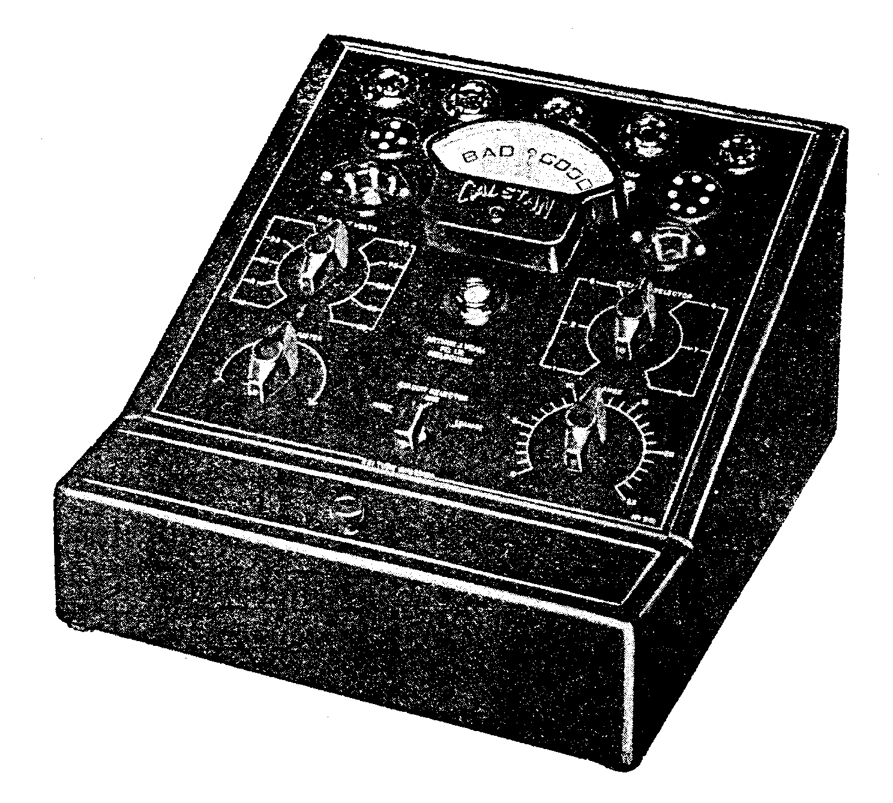

BATTERY OPERATED MODEL DC222

Checks either Battery or A.C. Valves.
The Velco Model DC222 Battery-Operated Valve Checker designed expressly for the country dealer who has no A.C. available. Operates from a 6 volt Accumulator and Vibrator (incorporated in unit) thus ensuring, an accurate at correct working voltages. A separate cheek on each valve element

with a short indicator removes all doubt regarding the condition of the valve.
Same Features as in A.C. Model described above. Price ready for use-£14n (Accumulator only extra). or on easy term - £4 deposit and 11 monthly payments of £1.

Instructions for Use of Velco Tube Checkers

he Model 222 Tube Checker is designed to supply an efficient and reliable means of testing all types of tubes. These instructions should be perused and studied for efficient operation.
It is necessary to accurately adjust the line voltage controls on the checker before attempting to test a tube.
The toggle switch at the left of panel should be set in the position nearest that of the supply voltage.
The "Circuit Selector Switch" should be placed in the position marked "Line." If the supply voltage is now
applied to the checker the meter needle will move up the scale to approximately full scale deflection. The "line adjust switch" should now be rotated until the needle lies directly over the arrow at the extreme right hand end of the meter scale. The tube checker is now ready for use. To protect the meter it is very necessary to test the tube for shorts before applying the efficiency test.
Place the "Circuit Selector" Switch in the shorts position leaving the Filaments Volts Switch at the lowest setting. The "Element Selector" Switch should now be rotated slowly.
At each position of the switch the Neon Indicator should be watched for any sign of a definite glow. A direct short will cause the Neon to glow brightly. A partial short will cause varying degrees of Neon brilliance. In actual practice a very weak glow will sometimes be noticed at certain Element Selector settings, but this can be disregarded generally as should also the sudden flicking of the Neon when the switch is rotated. Such effect is due to capacitative discharge.
If, a distinct and continuous glow is apparent at any Element Selector setting that particular tube should be considered defective and no further test applied. It sometimes occurs that a tube has an intermittent fault. By sharply tapping the tube at each Element Selector setting the short may be caused to appear; If the tube under test has passed the shorts test it can now be given an efficiency check. Set the Filaments Volts Switch to the correct value for the tube to be analysed.

The "Valve Range" Knob at the right of panel should be left at zero setting and the accompanying chart consulted for the positions of the Element Selector and Circuit Selector Switches. After they have been placed in their correct positions the Range Knob should be turned to its correct setting.

The condition of the tube will be indicated on the Meter Scale. Some. tube types require a more comprehensive test than this. Provision has been made for the thorough testing. of such tubes.
It is most important that the elements of these tubes be tested thoroughly as the tube efficiency can be seriously impaired should any fault be present in the various elements. Rectifiers, Diodes, etc., are among the special types which are listed on the accompanying chart.
It is always advisable to place the Range Control Knob to the lowest setting

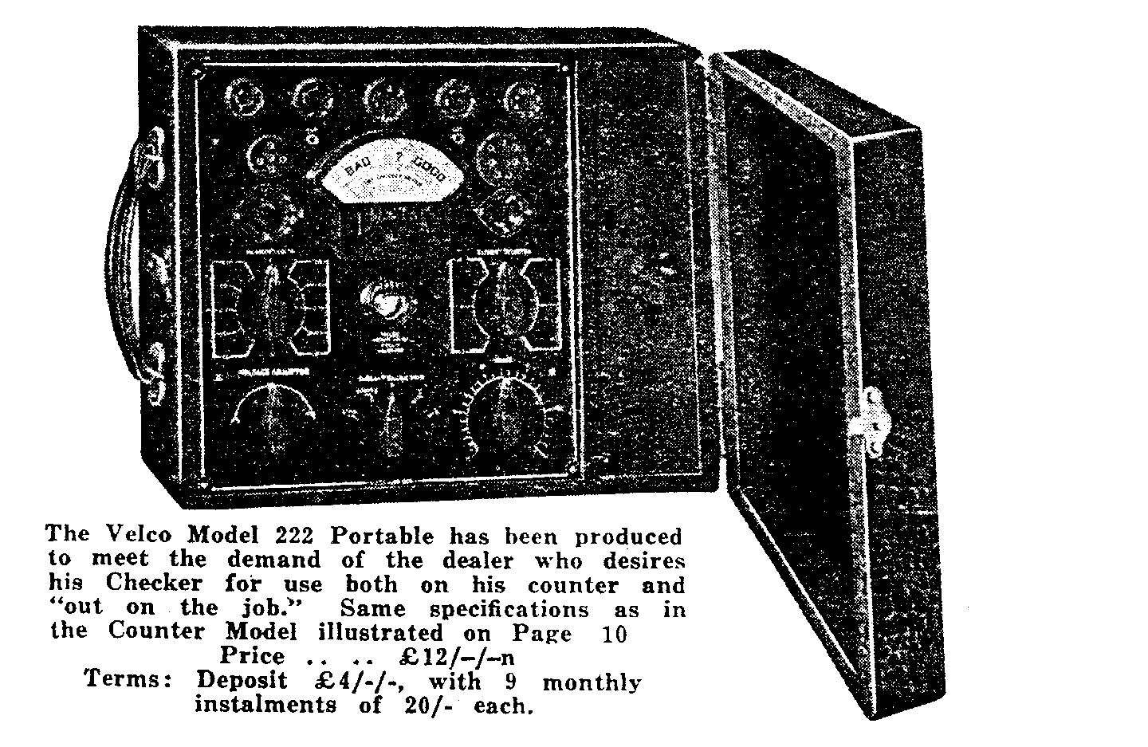
and work up from that position to the required - setting. Such a precaution - will safeguard the meter against overloading.
The line sockets marked "Cal" at the top of the panel are for the top cap connection Connecting cords are provided for this purpose.
The numbers shown on the Element Selector (1 to 8) correspond to the standard American socket numbering. The numerals shown on the top of the meter scale indicate the percentage efficiency of the tube
A special adaptor is provided for testing octal base rectifiers.

Combined Tube Checker
And Multimeter
Model 223

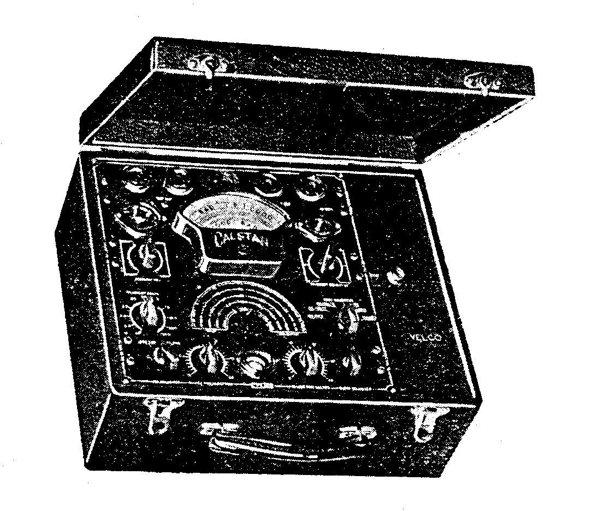The Tube Checker portion of the Model A.C.223 has the same specification as the Model A.C.222 described on Page 10, but a limited number are available with a vibrator which allows the use of this checker on a 6 volt accumulator. This unit also embodies a High Sensitivity 20,000 Ohm per volt meter.

A.C./D.C. Volts 0-5, 10 ,50, 250, 1000.

Milliamps – 1-5, 25, 100, 500.

Ohms- 0-2000, 0-20,000, 0-200,000

Price - £16/17/6n as mentioned above.

Easy Terms. - £15/17/6 Deposit, with 12 Monthly Installments of 20/- each.
Instructions for the use of
The Velco Model 223

The Calstan 223 Multimeter and Tube Checker is a very comprehensive instrument. It provides means for a complete test of all Components usually associated with Radio Receivers and Public Address equipment. In addition a complete analysis can be made of the individual tubes used in various equipment. All the voltages necessary for tube testing are obtained from power supply built into the instrument. It is necessary to have access to the A.C. mains. The mains cord will be found in the accessory compartment. When it is desired to test a tube the line voltage should be adjusted accurately otherwise the reading obtained will be fictitious.
At the lower left hand corner of the panel will be found a switch marked "Primary Set." This switch should he set at the voltage setting nearest the mains supply voltage. The "Test Selector" switch should be placed in the "Valves" position and the "Main Selector" switch set to position "L." If the line current is now applied to the instrument. a final adjustment can be made for correct line voltage application by moving "Primary Adj." until the meter needle is resting over the arrow at the extreme right hand end of GOOD-BAD Scale.
Provision is made for the testing for shorts between the tube element’s. This short test should be made before attempting tube efficiency tests as a shorting tube element can cause serious damage to the meter.

To carry out the short test, first turn the Main Selector Switch to the "S" position - and place the "Fil. Volts" switch to its lowest setting. The "Elements" switch should now be rotated slowly., At each position of the switch the Neon Indicator should be watched for any sign of a definite glow. A direct short will cause the Neon to glow brightly. A partial short or leakage will cause varying degrees of Neon brilliance.
In actual practice a very weak glow will sometimes noticed at certain Element settings, but this can be disregarded generally as should also the sudden flicking of the Neon when the switch is rotated. Such effect is due to capacitive discharge if a distinct and continuous glow is apparent at any- element setting that particular tube should be considered defective and no further tests applied .
It sometimes occur that a tube has a loose element due to perhaps a loose element. By sharply tapping the tube at each element setting the short may be caused to appear.

If the tube under test has passed the shorts test it cm now be given an efficiency check. Set the "Fil. Volts" Switch to the correct value for the tube under test. The "Valves Range" Knob should be left at zero setting and the tube chart consulted for the positions of the Main Selector Switch, also the Element Selector Switch. After these have been placed in their correct positions the Valve Range Knob should be placed in its right setting.

The condition of the tube will be indicated on the Meter Scale. Some tube types require a more comprehensive test than this. Provision has been made for the thorough testing of such tubes.

It is most important that the elements of these tubes be tested thoroughly as the tube efficiency can be seriously impaired should any fault be present in the various elements. Rectifiers, Diodes, etc., are among. the special types which are all listed on the accompanying chart. It is important to note that in the case of indirectly heated tubes the Elements Selector Switch should not be placed in the cathode position. With the switch in the cathode position the current is applied to the meter with reverse polarity, causing the needle to move off scale in the wrong direction.

It is always advisable to place the Range Control Knob to the lowest setting and working up from that position to the required setting: Such a precaution will safeguard the meter against overloading.

At the upper right hand side of the panel will be found two pairs of sockets marked "Elects" and "Static" respectively. With the correct manipulation of the controls it is possible to test the efficiency of a wide variety of condensers.

To test electrolytic types it is first necessary to adjust the mains voltage as explained earlier in these instructions. The test cords are inserted in the sockets marked "Elects." It is now necessary to place the Test Selector Switch in the position marked Condensers. The Main Selector Switch has five condenser settings, the numerals against each setting corresponding approximately

to the working voltage of various condenser types. Move the Main Selector Switch to the condenser tapping nearest the working voltage of the condenser under test.
The Range Control Chart Should be referred to for the various "Range Control" Settings.

It will be noticed that each capacity his a setting of its own.

Place the condenser to be tested across the "Elects" Sockets, being careful that the correct polarity is observed. The electrolytic scale can now be re ad for condenser efficiency. If the needle remains on the doubtful portion of the meter scale an open circuited condenser is indicated. It is always good practice to leave the Range Control at zero setting until the condenser is attached o the test sockets. Such an action will protect the meter should a short circuited condenser be applied. The Range Control can now be advanced to its correct position.

The testing of the dry condenser types can also be accomplished using the same switch positions as for electrolytics. The meter scale is not used for testing these condensers, efficiency being indicated by the various degrees of fluorescence given by the neon indicator.

A condenser that is in good condition will show a very sharp and well defined flash in the neon indicator. leaking condenser will be indicated by a very rapid and almost continuous succession of flashes.

A completely shorted condenser will be shown by a continuous glow from the neon.

When making the above test, adjust the Main Selector Switch to the voltage on the condenser range which gives the sharpest and most defined flash in the neon indicator.

At the lower left hand corner of the multimeter panel will be seen two sockets marked A.C.D.C. volts.

By the insertion of the test cords into these sockets any voltage value up to 1250 volts may be read. Five voltage ranges are provided. The 5 volt and 10 volt ranges can be read directly from the meter scale; all other ranges will have to be multiplied. Each space between the numerals represent 10 volts for the 50 volt range 50 volts for the 250 v. range, and 250 volts for the 1250 volt range.

It is necessary to set the Test Selector Switch to either the A.C. or D.C. position depending on the voltage under test. Two voltage scales are provided, one for A.C., the other for D.C. readings.
If there is doubt as to the voltage value to be applied to the meter always set the main selector switch to the highest voltage range and work down, thus protecting the meter.

At the left of ,the Multimeter panel two sockets will be found marked D.C. Ma's. After placing the Main Selector Switch in the milliamps position any value of milliamps up to 250 can be read using the D.C. meter scale. Five milliamp ranges are available. A choice of any one can be made by manipulating the Main Selector Switch. It will be necessary to multiply the D.C. Scale for the 25-100-250 milliamp readings.

The two sockets marked "Output, Volts" are used generally in conjunction with a signal generator, the purpose of the output meter being to provide a visual indication of correct Receiver alignment.

It can also be used for comparison in sensitivity tests of Radio Receivers and Public Address systems when a calibrated source of constant amplitude voltage is available.

The Output Meter is used mostly for Receiver alignment purposes where a modulated radio frequency signal is fed into the, signal frequency or intermediate frequency section of a Radio Receiver. The purpose of the Output Meter under such conditions is to indicate maximum energy transfer (max. needle swing) when all trimming condensers, etc., are brought to their peak.

The output meter is usually connected either across the, speaker transformer primary winding or from the plate of the output tube to, the chassis.
'The five voltage ranges are used in conjunction with the output meter, the larger the voltage range used the smaller the needle deflection providing the output volts are held constant.

When it is desired to use the output meter it, is necessary to set the Test Selector Switch to the A.C. volts position.

The Ohms readings are obtained by setting the Test Selector Switch to the Ohms position, then choosing the correct ohms range with the Main Selector Switch for the Resistor under test. Any resistance test made on the "S.C." setting of the Main Selector Switch can be read directly from the ohms section of the meter scale.

The two "ohms" setting to the left of S.C. necessitate the division of the ohms scale by 10 and 100 in that order.

The two "ohms" settings to the right of S.C. require the ohms scale to be multiplied by 10 and 100.
Before the ohms scale can be used on the highest ohms scale (multiply by 100) it is necessary to apply the Mains Supply to the Multimeter.

All the other ohms readings are used in conjunction with the dry batteries fitted under the panel.

Before applying the test prods to the resistor under test, the metal points should be shorted together and the knob marked "ohms adjust" rotated until the meter needle lies directly 6ver the scale divisional line marked "0" at the right extremity of the ohms scale.

After a lengthy period of use it will be found that the Ohms Adjuster will not bring the meter needle to the "0" setting. When such a condition arises it will be necessary to replace the batteries.

When replacing make sure that they are connected for correct polarity.

Whilst making a resistor test never hold the test prods by the metal points as an incorrect reading will result. This error can assume quite serious proportions when high resistor values are being checked.

Always hold the prods by the insulated sleeve.

Apart from its normal use in checking resistors the ohm meter can be used successfully in the location of open circuited coils, transformer winding, etc., also short circuited components can be readily located.

As a word of warning it might be stated here that although the meter movement is of robust design it must of necessity be very delicately suspended. It rests with the operator to use every ,care when using the instrument.

Always double check all connections and switch settings before applying the test. Should a high voltage be accidentally applied with the Test Selector Switch in the milliamp position a dislocated needle movement or a complete burn out may result. Always be certain that the meter range is adequate to accommodate the voltage and current that may exist. Be Careful.

EASY TERMS TQ APPROVED DEALERS.

Easy Repayments as listed throughout this book are available to approved dealers upon completion of our hire purchase agreement and its acceptance by us . Full details on request.

The Velco A.C. D.C. Multimeter

MODEL A.D. 135

See also the D.C. Multi-meter illustrated
On Page 18, and the A.C./D.C. Model on
Page 17

Can also be used as an Output Meter.

In neat leatherette covered case as illustrated. External tapping for reading output volts. For A.C. or D.C. For D.C. type only see above. Reads volts, milliamps and ohmage.

A.C./D.C. Volts – 0-5; 0-10; 0-50; 0-250; 0-1000.
Milliamps – 0-1; 5; 25; 100; 500.
Ohms – 0-2000; 0-20,000; 0-200,000.

Cash Price £8/5/-n
Or on Easy Terms – 55/- deposit and seven months payment of 20/- each.

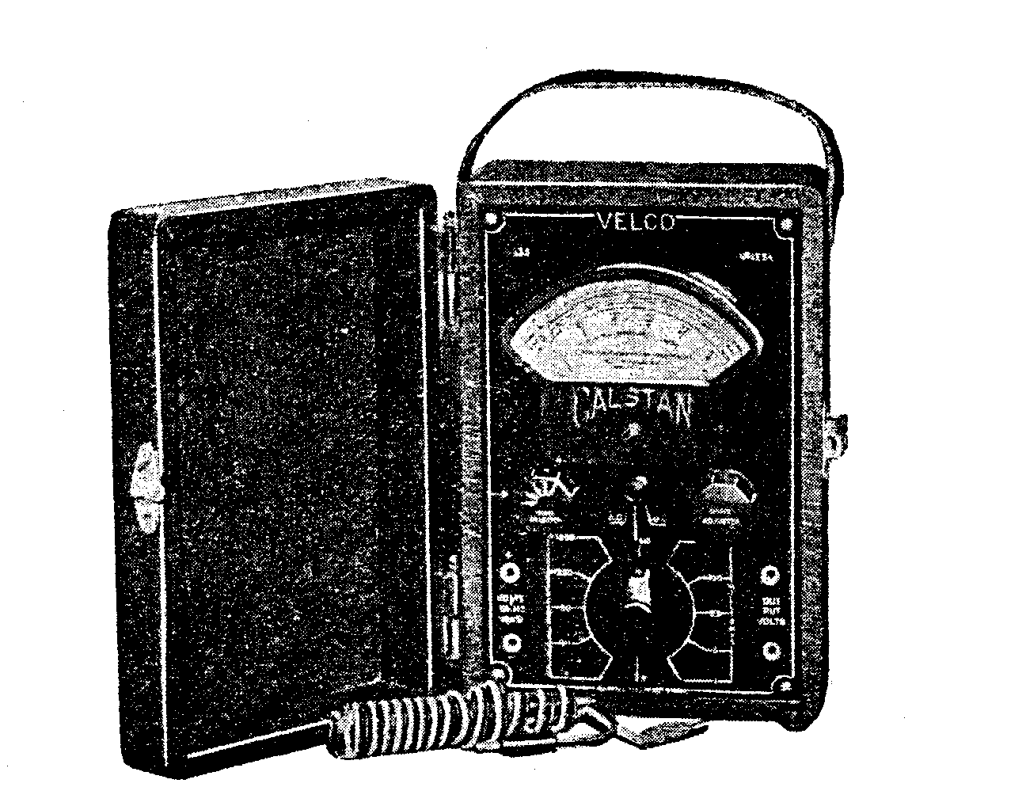

USES STANDARD 1,000 OHMS PER VOLT, METER ENSURING MAXIMUM SENSITIVITY.

Instructions for Use of Model A.D. 135

The Velco 135 Combination Meter is a very comprehensive Instrument. it enables the User to carry out any practical test on all Radio Receivers and Public Address Systems.

The meter used is definitely a precision instrument and is used in conjunction with individually calibrated shunts and loading resistors.

Five voltage ranges are available for both A.C. and D.C. Five D.C. milliamp ranges and four ohms settings are provided, also a pair of sockets for output volts.
If it is desired to make a D.C. voltage reading, the test cables should be inserted into the pair of sockets situated
on the left side of the panel, placing the red cord in the positive (+) socket and the black cord in the negative (-) socket.

Set the switch, located directly under the meter, to the D.C. position.

When reading the voltage scale always use the lower scale divisions. The 10, 50 and 250 volt settings are marked directly on the meter scale and can be read accordingly. When using the 5 volt setting divide the 10v. scale by two. To obtain correct readings on the 1250 volt setting, each space between the existing numerals is read as 250 volts.

The preceding instructions apply also to the A.C. voltage readings. The only adjustment necessary is to change the two way switch to the A.C. position.

The ohms readings are obtained by setting the Main Selector Switch to the ohms position, then choosing the ohms range necessary for the resistance value to be measured. The first two "Ohms selector" settings (from the off position) necessitate the division of the, numerals printed directly on the top scale by 100 and 10 in that order. With the ohms Selector on the third (or S.C.) .position the resistor values are read directly from the Meter Scale. The next Ohms Selector setting requires the existing scale markings to be multiplied by 10; that setting will of course be used for high resistor readings.

Before applying the test prods to the resistor, under test, the metal points should be shorted together and the knob marked "Ohms Adjuster" rotated until .the meter needle lies directly over the scale divisional line marked "'0" at the right hand extremity of the ohms scale.

After a lengthy period of use it will be found that the "ohms adjuster" will not bring the meter needle to "0" setting. When such a condition arises it will he necessary, to replace the batteries which are located under the panel. When replacing make sure that the battery’s are connected in correct polarity.

Whilst making a resistance test never hold the test prods by the metal points as an incorrect reading will result due to body leakage. The error can assume quite serious proportions when high resistor values are being checked. Always hold the prods by the insulated sleeve. Usually the two sockets marked "Output Volts" are used in conjunction with a signal generator, the purpose of the Output Meter being to provide a visual indication of correct Receiver alignment. It can also be used for a comparison in sensitivity tests of Radio Receivers or Public Address Systems where a calibrated , source of constant amplitude voltage is available.

The Output Meter is used mostly for Receiver alignment purposes where a modulated Radio Frequency signal is fed into either the signal, frequency or intermediate frequency sections of a Radio Receiver. The purpose of the output meter under such conditions is to indicate maximum energy transfer (max. needle swing) when all trimming condensers, etc., are brought to their peak. The output meter is usually connected either across the speakers transformer primary winding or from the plate of the output tube to the chassis.

The five voltage ranges are used in conjunction with the output meter. The larger the voltage range used the smaller the needle deflection, providing the output volts remains constant.

As a warning it might be stated here that although the meter movement is of robust design it must of necessity be very delicately suspended. It rests with the operator to use every care when using the instrument. Always double check all connections and switch settings before applying the test. Should a high voltage be accidentally applied with the selector switch in a milliamp position a dislocated meter needle movement or complete burn out may result. Always be certain that the meter range used is adequate to accommodate the voltage or current that may exist.

Be Careful.
Velco All-Purpose
Sound Equipment

The amplification of sound plays a big part in both the social and business life of the community and offers a constant source of income to the live dealer who has the necessary equipment available.

Vealls offer a range that adequately covers every likely field from small 7/8 watt types up to big 30/40 watt models that "tell the world." Write for big free catalogue giving complete details.

Velco Amplifiers may be purchased
for Cash, on Easy Terms
or on Daily Hire.

The VELCO A.D. 136
A.C./D.C. Multimeter
Instructions for Using

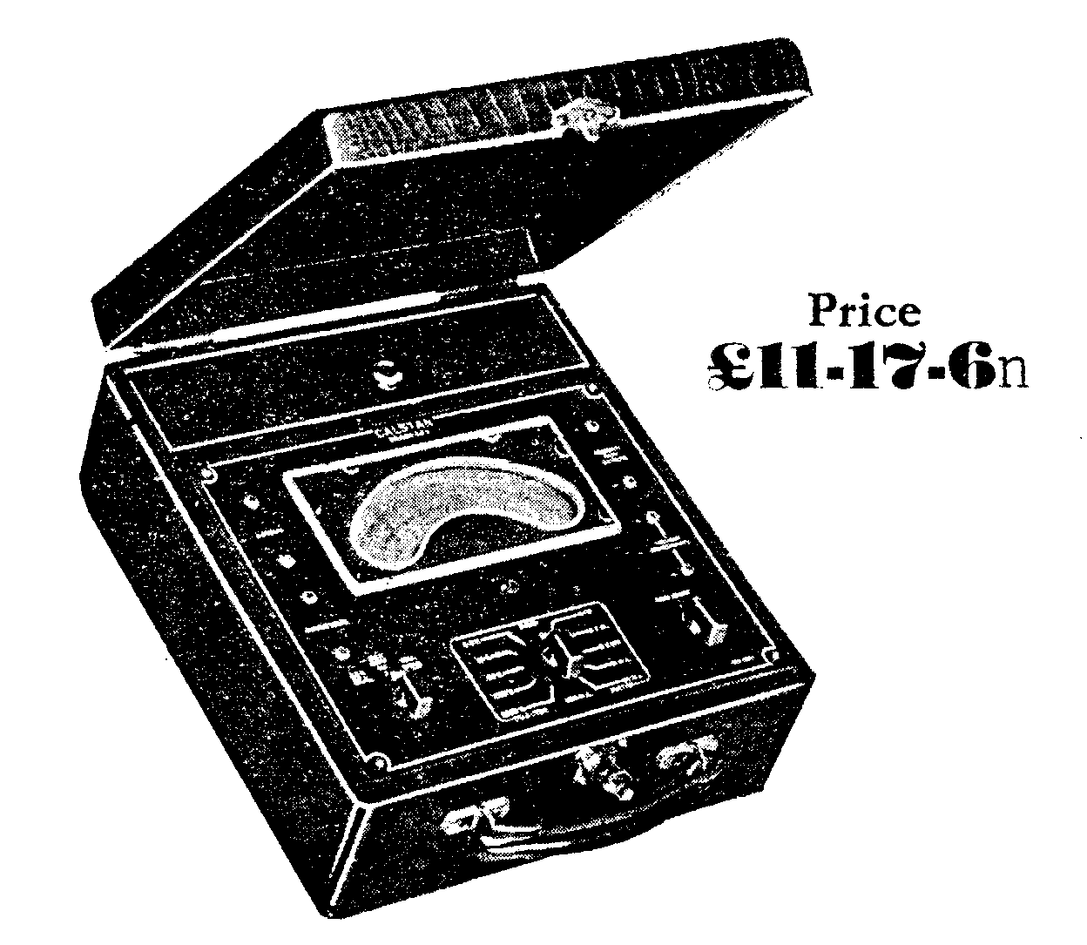

THE VELCO AD136

The Velco AD136 AC/DC Multimeter embodies a high sensitivity 20,000 ohm per volt meter, which obviates the necessity of a Vacuum Tube Voltmeter for average work.

Milliamps 0-1, 0-5, 0-100, 0-500.
D.C., A.C. and Output volts – 0-5, 0-10, 0-50, 0-250, 0-1000.
Ohms 0-2000, 0-20,000, 0-200,000

Price - £11/17/6n.

Easy Terms - £3/17/6 Deposit, with 9 Monthly Payments of 20/- each.

The Velco A.D. 136 A.C.-D.C. Multimeter is an instrument of high sensitivity and efficiency.

The meter incorporated in the instrument his a very high internal resistance (20,000 ohms. per volt) which enables the user to take readings of various sections of a radio receiver where the use of a meter of average resistance would cause serious error in readings. In addition to the high resistance voltage scale the meter is adaptable for general service work, such as A.C. and output volts up to 1000 v., also several ohms ranges.

The output volts section of the Multimeter is generally used in conjunction with a signal generator for receiver alignment purposes. A signal of constant amplitude is fed into the equipment under test, the output volts section of the instrument having been connected across either the Loud Speaker transformer primary or from the power valve plate to the chassis.

The object of the output volts scale is to indicate maximum receiver sensitivity by highest needle swing.
If the meter needle tends to run off scale use a higher voltage setting.

Ohms readings are obtained by placing the switches in their correct settings and shorting the test cords together. The "Ohms Adjust" knob should be rotated until the Meter Needle lies exactly on the zero ohms graduation of the ohms scale. This adjustment should be checked every time the ohms scale is used, also after changing to different ohms range. The ohms scale is also useful as a continuity tester for checking coil or transformer windings, also the location of shorting condensers, etc. After a period of use it will be noticed that the "Ohms Adjust" knob will not bring the needle to zero setting. When that condition exists it will be necessary to replace the dry batteries under the panel. Make sure the new batteries are wired for correct polarity

Away remember the meter is a delicate instrument. Every care should be taken to see that the switch settings are correct and that meter scale used is sufficient to read the amount of voltage or current in the circuit under test.

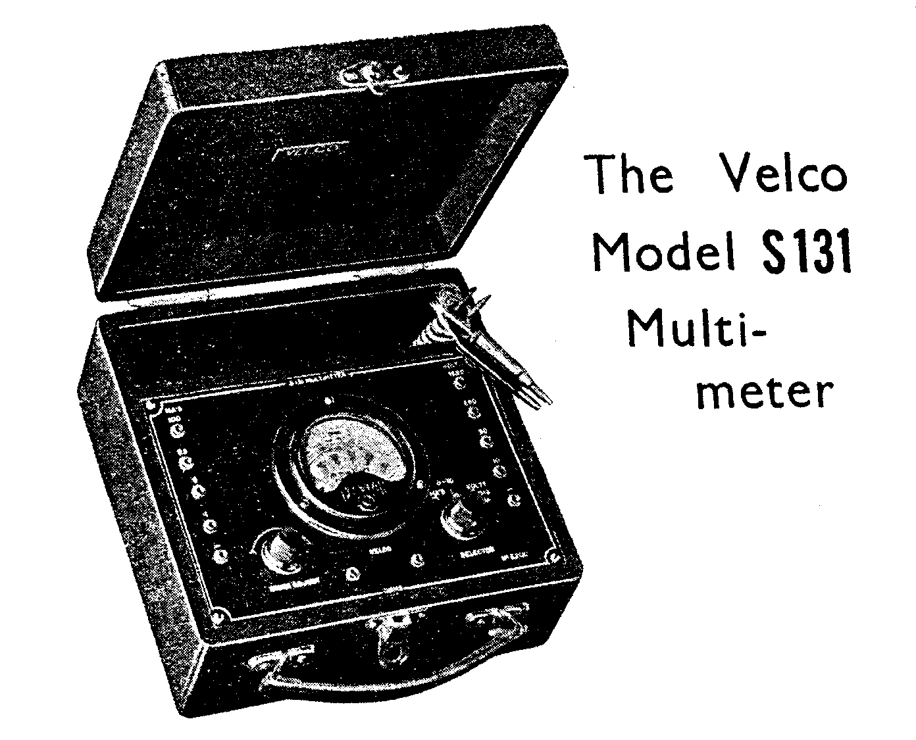
The Velco S131 D.C.
Multimeter is supplied complete in a leatherette case as illustrated. The meter is 1000 ohms per volt, with Volts, M.A.’s and Ohmage scales.
Ranges covered are :-

Ohms: 0-1000, 2000, 4000, 10,000, 20,000, 50,000 100,000
Milliamps: 0-1, 5, 25 and 100
Volts: 0-10, 50, 250 and 1250

All ranges are plainly marked. Battery for continuity tests and Ohms range, incorporated with Potentiometer for zero-adjusting.
Cash price .. .. .. £4/10/-n
Terms; deposit £1; 4 monthly payments of 20/- each.

Instructions for Using
The Multimeter correctly used enables the operator to locate practically any fault that may occur.
Along the right side of Multimeter panel, the four sockets from the top provide four different voltage values. The fifth socket is the meter negative. All that is necessary is to. place the test cords into the sockets giving the necessary voltage scales, and place the Selector Knob in the volts position, The correct reading of the applied voltage will be Shown on the meter scale. Each voltage value shown under the sockets has its counterpart on the scale. Along the left side of the Multimeter panel will be noticed

a row of sockets. The e first four down are the milliamp ranges, the fifth socket being the meter negative. The numerals shown under each socket have their counterpart on. the meter scale. Any value of milliamps applied to the correct pair of sockets will be accurately indicated on the meter.

It is essential, before attempting to use the milliamp scale, to set. the Selector Knob to the milliamp position.

The 0-l milliamp scale necessitates a different selector setting.

On. the bottom of the Multimeter Panel will be noticed two sockets marked "ohms." Upon the insertion of the test cords into these sockets and the setting of the Selector Knob to the ohms position, the ohms values of the resistor under test can be read directly from the top meter scale. If a test of low resistor values is required, the Selector Knob should be set to the position marked (0-:-l0). Whatever reading is then shown on the top scale should be divided by ten, a correct reading will then be obtained.

It is important to note that before attempting to measure a resistor the test prods should be shorted together, and the left pointer knob marked "ohms Adjust " rotated until the meter needle lies exactly over the scale divisional line marked zero. This zero adjustment should always be checked when resistor values are to be tried, also when the Selector Knob is changed from high or low ohms readings. When the ohms scale is being used never hold the metal points of the test prods with the fingers, as a fictitious reading will be obtained, due to body leakage. This error in resistor readings can assume quite serious proportions when a high value resistor is being checked. Always hold the test prods by the insulated sleeve.

The ohmmeter scale is a very useful instrument when used as a continuity meter. The location of shorting condensers, shorts between high potential windings and those at zero potential, open circuited transformers and coil windings, etc., can be located easily on this scale.

The 4.5 volt battery in the case is used in conjunction with the ohms scale. After a lengthy period of use it will be found that the ohms adjustor will not bring the meter needle to zero setting. When this occurs the battery should be replaced. When replacing see that the battery is connected for correct polarity.

Always check the Multimeter connections before taking readings and always make sure there is sufficient margin on the meter scale used to accommodate the voltage and current that may exist in the circuit to be measured.

THE VELCO ALL WAVE OSCILLATOR

Model 305

The new Velco fundamental All wave oscillators are so designed that they meet perfectly the many demands of the serviceman. They are battery operated and may be used at any time or in any place independently of power supply.

MODEL 305

It covers frequencies from 15 M.C. to 150 K.C. All frequencies are fundamental and fully stabilized. It has perfect attenuation of R.F., modulated R.F., and A.F. . signals.
The Velco All Wave Oscillator Model 305-Price £9/15/0n.
Or Easy Terms - 65/- Deposit and Seven Monthly Payments of 20/- ea.

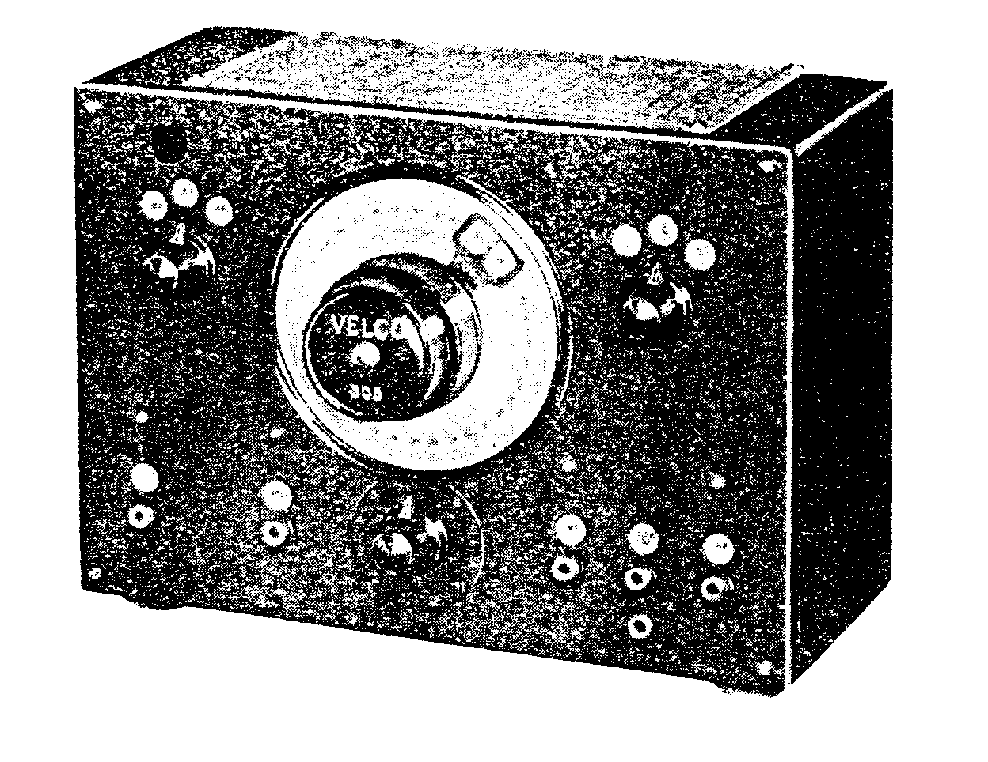

Instructions for Using The Velco Model 305

The Velco Oscillator is designed to provide an efficient and reliable means of aligning all types of Radio Receivers. The frequency range of the Velco Oscillator covers all frequencies usually associated with modern Radio Receivers.

The shielded cable to which is attached a metal box constitutes a combined coupling cable and dummy aerial. Of the two clips terminating the cable, the one with the Red sleeve is the live contact, the black sleeve at all times being at earth potential.

The knob at the top left corner of the oscillator has three positions. The knob should be left in the "Off" position when the oscillator is not in use. The pilot light mounted under the knob will give a visible warning when the oscillator is turned on.

With the knob in the "R.F." position Radio frequency oscillations will be generated by the R.F. oscillator tube and coil combination. The knob position marked "A.F." brings a second tube into operation; the purpose of that tube is to generate Audio Frequency oscillations. The circuit arrangement of the oscillator

allows the mingling of the audio with the radio frequency oscillations. This

superimposing of the two frequencies enables an audible signal to be present at the output meter and/or loud speaker when a Radio Receiver is being aligned.

The knob at the top right hand corner of the oscillator has three positions. The manipulation of this switch enables the different frequency bands to be covered.

No. 1 position covers a frequency band of from 150 kilocycles to 480 kilocycles.

No. 2 position 500 to 1600 kilocycles and No.8 position 6 megacycles to 18 megacycles. The necessary coverage at each switch setting is obtained by adjustment of the Slow Motion Dial.

On the top of the oscillator will be seen a chart setting out the dial positions for the various frequencies. Each oscillator has been individually calibrated against a standard signal generator of extreme accuracy, thus the operator can make his adjustments with the utmost confidence as to precision.
It will be noticed that with ..the wave band switch in position No. 8 the corresponding chart readings are shown in metres as well is megacycles, thus allowing a better under-standing of the short wave section.

Of the three sockets at the lower right of oscillator the one marked "R F." gives access to the maximum amount of R.F energy generated by the oscillator. That outlet is used generally on a Receiver of low sensitivity (minimum number of tubes) or when attempting to adjust a receiver which is very much out of alignment. In the latter case, after the receiver has been peaked somewhere near its maximum efficiency, the "Low R.F." outlet should be used; The amount of R.F. now available for alignment purposes has been greatly diminished and will allow a more accurate adjustment to be made to the various trimming and padding capacities on the Receiver.

The outlet marked "A.F." provides an audio frequency signal which can he applied to any audio amplifying system for test purposes. If for instance the Audio frequency end of a receiver is believed to be the cause of the non-functioning of the system, the A.F. outlet can be connected, say, between the grid and chassis of the final amplifying tube. If the audio signal is heard in the speaker it can be presumed that the output tube and speaker are correct. The same test should then be applied to an earlier stage in the Audio system. If a more powerful audio signal is desired the two sockets at the left of the oscillator marked Ext. Mod. should be used. Quite an appreciable amount of audio energy is available at that source and should suffice for any kind of Audio work.

Incidentally, the top left hand knob must always be in the "A..F." position for all Audio tests.

The knob directly under the Main Dial is an R.F. attenuator and enables the operator to govern the amount of R.F. voltage at the two R.F. outlets. The small socket mounted immediately under the Low R.F. outlet provides a direct contact to the metal box, an earth connection can be made to this socket if complete stability is desired.

Such earthing is not generally necessary for reliable operation.

The usual procedure to adopt with the oscillator when attempting to align a standard Broadcast Super Heterodyne will now be discussed.

In the following explanation it will be presumed that the Operator has an Output Meter at his disposal and connected to the output at the receiver. Such an instrument is essential for correct alignment. The ear is insufficiently responsive to small changes in sound to enable exact alignment to be obtained via that medium.

The Alignment should be commenced with the necessary adjustment to the Intermediate Frequency Transformers.

Insert the shielded cable supplied with the oscillator into the outlet marked "R.F." The clip with the Red sleeving is fastened on to the grid cap of the 1st Detector tube (mixer) and the black clip attached to the Earth terminal or any convenient part of the chassis. The banana plug connected to the dummy aerial which is attached to the shielded cable should be inserted into its socket. Turn the knob at the top left hand corner of the oscillator to the "A.F." position, then consult the chart attached to the oscillator for the Wave Band switch position necessary for the I.F. Transformer in question. Make certain that the Dial Setting is accurate. The oscillator section of the condenser gang should be shorted out before commencing I.F. alignment.

Presuming the Receiver tubes have heated the attenuator should be advanced until the output meter shows a steady deflection up the scale. It is quite possible that an audible indication from the Loud Speaker will be noticed before any appreciable needle deflection takes place. When the oscillator signal has become apparent a suitable aligning tool should be inserted into the screw of the variable capacity across the secondary of the final I.F. Transformer. (The I.F. Transformer feeding into the 2nd Detector). When the screw has been rotated in a certain direction an increase in output meter deflection will be noticed. Rotate the screw until max. deflection has been obtained. Attention should now be given to the remaining screw on the I.F. Transformer until maximum deflection is obtained. The next I.F. Transformer in line should receive similar attention, the object being all the while to bring the output meter up to highest deflection. When the I.F.'s have been adjusted; to their approximate peak the attenuator should be retarded until there is just sufficient useful meter deflection for alignment purposes. Final adjustment should now be given to the I.F. Transformers in their correct sequence as previously described, moving the screws very delicately and keeping a close watch on the output meter.

After aligning the I.E. Transformers attention can now be turned to the Condenser Gang and Padder.

Place the Wave Change Switch on the oscillator in its correct position and adjust the dial to 1500 K.C. as shown on the chart. Attach the Red clip to the aerial terminal of receiver and the black clip to the ground. (chassis), advance the attenuator and rotate the Receiver Dial near zero end (condenser plates open) until the oscillator signal is noticed.

If the receiver dial is marked off in frequencies it will be necessary to align the gang accordingly.

After having located the oscillator signal on the Receiver adjust the oscillator trimming condenser (on the Receiver) slowly in such a direction as to bring the Dial Pointer to the correct frequency setting on the Dial, predetermined by the modulated oscillator adjustment (1500 K.C.) The remaining trimmers on the condenser gang should now be adjusted for maximum meter deflection. The Oscillator Dial should now be placed in the 600 K.C. setting and the Receiver Dial rotated until the oscillator signal is apparent. The padding condenser can now be adjusted at the same time turning the receiver dial backward and forward until the maximum output meter deflection is obtained. If the Coils, Condenser Gang and Dial are designed for correct matching maximum meter deflection should be obtained with the dial pointer opposite the 600 K.C. marking. After the padder adjustment it will be found that some correction will be necessary at the 1500 K.C. setting of the receiver dial. This should be carried out as previously described in these instructions.

In the ease of an extremely sensitive Receiver it may be found that the signal intensity at the oscillator outlet "R.F." is too great. Under such conditions the shielded cable should be inserted in the "Low R.F." outlet, the alignment procedure remaining the same as before.

When the condenser gang is being aligned remove the banana plug from its socket in the dummy aerial. By so doing a load equivalent to the standard antenna system will be available and will enable a more accurate alignment to be obtained.

The equipment in the oscillator case consists of two 22 Volt H.T. Batteries and two 1.5 Volt Cells. These batteries should not be allowed to run too low as frequency drift will take place, causing inaccuracy in frequency output.

The Tubes used are type 30 Triodes, one as an R.F. oscillator, the other as a modulator, such a combination giving. excellent frequency stability.

When rotating. the Oscillator Dial do not force against the stops at either extremity of rotation, as error may develop due to dial misplacement.

Always treat the oscillator as a delicate instrument and avoid all severe jarring and such like abuse.

New Models

All wording etched on non-ferrous metal; leather carrying handle, rubber feet. Pilot light and black instrument knobs on each model. Five-inch dial reads direct in Kc/s, Mc/s (top half), and corresponding metres (bottom half); smooth planetary movement - adjustable for slip. Two attenuators on both models.
Specifications: Model 306, Battery - operated, with minimized battery drain ("B" battery drain approximately 5 ma., at 67.5 v.; "A" battery, 4.5 v., drain approx. 120 ma., including Pilot).
Band spread 150 Kc/s to 16 Mc/s on fundamentals without breaks; above 16 Me/s by using 2nd harmonics. R.F. signals modulated at will. High degree of stability and accuracy, particularly over 175 and 465 Kc/s channels, Model 307, A.C. Mains operated. Feed back prevented by line filters, thus maintaining good attenuation. Bandspread 150 Kc/s to 25 Mc/s on fundamentals without breaks. Both models available with or without built in output meter.
Output Meter 3 in. round type. Special Alnico magnet gives approx. 300% increase over old style. Ranges: 2, 5, 10, 50, 250. Provision for measuring A.C. Volts. All necessary cards and instructions supplied.
306 Battery Operated £10 10 0
306a (illus.) ditto with output meter 15 15 0
307 Mains Operated 10 17 6
307a ditto with Output Meter 16 2 6
Output Meter as used on both models . 5 10 0
Easy Terms Arranged.

THE VELCO COMBINED OSCILLATOR
And OUTOUT

METER – Model 305A

The Velco Combined Oscillator and Output Meter illustrated at left, like the Model 305 described en Page 18, accurately calibrated on all the most common frequencies used in modern broadcasting including those frequencies used. for I.F. Amplifiers:

Two type 30 valves are used, one as an R.F. Oscillator and the other an Audio Modulator. The Frequency ranges are suitable for all modern servicing and are all fundamentals, making it an ideal instrument for line production or large servicing organizations.

Price .. ... ..£13/15/-n

Easy Terms-£4/15/- dep., with 10 monthly payments of 20/- each.

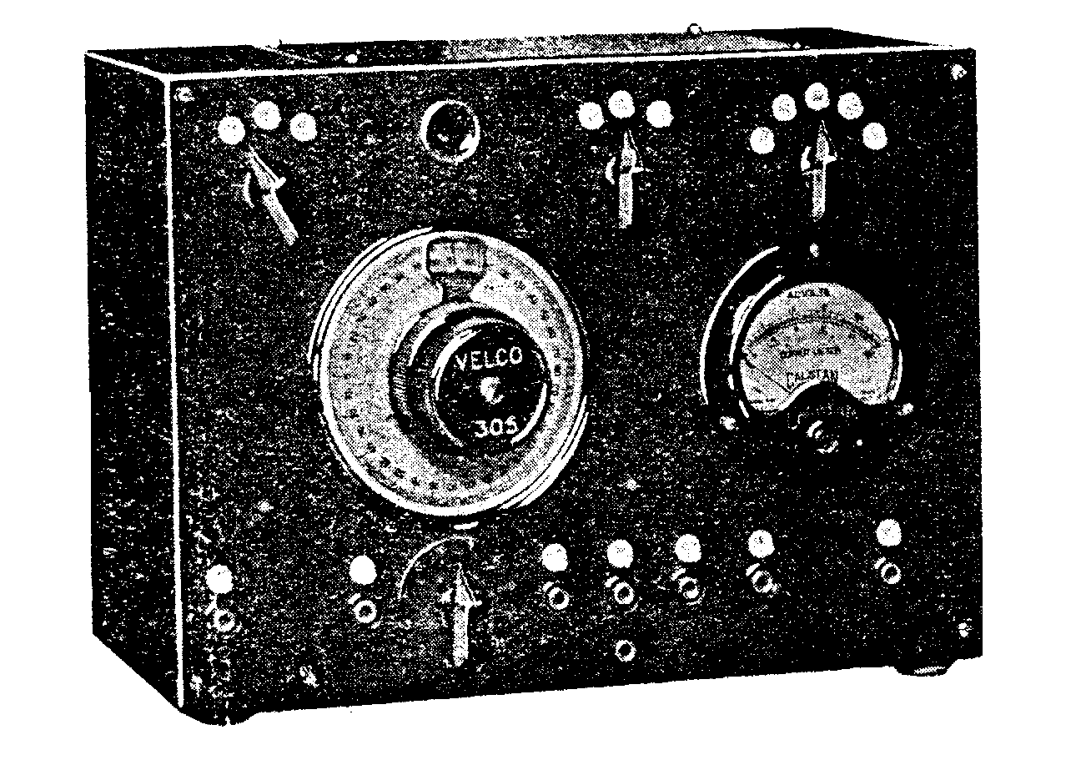

Instructions for Use

The Model 305A Instrument is identical with Model 305 with the addition of an Output Meter.

The following remarks wil1 be coffined to the Output Meter.

The purpose of the Output Meter is to provide a visual indication of correct Receiver alignment. It can also be used for comparison in sensitivity tests of Radio Receivers or Public Address Systems where a calibrated source of constant amplitude voltage is available.

The Output Meter is used mainly for Received alignment purposes where a modulated Radio frequency signal is fed into either the signal frequency or intermediate frequency section of a Radio Receiver. The purpose of the Output Meter under such conditions is to indicate maximum energy transfer (max. needle swing) when all trimming condensers etc., are brought to their peak.

The Output Meter is usually connected either across the speaker transformer primary winding or from the plate of the output tube to the chassis. Five Voltage Ranges are provided – 0-2.5, 0-10, 0-50, 0-250. The Rotary Switch is placed in whichever position gives sufficient alignment.

