From High Availability to Disaster Tolerance: Layering Domino
Clusters on Wolfpack

by Peter Eggimann

If you’re like most Notes administrators, you’ve been consolidating servers since the release of Notes R4, which provided performance and scaling improvements to support large numbers of users on a single server. As you’ve no doubt discovered, consolidating your servers has made network management and administration easier, and it’s reduced network traffic as a result of fewer replication events. But it also means that, if the server goes down, as many as 800 to 1000 users can be affected, making high availability of services in both planned maintenance and disaster scenarios a must.

This raises two questions: What do you mean by “high availability,” and what are your options for achieving it? I think most administrators would agree that high availability means providing services to the client with little or no disruption during planned maintenance and unplanned failure scenarios, and that the solution for achieving it should be both scalable and performance efficient. In addition, a high availability solution should support multiple software applications and possibly provide disaster tolerance.

Clearly, the Lotus recommendation is to use Domino clustering for high availability. Domino clustering is a software-based solution that provides a real-time, event-based replication technique to create and maintain identical Domino servers in a LAN environment. Domino clustering provides support for up to six cluster members independent of server architecture. Since these machines can be deployed across a wide area network (assuming LAN speeds), clustered Domino servers are protected against disaster scenarios at a local site.

But what about those who have chosen Wolfpack to provide availability for Domino in addition to file and print or other applications? Microsoft’s Wolfpack is an operating system solution that provides the capability to tightly couple multiple Windows NT servers over a common SCSI connection and to share resources among these servers. Wolfpack supports multiple software applications, provides transparent client failover, and offers the ability to add servers in a linear and scalable manner.

The good news is that these two solutions are not mutually exclusive. Many customers we work with at Digital choose to implement a Wolfpack solution first, to gain comprehensive local availability of all their software applications. Domino clustering is then added to Wolfpack to provide disaster tolerance for Domino applications across a wide area network. In this article, I’ll show you how it’s done.

First, we’ll look at Wolfpack clustering in more detail, then I’ll explain exactly how to implement Domino clustering on a Wolfpack cluster to create a hybrid solution that gives you the best of both worlds. Although this article focuses on using Wolfpack to provide Domino availability, Domino clustering can also be used to provide high availability in a LAN environment. So while I’ll provide the insights to Domino clustering you need for understanding the configuration presented here, for a more comprehensive picture of Domino, I highly recommend James Grigsby’s article, Flexing Domino’s Clustering Muscles, in the September/October 1997 issue of THE VIEW.
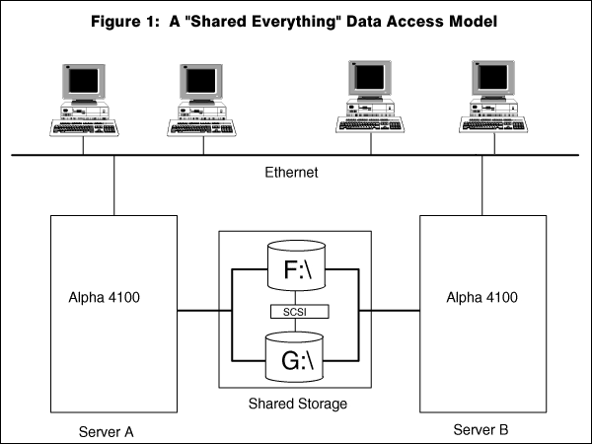

Operating System Cluster Data Models

Our first order of business is to understand Wolfpack in the context of operating system clusters in general. In operating system clusters, a high bandwidth interconnect technology is shared between the nodes that participate in the cluster. Typically, these systems implement either a “shared everything” or a “shared nothing” data model.

A shared everything model assumes that each node participating in the cluster has real-time and concurrent access to the shared devices and data in the cluster. An example of a shared everything model is the VAXCluster, which was pioneered by Digital. Each node is connected through a computer interconnect (CI) bus to a shared storage array accessible by all servers in the cluster. Concurrent access to the shared storage is provided by means of a distributed lock manager that prevents any of the nodes from updating data without first taking out a lock on that data. The lock manager synchronizes access to data at the record level and ensures a consistent view of the data in real time.

Users connect to this type of cluster using a cluster alias rather than the name of a particular server. This allows users access to applications and data without knowing which cluster node is providing the service. When a cluster node fails, one of the surviving servers takes control of the lock management function while the other nodes continue operating. In effect, a single system image is presented to a user.

Figure 1 illustrates this type of clustering. As you can see, each node in the cluster has access to drives F:\ and G:\. Using the cluster alias, clients can receive service from either node and can access either or both drives.
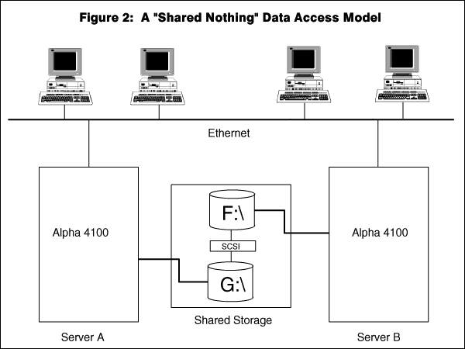
A shared nothing model assumes that resources are owned by only one node in the cluster at a time. Examples of a “shared nothing” or partitioned data model are Digital’s Windows NT Clusters and Microsoft’s Wolfpack. Both implementations assume that each node in the cluster has access only to the resources that it owns. Although the cluster is formed via a shared SCSI storage interconnect, only one cluster member is allowed to access a disk at a time. There is no distributed lock manager and no mechanism for processes to communicate state or context across the cluster.

In this type of model, the cluster software arbitrates which node has access to resources, and “moves” resources across the members of the cluster in the event of a failover or failback. Services must be provided that shut down applications and then start them up again when resources are moved from one node to another.

Figure 2 shows you what a “shared nothing” cluster looks like. As you can see, each server can access one of the drives, (but not both concurrently). When a failure occurs, the surviving member will take over control and remount the failed server drive resources with the same drive letters and then restart any applications or services.

The major advantage of an operating system “shared nothing” model is that you do not replicate databases, or changes to those databases, across the cluster unless there is a need to provide users in the cluster access to a common database. For mail users in particular, there is no need to replicate changes, since the surviving cluster node will assume ownership of the failed server resources (disks, users mail files, IP address) on failover. For this reason, there is almost no overhead for mail/messaging applications in this type of operating system cluster.

Okay, So What Exactly Is Wolfpack Clustering?

Wolfpack is the code name for the Microsoft Cluster Server (MSCS), which was developed in cooperation with many systems vendors and modeled after Digital’s Windows NT Cluster product. Because the Wolfpack name is still in general use, I use it to refer to the MSCS throughout this article.
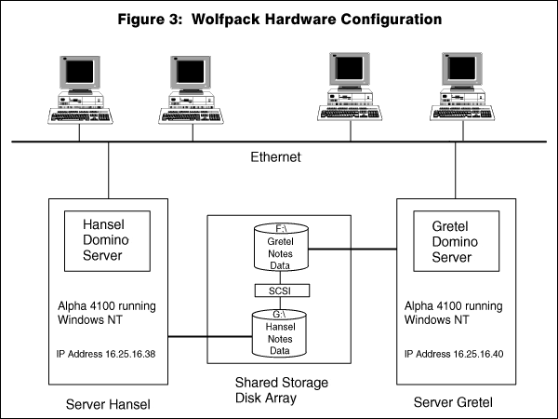
Wolfpack is operating system clustering based on a “shared nothing” model, with each node in the cluster defining, owning, and managing “resources” on behalf of the clients requesting services of the cluster. Figure 3 shows you what a typical Wolfpack system looks like.

As you can see, each cluster node is connected via a shared SCSI bus. The shared SCSI allows each node to share disk resources, with either node capable of accessing all disks in a degraded cluster condition. Because the nodes are connected by a shared SCSI, the physical distance between cluster nodes is limited by SCSI specifications. Ultra SCSI and fibre-channel-connected SCSI will allow nodes to be in different buildings or geographical locations soon, but for the time being, let’s assume each node is in the same computer room.

Each node in the cluster broadcasts a heartbeat over the ethernet to let the other nodes know it is alive and participating in the cluster. When one node in the cluster recognizes that the heartbeat from the other node has gone away, it will initiate a failover process to claim control of that node’s resources. As we’ll see later in the article, this failover process triggers a set of timeouts to validate that a node really has failed prior to the survivor taking control of those resources. Validating a failure is important, since a node may fail to communicate because a network link has been cut. Similarly, validating a failure maintains the integrity of the shared nothing model by ensuring that only one node controls the shared drives at any time.

As we’ve mentioned, each node in the cluster owns a set of resources. These resources are defined by an administrator as entities to be managed by the cluster on failover or failback events. These resources can be disks, IP addresses, application services, and file shares. Resources can be grouped so that when a resource is moved within the cluster, it moves along with its group. In Figure 3, we have a group defined which consists of a Domino partitioned server instance, an IP address which clients use to connect to this instance, and a series of disks that contain mail files and other Domino data. When a node in the cluster fails, or is taken down for planned maintenance, this failover group will move to the surviving member of the cluster with a dependency order defined by the administrator.

Wolfpack in Action

Let’s take a look at the events that can cause a failover and at what Wolfpack does in each case. At the most basic level, three events can trigger or cause a failover:

- Planned maintenance
- Hardware failure
- Software failure

Planned maintenance is an activity that requires a standalone environment for performing either software maintenance, such as a service pack upgrade, or hardware maintenance, such as adding additional CPUs or memory. Today, the ability to perform planned maintenance while providing uninterrupted service is the most critical reason customers want a highly available solution. After all, a new service pack release or hotfix is likely to come out before I finish writing this article! It is also likely that within the next several weeks or months, you’ll want to upgrade to Domino R4.6 or 5.0, or a new microcode release will come out that will require rebooting your server.

A hardware failure is the unexpected failure of a component such as a CPU or memory board, which causes the machine to crash. Clustering solutions were originally designed to primarily handle unplanned hardware failures. With the reliability of hardware currently approaching 99 percent at the system level, and with the use of RAID technologies and hotswap-able drives to recover from disk failure, hardware failure is less and less likely to contribute to overall downtime of a server. A power failure to the lab, or someone crashing the machine unintentionally, is a more likely event.

A software failure occurs when a software component hangs the server or aborts altogether and requires you to reboot the server in order to recover. For example, a software failure may occur when you’re out of database buffer pool and a process hangs as a result; it may be due to a mail router that aborted; or perhaps a process overwrites protected memory causing a Windows “blue death” screen. Whatever the cause, an unplanned software failure is very likely something you’ve seen recently, especially in a large server consolidation environment.

What Happens on Planned Failover?

Availability during planned maintenance is where an operating system cluster provides the most value. Wolfpack allows an administrator or system manager to gracefully shut down the system, migrate the users to another node in the cluster, do the upgrade, migrate the users back, and then do the same for the other cluster nodes.

Here’s what happens in a Wolfpack cluster when you have a planned maintenance activity to perform – upgrading a Windows NT service pack, for example:

- When you want to take a node out of the cluster, you initiate a “move group” within Wolfpack. This move group action informs the other node in the cluster that the first node is passing/relinquishing control of the specified groups.

- The server passing control of the group triggers a script that simply shuts down the Domino server process gracefully and moves the IP address and disks you defined as part of the group to the surviving member of the cluster.

- Once the disks and IP address are available on the surviving node, a second instance of the Domino server process is started on the surviving node. This partitioned server process is started with the same floating IP address and server name it had on the failed server.

- The surviving server then performs an ARP broadcast to update each client’s ARP cache with this server’s MAC hardware address and IP address.

Figure 4 illustrates this planned failover scenario. Here you see the servers Hansel and Gretel (these servers were shown in steady state in Figure 3); Gretel has failed over to Hansel, and Hansel now has Gretel’s IP address. Hansel is now running two instances of Domino (Hansel Domino and Gretel Domino), and it is accessing Gretel’s Notes data on Drive F:\ of the shared storage device.

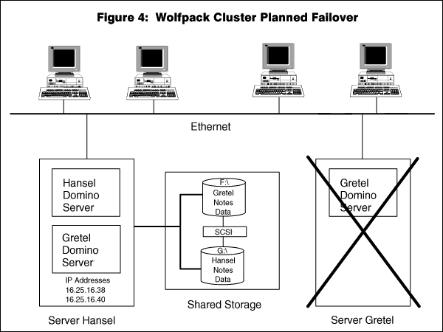
Let’s look at this scenario from the user’s perspective. The user experience during failover is one of the major differentiators between Domino clustering and Wolfpack. In a Domino cluster, the user must explicitly reconnect to another server. In a Wolfpack cluster, failover is transparent to the user most of the time.

So what do Notes users see when a node fails? Well, unless the Notes client is requesting services from the Domino server during the failover period, they do not see anything. Remember, when a Wolfpack failover or failback occurs, the IP address of the failed member floats to the surviving member, and the server’s MAC address is updated on the client. This means that when the Notes client makes a request to the Domino server, it does not know or care that it is now receiving services from a Domino server on a different machine.

If the Notes client is requesting Domino services during failover, the client will detect that the connection to the server has gone away, and it will transparently retry the connection. In a worse case scenario, if a user is saving a large document, or attempting to execute a long transaction, the Notes client will present a dialog box requesting the user to retry the failed transaction. When the save request or transaction is retried, it will complete successfully on the surviving server. The user will not be required to manually reconnect or log in to another physical server.

Mail continues to be routed because the second instance of the Domino server (i.e., the surviving server) takes on the same identity and responds to the same IP address as the failed Domino server process. Similarly, if you’re using Domino as a Web server, pages continue to be served.

By the way, with Wolfpack, as with most operating system clusters, total planned failover time is fast. All that needs to happen is for the Domino server process to gracefully shutdown and then restart on the surviving member. At Digital, we recently timed planned failover for 1500 NotesBench users at under 45 seconds for a large customer consolidating servers using an Alpha Server 4100 466Mhz Windows NT cluster.
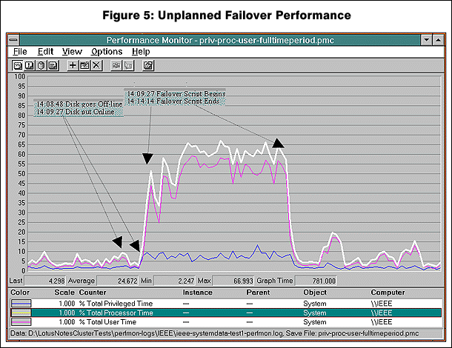
What Does Wolfpack Do in an Unplanned Failover?

A hardware failure, although much less likely, presents a more complicated scenario than planned maintenance. We’ll take as our example the same servers shown in Figure 4. Let’s assume server Gretel suffered a blue screen, or that a hardware failure occurred. Here is the order of events:

- Node Hansel detects the loss of heartbeat from node Gretel.

- Hansel waits until the heartbeat timeout expires to verify Gretel is down.

- Hansel then puts out a SCSI challenge to master Gretel’s disks.

- If the challenge goes unanswered during the timeout period, Hansel takes the drives.

- Hansel mounts the disks with the same drive letters as Gretel, and runs CHKDISK if a corrupted file is detected by Windows NT.

- Hansel starts the Domino partition server with the floating IP address from Gretel.

- A consistency check is run as part of Domino startup.

- The new MAC address is broadcast to the ARP caches of the clients.

- Clients transparently reconnect to the Domino server via the floating IP address.

Unlike a planned maintenance event, unplanned failover requires that timeouts be used to verify a failure really has occurred (as opposed to the heartbeat not being sent because the server is overloaded, or because the network connection has been severed). Unplanned failure also requires that the Domino server process run any recovery or fixup tasks to recover from corrupted .nsf files or databases since it was not shutdown gracefully. During the failover period, services are not provided to the Notes clients until the Domino server is fully up and running.

As you can see in Figure 5, the hardware timeouts complete in a relatively small period of time. They are represented on the graph as the time between the disk going offline and the start of the failover script. Hardware timeouts are tuneable: typically 5 seconds for the heartbeat timeout, and 30 seconds for the SCSI challenge.

Once these hardware timeouts occur, the surviving node takes over any resources once owned by the failed node and runs a script to start the Domino server process. The area under the curve represents Domino server startup, and accounts for the majority of the failover time. Exactly how much time depends on the number of processes in the notes.ini, the number of Domino databases open at the time of failure, and the number of fixups that need to be performed to recover those databases.

Wolfpack and Software Failures

With planned maintenance events and hardware failures, Wolfpack’s cluster software detects failure and initiates failover. If Windows NT crashes, the Wolfpack cluster software will generally treat it as a hardware event. The surviving cluster will detect the loss of “keep alive,” or heartbeat, and initiate the failover, not knowing if it was the machine that failed or the operating system.

Wolfpack also provides functionality for detecting failures of software resources. Through resource monitoring, an administrator can set how many times to restart a failed software process during a predefined period of time. If the process fails too many times during this period, a cluster failover can be triggered. It should be noted, however, that it is
much better to continue restarting the process than to trigger a cluster failover. Triggering a failover will just migrate the failing process to the surviving member of the cluster, with the result of putting the cluster in a degraded condition.

Wolfpack resource monitoring will only detect a failed process. In addition, you might want to consider monitoring the state of health of Domino using a product such as Candle’s Intelliwatch, which can be used to detect and restart the Domino software process using response time thresholds or connection thresholds. Additionally, you can monitor Domino server performance counters to prevent the database buffer pool from becoming exhausted, or to ensure that mail continues to be routed. Monitoring for these and similar conditions is critical for ensuring availability of the Domino server process.

Why Use Domino Clustering with Wolfpack?

As we’ve seen, Wolfpack clustering provides a very efficient way of sharing resources between servers without the performance overhead of replication, or the need to replicate storage, and it provides transparent failover for clients accessing these servers. It will quickly become the defacto standard clustering implementation for many applications within local computing environments.

However, if your company is like most we talk to, your organization is dispersed across several continents. To keep databases that are shared across wide geographic areas in synch, you require a solution with real-time replication capability - one that also allows users to access these databases at either location in the event of a server failover. Because the servers in a Wolfpack cluster must connect via a shared SCSI II technology, which imposes physical limitations, Wolfpack does not provide a solution for clustering across a wide geographic area. Even UltraSCSI or fibre channel extenders won’t allow Wolfpack nodes to be deployed at any great distance from each other. In addition, Wolfpack is currently restricted to clusters of two nodes of like computing architectures.

The strength of Domino clustering, however, is in its event-based replication technology. Clustered Domino databases can be on as many as six servers, and the servers can be on different types of platforms. More importantly, Domino’s clustering technology can be implemented over a high-speed, wide area network to provide disaster tolerance, or simply to integrate databases across geographic boundaries. This requires real-time replication of Domino databases and the associated cost of duplicating data. And it will not provide availability services for other applications or databases.
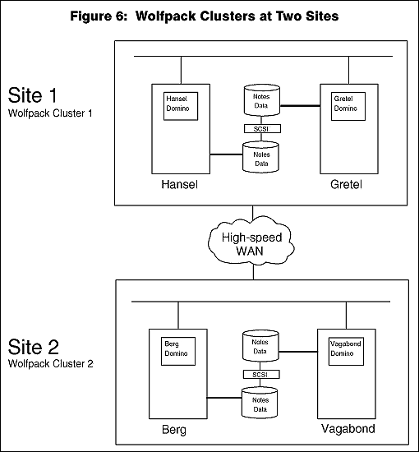
So, what’s the bottom line, you ask? Think of each of these technologies as strong in one of two dimensions: local area clustering, or geographically dispersed clustering. Wolfpack provides the most efficient solution for local area clustering, while Domino clustering is the best solution for wide area clustering and disaster tolerance. In the example we’ll look at now, Wolfpack is already in place as a local availability solution. We will layer Domino clustering on Wolfpack to gain disaster tolerance.

Wolfpack and Domino in a Geographical Cluster

Consider the Domino/Wolfpack configurations shown in Figure 6 and Figure 7.

Figure 6 shows two Wolfpack clusters at two different geographic locations. This configuration consists of four server nodes, called Hansel, Gretel, Berg, and Vagabond. These nodes are running Alpha Windows NT servers. Each server is running Domino. Hansel and Gretel are at the primary site, while Berg and Vagabond are at the remote, or disaster, site. The servers between these sites are connected via routers and T3 lines.

Hansel and Gretel are configured as one Wolfpack cluster (Wolfpack Cluster 1). Berg and Vagabond are configured as the other Wolfpack cluster (Wolfpack Cluster 2).

Figure 7 shows Domino clusters layered on the Wolfpack clusters. This configuration is designed to exploit the strengths of Wolfpack clustering for local computing availability, while taking advantage of Domino clustering to provide disaster tolerance across a high-speed wide area network:
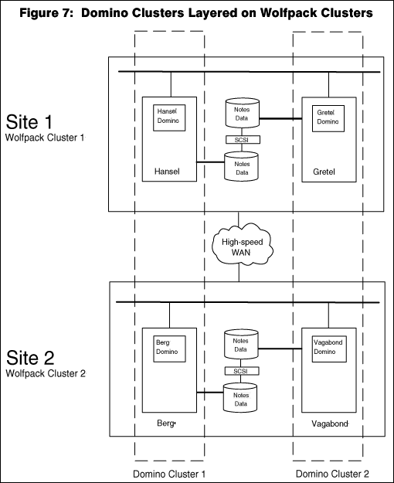
- Domino Cluster 1 consists of HansDomino and BergDomino. (That is, the Domino server running on Hansel is clustered with the Domino server on Berg.)

- Domino Cluster 2 consists of VagabondDomino and GretelDomino.

- In Cluster 1, HansDomino replicates with BergDomino.

- In Cluster 2, VagabondDomino replicates with GretelDomino.

These Domino clusters provide disaster tolerance in the event of a power failure (or even more catastrophic event) at the primary site where Hansel and Gretel are located.

Note that in this configuration we have four Domino servers clustered on Wolfpack, but we are only incurring the replication overhead of a two-node Domino cluster. In other words:

- The servers in each Domino cluster only need to replicate with each other.

- The Domino servers in the Wolfpack clusters don’t need to replicate with each other at all, since Wolfpack provides failover at the local site. For example, HansDomino does not replicate with Gretel Domino because Wolfpack provides failover for those disks.

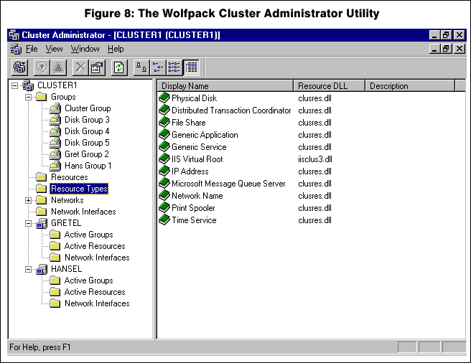
What happens if a node fails at the primary site? If node Hansel fails, for example, the Domino server HansDomino will be restarted on node Gretel as a second Domino partition server. Users will dynamically reconnect to the HansDomino partition server now running on node Gretel. This is an example of Wolfpack failover.

Now imagine the entire computer room at the local site (Site1) has lost power. Never happen, right? If it does happen, client requests for HansDomino and GretelDomino will be redirected over the wide area link to Wolfpack Cluster 2, to the surviving Domino servers BergDomino and VagabondDomino. This is an example of Domino cluster failover.

Implementing this hybrid solution is a three-step process:

- Configure two Wolfpack clusters.
- Install Domino partition servers on Wolfpack.
- Create Domino clusters.

Step 1: Configuring the Wolfpack Clusters

We’ll configure Wolfpack Cluster 1, which consists of Hansel and Gretel. You first saw this cluster in Figure 3, and then as part of the hybrid solution in Figure 7. Let’s assume we’ve already installed Windows NT and Wolfpack on Hansel and Gretel.

For each node in the cluster, configuration consists of creating resources (e.g., Domino servers) and assigning them to failover groups. We need to use the Wolfpack Cluster Administrator for this job. The Cluster Administrator Utility (shown in Figure 8) is installed under the Windows Administrator Tools program group during the Wolfpack Cluster installation process. The Cluster Administrator uses templates to create and define properties for cluster resources. We will be working with three types of resources: physical disk, generic service, and IP address.

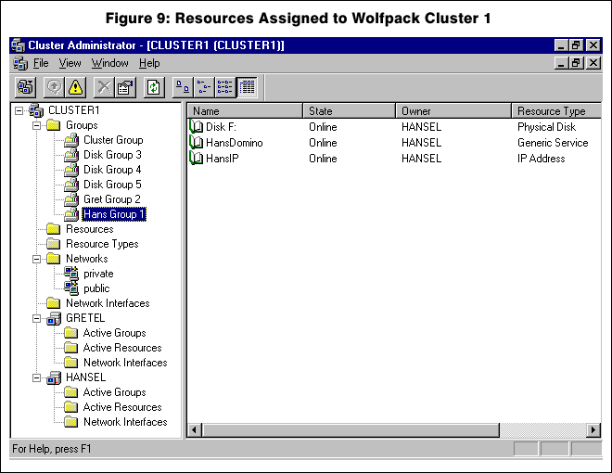
Specifically, we’ll use the Cluster Administrator to:

- Create a resource group for each Domino server in the Wolfpack cluster (Domino service, IP address, and disk drive).

- Specify the order in which resources are started in each group.

- Configure resource monitoring to detect failure of server processes, restart those processes, and to trigger failover when necessary.

Creating and Assigning Resources

Let’s assume we have two logical disks on the SCSI storage device that is shared by Hansel and Gretel. When the Wolfpack cluster software was installed, these automatically appeared as Physical Disk Resources in the Wolfpack Cluster Administrator utility (i.e., DiskGroup 1, which maps to physical drive F:\, and DiskGroup 2, which maps to drive G:\). These Physical Disks will be the Domino data disks for each of our partition servers. As Figure 7 shows, we’ve already renamed them Hans Group 1 and Gretel Group 2.

Now we manually create IP address and generic service resources for each of the two groups:

- Using the mouse, select Hans Group 1. Right click the group, and select New Resource from the list box that pops up.

- In the Resource Type box, select IPAddress. This will start an IP Address Configuration wizard that will define properties for the floating IP address assigned to Hans Group 1.

- Select Hans Group 1 again, and right click the group.

- In the Resource Type box, select Generic Service. This will start a Generic Service wizard that will define properties for the service we want to start when Hans Group 1 is brought “online.” Name this the HansDomino service.
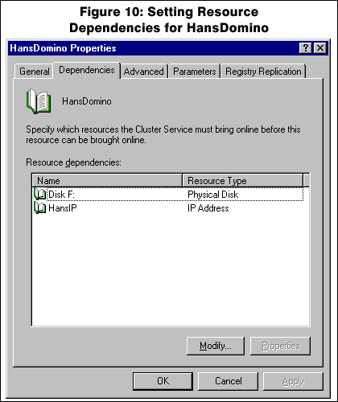
In Figure 9, we see that “Hans Group 1” now contains three resources: Disk F, HansDomino, and HansIP.

- Perform the same steps for Gretel Group 2.

Resource Dependencies

When a group is brought “online” on a cluster node, it is important that the resources are started in a set order. For example, application startup is typically dependent on access to initialization data files (i.e., notes.ini). If those files are not found, the application fails to start. In Wolfpack, you can set the order in which resources are started by means of resource dependencies.

For our configuration, we want to make the HansDomino resource dependent upon both the Disk F resource and the HansIP resource. In other words, we want Hans Group 1 to start the Disk F resource first, then the IP Address resource, and finally the HansDomino resource. We’ll set these dependencies using the Dependencies page of the HansDomino Properties window, as illustrated in Figure 10. (Right click HansDomino in the Wolfpack Cluster Administrator and select Properties.)

Now, if a failure occurs on node Hansel, Hans Group 1 will migrate to and be owned by Gretel. When the Group is moved or failed over to Gretel, resources assigned to the group will come online on server Gretel. Disk F will be made available to the operating system, HansIP will bind to a preconfigured network adapter on node Gretel, and the Domino server HansDomino will start on node Gretel.

Resource Monitoring

If a resource fails, you can configure it to restart, not be restarted, or to fail the group that contains the resource over to another node. You can configure these Resource monitoring settings through the Advanced Properties page of the group.
Wolfpack allows you to configure groups to run on a preferred node of the cluster. In our example, Hans Group 1 is configured to run on node Hansel as its primary server. If node Hansel fails, or one of the resources in Hans Group 1 fails, the group will be moved or failed over to node Gretel.

Figure 11 shows that HansDomino will restart automatically if it fails. HansDomino will restart three times in 900 seconds. After the fourth failure, the Wolfpack Cluster service will fail Hans Group 1 over to Gretel.

Configuring Failback

Failback allows groups to be returned or “failed back” to their primary server. There are three choices for Failback:

- Prevent Failback
- Allow Failback immediately
- Schedule Failback

You make these choices on the Failback Properties page, as shown in Figure 12.

In a production environment, the best choice may be to either prevent failback until the problem can be resolved or schedule failback after hours. These choices minimize any interruption of service that may be caused by resources moving from one node to another. If you allow failback immediately, the result may be a “ping/pong” condition where groups are continually migrated from one server to another because of a recurring hardware failure.

Creating the Second Wolfpack Cluster

To configure Wolfpack Cluster 2 at the remote site (servers Berg and Vagabond), we follow the same steps as for the first cluster.

Step 2: Installing Domino Partition Servers on Wolfpack
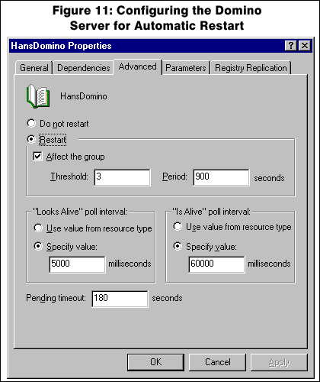
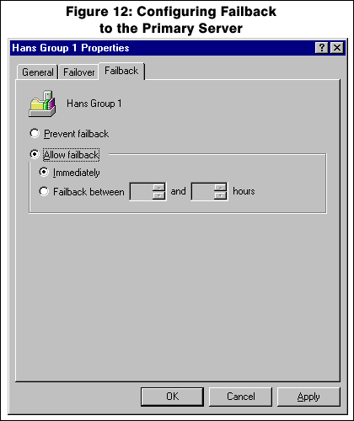
With Wolfpack cluster resources created and assigned to failover groups, we are ready to install the Domino servers. Because each node in our Wolfpack cluster must be capable of running two instances of Domino in the event that one node has failed (see Figure 4), we need to install Domino partition servers. Partition servers and Domino clustering are both available as part of Domino Advanced Services.

We will install two Domino servers, HansDomino and GretelDomino. These servers will be in the same Notes domain. Before we begin the installation, we move all the cluster resources to node Hansel so that it has access to both drive F:\ and drive G:\ and to both floating IP addresses.

To install Domino on Hansel, we do the following:

- Start the Domino installation by selecting install.exe from the platform-specific subdirectory on the distribution CD.

- When the installation program begins, select Custom Installation.

- Choose a local, non-shared drive to install the program files, for example “C:\notes”.

- Choose a shared SCSI drive to install the notes data files. We will choose drive “F:\notes\data,” which belongs to Hans Group 1.
- Choose the Advanced Services Tab and select all three options. This will install the Domino partition server and cluster software.

- Once the files are installed, start Notes Client 1 in the Lotus Application program group on server Hansel to configure the first Domino partition server. Configure this partition as HansDomino.

- HansDomino is now configured on drive F:\. Because server Hansel will need to run Gretel’s Domino server on drive G:\ if Gretel fails, we now install a second Domino partition on drive G:\. Start the installation program again and select Custom Installation.

- Change the default location for the data files of the second partition (GretelDomino) from F:\notes\data2 to G:\notes\data.

Because Domino partition servers use common program files and unique data files, there is no option to re-install the program files during installation of the second, and all subsequent, partitions.

- Configure the Domino partition server GretelDomino by starting Notes Client 2 in the Lotus Application program group. Cluster node Hansel is now fully configured to run both Domino partitions: HansDomino and GretelDomino.

Configuring Domino on the Second Node in Wolfpack Cluster 1

We now have to repeat the installation process on cluster node Gretel. Since both Domino servers were configured during the Hansel installation, we only need to install the Notes program files on Gretel’s local, non-shared C:\notes drive and create the Lotus Application Program Group.

To begin this installation, use the Cluster
Administrator Program to move all cluster resources to node Gretel. Now repeat the Domino server installation process for both Domino partition servers. This is similar to a Domino upgrade. Therefore, there is no need to reconfigure the Domino servers using the Notes clients. The information in the notes.ini files is retained from the previous installation on node Hansel.

TCP/IP Considerations

The network adapter of a cluster node can have two or three IP addresses bound to it at any one time depending on the state of the cluster. For example, in a failover state, the surviving node takes on additional IP addresses from the failed server and binds them to the physical NIC.

We need to ensure that the Domino server process binds to the same IP address, independent of the node on which the Domino partition server is running. The notes.ini and httpd.cnf files require manual edits to bind a Domino partition server to a specific IP address. These files are stored in the data directory of each Domino partition server.

Let’s look at our example of Hans Group 1. In this group, we have an IP address resource 16.25.16.38, and a generic service resource HansDomino. To force the HansDomino partition server to bind to 16.25.16.38, we need the following entry in the notes.ini file:

TCPIP_TcpipAddress=0,16.25.16.38:1352

This entry ensures that HansDomino will respond to all incoming requests from Notes clients and other Domino servers on TCPIP Address 16.25.16.38 Port 1352.

What about requests from Web browser clients? To ensure that the HTTP process responds to the correct address, we edit the httpd.cnf file and insert the following lines:

BindSpecific yes
Hostname 16.25.16.38

This entry forces HansDomino to respond to all incoming requests from Web-based applications and clients on TCPIP Address 16.25.16.38 Port 80.

Perform the same edits to the notes.ini and httpd.cnf files for GretelDomino Server in G:\notes\data, substituting the IP Address resource specified in Gretel Group 1.

Starting and Stopping Partitioned Servers as an NT Service

The current release of Domino Advanced Services does not support running a Domino partition server as a Windows NT service. The problem is that we cannot run multiple instances of the executable that starts Domino as an NT service on the same machine (nservice.exe for Intel or aservice.exe for Alpha).

Domino partition servers are started by the execution of a batch file (Nserve.bat) that is created during the partition server installation. This batch file is located in the notes\data directory:

Nserve.bat
Set NotesPartition=1
C:\notes\aserver.exe=f:\notes\data\notes.ini

Two utilities in the Windows NT Resource Kit can help us start the Domino partition servers as Windows NT services. These are instsrv.exe and srvany.exe.

Srvany.exe allows us to start *.bat or *.cmd files as Windows NT services. The instructions and examples are located in SRVANY.WRI in the Windows NT Resource Kit.

To gracefully shut down a Domino partition server you can modify Nserve.bat with the following edits:

Kserve.bat
Set NotesPartition=1
C:\notes\aserver.exe =f:\notes\data\notes.ini -q

Step 3: Creating Domino Clusters

We’re ready to tie our two Wolfpack clusters together by forming two Domino clusters connected over the WAN (wide area network). Here’s how:

- Open the Public Address Book on the Domino administration server. Go to the Servers view, and select HansDomino.

- Edit the HansDomino Server document and choose Add to Cluster. If this is the first cluster in your Notes Domain, the dialog box will ask you to create a new cluster.

- Enter the cluster name. Let’s call it “Domino Cluster 1.”

- Next, select BergDomino from the Servers view.

- Edit the Server document and select Add to Cluster. Select Domino Cluster 1 and add BergDomino.

In the Clusters view of the Public Address Book, we now have Domino Cluster 1 consisting of Domino servers HansDomino and BergDomino.

To create a second Domino Cluster consisting of GretelDomino and VagabondDomino:

- Edit the GretelDomino Server document, and select Add to Cluster. This time the dialog box will prompt you to add the server to an existing cluster or to create a new cluster.

- Select Create a new cluster, and call this cluster “Domino Cluster 2.”

- Edit the VagabondDomino Server document, and add this server to Domino Cluster 2.

In the Clusters View, we should now have two clusters: Domino Cluster 1 and Domino Cluster 2.

Domino clustering provides workload balancing by redirecting client requests from one server in a cluster to another. In our cluster, we want to disable workload balancing to prevent redirection from taking place over the WAN. While this redirection would not compromise the integrity of the cluster, it would result in worse response time because of the network latency.

Variations on Our Disaster-Tolerant Cluster Configuration

Moving beyond our hybrid solution, we can further exploit the Domino and Wolfpack clustering technologies. For example, instead of a two-node Windows NT or Wolfpack cluster at the remote site, we can configure a Unix cluster to handle remote site requirements for Domino.

Perhaps you don’t need a cluster at your remote backup site. Consider putting a single super server at that site – an Alpha Server 8400 running Windows NT and multiple Domino partition servers, each handling one or more local site clusters. Configure it with 14 GB of memory (2 GB per Domino partition server), and I’ll bet it will handle anything you can throw at it. But you better have a wide network pipe to drive it!

Even if you don’t have a remote site, what about all those other servers in your company, the ones in other divisions or locations that are running Domino in addition to other mission-critical applications? You might want to find out what their plans are for disaster recovery or high availability. Combining computing resources into geographic clusters might result in consolidating servers into more efficient work groups at higher levels of availability.

Tips for Designing Wolfpack
Clusters

You’ll want to remember the following when designing and configuring Domino in a Wolfpack cluster:

- You can configure the cluster to run in a symmetric mode, that is, with Domino servers on both nodes, or in asymmetric mode, with Domino running on one node and another application like SQL/Server or file and print running on the other. As we’ve seen, symmetric mode for Domino requires that you use Domino partition servers. For applications other than Domino, you must be able to run multiple instances of the application process on a Wolfpack node.

- Configure cluster members with enough resources so that they can run in a degraded mode. You may not need to run them at full capacity or with the same level of service, but you should plan extra resources (in particular, memory) for each server participating in the cluster. Keep the cluster balanced with an equal amount of CPU processing power on each node.
- Use a dedicated NIC for cluster “keep alive” polling. This keeps the heartbeat off the public network servicing your Notes clients. If the cluster heartbeat times out because the public network is saturated, you risk prematurely triggering a cluster failover.

- Use hardware-based RAID for your Domino data. Wolfpack does not support Windows NT software-based RAID. Consider RAID 0+1 if performance is the most critical requirement, and RAID 5 if cost and availability is the most critical.

- In the Public Address Book, define the Domino server by its floating IP address and not its server name. This allows clients to reconnect to an IP address that floats among cluster nodes. It is the key to transparent client failover and failback.

- Be careful about how you define failback. Scheduled failback is a useful feature that enables you to rebalance the cluster during off-hours, but be sure the original cause of the failure is resolved. Otherwise, you may end up pinging users back and forth on an unstable server.

- Make sure your virus checker, monitoring, and backup software work with the Domino partition server. On failover, a second instance of the Domino server will run on the surviving server; you’ll want the monitor to recognize it and the virus checker and backup software to support this condition.

- Set up replication only for shared databases that must be accessed by both nodes in the cluster. Remember, disks will be moved between cluster members on the failure of the primary node, so there’s no need to replicate non-shared data such as mail or personal databases.

Conclusion

Choosing an availability solution is driven by a number of considerations. As a start to understanding which approach you should take, I suggest answering the following questions:

- Will the cluster be used only for Domino, or for other applications as well?

- Is the primary reason for the cluster to provide additional capacity or growth?

- Is planned software and/or hardware maintenance the primary consideration?

- Is unplanned hardware failure the primary availability concern?

- Is transparent reconnection of the clients required upon server failure?

- Are nodes of like or disparate architectures going to be in the cluster?

- Is disaster tolerance or geographic clustering required for availability?

- Is the cost of replicating data or disk devices a consideration?

- How many nodes and what type of nodes are required in the cluster?

- Is network performance or replication overhead a concern?

The Wolfpack “shared nothing” model provides a great local solution when you require transparent reconnection, the ability to support multiple software solutions, and linear scalability as nodes are added to the cluster. Domino clusters provide a great solution when you require support for up to six nodes independent of processor architecture, dynamic load balancing across cluster members, and real-time event replication across a geographically dispersed network.

As server consolidation continues, I believe that organizations will rapidly adopt Wolfpack for its performance and scalability attributes, as well as the other benefits it offers. Likewise, as enterprises continue to integrate large enterprise Domino environments across wide geographic regions, the replication of mission-critical information will continue to drive the need for Domino clustering. With the rapid acceptance of Wolfpack, Domino clusters will undoubtedly be formed from existing Wolfpack clusters. These configurations will evolve into disaster-tolerant geographic clusters that are similar to our hybrid solution with large consolidated Windows NT servers as the back-end information repository for the enterprise.

Watch in the coming months for further developments from Lotus that integrate Domino clusters more tightly with operating system clusters like Wolfpack - further enhancing your ability to create clusters that exploit the strengths of these two great clustering approaches.

Acknowledgments

I would like to acknowledge the people in the Digital Partner Engineering Organization responsible for NotesBench performance and cluster testing of the Domino solution who contributed to this paper. In particular, Ken Bell has been instrumental in developing and testing the Domino solution on Digital’s Windows NT Clusters, and Wolfpack. He is one of the key people responsible for designing and driving our clustering solutions, and he has provided valuable input and consulting for this article.

Thanks also to the Domino Clustering team at Iris for their interest and helpful review of this article. While the Wolfpack and disaster tolerant configuration presented in this article has been tested by Digital, it has not been officially certified by Lotus at this time. Lotus, however, would like you to know they welcome the testing and implementation of innovative configurations with Domino.

Peter Eggiman is a Senior Engineering Manager at Digital responsible for the engineering relationship with Lotus/Iris and other partners providing enabling technologies such as open file backup, virus scanners, and monitoring software for the Domino environment. He has been with Digital for 16 years, and has spent the majority of time working on performance optimization and clustering projects. He enjoys spending free time collecting and repairing antique clocks.

