February 2000
Prepared by Donald Livengood
Applied Microsoft Technology Group
Compaq Computer Corporation

Contents
Introduction 3
SMTP: Core Transport 3
SMTP Virtual Servers 4
Routing Groups 8
Local Delivery 8
Intra-Routing Group Delivery 9
Connecting Routing Groups 10
Inter-Routing Group Delivery 12
Routing within the Enterprise 13
Link State Routing 13
Link State Updates between Routing Groups 15
Coexistence with Exchange 5.5 18
Changing our Designs and Best Practices 19
Summary 19
Appendix A: SMTP Extensions in Windows 2000 20
CHUNKING 20
DSN 21
PIPELINING 21

Routing in Exchange 2000
Abstract: Exchange 2000 introduces a brand new routing architecture based on SMTP. This White Paper provides a detailed description of the Exchange 2000 routing architecture and introduces the Exchange 2000 routing terminology and methodologies. It contains the following information:
- A description of the SMTP Core Transport
- Information on how to connect Routing Groups
- A description of inter-routing group delivery
- An explanation of how Exchange 2000 coexists with Exchange 5.5 from a routing standpoint
- Necessary changes to designs and best practices

Notice
The information in this publication is subject to change without notice and is provided “AS IS” WITHOUT WARRANTY OF ANY KIND. THE ENTIRE RISK ARISING OUT OF THE USE OF THIS INFORMATION REMAINS WITH RECIPIENT. IN NO EVENT SHALL COMPAQ BE LIABLE FOR ANY DIRECT, CONSEQUENTIAL, INCIDENTAL, SPECIAL, PUNITIVE OR OTHER DAMAGES WHATSOEVER (INCLUDING WITHOUT LIMITATION, DAMAGES FOR LOSS OF BUSINESS PROFITS, BUSINESS INTERRUPTION OR LOSS OF BUSINESS INFORMATION), EVEN IF COMPAQ HAS BEEN ADVISED OF THE POSSIBILITY OF SUCH DAMAGES.
The limited warranties for Compaq products are exclusively set forth in the documentation accompanying such products. Nothing herein should be construed as constituting a further or additional warranty.
This publication does not constitute an endorsement of the product or products that were tested. The configuration or configurations tested or described may or may not be the only available solution. This test is not a determination of product quality or correctness, nor does it ensure compliance with any federal, state or local requirements.
Product names mentioned herein may be trademarks and/or registered trademarks of their respective companies.
Compaq, Contura, Deskpro, Fastart, Compaq Insight Manager, LTE, PageMarq, Systempro, Systempro/LT, ProLiant, TwinTray, ROMPaq, LicensePaq, QVision, SLT, ProLinea, SmartStart, NetFlex, DirectPlus, QuickFind, RemotePaq, BackPaq, TechPaq, SpeedPaq, QuickBack, PaqFax, Presario, SilentCool, CompaqCare (design), Aero, SmartStation, MiniStation, and PaqRap registered in United States Patent and Trademark Office.
Netelligent, Armada, Cruiser, Concerto, QuickChoice, ProSignia, Systempro/XL, Net1, LTE Elite, Vocalyst, PageMate, SoftPaq, FirstPaq, SolutionPaq, EasyPoint, EZ Help, MaxLight, MultiLock, QuickBlank, QuickLock, UltraView, Innovate logo, Wonder Tools logo in black/white and color, and Compaq PC Card Solution logo are trademarks and/or service marks of Compaq Computer Corporation.
Microsoft, Windows, Windows NT, Windows NT Server and Workstation, and Microsoft SQL Server for Windows NT are trademarks and/or registered trademarks of Microsoft Corporation.
NetWare and Novell are registered trademarks and intraNetWare, NDS, and Novell Directory Services are trademarks of Novell, Inc.
Pentium is a registered trademark of Intel Corporation.
NonStop registered in U.S. Patent and Trademark Office.
Copyright ©1999 Compaq Computer Corporation. All rights reserved. Printed in the U.S.A.

Introduction

Exchange 2000 introduces a brand new routing architecture. Instead of the core routing being based on X.400 and RPCs as it was with pre-Exchange 2000 servers (5.5, 5.0, and 4.0), the new routing architecture is based on SMTP.

SMTP: Core Transport
SMTP, the Simple Mail Transfer Protocol, is the default protocol used for the transmission of messages between Exchange 2000 servers. The protocol is well established and was first defined in RFC 821 in 1982.

Until Exchange 2000, the message transfer agent, or MTA, in Exchange was based upon X.400 and RPCs. This technology served its purpose well and produced a very functional transport core for companies implementing Exchange 4.0 through 5.5. An obvious question is why would Microsoft change something that is working very well? The answer can be found in the underlying operating system, Windows 2000.

With Windows 2000, Microsoft has exposed and relies heavily upon the Active Directory. Directory services, and especially the Active Directory, bring many benefits to an Enterprise most of which are outside of the scope of this document. One technical benefit and capability of the Active Directory is the integration of DNS. The other obvious benefits the Active Directory brings are a single point of authentication and the central storage of configuration information. Microsoft had a specific goal in leveraging these capabilities and the associated information within the transport of Exchange 2000. To do this, they had two choices; modify the current MTA or create a new, more powerful transport core. They chose the latter.

Recreating a new transport core may seem like a lot of work; and no doubt it was. However this recreation was the only logical step for three reasons:

- The Exchange 5.5 (and older), the MTA was based on an X.400 MTA purchased from another vendor. X.400, in general, isn’t as easy to enhance as SMTP and this is especially true if it is older code written with different goals in mind than those required for Exchange 2000.

- Microsoft has proven, via the IMS (Internet Mail Service) in Exchange 5.5 and via their MCIS product that they can produce a very fast SMTP-based MTA. As it turns out, the IMS is the fastest connector in an Exchange 5.5 implementation.

- The world is Internet protocol based, and this point alone justifies SMTP.

In addition to the features and functions required by Exchange 2000, Microsoft also decided that an SMTP service should be included as part of the operating system. This, too, makes sense when you consider that every Unix platform includes a basic SMTP service and they will be competing head-to-head with Unix platforms. As it turns out, the Exchange 2000 engineering team wrote the SMTP service included in Windows 2000.

The SMTP service supplied as part of the Windows 2000 operating system is a solid SMTP transfer agent. When Exchange 2000 is installed, that service is enhanced. Before we discuss those enhancements, let’s examine the SMTP service as it is delivered in Windows 2000.

The Windows 2000 SMTP service is highly functional and implements the majority of the enhanced SMTP features defined in the various messaging related RFCs. For instance, “Chunking”, DSN (Delivery Status Notification), and “Pipelining” are all supported. Descriptions of these features are given in Appendix A at the end of this document.

SMTP Virtual Servers
It is important to realize that SMTP, along with other Internet protocols, is supplied by IIS version 5.0. Each service supplied by IIS, including SMTP, is implemented as a Virtual Server. A Virtual Server is the binding of a protocol, a port, and an IP address. For example, a server with the IP address: 16.188.153.200 would have a Virtual Server consisting of:
- Service: SMTP
- Port: 25
- IP Address: 16.188.153.200

The advantage of Virtual Servers is that they allow you to have multiple instances of the same service (for example, SMTP) on a single server. More interestingly, each Virtual Server can be configured with different characteristics. This becomes clear, and important, when you consider that a single NIC can be assigned multiple IP addresses, and in the case of an ISP, each SMTP Virtual Server could be dedicated to a particular customer. In short, Virtual Servers allow a customer to implement an SMTP service on a per IP address basis or, less likely, a per port basis. This was not possible with Exchange 5.5, as only a single IMS could be implemented per server.

One thing to note is that services supplied by IIS store their configuration information in the IIS Metabase. The Metabase is a hierarchical database that has many of the same characteristics as the Active Directory, including inheritance. The significance and importance of the Metabase will become clear later.

Remember, so far we’re only talking about Windows 2000. So then, how does this all relate to Exchange 2000? As part of the Exchange 2000 installation, the Windows 2000 SMTP service is modified to be aware of Exchange specific information; namely, mailboxes. As you may have learned from other research, Exchange 2000 can be thought of as the binding of the Exchange Information Store and IIS v5.0. This binding is accomplished via a high-speed, shared memory interface code named “Epoxy”. Think of “Epoxy” as its name implies, as glue. In this case, the glue allows services hosted within the context of IIS to access information in the Exchange 2000 store via their native protocol. In short, SMTP or any of the other Internet protocols hosted in IIS have access to the Information Store; or, as it is now known, the WebStore.

After installation of Exchange 2000, the now Exchange 2000 enhanced SMTP service is also implemented within the context of IIS as a Virtual Server, and each Virtual Server instance of SMTP has all of the capabilities of the base Windows 2000 SMTP service. The major functional difference is that the Exchange 2000 enhanced SMTP service is conscious of the Active Directory and, therefore, information stored in AD, such as mailboxes. The other important enhancements are those made to Advanced Queuing, which provided the ability to deliver to the Information Store, and management capabilities.

Active Directory
A transport system alone does not make a messaging system. Having SMTP in the underlying operating system is great, but where are the messages going to be delivered? More importantly, even if there is a message store to deliver a message to, how do you determine which one to use? Directory services are key to this “location brokering” function.

The Exchange 2000 transport must determine the final destination of a message. That destination will either be another transport system or, more likely, a mailbox. In an enterprise environment mailboxes can be spread over any number of servers and, with Exchange 2000, the mailboxes can be present in a wide range of storage groups on a single server. Because all of this information: users, Message Store, Server name, etc. is stored in Active Directory, the transport system uses the Active Directory to determine the final destination of a message. The transport service will query the Active Directory to determine where a message should be sent or delivered. This capability is called “categorization” and there is a Categorizer component within Exchange 2000, which supplies this function.

Advanced Queuing
Although part of the Windows 2000 SMTP service, Advanced Queuing is an important component of the Exchange 2000 core transport. Advance Queuing builds and manages queues based on domains and links. Domain queues exist for messages grouped by their final destination, and link queues are messages grouped by their next hop. Domain queues are created just as you would expect, for domains such as; Compaq.com, digital.com, Tandem.com. Link queues represent the next hop messages take. For example, if all messages to an Internet domain must traverse an ISP via a smarthost, the link queue would show messages queued for the ISP and the domain queue would be organized by domain name.

Advanced Queuing also provides a queue management API. This API is used within the Exhange 2000 management interface and has the capability of stopping, starting, pausing, or freezing a queue. There is also a Queue Viewer tool that uses the API to display queue information from the Exchange 2000 System Manager Console.

In addition to managing queue information, Advanced Queuing is also the component that generates Delivery Status Notifications.
Events
It is worth mentioning at this point that the transport system operates on top of an event model. Events are spread throughout Exchange 2000 and are used by various components in normal Exchange 2000 operations. There are various places where Events are exposed in the product and this is particularly true for the transfer system.

There are two classes of events that are related to the transfer system; transport events and protocol events. Examples of transport events are events that commence when messages are submitted, when routing information is determined, before messages are categorized, as they are categorized, and after they are categorized. In addition, events can be connected with SMTP protocol commands. For example, it is possible to create a brand new SMTP command that, when issued, performs some pre-defined function. An example might be creating a command called QUEUE that, when issued, returns a notification of the number of messages queued for delivery.

This event architecture is likely to be leveraged by ISVs to add features and functions to Exchange 2000. A detailed discussion of Events can be found in the 1999 Microsoft Exchange Conference presentation (4-402) by David Lemson of Microsoft titled: Building Applications With Exchange 2000 Transport and Protocol Events. Information about events is also located on the Exchange 2000 SDK where you will find information on SMTP Server Events for Windows 2000 and, inside the Microsoft Exchange 2000 Server section, in a sub-section named, SMTP/NNTP Transport event sinks with CDO.

Access to the Information Store
The basic transport system must provide store and forward capability. For store-and-forward, the transport service uses NTFS. Eventually though, the transport core must be able to deliver the message to the Information Store. With Exchange 2000, an Exchange Store driver is installed that understands the Exchange ExIFS (Installable File System). This driver allows the transfer system to deposit message directly into the Information Store.

For messages arriving into an Exchange 2000 organization via SMTP and the Internet, the message will actually be stored in the new Streaming file (.STM), with certain message attributes (TO:, CC:, SUBJECT: etc.) being promoted to MAPI properties in the .EDB file. The Exchange Store driver enables this capability.

Management
Exchange 2000 also enhances the management capabilities of the underlying Windows 2000 SMTP service. The Exchange 2000 System Manager Console includes a common interface to manage not only Exchange 2000 specific information such as mailboxes, but also the ability to manage the protocols that are hosted in IIS. In other words, instead of having to use the IIS management interface to manipulate the SMTP Virtual Server(s), you can manipulate them via Exchange 2000.

It is important to note that Exchange 2000 stores all of its configuration information in the Active Directory, and IIS stores its information in its Metabase. So, if you modify the SMTP Virtual server from the Exchange 2000 System Manager Console, how is the information moved from the Active Directory into the Metabase? As it turns out, a service called Metabase Update runs as part of the Exchange 2000 System Attendant. Whenever information for one of the Internet protocols is changed, the Metabase Update service starts up and updates the protocol specific configuration information in the IIS Metabase.

Grouping Servers
From a transport perspective, Exchange 2000 servers are grouped by a newly introduced concept called a Routing Group. A Routing Group can be defined as a collection of well-connected servers that communicate, via SMTP, in a point-to-point fashion. Again, from a transport perspective, Routing Groups are similar to Exchange 5.5 Sites. The major difference, and it is major, is that Sites in 5.5 defined a common boundary for permission, administration, and transport. With Exchange 2000, those elements are separate. In essence, with Exchange 2000 you have the freedom to assign server management permissions to a specific IT support group, and assign management and configuration of message transfer to a more network-centric organization in the enterprise. This flexibility alone is a huge advantage over the Exchange 5.5 realm in terms of administration.

As an illustration, in Exchange 5.5 deployments it was very likely that Administrative control was handed out on a per-Site basis. In some cases, message transport was negatively affected based on the careless or unknowing creation of extraneous connectors or IMS (Internet Mail Services) at a poorly managed site. Because of the separation of Administrative Groups from Routing Groups in Exchange 2000, tighter control can be maintained with regards to available connectors, and the management of transport specific tasks can be allocated to a focused group.

To make things simple during installation, Exchange 2000 servers are automatically created as members of a Routing Group. By default, for a green field installation, the first Routing Group created is called “First Routing Group.” If other Routing Groups are present in the Exchange 2000 organization, the installation procedure will prompt the installer for the particular routing group to join. The ability to select routing groups is only available if multiple Routing Groups have been created.

Routing Groups
A Routing Group is merely a collection of well-connected servers that communicate in a point-to-point fashion over SMTP. In the context of a Routing Group, “well connected” can be defined as a persistent, point-to-point, low latency connection between servers. So, as a member of a Routing Group, any server has immediate network access to other members of the Routing Group. Routing Group membership is maintained in the Configuration Naming Context of the Active Directory, and is displayed through the Exchange 2000 System Manager Console, which is an Exchange 2000 specific collection of MMC snap-ins.

Routing Group membership is initially established during installation. One of the additional benefits and feature of Exchange 2000 is the ability to easily change Routing Group membership. In fact, creating new Routing Groups and moving servers between them is as easy as drag-and-drop; try that with Exchange 5.5 Sites!

Example Environment
At we need more background information to explain points in the remainder of this document, let’s put some details around an example environment:

First, assume all of the servers discussed are members of an Exchange 2000 organization called “Starcor”. We’ll define a few users and servers as:

- Users: Linda and Alexa
- Exchange 2000 “home” server: Atlanta
- Routing Group: Americas
- Users: Jackson
- Exchange 2000 “home” server: Tampa
- Routing Group: Americas
- User: Pierre
- Exchange 2000 “home” server: Valbonne
- Routing Group: Europe
- User: Kimie
- Exchange 2000 “home” server: Tokyo
- Routing Group: Asia Pacific

The following discussions reference these examples when describing how messages and information are passed from server to server.

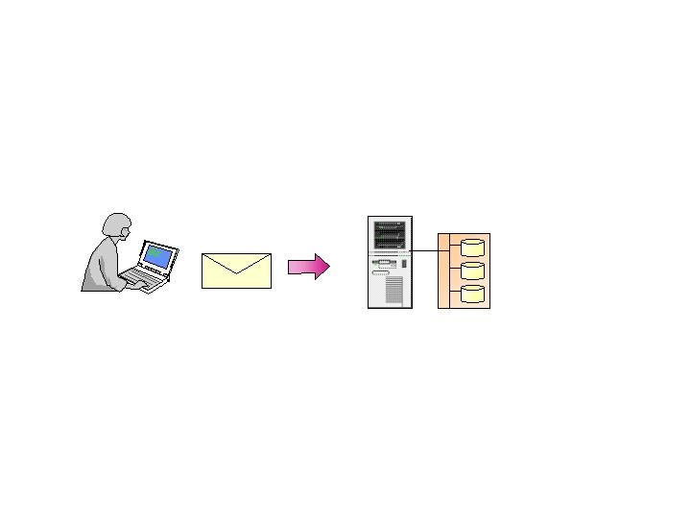
Local Delivery

Local delivery, in our example, would be Linda sending a message to Alexa. When a message is sent from one user to another on the same Exchange server using a MAPI based client (such as Outlook 98 or Outlook 2000), the message transfer works in exactly the same way as it did with previous versions of Exchange. Specifically, the message is submitted to the information store and a pointer to the message is passed via the transport mechanism. The benefit here is that transport events are “fired” even for local deliveries.
Figure 1: Both users are located on server, Atlanta
Both users located on Server “Atlanta”

The user was determined to be local when the Categorizer made it’s query to the Active Directory. When the Categorizer queried the Active Directory for the recipient’s information, the Active Directory returned a value for HOME-MDB (Atlanta), which indicated that the recipient’s message store was on the local server.

Intra-Routing Group Delivery
Intra-routing group delivery, in our example, would be Linda sending a message to Jackson. When a message is sent from one user to another within the same Routing Group, the scenario changes slightly. When Linda submits the message, just as before, the Information Store performs a lookup in AD for the recipient.
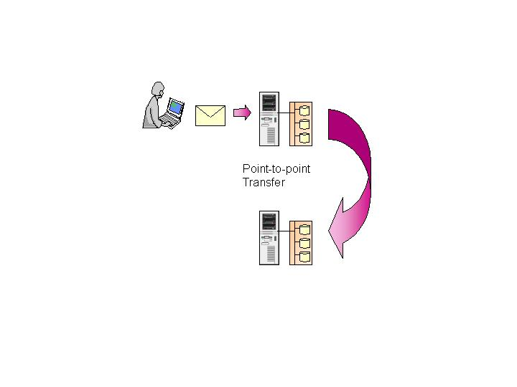
Atlanta

Tampa
If the recipient’s server is an Exchange 2000 server in the same Routing Group, the message is routed via SMTP to the recipient’s server. Message transfer within a routing group is point-to-point, meaning that the originating server communicates directly with the target server.
Figure 2:
Messages Figure 2: Messages sent within same Routing Group

How does a server determine which Routing Group another server is a member of? The Active Directory. Each Routing Group is maintained in the Active Directory along with a list of member servers.
When the recipient’s server receives the message, it locates the recipient in the Active Directory and transfers the message to the recipient’s mailbox.

So, how do these two servers actually communicate? Do they use DNS or are MX records required? The servers do, in fact, communicate via DNS. Remember that MX records in DNS identify those servers that can handle Mail Exchange (MX). Since every Exchange 2000 server can accept SMTP connections, there’s no need for MX records, and, by default, every server automatically gets a DNS “A” record when it is a member of a domain. So within a Routing Group, all that is required is the conversion of a host name to an IP address. This is exactly what DNS is used for in a pure Exchange 2000 configuration. The server names themselves are stored in the Active Directory so DNS is only required to obtain the actual IP address. Once that is obtained, the two servers communicate through port 25 using SMTP.

In our example, once server Atlanta determines that mail for Jackson must be delivered to server Tampa (determined via calls to the Active Directory), it calls DNS to resolve the server name to an IP address and then connects to that address on port 25.

Connecting Routing Groups
As you would expect, large organizations are likely to have multiple Routing Groups. As we’ve stated, servers within a Routing Group have direct, point-to-point connections between them. If an environment has multiple routing groups then the routing groups must be connected somehow. With Exchange 2000, just as with Sites in previous versions of Exchange, Routing Groups are connected via Bridgehead servers.

Bridgehead servers are established to define communications paths between Routing Groups. Single or multiple Bridgehead servers can be used between Routing Groups. The actual mechanism used to join Bridgehead servers in separate routing groups, is a Connector (just as in previous version of Exchange).

With Exchange 2000 there are three choices when connecting Routing Groups:

- Routing Group Connector (a transport independent transport)
- SMTP Connector (SMTP Based transport)
- X.400 Connector (X.400 based transport)

Routing Group Connector. The RGC (Routing Group Connector) is be the first, and most common choice for connecting Routing Groups. Unlike RPC-based Site connectors in previous versions of Exchange, in a pure Exchange 2000 environment Routing Group Connectors use SMTP as the base transport and, therefore, are much more tolerant of high-latency and low bandwidth connections. RGCs can also be scheduled, unlike Site Connectors. However, like the pre-Exchange 2000 Site Connectors, Routing Group Connectors are very easy to configure and allow for automatic generation of the remote end (remote Bridgehead) of the connection.

SMTP Connector. The SMTP Connector can be thought of as the Exchange 2000 version of the IMS. Its primary is to connect Exchange 2000 environments to the Internet or to non-Exchange 2000 SMTP capable systems (for example, PMDF and Unix Sendmail). This connector can also be used to connect Routing Groups, but when you consider that the protocol used for RGCs and SMTP Connectors is the same in a pure Exchange 2000 environment, it is unlikely to be used.

X.400 Connector. The X.400 Connector is virtually identical in Exchange 2000 as it is to previous versions of Exchange; the user interface for the connector is exactly the same. The X.400 Connector can be used in the same scenarios for Exchange 2000 as it was used for prior versions of Exchange; namely low-bandwidth scenarios, connectivity to X.400 providers, or to connect Exchange 2000 Routing Groups. The X.400 connector can also be used to connect to Exchange 5.5 systems that are not connected by other means.

For many environments there may be a certain comfort level associated with X.400 Connectors. It has worked well for years and has provided a very reliable service, even over low bandwidths. Because of this, and the fact that X.400 connectors can be scheduled, many Exchange 5.5 environments have used this connector to connect Sites. It’s important to note that if an Exchange 5.5 server is upgraded to Exchange 2000, any X.400 connectors in place will be maintained after the upgrade.

With the capabilities of the RGC, though, it is expected that most Exchange environments will phase out the use of X.400 to connect Routing Groups. The most likely scenario is that the X.400 connectors will remain in place and RGCs will be brought on-line. The RGCs can then be set to a lower cost, validated for their operation and performance, and remain the primary connector. Over time, the X.400 connectors can be phased out altogether.

Inter-Routing Group Delivery
The scenario now changes to that of a message that needs to be delivered to another Exchange 2000 server in a different Routing Group. Let’s assume Linda is sending a message to Pierre in Valbonne. Since we didn’t establish the connection method between the Americas and Europe Routing Groups, just assume that a Routing Group Connector has been configured, with the Atlanta server being the Bridgehead for the Americas Routing Group.
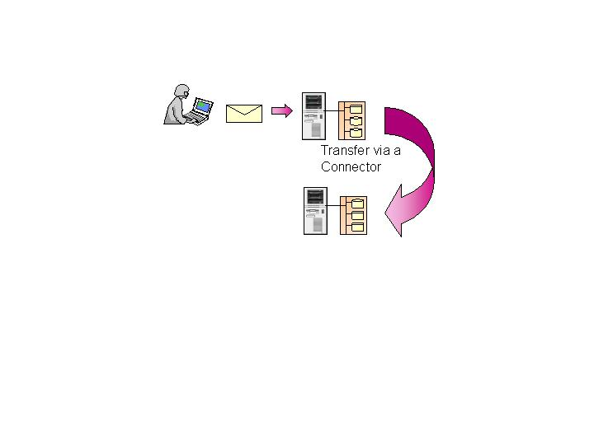
The Atlanta server (specifically, the Categorizer on that server) looks up the recipient, Pierre, in the Active Directory and determines that the recipient system is in a different Routing Group; specifically, Europe.
Atlanta server in RG Americas
Valbonne server in RG Europe

When the recipient’s mailbox is on a server in a different Routing Group, the message must be transferred over a connector. In this case, when the server determines the recipient is on a server in a different Routing Group, it identifies a route for the message to take and routes the message to the appropriate connector, in our case, an RGC. If the originating server is a Bridgehead server, as in our case, it can open a connection and transfer the message directly to a Bridgehead server (Valbonne) in the recipient’s routing group.
Figure 3: Inter-Routing Group Delivery

All of the servers in a Routing Group maintains a table of link state information, which the servers use to determine whether connectors and connections are up or down. The status of the connectors enables servers to determine the optimal route from one routing group to another or, potentially, to reroute messages if a connector or network connection is down.

When a remote Bridgehead server receives the message, the delivery process is repeated until the message is delivered to the recipient’s mailbox. Depending on the path a message must take to arrive at the recipient’s mailbox, the message may travel through multiple servers and routing groups.

This section describes how messages are delivered in an Exchange 2000 environment; point-to-point (via SMTP) within a Routing Group, and via bridgehead servers and connectors between Routing Groups. The following sections describe how the Link State information (referenced earlier in the description) is used.

Routing within the Enterprise
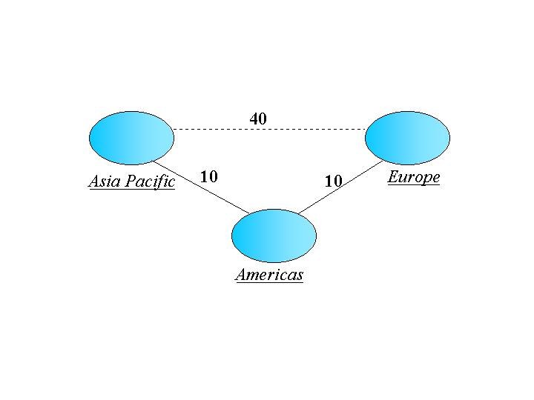
In the previous examples, we described how messages are routed within a Routing Group and between Routing Groups. The scenario remains the same when the routing environment is broadened to encompass an entire Enterprise. Going back to our previous example, assume that we’ve built a routing architecture with the Americas Routing Group as the hub, as shown in Figure 4. Furthermore, only one server in the Americas Routing Group, the Atlanta server, is the Bridgehead for connections to both Asia Pacific and Europe.
Figure 4: Routing Groups with costs assigned

As you expect, messages sent between Asia Pacific and Europe, in our case, Kieran sending to Pierre, would traverse the Americas Routing Group. The direct connection between Asia Pacific and Europe would only be used if the link between the Americas Routing Group and either of the other Routing Groups failed. Again, this is exactly what you would expect with a transfer system that has the capability of assigning costs. The interesting piece is how this happens in Exchange 2000 and, more impressively, how quickly the routing and re-routing decisions are made. The key to all of this is Link State Routing.

Link State Routing
Link State Routing is the method by which Exchange 2000 servers determine the most efficient and cost effective path for message transport. In effect, Link State Routing allows a server to determine the best way to get something from Point A to Point B.

In order for this effective routing to take place, information must be communicated to all servers in an Exchange 2000 environment; specifically, to all servers within an Exchange 2000 organization. Communications within Routing Groups are handled differently to communications between different Routing Groups. Routing information needs to be managed somehow, and a Routing Master server is assigned this task. In Exchange 2000 the first server to join a Routing Group is assigned as the Routing Master and manages routing information within a Routing Group. This is a low-overhead task and can be easily reassigned from server-to-server within a Routing Group.

Routing Master and Link State Updates
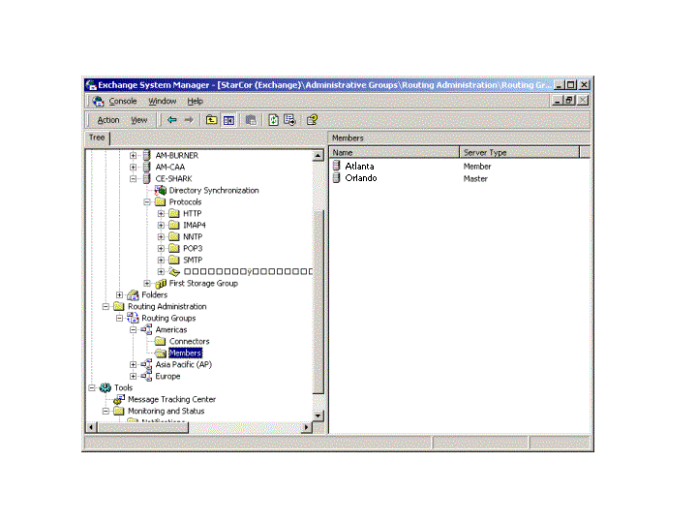
As stated, the first server in a Routing Group is automatically designated as the Routing Master, by default. If multiple servers are added to a routing group they are designated as Member servers. The master role can be transferred to another server via a single right button mouse click.

The job of the routing master is twofold:
- The master is the only entity that is allowed to change the state of links belonging to its Routing Group, and increment the version number associated with its “view”. The importance of this will surface in a moment.
Figure 5: Master Server and Member Servers
- The master updates all members in the routing group with Link State information associated with its Routing Group and other Routing Groups. Link State information about other Routing Groups is fed to the Routing Master from Bridgehead servers connected to other Routing Groups.

To communicate routing information to Routing Group member servers, the master connects via TCP/IP to port 691 on each member server. The protocol used to transmit the Link State information is a Microsoft invented protocol called “Link State Update Protocol”. The information communicated gives each member server a “view” or a “graph” of the entire Exchange 2000 Routing environment, as well as a version number associated with that particular information update. Specifically, there is a version number for every Routing Group in the Exchange 2000 organization and the version number can only be incremented by the master server of each Routing Group. Conceptually, each member server has a view of how all Routing Groups are connected and the state of those connections (up, down, or delayed) as well as the version associated with each ‘view’ of each Routing Group.

Link information is sent from the master to each member as the information changes. If no changes take place within a defined period (10 minutes as of Beta 3), the master connects to each member server, again via Port 691, to determine if each member is operating with the latest version of the Link State information.

The algorithm used to create the view, or graph, of the environment is based on Dijkstra’s algorithm. Dijkstra’s algorithm is a well-known, well-accepted method for determining the least cost between nodes in a network. Many Network Router vendors (for example, Cisco) use the algorithm in their products though it is probably more widely known as OSPF (Open Shortest Path First). The algorithm itself prevents looping and incorporates dynamic re-routing, which fits perfectly with Exchange 2000 transport needs.

Using this information, each server within a Routing Group can make an intelligent decision about which path to use when transferring a message. (The routing path is defined by the Connectors.) Again, the routing information is updated as it changes.

Updating the Master
As stated, the routing Master within a Routing Group receives link updates from the Bridgehead servers in the Routing Group. Each Bridgehead server connector can easily determine the state of its connection to other Bridgehead servers; they are either up or down. Determining the link status occurs in two ways: either by sending a message, or through periodic polling. In either case, if a Bridgehead server cannot communicate with the remote Bridgehead, a link status change is sent from the local Bridgehead to its Routing Master. This communication also takes place via TCP/IP to port 691 on the master. This action, in turn, updates the “view”, and increments the version of the view for the Routing Group.

Link State Updates between Routing Groups
In a large environment, it is likely that scenarios will exist where Routing Groups do not have direct connections to each other, for example in a case where intermediate Routing Groups needs to be traversed. To obtain updates in this type of environment, the Link State information needs to be passed between Routing Groups. In a pure, or native, Exchange 2000 environment, Routing Groups are either connected via an SMTP based connector (an RGC or SMTP Connector) or an X.400 connector. Microsoft has implemented extensions to both SMTP and X.400 to carry this link state information. For SMTP, the extended command implemented to handle link state information is XLINK2STATE. So, in the case of SMTP connectivity between Routing Groups, when one Routing Group needs to pass link information to another, it first uses the EHLO command and then sends the XLINK2STATE command followed by the routing information update. The routing information is passed in a binary format. The update operation happens as soon as a connection is made between Routing Groups and, therefore, before any actual message processing takes place.

Perhaps the best way of understanding how link state works and what happens to messages in the event of failures is to give an example. Assume we have five routing groups; RG1, RG2, RG3, RG4, and RG5 connected with Routing Group Connectors and costs shown in Figure 6.

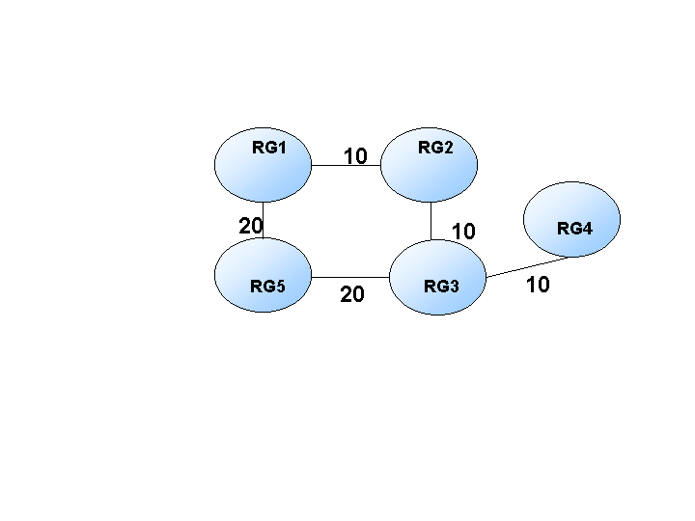
Normal Message Flow
As you can see from the cost of the connections, a message sent from RG1 to RG4 will hop via RG2 and RG3
.

Single In-line Failure
Assume that the network fails between RG2 and RG3. Unless there are messages waiting to be transferred over this link, the failure will not be picked up immediately. Therefore, if a user in RG1 sends a message to a user in RG4, the routing process will take place as follows:
Figure 6: Link State Routing with 5 Routing Goups

- The Bridgehead in RG1 sends the message to a target bridgehead in RG2.

- Through a call to its Routing engine (a.k.a. “Routing”), RG2 attempts to open an SMTP connection to a target Bridgehead in RG3.

- If there are multiple target Bridgeheads specified on the connector to RG3, the local Bridgehead in RG2 attempts to open a connection in sequential order in case a single Bridgehead has failed.

- If none of the Bridgeheads in RG3 can be contacted, the connection goes into a GLITCH-RETRY state. Essentially, the connection backs off for 60 seconds and then tries the transfer again.

- If after a re-connection attempt, the link is still not operational, the connection is marked as DOWN.

- The Bridgehead in RG2 connects to port 691 of the RG Master (in RG2) and sends a link DOWN notification..

- The RG Master (in RG2) updates the routing information for RG2 and sends an updated view of routing to all nodes in RG2, including the Bridgehead.

- The Bridgehead in RG2 calculates that an alternate route is available to RG4 via RG1, RG5 and RG3. Remember, all servers in an Exchange 2000 organization contain a routing “view” of the entire organization and can make routing decisions directly.

- Before the messages are routed back through RG1, the link DOWN information (for RG3) is sent to the Bridgehead in RG1. The communication takes place using the X2LINK2STATE ESMTP command verb after issuing an EHLO. In essence, the version numbers for each Routing Groups view are compared. In this case, the version number associated with RG2’s “view” has changed, and RG1 (and the other Routing Groupss in the organization) need to be updated with the new “view” for RG2.

- The Bridgehead in RG1 updates its copy of RG2s view and the associated version number and immediately connects to the RG Master in RG1 through port 691. It then transfers the link DOWN information contained in the new version RG2’s “view”.

- The RG Master in RG1 immediately floods this data to all other Exchange 2000 servers in the Routing Group. So, all servers in RG1 now contain the latest version of RG2’s “view” of connectivity..

- Using the new link information, the Bridgehead in RG1 calculates that the best route to RG4 is via RG5

- Before messages are routed to the Bridgehead in RG5, the link state information is propagated to the Bridgehead in RG5 as described before and version associated with RG2 is compared and updated. There is a possibility that RG5 already knows that the link is down if messages were trying to route from RG3 to RG2.

- RG5 continues the process and routes the messages via RG3 and onwards to the destination, RG4

A point to note is that although messages are now flowing through the alternative route, it is likely to be more costly, and we need to know when the original link is available. After a link has been tagged as DOWN, the original Bridgehead will continue to retry the connection based on the interval set on the SMTP Virtual Server. By default, this is 15 minutes. Although there are no actual messages waiting to transfer, the retry is simply an attempt to open port 25 on the destination server. Once a connection has been re-established, the Bridgehead notifies the local Routing Group Master that the connection is available and link information is again propagated to all member servers. Likewise, the information is transferred throughout the organization as described earlier.

Multiple In-line Failures
An interesting scenario takes place when multiple link failures occur. With previous versions of Exchange, the message would potentially ping-pong between the links in a frenzied attempt to find an open connection. However, because of link state routing, the Exchange 2000 transport environment is more intelligent. Take the single in-line failure scenario above and assume that the network link between RG5 and RG3 also fails. In this case:

- The Bridgehead in RG5 attempts to open the connection to the target Bridgehead in RG3, and fails.

- The connection goes into the GLITCH-RETRY state and retries after 60-seconds.
- If a connection cannot be established, the link is tagged as DOWN and the Routing Group Master is informed (which in turn floods the state to the other servers within the Routing Group).
- A call is made to the Routing Group on the Bridgehead server and it calculates that all available routes to RG4 are down. The cost of the connection is therefore INFINITE.

- The messages wait in the queue and every 15 minutes (by default) a further call is made to the Routing Group to see if any links are available.

- If a link becomes available, the messages are re-routed as appropriate. If after 48 hours, the messages are still in the queue, they are non-delivered as NDR’s back to the sender in RG1.

This is great stuff and it happens very quickly! So now we will determine if this will work between different Exchange 2000 Organizations. After all, between Routing Groups we’re just using extensions to SMTP and X.400 to update the routing information. What happens if we connect two Exchange 2000 organizations with either an SMTP or X.400 Connector? Remember that all Routing information, including configured Routing Groups, is kept within the Configuration Naming Context in the Active Directory (within the context of an Exchange 2000 organization). As such, a server from one Exchange 2000 organization has no knowledge about Routing Groups contained within another Exchange 2000 organization. Additionally, when Link State information is passed between Routing Groups, a GUID (Globally Unique Identifier) is included in the link information. This GUID identifies the Exchange 2000 organization to which a Routing Group is a member. If the GUIDs of two Bridgehead servers that are communicating don’t match, the Link information is ignored.

It is clear that link state information between Routing Groups is very beneficial, but what happens with connections to external environments such as the Internet? In the case of the Internet, one or more SMTP connectors would be configured to enable the transport of messages. In the case of multiple Internet access points, link information regarding the state of these connections is updated through the environment. If one of the external connections becomes unavailable, messages are no longer be routed to that down link and any messages queued at that SMTP Connector would be re-routed. Obviously, considerations such as Address Space associated with a connector come into play, but the point is that routing is inclusive of SMTP or X.400 connections to the external world.

In the case of EDK, or Store Based gateways, routing information is only available up to the point of submission of messages to the Information Store. Link information about the remote messaging network, for example cc:Mail, is not propagated via link state updates. In essence, EDK gateways are no different than they are with Exchange 5.5, with the possible exception of modified management interfaces. From a routing perspective, nothing has changed with regard to EDK gateways.

As you can see, link state routing and the management of routing information is completely different from Exchange 5.5. In Exchange 5.5, routing information was maintained in the GWART (Gateway Address Routing Table). While Exchange 2000 performs dynamic routing updates, the GWART is normally only updated nightly. The algorithms used are different too. Exchange 2000 uses the Dijkstra/OSPF algorithm where every Routing Group is treated as a node in a network. If connectivity is lost within the network, the information is immediately propagated throughout the environment. More importantly, messages in transit are dynamically rerouted and new messages are not submitted along paths with broken links.

Exchange 5.5s algorithm is much less dynamic and learns nothing about down links in the network.

Coexistence with Exchange 5.5
As indicated earlier, it is possible to install an Exchange 2000 server as a member of an Exchange 5.5 Site. For this to work properly, the Active Directory Connector must be configured in advance in order to populate the Active Directory with Exchange 5.5 directory service information. Once that has been accomplished, the installation process will prompt as to whether the Exchange 2000 server will join an existing 5.5 site.

Once established as a member of an Exchange 5.5 site, message communication takes place via RPCs. This may seem odd considering that the default method of communication between Exchange 2000 servers is SMTP. However, if you think about it, the only protocol guaranteed to be available on an Exchange 5.5 (or prior) server is RPC. With this it mind, it makes sense for the Exchange 2000 server to use RPCs to communicate with down-level Exchange servers.

The same X.400/RPC based MTA used in Exchange 5.5 servers is included in Exchange 2000 and is specifically used when communicating with 5.5 servers. In environments such as this, it’s important to keep in mind all of the best practices established for membership within a 5.5 site, even when the member is an Exchange 2000 server.

Since we’re now talking about co-existence, let’s paint a quick scenario. Assume we have an Exchange 5.5 server in Site Belfast with a Site Connector configured on it that is communicating with a separate Exchange 5.5 Site called Dublin. If we upgrade this server to Exchange 2000 the Site Connector becomes a Routing Group Connector. In this scenario, the Routing Group Connector will use RPCs when communicating to the Dublin Exchange 5.5 Site. The Routing Group Connector is said to be protocol independent due to its ability to use both RPCs and SMTP.

Obviously SMTP connectors and X.400 connectors could also be used to communicate between Exchange 2000 and Exchange 5.5. Note that when an Exchange 5.5 system that has SMTP or X.400 connectors configured, is upgraded to Exchange 2000, those connectors and their configuration are maintained and available in Exchange 2000.

The ability of Exchange 2000 to detect an Exchange 5.5 system and communicate with it using RPCs is just one example of the co-existence capabilities available between Exchange 2000 and Exchange 5.5. One of the larger issues is the co-existence of the Exchange 5.5 Directory Service and Active Directory. That topic, which could fill an entire book, is beyond the scope of this paper.

Changing our Designs and Best Practices
Because Exchange 2000 provides such a reliable and dynamic transfer system, we may see major changes in our designs. Indeed, other aspects of the product will certainly drive design changes. From a transport perspective, though, architecture designs may be quite different.

In Exchange 5.5, a best practice was to design routing hubs and even Strong Hubs. With Exchange 2000 hubs may not be necessary. Since the core transport can quickly and efficiently update its knowledge of links, and since the base protocol works so well over low bandwidths, a point-to-point design between Routing Groups may make more sense. In fact, it would not be surprising if Microsoft allowed customers to turn off routing completely in some future release of the product, eliminating Routing Groups, and allowing all servers to communicate in a point-to-point fashion. While this may sound a bit chaotic, it would be very easy to manage and only requires a reliable, stable, well performing transport system, which Microsoft has with their SMTP based core transport.

However, before you start implementing single Routing Groups for an entire organization, be sure to think about issues such as the ability to control traffic, the cost of using different network lines, and issues such as Public Folder access and propagation. A totally point-to-point design is not bullet-proof and does require thought and planning.

Summary
As you can see, the combination of SMTP and Link State Routing in Exchange 2000 brings a whole new set of considerations and possibilities from a routing standpoint. No longer are we bound by limitations imposed by RPC communication, nor the fairly arcane routing mechanisms, such as the GWART, that exist in previous versions of Exchange. Also, since the underlying SMTP transfer is handled via the implementation of SMTP Virtual servers, a wide variety of service levels and configurations can be established to define the communications paths. Taken as a whole, the new routing environment in Exchange 2000 is far superior to that of its predecessors.

Appendix A: SMTP Extensions in Windows 2000
This appendix describes the following Windows 2000 SMTP extension commands:
- CHUNKING
- DSN
- PIPELINING

In addition to supporting the three commands described below, the Windows 2000 SMTP service also supports: VRFY, EXPN, ETRN, SIZE, TLS, AUTH, and 8BITMIME.
To get a full list of the commands supported, simply Telnet to port 25 on a Windows 2000 server with SMTP running. When you issue an EHLO command, it reports back with a list of the commands that it supports.

CHUNKING
RFC821 specifies that the DATA command is issued by an SMTP client to signify the start of the message data. The RFC also states that “end of data” is signified by sending a carriage return sequence ( this consists of: line feed, full stop, carriage return – linefeed).

This is a very slow and inefficient way of sending data bodyparts as the SMTP host has to continually scan for the end of data. This only gets worse as messages increase in size, which is the case in this ever changing world. The majority of SMTP servers on the Internet, including Exchange Server 5.5’s Internet Mail Service (IMS), only support this method of sending data. To overcome this performance bottleneck, Exchange 2000 implements the BDAT command from the CHUNKING ESMTP specification, as defined in RFC1830. Essentially, this replaces the standard DATA command verb with the BDAT command, plus an argument. The argument specifies the expected number of bytes in the message bodypart and can vastly improve performance. Performance improves because the receiving SMTP server only has to count bytes to determine end of transmission, and not scan for "CR LF . CR LF" sequences. So, how does it work? The following describes the behavior generically:

- When an SMTP service wishes to submit (using the MAIL command) a large message using the CHUNKING extension, it first issues the EHLO command to the receiving SMTP transfer agent. If the receiving SMTP agent responds with code 250 to the EHLO command, and the response includes the EHLO keyword value CHUNKING, then the receiving SMTP agent is indicating that it supports the BDAT command and will accept the sending of messages in chunks.

- After MAIL FROM and RCPT TO responses (need to explain what these commands do) are collected and processed, the message is sent using a series of BDAT commands. The BDAT command takes one argument, which is the exact length of the data segment in octets. The message data is sent immediately after the BDAT command. Once the receiver-SMTP receives the specified number of octets it will return a 250 reply code indicating success.

- The LAST parameter on the BDAT command indicates that this is the last chunk of message data to be sent. Any BDAT command sent after the BDAT LAST is illegal and a 503 "Bad sequence of commands" reply code in sent in response. The state resulting from this error is indeterminate. (A RSET, meaning reset, command must be sent to clear the transaction before continuing.)

- A 250 response should be sent to each BDAT data block. If a 5XX code is sent in response to a BDAT chunk, the message should be considered failed and the sender SMTP should not send any additional BDAT segments.
Specific to Exchange 2000, when an Exchange 2000 Server creates an outbound connection it always attempts to use BDAT if the remote SMTP host supports it. If there is no support at the other end of the connection, the Exchange 2000 server will fail-through to the standard DATA command.

DSN
Many of the basic features that users enjoy in a client/server based messaging system are only just being implemented in the messaging protocols on the Internet. One of these is DNS (Delivery Status Notification) support, as defined under RFC 1894. DSN, in short, allows Message Transfer Agents and/or gateway to report on the status of a message. For example, using DSN the MTA (SMTP or X.400?) could report delivery failure, delay, or relay of a message.
[Can you compare DSN to X.400 notifications? Or what will a client see for the different notifications?]

PIPELINING
RFC821defines that an acknowledgement is sent for each SMTP command issued. For many of the commands, this is normally the “250 OK” acknowledgement, meaning the last command was successful. As SMTP implementations have become more reliable, the overhead of waiting for a command acknowledgement can slow down the overall performance of the message transfer.

To overcome this performance bottleneck, Exchange 2000 implements PIPELINING as defined under RFC2197. This allows multiple commands to be streamed from the SMTP client to the host without waiting for an acknowledgement.

One of the better sources for messaging related RFCs is the Internet Message Consortium at http://www.imc.org/
While it is perfectly legitimate to assign a port number other than 25 to SMTP, it is usually only done in special circumstances. One such circumstance might be redirection of messages to a special processing engine. In the past this method was used to incorporate Virus Checking services into a backbone.
Exchange 2000 supports POP3, IMAP3, NNTP, HTTP/DAV, and SMTP through the IIS (InetInfo.exe) process.
An Exchange 2000 Server can handle from 1 to 15 storage groups (this may be limited to 4 at RTM). Each Storage Group is managed by a separate instance of ESE (Extensible Storage Engine). Each ESE instance can address up to 6 MDB (message database files). Within a Storage group the MDBs share the same set of transaction log files.
Both of these event classes are synchronous and can effectively halt the delivery of particular messages, which was not possible in the past.
It may be interesting to see if Microsoft actually uses the WebStore directly for store-and-forward purposes in the future, instead of NTFS. In an Enterprise setting it is likely that a vast majority of messages received by an Exchange 2000 server will not be routed elsewhere, but delivered to the store. Stay tuned.
Details of how information is moved between the streaming file and the .edb file are not discussed in this paper. This topic is covered in the Data Storage Management white paper authored by Pierre Bijaoui.
Note that the recipient’s server could potentially be an Exchange 5.5 server. This might occur when an Exchange 2000 server is installed in an Exchange 5.5 Site (and the Active Directory Connector has previously been configured). In this specific case, the message will be sent to the Exchange 5.5 system via RPCs (using the legacy X.400 based MTA module).
It should be noted that one feature that RPC communications brought us, both within an Exchange 5.5 site and through the use of Site Connectors, was encrypted communications. By default, this is not the case within an Exchange 2000 Routing Group or through any of the connectors. Encryption can be handled at the TCP/IP level through the implementation of IPSEC. With IPSEC, all TCP/IP communication will be encrypted.

