
[
September, 1999
.
.
.
.
.
.
.
.
.
.
.
.
.
.
.
.
.
.
.
.
.
.
.
.
.
.
.
.
.
.
.
.
.
.
.
.
.
.
.
.
.
.
.
.
.
.
.
.
.
.
.
.
.
.
.
.
.
.
.
.
.
.
.
.
.
.
.
.
.
.
.
.
.
.
.
.
.
.
.
.
.
.
.
.
.
.
.
.
.
.
.
.
.
.
.
.
.
.
.
.
.
.
.
.
.
.
.
.
.
.
.
.
.
.
.
.
.
.
.
.
.
.
.
.
.
.
.
.
.
.
.
.
.
.
.
.
.
.
.
.
.
.
.
.
.
.
.
.
.
.
.
.
.
.
.
.
.
.
.
.

Prepared by
Jan De Clercq,
Applied Microsoft Technologies Group, Compaq Professional Services

Compaq Computer Corporation

Contents
Executive Summary 6
Windows 2000 Security 7
Kerberos 14
Conclusion 53

Acknowledgments:
Micky Balladelli
John Brezak
Dave Lindner
Alain Lissoir Will McGrath
Tony Redmond
John Rhoton
Rudy Schockaert
Roland Schoenauen

Windows 2000 Authentication: Under The Hood
This white paper focuses on one of the core operating system security services of Windows 2000: Authentication. Without a solid and trustworthy authentication mechanism network operating system security becomes completely unreliable and in a certain sense even worthless. Windows 2000 implements the IETF standard Kerberos as its new default authentication protocol. The primary focus of this white paper is Kerberos.
The purpose of this document is however not just to give a thorough understanding of the basic protocol; it also addresses key concepts such as the Windows 2000 authentication architecture, the link between authentication and authorization, cross-domain operation and last but not least Kerberos authentication interoperability.

Notice

.
.
.
.
.
.
.
.
.
.
.
.
.
.
.
.
.
.
.
.
.
.
.
.
.
.
.
.
.
.
.
.
.
.
.
.
.
.
.
.
.
.
.
.
.
.
.
.
.
.
.
.
.
.
.
.
.
.
.
.
.
.
.
.
.
.
.
.
.
.
.
.
.
.
.
.
.
.
.
.
.
.
.
.
.
.
.
.
.
.
.
.
.
.
.
.
.
.
.
.
.
.
.
.
.
.
.
.
.
.
.
.
.
.
.
.
.
.
.
.
.
.
.
.
.
.
.
.
.
.
.
.
.
.
.
.
.
.
.
.
.
.
.
.
.
.
.
.
.
.
.
.
.
.
.
.
.
.
.
.
.

The information in this publication is subject to change without notice.
Compaq Computer Corporation shall not be liable for technical or editorial errors or omissions contained herein, nor for incidental or consequential damages resulting from the furnishing, performance, or use of this material.
This publication does not constitute an endorsement of the product or products that were tested. The configuration or configurations tested or described may or may not be the only available solution. This test is not a determination of product quality or correctness, nor does it ensure compliance with any federal, state or local requirements. Compaq does not warrant products other than its own strictly as stated in Compaq product warranties.
Product names mentioned herein may be trademarks and/or registered trademarks of their respective companies.
Compaq, Contura, Deskpro, Fastart, Compaq Insight Manager, LTE, PageMarq, Systempro, Systempro/LT, ProLiant, TwinTray, LicensePaq, QVision, SLT, ProLinea, SmartStart, NetFlex, DirectPlus, QuickFind, RemotePaq, BackPaq, TechPaq, SpeedPaq, QuickBack, PaqFax, registered United States Patent and Trademark Office.
Aero, Concerto, QuickChoice, ProSignia, Systempro/XL, Net1, SilentCool, LTE Elite, Presario, SmartStation, MiniStation, Vocalyst, PageMate, SoftPaq, FirstPaq, SolutionPaq, EasyPoint, EZ Help, MaxLight, MultiLock, QuickBlank, QuickLock, TriFlex Architecture and UltraView, CompaqCare and the Innovate logo, are trademarks and/or service marks of Compaq Computer Corporation.
Other product names mentioned herein may be trademarks and/or registered trademarks of their respective companies.
©1999 Compaq Computer Corporation. Printed in the U.S.A.
Microsoft, Windows, Windows NT, Windows NT Advanced Server, SQL Server for Windows NT are trademarks and/or registered trademarks of Microsoft Corporation.

Friday, October 15, 1999
Version 1.
Table of contents
Executive Summary 6
WINDOWS 2000 SECURITY 7
Security Features 7
Integrated with the directory services 7
Based on open standards 7
Support for strong security 7
Support for Single Sign-on 7
Operating System Security 8
Core Concepts 8
Windows 2000 domain controllers 9
Authentication 9
Windows 2000 Authentication architecture 10
Architecture for Interactive authentication 10
Architecture for non-interactive authentication 11
Overview 13
Kerberos 14
Kerberos positioning 14
The Basic Protocol 16
Step 1: Kerberos authentication is based on symmetric key cryptography 16
Step 2: A Kerberos KDC provides scalability 18
Step 3: The Kerberos ticket provides secure transport of the session key 19
Step 4: The Kerberos KDC distributes the ticket by the sending them via the client 20
Step 5: The Kerberos Ticket Granting Ticket limits the use of the entities’ master keys 22
Bringing it all together 24
Kerberos preauthentication data 25
Kerberos data Confidentiality, Authentication and Integrity services 25
Inter-realm authentication 26
Kerberos authentication database security 26
Real-world Windows 2000 Kerberos logon Examples 28
Local logon 28
Network logon 30
Kerberos Advantages 32
Faster Authentication 32
Mutual authentication 33
Transitive Trust 33
Kerberos is an Open Standard 37
Support for Delegation 37
Support for Smart-card logon 39
Advanced Kerberos Topics 40
From authentication to authorization 40
The Kerberos ticket and authenticator 41
Kerberized Applications 42
Kerberos GPO settings 44
Smart Card Logon 44
Kerberos Transport protocols and ports 46
Delegation of Authentication 46
Kerberos Time Sensitivity 48
Kerberos interoperability 48
Logon Names 51
Troubleshooting Kerberos 53
Conclusion 53
Conclusion 54
Appendix 1: Analyzing Kerberos Tickets 55
Appendix 2: Kerberos Ticket and Authenticator fields 59
Appendix 3: Kerberos ports 61
Appendix 4: Basic SNTP Operation 62

Figure 1: Operating System security building blocks 8
Figure 2: Windows 2000 interactive Authentication Architecture 11
Figure 3: Windows 2000 non-interactive Authentication Architecture 11
Figure 4: Negotiate Security Support Provider 12
Figure 5: Kerberos positioning 14
Figure 6: Session key and encrypted session keys 16
Figure 7: Kerberos authentication is based on symmetric key cryptography 17
Figure 8: The Kerberos KDC provides scalability 18
Figure 9: The Kerberos ticket provides secure transport of the session key 19
Figure 10: Windows 2000 key hierarchy 20
Figure 11: Method 1 to distribute the encrypted session keys. 21
Figure 12: Method 2 to distribute the encrypted session keys. 21
Figure 13: Distribution of session key by KDC: usage of user’s master key 22
Figure 14: Distribution of session key by KDC: usage of session key 23
Figure 15: Basic Kerberos protocol 24
Figure 16: Interactive logon in single domain, part 1 28
Figure 17: Interactive logon in single domain, part 2 28
Figure 18: Interactive logon in multiple domain 29
Figure 19: Non-interactive logon in single domain 30
Figure 20: Non-interactive logon in multiple domain 31
Figure 21: Kerberos provides faster authentication 32
Figure 22: Klist tool 33
Figure 23: Active Directory Domains and Trusts 34
Figure 24: Transitive trust authentication traffic 34
Figure 25: Shortcut trust authentication traffic 35
Figure 26: Domain trusts 36
Figure 27: Account mappings 37
Figure 28: Account settings for delegation 38
Figure 29: From authentication to authorization 40
Figure 30: Ticket and Authenticator details 42
Figure 31: Secure Dynamic DNS update sequence 43
Figure 32: Secure Dynamic DNS settings 43
Figure 33: Kerberos GPO settings 44
Figure 34: Windows 2000 smart card logon 45
Figure 35: Network Monitor Kerberos trace 46
Figure 36: Kerberos delegation 47
Figure 37: Unix Tru64 – Windows 2000 Kerberos interoperability 49
Figure 38: Windows 2000 account naming 52
Figure 39: Adding UPN suffixes 52
Figure 40: Mytoken 53
Figure 41: Klist output for interactive logon in single domain 56
Figure 42: Klist output for non-interactive logon in multiple domain 57

Executive Summary
The security of an operating system such as Windows 2000 depends in the first place on the quality of user authentication. By supporting Kerberos and smart card logon Microsoft has clearly succeeded in enhancing the OS authentication process.
The first part of this white paper focuses on the core concepts that drive Windows 2000 authentication, mechanisms and architecture. Frequent comparisons are made to the equivalents in Windows NT 4.0.
The largest part of this white paper is dedicated to a detailed explanation of how the Kerberos protocol works and how it has been implemented in Windows 2000. We’ll look in detail at the basic protocol and explain how advantage is gained by implementing Kerberos in a Windows 2000 environment.
Finally we’ll address some advanced Kerberos subjects such as the link between a Kerberos ticket and an access token, Kerberos interoperability, Kerberized applications, and smart card logon.
The reader of this white paper is assumed to have knowledge of security basics, Windows NT4 and Windows 2000. The content of the white paper is based on Windows 2000 RC1 (Build 2072). Some changes may be made in later builds as the product evolves towards final delivery.
Feedback may be addressed directly to mailto:jan.declercq@compaq.com.

WINDOWS 2000 SECURITY
Security Features

Integrated with the directory services
Security components in Windows 2000 are tightly integrated with the Windows 2000 Active Directory. This integration is implemented as follows:
- The Active Directory is the storage for account security information and for security policy information.
- Access to the Active Directory is secured via the Windows 2000 security model. Access to directory objects is authenticated and controlled according to the security model..

Based on open standards
Windows 2000 security is based upon numerous open standards; some well-known examples are:
- Kerberos, an authentication protocol for distributed systems.
- IPsec and L2TP: two well known tunneling standards. Tunneling enables the secure transmission of data over an untrusted network.
Open standards facilitate the interoperability with other operating system environments.

Support for strong security
Windows 2000 includes support for several strong security methods:
- Windows 2000 incorporates Kerberos V5 as the default authentication protocol. By comparison, the default in Windows NT 4.0 is NTLM, the NT-Lan Manager challenge-response mechanism. Kerberos V5 is widely regarded as a ‘strong’ authentication protocol; this means that it is almost impossible to compromise the security of the protocol.
- Windows 2000 includes support for public key applications, based on asymmetric cryptography.

Support for Single Sign-on
Windows NT has always provided a single-sign on feature. The purpose of single sign-on is to minimize the number of times the user must enter his credentials (his user-id and password). The user authenticates once at the beginning of a logon session; from that moment on, he should be able to access any resource in the domain or the domain tree (without additional authentication). Single sign-on also simplifies credential administration.
Windows 2000 extends the single sign-on process as follows:
- Windows 2000 now supports Kerberos as an authentication protocol;
- Windows 2000 supports the SSL and TLS protocols. The X509v3 certificates supported by these protocols can be used as credentials for Windows 2000 authentication.
Operating System Security
Operating system security is based upon three core services: authentication, authorization (or access control) and auditing. Although these three services serve three different goals, they are interdependent: a good auditing system depends on a good authorization system, which in turn depends on a good authentication system.
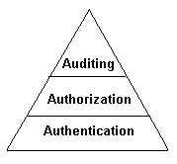

For a better understanding of the authorization and auditing refer to the Compaq white paper on “Security fundamentals as implemented in Windows 2000”.

Core Concepts
Windows 2000 operating system security is based upon the following core concepts: a ‘domain’, ‘domain controllers’, ‘SIDs’ and ‘Trust relationships’:
Figure 1: Operating System security building blocks: authentication, authorization and auditing.

- As in NT4 a domain defines a security and management boundary. It is an administrative grouping of networked machines, which offer resources (such as file and printing services) to domain users. The use of domains simplifies the administration of a group of computer resources.
- A domain controller is a server computer that holds the domain security database, and that authenticates all users for network resource access. The default domain security database of Windows 2000 is the Active Directory, which replaces the SAM used in Windows NT 4.0. The Active Directory contains a copy of a user’s credentials (the user-ID and a hash of the user’s password) used during the Windows 2000 authentication process.
- Trust relationships define an administrative and communication link between two domains. A trust relationship permits users from one domain to access resources in other domains.
- Every object (a user, a machine, a group) that is created in the domain security database gets a unique Security Identifier (SID). Every object that has a SID is considered a ‘security principal’ and can be granted access to other objects.

A SID consists of the following parts:
Field | Example: S-1-5-32-544
Character “S” identifying the object as a SID | S
The Revision level of the SID structure | 1
An identifier for the authority that issued the SID. (5 for example stands for a Windows NT/ Windows 2000 system). Possible values for this field are: 0,1,2,3 or 5 | 5  (SECURITY_NT_AUTHORITY)
A variable number of identifiers for subauthorities (also known as relative identifiers (RIDs): they uniquely identify the security object ‘relative’ to the authority issuing the SID. | 32  (SECURITY_BUILTIN_DOMAIN_RID)
544
(DOMAIN_ALIAS_RID_ADMINS)

Windows 2000 domain controllers
In Windows 2000 every domain controller contains a read-write copy of the domain directory database. This is different from Windows NT4 where there the Primary Domain Controller (PDC) is the only one to host a read-write copy. All other Windows NT4 domain controllers hold a read-only copy of the domain database and serve as Backup Domain Controllers (BDCs).
Windows 2000 supports mixed mode domains. In other words, a domain can contain controllers that run both Windows 2000 and Windows NT 4.0. To support downlevel domain controllers within a Windows 2000 domain a single domain controller is nominated to act as the PDC emulator. “PDC emulator“ is one of the FSMO roles (FSMO stands for Flexible Single Master of Operations). There can only be one PDC in a domain so hence the name “single master”.
Another security-related FSMO role is the RID master. Most operations on directory objects can be performed as multi-master operations. Others can only be done at one domain controller. An excellent example of such an operation is the management of the RIDs. RIDs need to be unique within a domain. The RID master allocates a pool of RIDs for each of the other domain controllers and keeps track of the set of allocated RIDs.

Authentication
Before an entity is given access to a resource or a service on a Windows 2000 system, the operating system must be sure of whom it is dealing with. The primary purpose of the authentication process is to answer the question “who or what is the system talking to?”
In a Windows environment, the authentication process begins every time you press CTRL+ALT+DEL to logon to a machine or a domain (this is called an ‘interactive logon’), or when you access a network resource (this is called a ‘non-interactive logon’).
Users authenticate themselves by providing “credentials” to an authentication authority. Normally, the credentials include the account name they wish to use and the password for the account. The fact that you know the combination of these ‘basic’ credentials is regarded to by the operating system as a proof of your identity. The authentication authority differs depending on what you’re logging on to. If you log on locally to a machine it is the machine itself, but if you logon to a domain authentication is performed against a domain controller.
The Windows 2000 authentication process can make use of different authentication protocols:
- NTLM (NT LAN Manager);
- Kerberos;
- SSL, TLS;
- Distributed Password authentication (DPA).
The way these protocols are embedded in the Windows 2000 authentication architecture is explained in the next section.

Windows 2000 Authentication architecture
Since its early days one of the most important design principles of NT has been “modularity”. NT’s authentication architecture is an excellent example of a modular architecture build upon different abstraction layers.
The authentication architecture of Windows 2000 is basically the same as the one used in NT4. 90% of the changes that Microsoft incorporated can be described as the plugging in of supplementary security modules. Elsewhere in this paper we’ll look at the new modules that Microsoft provided.

Windows 2000 is built upon two basic authentication types: local (or interactive) authentication and network (or non-interactive) authentication. Both of them have slightly different architectures.
A local or interactive authentication happens whenever a user initiates a SAS (CTRL-ALT-DEL) sequence to authenticate to a Windows 2000 machine or domain; or in other words when a user logs on through a user interface.
A network or non-interactive authentication happens when a client application calls into the SSPI (Security Support Provider Interface) to establish a secure network connection.

Architecture for Interactive authentication
Figure 2 illustrates the architecture for interactive authentication.
Whenever a user initiates a SAS sequence the Winlogon service calls the GINA module. Winlogon is the OS component that provides interactive authentication. GINA is the component responsible for displaying the logon interface, extracting the user’s credentials and passing them to the Local Security Authority (LSA).
The Local Security Authority is the OS kernel component that interacts with the local security database and the authentication packages. It deals with user authentication and logon to the local machine. To decide if a user is permitted to logon the LSA relies on both authentication packages and security databases.
Authentication packages are software packages that implement the different authentication protocols. In NT4 the only available authentication package was MSV1_0. It’s this package that performed a pass-through authentication if there wasn’t a credential store (A SAM database) available locally to validate the user’s credentials. If needed software vendors can implement their own Authentication package to provide other authentication protocols.
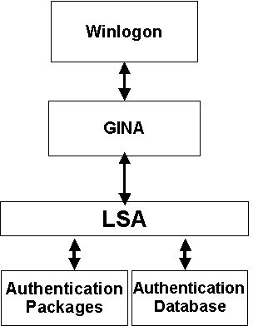

Windows 2000 comes with 2 authentication packages: MSV1_0 and Kerberos. The Kerberos authentication package cannot handle local logon requests on non-domain controllers: Kerberos requires the presence of a KDC (Key Distribution Center) service, which is only available on a Windows 2000 domain controller.
Figure 2: Windows 2000 interactive Authentication Architecture

Figure 3: Windows 2000 non-interactive Authentication Architecture
ca

The Authentication database stores the credentials that are needed in the authentication process. NT4 machines and Windows 2000 non-domain controllers store credentials in the SAM database.

Architecture for non-interactive authentication
Figure 3 provides a simplified overview of the non-interactive authentication architecture.
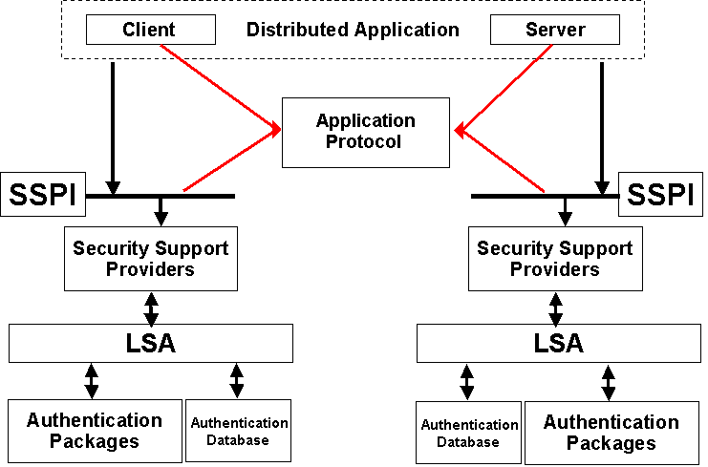

This architecture introduces two new important concepts: the SSPI and Security Support Providers (SSPs).
- A Security Support Provider is a dll that implements an authentication protocol.
- The SSPI is the interface that is called by applications to establish a secure authenticated network connection.
A distributed application consists of a client and a server component; each wants to authenticate the other’s identity. A good example is an Outlook client accessing an Exchange mailbox.
The actual communication between the client and the server component happens via application protocols. Typical LAN application protocols are SMB and RPC. Application protocols that are more Internet-oriented are HTTP, POP3, NNTP, LDAP and CIFS.
The SSPI is an Application Programming Interface (API) that sits between the application layer protocols and the security protocols; its primary function is to extend the Windows 2000 single sign-on to multiple authentication protocols.
Security Support Providers are modules that implement different security models for network logon and file access. SSPs can be plugged into the SSPI. Out-of-the box Windows 2000 supports the following SSPs: NTLM, Kerberos, SChannel (SSL and TLS) and Distributed Password Authentication (DPA). NTLM is the default authentication protocol of NT4. DPA is a new challenge-response based authentication protocol introduced in the Microsoft Commercial Internet System (MCIS). Software vendors can also implement their own SSP to provide other security models.
Because the availability of multiple security models to perform ‘authentication’, there has to be some kind of negotiation between the client and the server before the actual authentication can take place. To enable the negotiation Microsoft included a special SSP package called “Negotiate”.
Figure 4: Negotiate Security Support Provider

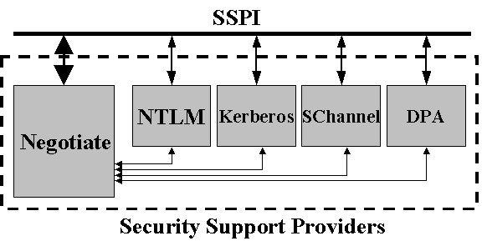

The first SSP that is called by the SSPI when a call for authentication arrives is the Negotiate SSP. The negotiate package will run through the locally available SSPs and compare them with the SSPs available at the other side. In Windows 2000 the first choice for authentication is Kerberos. If Kerberos is unavailable the security system will fall back to NTLM for authentication. For example: 2 Windows 2000 systems will authenticate using NTLM if a KDC service is unavailable in their domain.
Most SSPs rely on Cryptographic Service Providers (CSPs). These are modules that provide basic cryptographic functions such as encryption using Data Encryption Standard (DES), signing using RSA or hashing using Message Digest 4 (MD4). SSPs can refer to different CSPs thanks to another abstraction layer introduced in NT4: the CryptoAPI (or CAPI).
The different SSPs access the authentication packages via the LSA. The LSA validates credentials by comparing them with the entries in an authentication database (For Kerberos: the Active Directory). “Authentication packages” and the “LSA” were explained in the previous section on interactive authentication.

Overview
The table below gives an overview of the different authentication types and the Authentication packages and Security Support Providers available in NT4 and Windows 2000.

Authentication type | Authentication object | Object type | Authentication Package |  | Security Support Provider
Interactive authentication | Machine  (local logon) | Non-domain controller | NT4 | MSV1_0 | NT4 | NA
Interactive authentication | Machine  (local logon) | Non-domain controller | Win2K | MSV1_0 | Win2K | NA
Interactive authentication | Machine  (local logon) | Domain controller | NT4 | MSV1_0 | NT4 | NA
Interactive authentication | Machine  (local logon) | Domain controller | Win2K | Kerberos | Win2K | NA
Interactive authentication | Domain  (domain logon) | Any Machine | NT4 | MSV1_0 | NT4 | NA
Interactive authentication | Domain  (domain logon) | Any Machine | Win2K | Kerberos | Win2K | NA
Non-interactive authentication | NA | Any Machine | NT4 | MSV1_0 | NT4 | NTLM
Non-interactive authentication | NA | Any Machine | Win2K | Kerberos | Win2K | Kerberos  NTLM  Secure Channel  Negotiate
The most important updates to the Windows 2000 authentication architecture are the following:
- Kerberos, the new default authentication protocol, has been implemented as both an Authentication Package and a Security Support Provider (SSP).
- Windows 2000 also includes another new SSP: the Negotiate package. Negotiate permits two network entities negotiate an authentication protocol.
- The authentication credentials are stored in the Active Directory. The Active Directory replaces the NT4 SAM on domain controllers.

Kerberos

In Greek Mythology Kerberos is a three-headed dog, guarding the entrance to the underworld. In this white paper Kerberos refers to the authentication protocol developed as part of the MIT Athena project. Kerberos is embedded in Windows 2000 as the new default authentication protocol.

A little more about the dog’s three heads: they stand for authentication, access control and auditing. The basic Kerberos protocol (as defined in RFC 1510) only deals with authentication. Microsoft’s implementation of the protocol also includes extensions for access control. Later on in the white paper we’ll explain how one of the secret keys exchanged during the Kerberos authentication sequence can be used for packet authentication, integrity and confidentiality services.

Another way to explain the dog’s three heads is to look at the basic entities the protocol is dealing with: there are always three: two entities that want to authenticate to one another (for instance a user and a server hosting some resource) and an entity that mediates between the two or a trusted third party as represented by the Kerberos Key Distribution Center (KDC).
Kerberos positioning
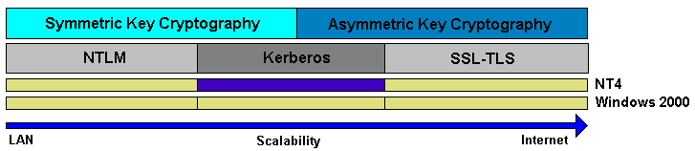

Figure 5 aligns NTLM, Kerberos and SSL-TLS with the main cryptographic technology they rely upon. NTLM purely relies on symmetric key cryptography. SSL-TLS, used for authentication, is based purely on asymmetric key cryptography. Kerberos as it is implemented in Windows 2000 sits between the two: although it is primarily based on symmetric key cryptographic, it also incorporates parts based on asymmetric key cryptography.
Figure 5: Kerberos positioning.

Authentication protocols such as SSL and TLS that are purely based on asymmetric cryptography are much more scalable compared to protocols such as NTLM and Kerberos (as defined in RFC 1510). However: the underlying technologies and standards are currently still in full evolution. Compared to their symmetric-key counterparts they also are more complex on the level of administration and user-interaction. In some degree, the last couple of sentences explain why Microsoft didn’t choose for a ‘full’ asymmetric-crypto based solution and instead incorporated Kerberos as the new default authentication protocol of Windows 2000.
Microsoft has extended Kerberos in two important ways:
- MS Kerberos supports the use of public-key credentials for authentication (this extension is known as PKINIT).
- MS Kerberos tickets can contain authorization data (user privileges and group membership).
Just like NTLM, the default authentication protocol of NT4, Kerberos is a trusted-third party authentication protocol: in a Windows 2000 domain every Domain Controller is a Kerberos Key Distribution Center (KDC) that acts as a trusted arbitrator for domain authentication.
Every Windows 2000 workstation or server includes a client Kerberos authentication provider. Windows 2000 does not include Kerberos support for other clients: if you want your NT4, Windows 95 or 98 clients to authenticate using Kerberos you’ll need to upgrade your workstation to Windows 2000 Professional.
The Basic Protocol
The following paragraphs explain the basic Kerberos protocol as it is defined in RFC 1510. Although Microsoft’s Windows 2000 Kerberos implementation is based on this standard some additional features have been added: the two most important extensions are the support for authorization data and public key credentials. Both extensions will be explained further on in this paper.
Those not familiar with Kerberos may be bewildered by the need for numerous diverse keys to be transmitted around the network. In order to break down the complexity of the protocol we will approach it in five steps:
- Step 1: Kerberos authentication is based on symmetric key cryptography.
- Step 2: The Kerberos KDC provides scalability.
- Step 3: A Kerberos ticket provides secure transport of a session key.
- Step 4: The Kerberos KDC distributes the ticket by sending them via the client.
- Step 5: The Kerberos Ticket Granting Ticket limits the use of the entities’ master keys
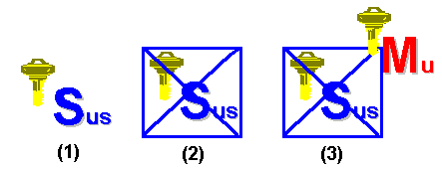

Before starting to explore how Kerberos works, we should explain the notations that will be used in the illustrations:
Figure 6: session key and encrypted session keys.

- u stands for user, s stands for resource server, k stands for KDC.
- S stands for session key; Sus means the session key shared between the user and the resource server.
- M stands for master key; Mu is the master key of the user.
- Drawing (1) in Figure 5 represents the session key shared between the user and resource server.
- Drawing (2) represents the same session key, but this time encrypted.
- Drawing (3) represents the same session key, encrypted using the master key of the user.

Step 1: Kerberos authentication is based on symmetric key cryptography
To authenticate entities Kerberos uses symmetric key cryptography. In symmetric key cryptography the communicating entities use the same key for both encryption and decryption. The basic mathematical formula behind this process is the following:
D_{K}(E_{K}(M)) = M
This means that the decryption of the encrypted text (M) (where the encryption (E) and decryption (D) processes are both using the same key K) results in the readable text (M).
This is what happens when Alice wants to authenticate to a resource server using a symmetric key cipher:
- Alice encrypts her name and the current timestamp using a symmetric key
- The encrypted message and Alice’s name are sent to the resource server.
- The resource server decrypts the message.
- The resource server checks Alice’s name and the timestamp (this is the result of the decryption process). If they’re OK, Alice is authenticated to the server.
Figure 7: Kerberos authentication is based on symmetric key cryptography

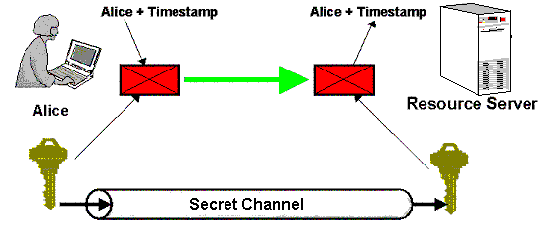

Why does this process authenticate Alice to the resource server? If the resource server can successfully decrypt the message, this means if it results in Alice’s name and an acceptable timestamp, the resource server knows that only Alice could have encrypted this information, since she’s the only one, besides the resource server, that also knows the symmetric key. The encrypted packet containing Alice’s name and the timestamp is known in Kerberos as the ‘authenticator’.
The timestamp that is used in the exchange above is a critical component of Kerberos: it provides “authenticator uniqueness” which is necessary to protect against replay attacks. Replay attacks could occur if a hacker reused an old authenticator (intercepted from the network) to authenticate to the resource server. The timestamp also explains the “time sensitivity” of Kerberos and of Windows 2000 in general.
In Kerberos the secret key is called a session key. A session key exists between all Kerberos principals that want to authenticate to each other.
To provide mutual authentication Kerberos includes an additional exchange that authenticates the server to the client. In turn, the server will encrypt its name and the current timestamp and send it to Alice.
A big problem when using a symmetric protocol is the distribution of the ‘secret’ key: in practice the key is generated at one side of the communication channel and should be sent to the other side of the communication channel in a secure way; this means protecting the confidentiality of the key. If anybody could read the secret key when it’s sent across the network, the whole authentication system becomes worthless: the secrecy of the secret key is a vital part of a symmetric cipher.
Steps 2, 3 and 4 explain how the Kerberos developers have resolved the problem of secure session key distribution.

Step 2: A Kerberos KDC provides scalability

The Kerberos protocol always deals with three entities: two entities that want to authenticate to one another and one entity that mediates between these two entities for authentication: the Key Distribution Center (KDC). Why do we need a KDC?

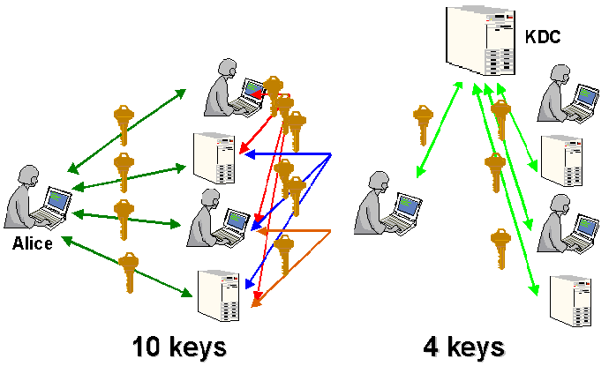

Suppose that Alice is part of a workgroup consisting of 5 entities. The 5 entities all want to authenticate to one another using symmetric key cryptography. Since every entity needs to share a secret key with every other entity, we’ll need 10 keys secret key with every other entity, we’ll need 10 keys. The mathematical formula behind this is n (n-1)/2. In a 50000-employee company we would need about 1,500,000,000 keys. It is clear that this solution is not scalable to the level of a big company.

To make Kerberos more scalable the Kerberos developers included the concept of a Key Distribution Center (KDC). The Key Distribution Center (KDC) is a trusted third party with whom every entity shares a secret key: this key is called the entity’s ‘master’ key. All entities “trust” the KDC to mediate in their mutual authentication.
Figure 8: The Kerberos KDC provides scalability

In Windows 2000 the KDC is a service that is installed on every domain controller as part of the “dcpromo” Active Directory installation process. Every Windows 2000 domain controller runs a KDC service. If a domain has multiple domain controllers this feature can provide fault tolerance for the authentication process: if one DC is down another one can take over.

The concept of a master key is not new to Windows 2000 and Kerberos: it already existed in NT4. In both NT4 and Windows 2000, the master key is derived from a user’s, a machine’s or a service’s password. The password is a ‘secret’ key that is shared between all the security principals (a user, a machine, a server) and the KDC (located on domain controllers). Both the entity and the KDC must know the master key before the actual Kerberos authentication process can take place.

The master key is generated as part of the domain ‘enrollment’ process. A user’s master key is created when the administrator enrolls the user and enters a password. The machine’s master key is derived from the machine password that is automatically and transparently created when an administrator joins the machine into a domain. A hashed version of each master key is stored in the Active Directory. The Active Directory is the KDC’s authentication database.

Step 3: The Kerberos ticket provides secure transport of the session key
Figure 9: The Kerberos ticket provides secure transport of the session key.

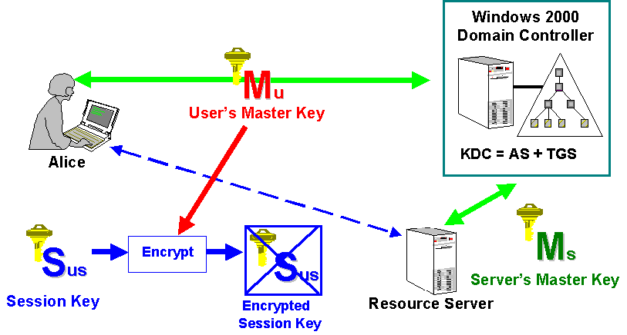

Figure 9 illustrates the 3 basic entities that the Kerberos protocol deals with:
- A client.
- A resource server, containing a resource the client wants to access.
- A Key Distribution Center (KDC), this is a Windows 2000 domain controller.
The figure also shows the master keys shared between the entities participating in the authentication process and the KDC.
Remember that in the first step we talked about the problem of distributing the secret key (the session key) when dealing with symmetric key ciphers. This paragraph explains how Kerberos resolves this problem.
In the previous paragraph we explained that every entity shares a master key with the KDC. We also said that all entities trust the KDC to mediate in their mutual authentication: in other words when an entity needs to authenticate to another entity, it will request a session key from the KDC. The KDC will generate the session key and distribute it to both entities. The session key is the key introduced in step 1, it is the one used for authentication. The master key was introduced in step 2. The next paragraph makes the link between the “session key” and the “master key” and explains why we need a “master key”.
After the KDC has generated the session key, it must be transmitted to the destination entities. To secure the transport across a communication channel Kerberos encrypts the session key with the master key of the destination entity. As there are two destinations, two versions of the session key must be generated:
- one encrypted with Alice’s master key;
- one encrypted with the master key of the resource server.
The session key encrypted with the resource server’s master key is known as a ‘ticket’ in Kerberos terminology. A Kerberos ticket provides a way to transport a Kerberos session key securely across the network. It can only be decrypted by the destination resource server and a Windows 2000 domain controller.
By securing the transport of the session key using the master key, Kerberos creates what is known as a key hierarchy (see Figure 10)
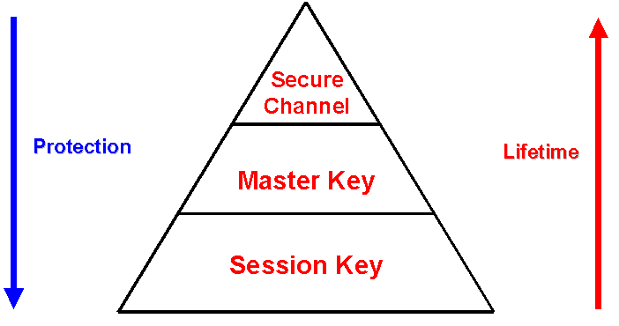
Figure 10 shows the Windows 2000 key hierarchy, consisting of:
Figure 10: Windows 2000 key hierarchy

- The session key (or short-term key): a session key is a secret key that is shared between two entities for authentication purposes. The session key is generated by the KDC. Since it is a critical part of the Kerberos authentication protocol, it is never sent in the clear over a communication channel: it is encrypted using the master key.
- The master key (or long-term key): the master key is a secret key that is shared between each entity and the KDC. It must be known to both the entity and the KDC before the actual Kerberos protocol communication can take place. The master key is generated as part of the domain ‘enrollment’ process and is derived from a user’s, a machine’s or a service’s password. The transport of the master key over a communication channel is secured using a ‘secure channel’.
- The Secure Channel: when Windows 2000 is using a secure channel, it is using a master key to secure the transport of another master key. The following example illustrates the ‘secure channel’ concept. When you create a new user, the user’s password will be sent to the domain controller using a secure channel. The secure channel is in this case nothing else then a master key shared between the workstation you’re working on and the domain controller.
In the above key hierarchy also the following are true:
- Higher level keys protect lower level keys.
- Higher level keying material has a longer lifetime than lower level keying material.
- Lower level keying material is used more frequently for sending encrypted packets across the network. This means that there’s a higher risk for brute-force attacks on these packets and that the associated keys should be changed more often.

Step 4: The Kerberos KDC distributes the ticket by the sending them via the client
The KDC can distribute the encrypted session keys to the client (Alice) and the resource server in two ways:
- Method 1: The KDC could send it directly to both the client and the resource server. (As shown in Figure 11)
- Method 2: The KDC could send the two encrypted session keys both to the client. The client could send out the resource server’s encrypted session key later on in the Kerberos authentication sequence. (As shown in Figure 12)

The first method has the following disadvantages:

- The resource server has to cache all the session keys: one session key for each client that wants to access a resource on the server. This would also impose a huge security risk on the server side.
- Synchronisation problems could occur: the client could already be using the session key while the resource server hasn’t even received its copy yet.
Figure 11: Method 1 to distribute the encrypted session keys.

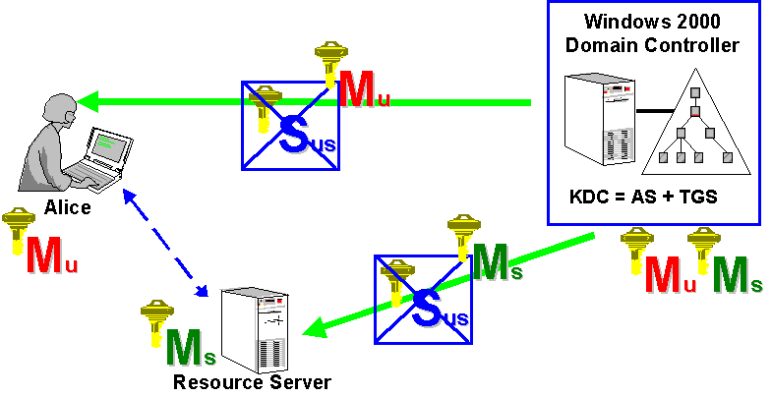
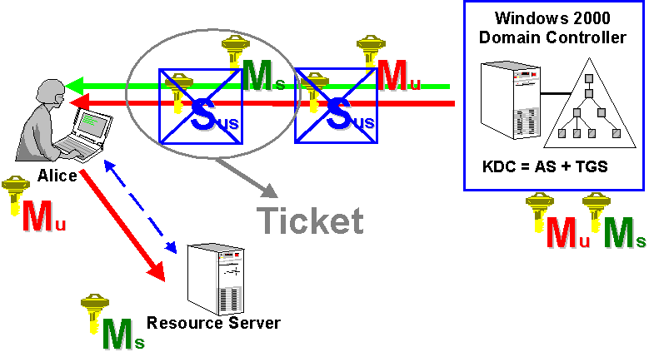

Because of the disadvantages associated to Method 1 Kerberos uses the alternative explained below as Method 2 (see Figure 12):
Figure 12: Method 2 to distribute the encrypted session keys.

- Both the encrypted session keys (the one for the client, encrypted with client’s master key and the one for the resource server, encrypted with the resource server’s master key) are sent to the client.
- The client can decrypt the packet encrypted with its master key and get out the session key. The client can cache both the session key (to be used later on for authenticating the client to the server) and the server’s copy of the session key (also known as a ticket).
- When the client needs to authenticate to the resource server the client will send out the server’s copy of the session key.
The key advantage of method 2 lies in its unique caching architecture: the client can cache tickets; for the server there’s no need to cache the tickets: it receives them from the client as needed. Here’s an important detail: tickets are kept in a special system memory area, which is never paged to disk. The reuse of the cached tickets is limited because of a ticket’s limited lifetime and renewal time.
Figure 11: Method 2 to distribute the encrypted session keys.

Also note that the KDC is mainly a “Ticket Distribution Center”: it generates the session keys and distributes them to both entities using tickets. It doesn’t keep track of all the session keys; remember that only the master keys are stored in the Active Directory.

Step 5: The Kerberos Ticket Granting Ticket limits the use of the entities’ master keys
There’s yet another important weakness in the protocol that we haven’t addressed so far: the session key that is sent back from the KDC to the client is encrypted using the user’s master key. (Remember that the user’s master key is derived from the user’s password)

This packet is sent over the network when the user needs a session key to authenticate to a resource server. Every time there’s an opportunity for hackers to intercept the encrypted packet off the network and to perform -offline- a brute-force attack to derive the user’s master key.

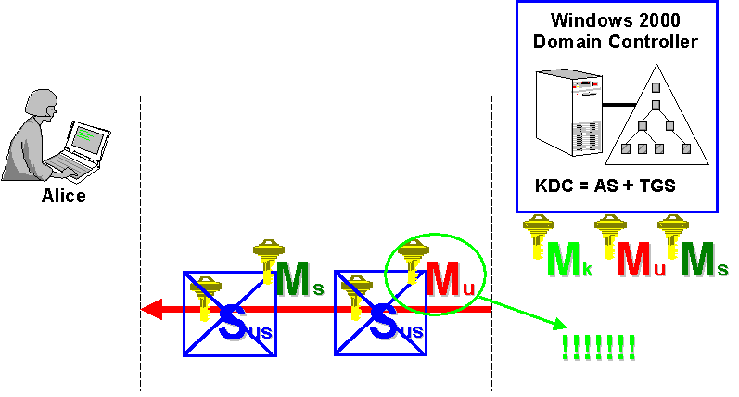
In a brute-force attack a hacker tries to guess the key that was used to encrypt a packet by trying out all the possible keys and looking at the result. Such attacks are certainly not unrealistic: remember the tools that were available in NT4 to do brute-force attacks on the SAM database or on authentication packets sent across the network.

There’s clearly a need here for a strong secret to replace the user’s master key: this is the role of the session key shared between each entity and the KDC. This session key will replace the user’s password to authenticate the user to the KDC. Although it has an identical function (authentication) the session key introduced in this step is NOT the same as the one used in the previous paragraphs: this session key is shared between the user and the KDC, the other session key is shared between the user and the resource server.
Figure 13: Distribution of session key by KDC: usage of user’s master key.

Just like the user’s master key both the user and the KDC must know this session key. It is ‘stronger’ than the user’s master key because it has a limited lifetime; it changes more often, and thus limits the chances that the session key is guessed during a brute-force attack.

To securely transport this session key we will use the same principles as the ones described in step 3 and 4:

- Step 3: Kerberos uses a ticket to provide secure transport of the session key: this ticket is known as the Ticket Granting Ticket (TGT).
- Step 4: Kerberos distributes the tickets by sending them out via the client. The KDC sends the TGT to the client; the client caches the TGT and can send it to the KDC as needed. There’s no need for the KDC to cache the TGTs of all the clients.
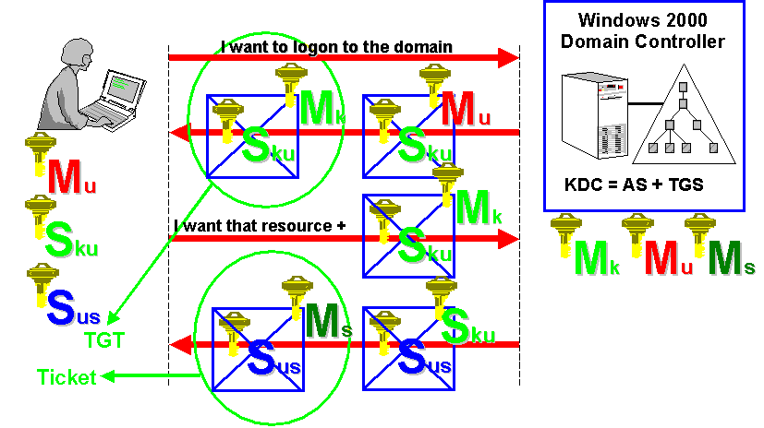

Figure 14 shows how this new session key (S_{ku}) and the associated TGT are used in the basic Kerberos protocol exchange:
Figure 14: Distribution of session key by KDC: usage of session key

- Alice sends a logon message to the domain controller. This message is secured using Alice’s master key, derived from Alice’s password.
- The KDC will then send out a secured copy of the session key to be used for authentication between Alice and the KDC for the rest of the logon session (this session key will replace the user’s password). The copy of the session key encrypted with KDC’s master key is called the TGT.
- The session key and the TGT will be cached in Alice’s local credential cache.
- Later on, when Alice wants to access a resource on the resource server, the security process acting on Alice’s behalf will send out a request for a ticket to the KDC using the locally cached TGT. The request for the resource will be secured using the session key S_{ku}.
- Finally the KDC will send back a ticket and a new session key to Alice, which she can use later on to authenticate to the resource server. Notice that in Figure 14 the new session key is not encrypted using Alice’s master key, but using the newly created session key S_{ku}.
This sequence shows how in the basic Kerberos Exchange:
- The TGT is reused to request tickets for other application or resource servers.
- Ticket requests don’t require further use of the client’s master key. During the logon session a weak secret (the master key derived from a clients password) is exchanged for a strong secret (the session key contained within the TGT). In other words: at logon time and at each TGT renewal the user will authenticate to the KDC with his password, in subsequent ticket requests he will authenticate using the session key, which is contained in the TGT. As a consequence: if a user’s password is changed during a logon session, the user will have to re-enter his user-ID and password to obtain a new TGT.
- The newly created session key (S_{ku}) doesn’t need to be cached on the KDC: the KDC gets it from the client each time the client requests a new service ticket. S_{ku} is encrypted using the KDC’s master key (remember: this is what they call the TGT).

Bringing it all together
In this paragraph we’ll bring together all the elements explained in the previous 5 steps to explain the complete Kerberos protocol.
Figure 15: Basic Kerberos protocol

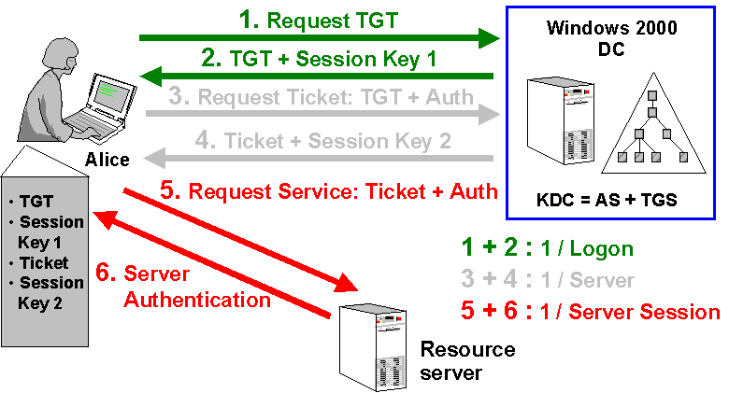

Figure 15 shows the complete Kerberos protocol: it consists of 3 major phases, each one made up of 2 steps:
- Phase 1: Authentication Service Exchange (happens once per logon session).
  - Step 1: Authentication Server Request (KRB_AS_REQ). The user logs on the domain from his local machine. A TGT request is sent to a Windows 2000 DC (AS service of the KDC) (the discovery of a DC happens via DNS).
  - Step 2: Authentication Server Reply (KRB_AS_REP). The Windows 2000 DC (AS) returns a TGT and a session key.
- Phase 2: Ticket-Granting Service Exchange (happens once per requested server)
  - Step 1: TGS Request (KRB_TGS_REQ). The user wants to access an application on a server. A ticket request for the application server is sent to the Windows 2000 DC (TGS service of the KDC). This request consists of the user’s TGT and an authenticator.
  - Step 2: TGS Reply (KRB_TGS_REP). The Windows 2000 DC (TGS) returns a ticket and a session key.
- Phase 3:Client-Server Authentication Exchange (happens once per server session)
  - Step 1: Application Server Request (KRB_AP_REQ). The ticket is sent to the application server. Upon receiving the ticket and the authenticator, the server can authenticate the user.
  - Step 2: Application Server Reply (KRB_AP_REP). The server replies to the user with another authenticator. On receiving this authenticator, the user can authenticate the server.

In this exchange the following keys and tickets are cached on the client: the TGT, the ticket used to authenticate to the resource server and two session keys: one to authenticate to the KDC and one to authenticate to the resource server.

The global picture also shows a side effect related to the usage of an authenticator: it not only offers the resource server a way to check Alice’s identity, it also ensures that the ticket is not a replay of previously sent information. Without the authenticator a hacker could grab a ticket off the network and use it for impersonating Alice to a resource server.

Kerberos preauthentication data
Pre-authentication is a feature introduced in Kerberos V5. Using pre-authentication data a client can prove the knowledge of its password to the KDC before the TGT is issued. In standard Kerberos (the one explained in the previous paragraphs) authentication is completely based on the client’s ability to decrypt the packet returned from the KDC using its master key (in the KRB_AS_REP subprotocol).
Pre-authentication also lowers the probability for a brute-force attack. Without pre-authentication data it is easy for a hacker to do a brute-force attack on the encrypted packets returned from the KDC. A hacker can easily send out dummy requests for authentication. Each time he will get back another encrypted packet, which means he gets another chance to do a brute-force attack and to guess the user’s master key.
In a regular logon session the preauthentication data consist of an encrypted timestamp. When logon using a smart card the preauthentication data consist of user’s public key certificate.
In Windows 2000 preauthentication is the default. An administrator can turn it off using the “Don’t require Kerberos preauthentication” checkbox in the account options list of the account properties of each account object.

Kerberos data Confidentiality, Authentication and Integrity services
Windows 2000 includes the Kerberos extensions to provide data confidentiality and authentication of messages sent after the initial subprotocol steps. These extensions are known as KRB_PRIV (data confidentiality service) and KRB_SAFE (data authentication and integrity service).
These two extensions are based on the existence of a session key between two entities at the end of each Kerberos authentication protocol exchange.
The session key can be used to encrypt a hash. The hash is the result of running a hash function on a portion of data, sent out between the two entities after the initial Kerberos authentication protocol. This provides both data authentication (only 2 entities know the session key) and data integrity (because of the hash function).
The same key can be used to bulk encrypt data and hence provide data confidentiality services.

Inter-realm authentication
To enable inter-domain Kerberos authentication every domain that is trusted by a domain A is registered in domain A’s Active Directory as another Kerberos principal. Inter-domain authentication traffic will be secured using the master key and the session key of the “domain” principal.
This also explains the ‘trust’ concept. A trust is a shared secret between two domain controllers.
- If only domain A is registered as principal in domain B, we have a one-way trust going from B to A (domain B trusts domain A). In this case domain A’s master key is the shared secret.
- if only domain B is registered as a principal in domain A, we have a one-way trust going from A to B (domain A trusts domain B). In this case domain B’s master key is the shared secret.
- If both are registered as principals we have a two-way trust. In this case there are 2 master keys or 2 shared secrets.
The creation of the “domain” principals and the master keys happens during the dcpromo process when a domain joins an existing domain tree. More details on the types of trust are provided in the chapter on the features of Kerberos.
The fact that the Kerberos KDC service is made up of two subservices is also due to inter-domain authentication traffic:
- The Authentication Service authenticates accounts and issues TGTs.
- The Ticket Granting Service issues tickets for resource servers based on the presence of a TGT.
In a typical interdomain authentication example the AS of the KDC in the domain where the user’s account is defined will deliver the TGT1.
If the user accesses a resource hosted on a server in another domain the ticket will be issued by the TGS of the KDC in the domain of the resource (based on the presence of the TGT1)
All this will become clearer after reading the examples on the following pages and the example in Appendix 1.

Kerberos authentication database security
The credentials (a user’s ID and hashed password) used during the Kerberos authentication sequence are stored in the Active Directory. Anybody that could access the authentication database and get out the user credentials could impersonate any user. Since we’re dealing with a multi-master directory model the risk for unauthorized access is even bigger.
Accessing the credentials is however not that simple:
- Access to every Active Directory object is validated by the DSA (Directory Service Agent) which is linked to the LSA (Local Security Authority). The LSA and DSA are both part of the Windows 2000 kernel. To access hashed passwords a special privilege “Trusted Computer Base“ is required.
- To protect against offline attacks (for instance on a copy of the Active Directory database located on a backup tape) the Active Directory can be encrypted with a special key called the “syskey”. This feature was also available in NT4 to protect the SAM. If you’re implementing this solution look after a very safe place to store the symmetric key (the syskey) used for encryption.
- Replication between Windows 2000 domain controllers of information contained in the Active Directory occurs across a secure channel. The secure channel guarantees the confidentiality of the replicated data.

In high security environments it can be appropriate to install the KDC service on a server located in room with sufficient physical security provisions.

Real-world Windows 2000 Kerberos logon Examples

In this section we’ll discuss some real-world Kerberos logon examples.

Local logon
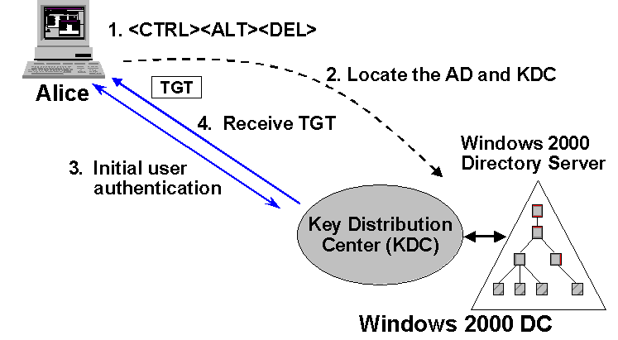

This is what happens during a local logon in a single-domain environment:
Figure 16: Interactive logon in single domain, part 1

- The user presses <CTRL><ALT><DEL> and chooses to logon to the domain.
- The client software acting on behalf of the user tries to locate a domain controller (hosting the Active Directory and the KDC service) for the domain; this is done by querying DNS. (Generally, the domain controller is already known, discovery is also a part of the ‘secure channel’ setup.)
- Once the DC is found, the client sends a Kerberos authentication request to the DC. This request authenticates the user to the DC and also contains a TGT request (KRB_AS_REQ).
- The Authentication Service authenticates the user, generates a TGT and sends it back to the client (KRB_AS_REP).
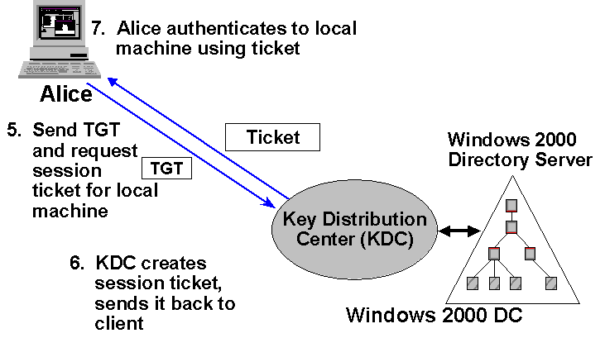

- The local machine where the user logged on is, just like any other resource, a resource for which the user needs a ticket. The user sends a ticket request to the DC using his TGT (together with an authenticator) (KRB_TGS_REQ).
Figure 17: Interactive logon in single domain, part 2

- The TGS of the DC checks the TGT and the authenticator, generates a ticket for the local machine and sends it back to the client. (KRB_TGS_REP)
- On the client, the ticket is presented to the Local Security Authority, who will create an access token for the user. From then on, any process acting on behalf of the user can access the local machine’s resources.
Let’s look now what happens with a local logon in a multidomain environment.
Figure 18 shows a typical multidomain environment, consisting of a parent domain Compaq.com and two child domains NA (north-America) and Europe. In the local logon example below user A’s account is defined in the Europe domain. User A logs on to a workstation whose account is defined in the NA domain.
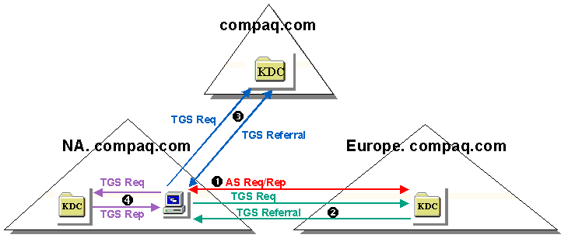

The local logon process can be subdivided into the four following steps:
Figure 18: Interactive logon in multiple domain

Step 1: AS exchange (KRB_AS_REQ and KRB_AS_REP):
- To log on the ‘Europe.compaq.com’-user a TGT request is sent to a KDC in Europe.compaq.com. Therefore, the AS request and reply is sent directly between the client station and the KDC of Europe.compaq.com.

Steps 2, 3 and 4: TGS exchanges (KRB_TGS_REQ and KRB_TGS_REP):
- To request a ticket for the Europe.compaq.com user to work on the workstation (located in NA.compaq.com), a TGS request is sent directly to the KDC of Europe.compaq.com.
- The KDC of domain Europe.compaq.com cannot give credentials that allow a user of the Europe.compaq.com domain to work on a workstation in NA.compaq.com. A KDC of NA.compaq.com can only return such credentials. Therefore, the TGS reply contains a referral ticket to the domain closest to NA.compaq.com and with which NA.Compaq.com has a ‘real’ Kerberos trust. In the above example, it is compaq.com.
- The referral ticket is a ticket to a KDC of domain compaq.com and is encrypted with the key shared between the realms Europe.compaq.com and compaq.com.
- On receiving the referral ticket, the client locates a KDC of the intermediary domain compaq.com and sends a TGS request including the referral ticket to that KDC.
- The KDC in compaq.com decrypts the ticket using the inter-realm key and detects that this is a ticket request for a workstation in NA.compaq.com. The KDC checks on the next closest domain for NA.compaq.com and sends the client a referral ticket to this domain.
- The client asks a KDC of NA.compaq.com for a ticket for the local workstation. Finally, the KDC of NA.compaq.com will send a TGS reply with a valid ticket for the workstation.

Network logon
When a user logged on to a domain wants to access a resource located on a server within the same domain, a ‘network logon’ happens.
Figure 19: Non-interactive logon in single domain

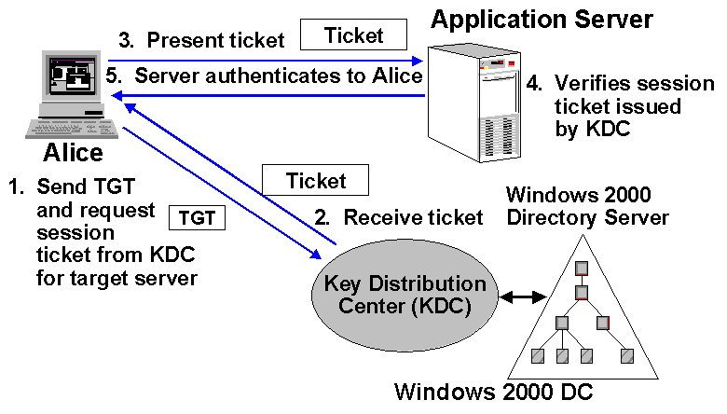
- The client sends a server-ticket request to the DC using his TGT (together with an authenticator) (KRB_TGS_REQ).
- The TGS of the DC checks the authenticator, generates a server-ticket, and sends it back to the client (KRB_TGS_REP).
- The client sends the ticket (together with an authenticator) to the application server (KRB_AP_REQ).
- The application verifies the ticket with the authenticator and sends back his authenticator to the client (server authentication) (KRB_AP_REP).
Let’s look now what happens with a local logon in a multidomain environment. Again we’re using the example of a parent domain and two child domains. In the network logon example below user A’s is logged on to the NA domain (the user and computer account are defined in the NA domain). User A wants to access a resource hosted on a server in the Europe domain.
The network logon process can be subdivided in the following four steps:
Steps 1, 2, and 3: TGS exchanges:
- Before the client can contact the KDC in realm Europe.compaq.com, the client must have a valid ticket to talk to the KDC of that domain. Since there is no direct trust between Europe.compaq.com and NA.compaq.com, the client must request the ticket via an intermediary domain.
- The client first requests a ticket for the KDC of the domain closest to the Europe.compaq.com domain; this is compaq.com. Since there is a direct trust between NA.compaq.com and compaq.com he can request the ticket to its own KDC.
The KDC will return a ticket encrypted with the inter-realm key shared with between NA.compaq.com and compaq.com.
- With this ticket, the client can send a TGS request to the KDC of realm compaq.com, requesting a ticket for the KDC of the Europe.compaq.com realm. Since there is a direct trust between compaq.com and Europe.compaq.com the KDC of Europe.compaq.com can answer this request (the returned ticket will be encrypted with the inter-realm key shared with between compaq.com and Europe.compaq.com).
- With the above ticket, the client finally can send a TGS request to a KDC of realm Europe.compaq.com requesting a ticket for the target file server.
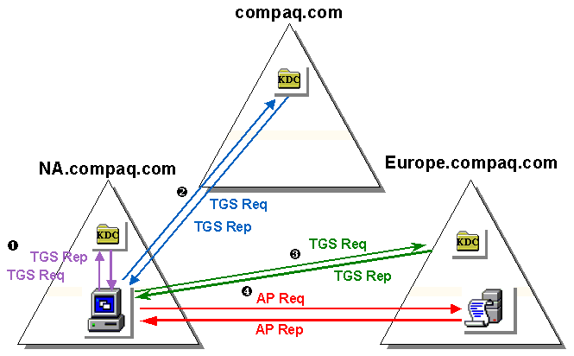

Step 4: Application Server Exchange
Figure 20: Non-interactive logon in multiple domain

- With the ticket received from the target server’s KDC, the client sends a request (consisting of the ticket and an authenticator) to the target server.
- As the last step, the target server will authenticate back to the client.

Kerberos Advantages
So far, we have explained the basic Kerberos protocol. We now need to consider the main advantages Kerberos brings to the Windows 2000 operating system. These include:
- Faster authentication
- Mutual authentication
- Transitive trust
- Kerberos is an open standard
- Support for delegation
- Support for smart-card logon

Faster Authentication

The core of the Kerberos protocol uses a unique ticketing system that provides faster authentication:
- Every authenticated domain entity can request ‘tickets’ from its KDC to access other domain resources;
- The tickets are considered as ‘access permits’ by the resource servers;
- The ticket can be used more then once (by default it has an eight hour lifetime) and can be cached on the client side.
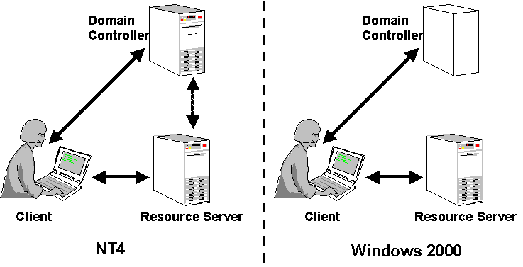
When a resource server or the Kerberos KDC gets a ticket (the encrypted session key) and an authenticator (the client’s name and a timestamp encrypted with the session key) from the client, the server has enough information to authenticate the client. NT 4.0 requires the server to contact a domain controller to validate a user’s authentication request (this process was known as pass-through authentication in NT4). Thanks to Kerberos Win2K doesn’t require pass-through authentication. This system clearly accelerates the authentication process, but it also puts a greater workload on the client.
Figure 21: Kerberos provides faster authentication

During a user’s logon session its Kerberos tickets are renewed automatically. Each ticket has also a ‘maximum renewable period’ property, that limits the transparant renewal process. If this period expires the user will have to logoff and logon to obtain a new ticket. When logging off the user’s ticket cache is cleared.

The Windows 2000 SDK includes Klist, a tool that lets you view the Kerberos tickets that the local machine has cached and lists the tickets’ properties (see Figure 22). The Appendix on “Analyzing Kerberos tickets” explains the Klist tool in more detail.

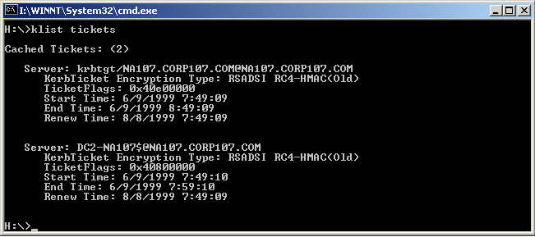

Mutual authentication
Figure 22: klist tool

To validate a client’s identity, NT 4.0 supports a challenge/response authentication sequence in which the server challenges the client, the client calculates a response, and the server validates that response. Thus, NT 4.0 creates a situation in which users might provide their credentials to a bogus server. To prevent this fault, Kerberos supports mutual authentication in which the client authenticates to the server and the server authenticates to the client.

Transitive Trust

As in NT 4.0, a trust (i.e., a secret that two domain controllers share) between two Windows 2000 domains facilitates cross-domain resource access and creates cross-domain account visibility. Microsoft simplifies trust creation and management in Windows 2000 by letting you create trusts automatically as part of the domain hierarchy building process (dcpromo) and allowing transitive trust. Transitive trust means that if both europe.compaq.com and us.compaq.com trust compaq.com, then europe.compaq.com implicitly trusts us.compaq.com. Transitive trust also reduces the number of trusts needed for authentication. In the example below, only 4 trusts are needed (between each parent and child domain) to obtain authentication interoperability between all domains.

Transitive trust is only a logical concept—no shared secret exists between the domain controllers of the domains that share a transitive trust. This setup means that for authentication to occur between entities on opposite ends of a transitive trust, the authentication process doesn’t flow across the transitive trust but through the trust path (i.e., the tree of entities within a transitive trust). Microsoft claims that this referral process doesn’t affect network traffic and the traffic this process generates is comparable to the traffic NT 4.0’s pass-through authentication process generates. The referral process is evidence that Kerberos isn’t suited for large distributed environments such as the Internet. Kerberos is an intranet-authentication protocol.

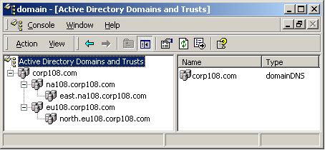

Suppose Alice has logged on to north.europe.corp.com with her user account, and she wants to access a resource on a server in east.northamerica.corp.com. The following steps walk you through the Kerberos authentication process in a tree that contains five domains (illustrated in Figure 24):
Figure 23: Active Directory Domains and Trusts

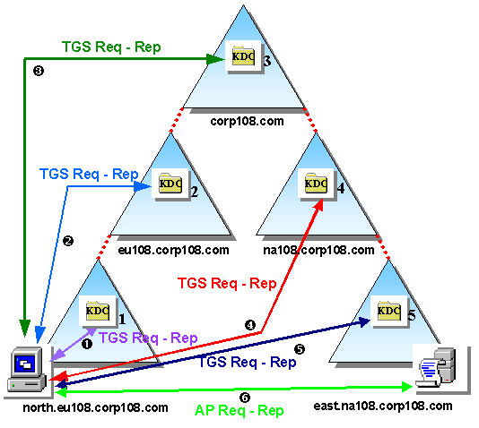

- Step 1: Alice uses her ticket-granting ticket (TGT) to try to obtain a ticket from KDC1 for the resource server in the east domain. KDC1 isn’t the authority for the resource server’s east domain, so KDC1 refers Alice to the domain closest to the target domain that the north domain has a Kerberos trust relationship with. This domain is europe.
Figure 24: Transitive trust authentication traffic

- Step 2: KDC2 refers Alice to KDC3.
- Step 3: KDC3 refers Alice to KDC4.
- Step 4: KDC4 refers Alice to KDC5.
- Step 5: KDC5 is the authority for the east domain, so KDC5 generates a ticket for Alice.
- Step 6: Alice uses the ticket from KDC5 to access the resource server.

If you use Windows 2000’s software development kit (SDK) Klist utility to look at the ticket cache on Alice’s machine, you’ll find one TGT for each domain, one ticket for Alice’s machine (part of the north domain), and one ticket for the resource server. (7 tickets).

You can shorten this referral process by creating an explicit trust relationship (i.e., a shortcut trust) between the north and east domains. In this case, Alice will go through the following steps to access the resource located in the east domain (illustrated in Figure 25):

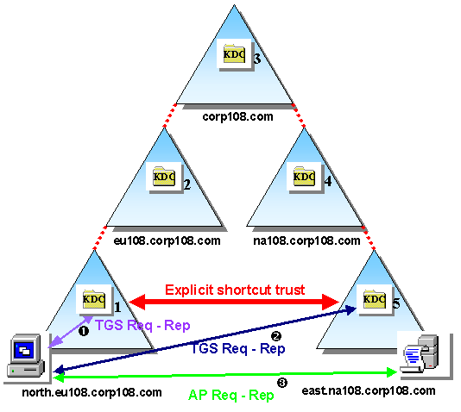

- Step 1: Alice uses her TGT to try to obtain a ticket from KDC1 for the resource server in the east domain. KDC1 isn’t the authority for the resource server’s east domain, so KDC1 refers Alice to the domain closest to the target domain that the north domain has a Kerberos trust relationship with. This domain is east.
Figure 25: Shortcut trust authentication traffic

- Step 2: KDC5 is the authority for the resource server’s east domain, so KDC5 generates a ticket for Alice.
- Step 3: Alice uses the ticket from KDC5 to access the resource server.

If you look at the ticket cache on Alice’s machine after this process, you’ll find only four tickets: one TGT for the north domain, one TGT for the east domain, one ticket for Alice’s machine, and one ticket for the resource server. A shortcut trust reduces the interdomain authentication traffic and the number of Kerberos tickets issued. To a certain extent it also provides fault-tolerance for the authentication process.

In Windows 2000 you can view trust relationships through each domain objects’ properties, as Figure 26 shows, or you can use the trustdom.exe command prompt utility. You can also use these tools to explicitly create trusts.

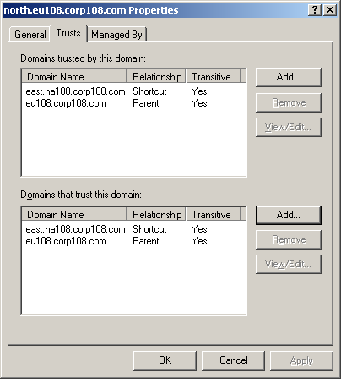

End users who are working from Kerberos-compliant workstations can see the effect of transitive trusts when they log on. They can choose every domain with which their domain has a direct trust or an indirect trust. An NT 4.0 end user sees only the direct trusts of his or her domain.
Figure 26: Domain trusts

Type | Creation | Characteristics
Tree-Root trust  Between two tree root domains in same forest | Implicitly, dcpromo | Transitive, two-way
Parent-Child trust  Between parent-child domain in same tree | Implicitly, dcpromo | Transitive, two-way
Shortcut (cross-link) trust  Between any domain in same forest | Explicitly | Transitive, one- or two-way
External trust  Between domains in different forests | Explicitly | Non-transitive, one- or two way
Non-Windows trust  Between two Kerberos KDCs (for instance between a Windows 2000 domain and an MIT Kerberos based domain) | Explicitly | Non-transitive, one- or two way

As outlined in the table above, Windows 2000 contains five basic types of trust relationships. Windows 2000 Kerberos trusts that you implicitly or explicitly create within the same forest are transitive by default. Microsoft included a check box in NT 5.0 Beta 2 that let you turn off transitivity, but Microsoft didn’t include this option in beta 3. Explicit trusts between forests or trusts to non-Win2K domains, such as a UNIX Kerberos domain, are non-transitive by default. So, if you want authentication interoperability between two domains that are part of different forests, you have to establish a trust relationship between the two domains manually.

Kerberos is an Open Standard

Microsoft based its Kerberos implementation on the open standard that RFC 1510 defines (i.e., Kerberos V5), which means that Kerberos can provide authentication interoperability between Windows 2000 and other OSs that support an RFC 1510-based Kerberos implementation.

Kerberos authentication interoperability comes in three flavors: A Windows 2000 server hosts the Kerberos KDC and serves as a KDC for Windows 2000 and other platform clients. Alternatively, a non-Windows 2000 server hosts the Kerberos KDC and serves as a KDC for Windows 2000 and other platform clients. Finally, you can create a cross-realm trust relationship between a Windows 2000 domain and another platform to provide authentication interoperability. In this case, you have two KDCs—one KDC on each side of the trust relationship.

As we will explain later on in this white paper, authentication interoperability is not as simple as it looks like. For example, to use a cross-realm trust to obtain authentication interoperability between Windows 2000 and a UNIX platform, you must define an explicit mapping between each UNIX account that will access resources in your Windows 2000 domain and a Windows 2000 account, as Figure 27 shows.

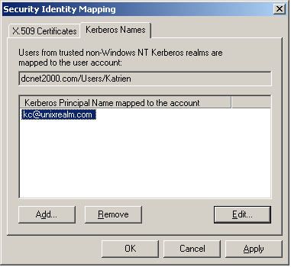

Figure 27: Account mappings

For an NT 4.0, UNIX or MVS Kerberos implementation, check out Cybersafe’s Trustbroker. This product also includes Kerberos public key security integration.

Support for Delegation

Using authentication delegation, user A can give rights to intermediary machine B to authenticate to an application server C as if machine B was user A. This means that application server C will base access control decisions on user A’s identity rather than on machine B’s account. Delegation is also known as authentication forwarding. In the Kerberos delegation process, user A forwards a ticket to intermediary machine B, and machine B uses user A’s ticket to authenticate to application server C.

You can use delegation for authentication in multitier applications, such as Outlook Web Access (OWA). When using OWA a user accesses his mailbox from a browser In most cases, the Microsoft Exchange Server that contains users’ mailboxes isn’t collocated to the Microsoft Internet Information Server (IIS). This means that IIS must authenticate to the Exchange Server as if he (the IIS server) was the user. In NT 4.0, this scenario causes problems when you want to use the NT LAN Manager (NTLM) protocol for authentication on both links (i.e., between the browser and IIS and between IIS and the Exchange Server) because NTLM doesn’t support delegation. Although every Platinum Exchange server will run an IIS server, this problem can reoccur if the web front-end (IIS) server, used for accessing a mailbox, and the Platinum mailbox server are not collocated.

You can set delegation on each Win2K user and computer account by selecting the Account is trusted for delegation check box in an account’s properties dialog box, as figure 28 shows. You can also use the Win2K GPO Enable computer and user accounts to be trusted for delegation entry to set delegation.

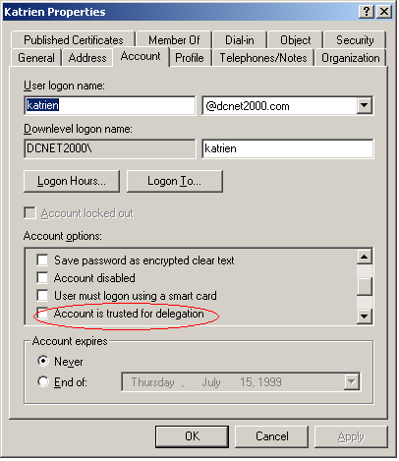
If the checkbox in a user objects’s properties is checked it means that any server can forward the user’s Kerberos credentials. If “Trust computer for delegation” is checked in a computer object’s properties it means that the computer can forward the credentials of any user.
Figure 28: Account settings for delegation

Support for Smart-card logon

Windows 2000 includes support for smart card logon, which provides much stronger authentication than password logon does because smart card logon relies on two-factor authentication. To log on, a user needs a smart card and its personal identification number (PIN) code. In addition, smart card logon blocks Trojan horse attacks, attempting to grab a user’s password out of system memory.

In Windows 2000, an extension to the Kerberos protocol, PKINIT, makes smart card logon possible. During a PKINIT-based logon sequence, PKINIT replaces all occurrences of a user’s password with the user’s public key credentials that the system has stored on a smart card. (For more information about PKINIT, see the Internet Engineering Task Force—IETF—document at http://search.ietf.org/internet-drafts/draft-ietf-cat-kerberos-pk-init-09.txt.)

To use smart card logon, you need to install a Windows 2000 certificate server that has the necessary smart card logon certificate templates loaded. Users need a smart card reader and a smart card. Win2K currently supports smart cards from Gemplus and Schlumberger (both vendors provide a Cryptographic Service Provider—CSP—as a plug-in to Microsoft’s CryptoAPI).

Smart card installation is straightforward thanks to Windows 2000’s Plug and Play (PnP) support. In addition, Microsoft lets you define an enrollment agent to centralize and accelerate loading your corporate users’ smart cards. An enrollment agent is an account with a special certificate that has permission to request and load other users’ certificates.
Advanced Kerberos Topics
In this section we’ll focus on some advanced Kerberos topics: the link between authentication and authorization, the content of Kerberos tickets and authenticators, the details behind smart card logon, Kerberos transport protocol and port usage.

From authentication to authorization
Figure 29 illustrates the link between Authentication and Authorization. In what follows we will explain how we get from the Kerberos ticket (the basic entity used for authentication) to the access token (the basic entity used for authorization).

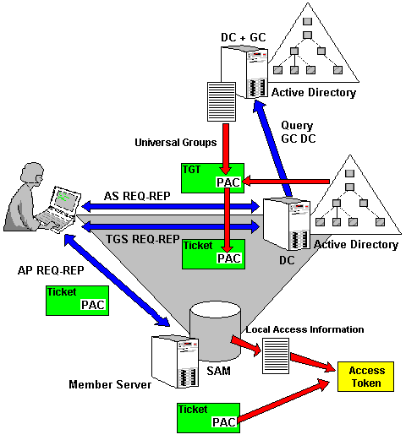
Figure 29: From authentication to authorization

An important component in this process is the PAC: the Privilege Attribute Certificate. Microsoft extended the base Kerberos protocol to include authorization data. A Windows 2000 ticket and TGT both contain a special field called the Privilege Attribute Certificate (PAC) (This concept also appears in the DCE authentication protocol…). The PAC contains a user’s domain group memberships.
Like in any other Kerberos authentication sequence we’re once more dealing with 3 entities: a user, a resource server (containing some resource the user wants to access) and a Kerberos KDC.
Once the client’s workstation has located a Domain controller it will request a Ticket Granting Ticket (AS REQ subprotocol). The KDC will generate the TGT and embed the following user authorization data in it (into the PAC):
- The user’s Global group memberships and Domain local group memberships: available in the KDC’s local Active Directory (Domain NC);
- The user’s Universal group memberships: available in the Global Catalog. If the KDC server himself doesn’t host a Global Catalog, the KDC service will need to query a global catalog on another domain controller.
The KDC sends the TGT back to client (AS REQ subprotocol); from then on the client can cache the TGT for the entirety of its lifetime.
The client decides that he wants to access a resource hosted on some member server. The client sends a request for a ticket to the KDC. If the member server is part of the same domain the local KDC can generate a ticket for the client. This ticket will contain the same PAC as the one contained in the TGT. The ticket is send back to the client (AS REP subprotocol)
If the member server is part of another domain the KDC will refer the client to another KDC.
The client authenticates to the resource server using the ticket. The LSA on the resource server will generate the user’s access token (for use in subsequent access control decisions). Within the access token the LSA will embed:
- The user’s authorization data found in the ticket.
- The user’s authorization data found in the local security database (SAM): these are the user’s Local group memberships.

Group Type | Group: Available Where? | Membership: Available Where?
Universal group | AD: Global Catalog (Subset of Domain NC) | AD: Global Catalog (Subset of Domain NC)
Global group | AD: Global Catalog (Subset of Domain NC) | AD: Domain NC
Domain local group | AD: Domain NC | AD: Domain NC
Local group | SAM | SAM
The presence of at least one domain controller hosting a Global Catalog per domain tree is mandatory to logon a normal user. Accounts that are member of the Administrators or Domain Admins groups can logon even when a Global Catalog server is not available.
Key things to remember from this section are the following:
- The PAC data are added to a ticket on the KDC level and are inherited between subsequent TGT and ticket requests and renewals.
- The PAC data are not refreshed at ticket-request time; this means that if a user’s group memberships change during its logon session, he’ll still have to logoff-logon (just as in NT4).

The Kerberos ticket and authenticator
This paragraph provides some inside information on the Kerberos ticket and authenticator. A detailed overview of the content of a Kerberos ticket and authenticator are available in Appendix 2 of this white paper.
Remember that the primary purpose of a ticket is to securely transport the session key to be used for authentication between two entities. A ticket can only be decrypted by a KDC and the destination resource server. This way the client cannot decrypt and change it’s own authorization data (the information contained in the PAC).
An authenticator is the Kerberos object that is providing the actual authentication. An authenticator can be checked by anyone possessing the corresponding session key.
The concepts of a ticket and an authenticator are illustrated in Figure 30.
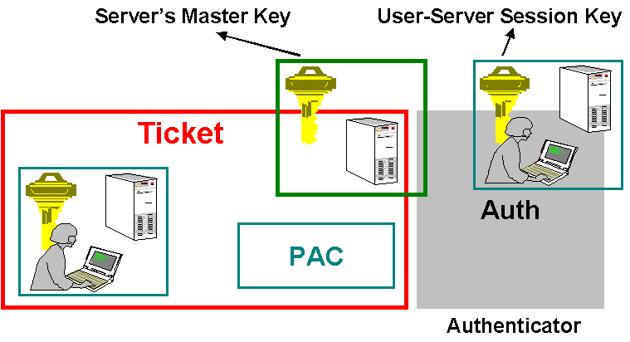

An interesting detail on the PAC, the part of the ticket containing authorization data, is the following:
Figure 30: Ticket and Authenticator details

The PAC’s content is digitally signed by the KDC that issued the corresponding ticket. This is done to block malicious server server-side services that want to change authorization data. The LSA (Local Security Authority) will require a validation of the signature for every ticket coming from a service that is not running using the local system account. To validate the signature the server will need to set up a secure channel to the KDC that signed the authorization data.

Kerberized Applications
Kerberized applications are applications that use the Kerberos authentication protocol to provide authentication (and maybe in a later phase to provide encryption and signing for subsequent messages). Authentication can be related to a user, a machine or a service (any ‘principal’).
In its current release, Windows 2000 includes the following Kerberized applications:
- LDAP to AD

- CIFS/SMB remote file access
- Secure dynamic DNS update
- Distributed File System Management
- Host-Host Internet Protocol (IP) security using ISAKMP
- Secure intranet Web services using IIS
- Authenticate certificate request to Certification Authority (CA)
- DCOM RPC security provider

-  

To illustrate the functioning of a Kerberized application let’s have a look at ‘Secure dynamic DNS update’.
The goal of providing a ‘secure dynamic DNS update’ facility is that not just anyone can perform updates on the DNS database. We want that the one who requests an update to be authenticated and authorized to perform the action on the DNS object(s). In Windows 2000, this is possible because of the combination of the following technologies:
- Kerberos can provide authentication of the client wishing to modify the DNS database;
- The integration of the DNS database with the AD means that the normal Windows 2000 authorization model can be applied to any DNS object (using ACLs).
Secure Dynamic DNS update is illustrated in Figure 31.
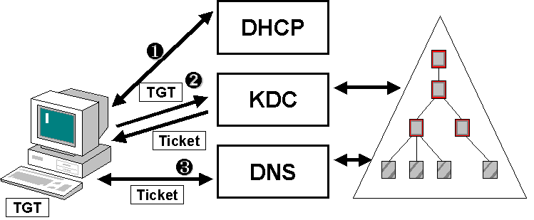

- A workstation receives its IP configuration information from a DHCP server as part of the startup process; this dynamic information should be communicated to the DNS database in a secure manner. (Step 1)
Figure 31: Secure Dynamic DNS update sequence

- The client, which already authenticated to the KDC in an earlier phase, requests a ticket for the DNS service to the KDC. (Step 2)
- To authenticate to the DNS service, the client presents his ticket.
Figure 32: Secure Dynamic DNS settings

- The DNS service checks the client’s credentials. If the authentication is succesful the usual authorization rules regarding object access apply to the client. (Step 3)
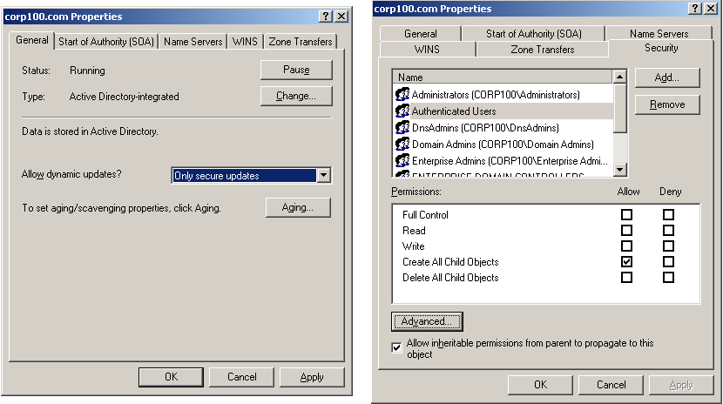
Figure 32 illustrates how Secure Dynamic DNS updates can be configured for a portion of the DNS database.
- “Only Secure Updates” is a property that can be set on the level of each Active Directory-integrated DNS zone file.
- To see the corresponding ACLs go to the ACL editor of the zone file: here you’ll find that by default only “Authenticated Users” can update the zone file data (“create child objects”).

Kerberos GPO settings
The Windows 2000 Account Policies include a special subfolder for Kerberos-related policy settings.

The TGT’s lifetime, the service ticket’s lifetime and the ‘maximum renewable period’ are the three most important variables that can be set using a Windows 2000 Group Policy Object (GPO) (see Figure 33). The default lifetimes are 10 hours for a TGT, 10 hours for a ticket, and 7 days for TGT renewal. Obviously the TGT’s ‘maximum renewable period’ should always be bigger than its lifetime.
Figure 33: Kerberos GPO settings

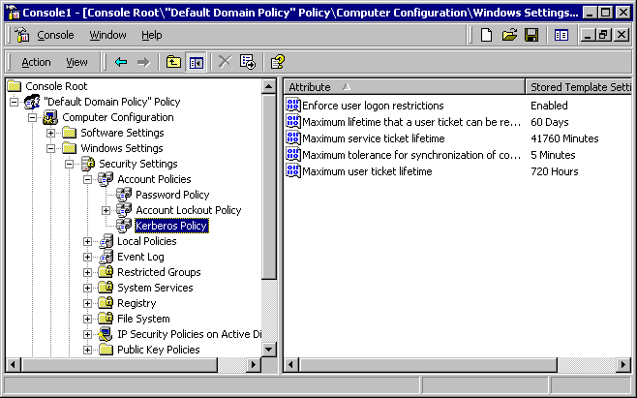

Another setting that can be set in the same GPO folder is the maximum time skew that can be tolerated between a ticket’s timestamp and the current timestamp at the receiving end. Kerberos is using a timestamp to protect against replay attacks. Setting this setting too high creates a bigger risk for replay attacks.
Although not directly related to Kerberos the Kerberos Policy folder also includes the setting “Enforce user logon restrictions”. This setting enforces the evaluation of a user’s rights on the target computer (the resource server) by the KDC. This evaluation occurs on every service ticket request. By default the setting is on.

Smart Card Logon
Windows 2000 includes support for the extensions to Kerberos Version 5 to support public-key-based authentication (PKINIT). These extensions allow a client and the KDC to perform the Authentication Request (KRB_AS_REQ) and Reply (KRB_AS_REP) phases by making use of the client’s public key credentials. As explained earlier in this white paper it is PKINIT that enables smart card logon to a Windows 2000 domain.
To a certain extent PKINIT takes away the need for a “master key “. All occurrences of the master key during the AS sequences are replaced by the user’s public key credentials:

Standard Kerberos usage of master key (AS REQ-REP) | PKINIT replacement
Client-side encryption of the pre-authentication data | Private key
KDC-side decryption of the pre-authentication data | Public key
KDC-side encryption of session key | Public key
Client-side decryption of session key | Private key

PKINIT introduces a new trust model: the KDC doesn’t necessarily identify all the users (as was the case with the “master key” concept). When using certificates a Certification Authority identifies the users prior to the Kerberos exchange. Of course the KDC needs to trust the CA.
Figure 34: Windows 2000 smart card logon

PKINIT extends the basic Kerberos protocol by introducing two new pre-authentication messages: PA-PK-AS-REQ and PA-PK-AS-REP.
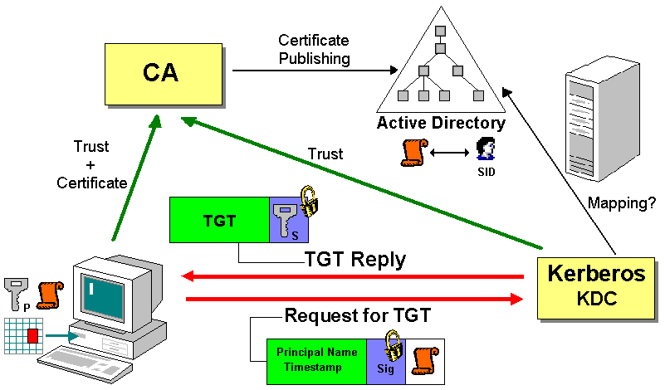

Figure 34 explains how Kerberos smart card logon works:
- The user starts the logon process by introducing his smartcard and by authenticating to the card using his PIN code. The smartcard contains the user’s public key credentials: his private-public key pair and the user’s certificate.
- A TGT request is sent to the KDC (AS); this request contains the following (PA-PK-AS-REQ):
  - The user’s principal name and a timestamp.
  - The above signed with the user’s private key.
  - A copy of the user’s certificate.
- To validate the request and the digital signature on it, the KDC will validate the user’s certificate. The KDC will then query the Active Directory for a mapping between the certificate and a Windows 2000 SID and issue a TGT for the corresponding SID.
- The KDC sends back the TGT to the user. The user’s copy of the session is encrypted with the user’s public key (PA-PK-AS-REP).
- To retrieve its copy of the session key the user uses his private key.

Kerberos Transport protocols and ports
Kerberos typically uses the connectionless UDP protocol as a transport protocol. Microsoft uses TCP on certain occasions to take advantage of TCP’s bigger Maximum Transmission Unit (MTU) capacity. Microsoft has chosen to use TCP if the ticket size is bigger than 4k. UDP has a 1500 octet MTU limit. Windows 2000 Kerberos ticket can easily grow beyond this limit if they are carrying a large PAC field. The use of TCP is in accordance with the revised RFC1510.
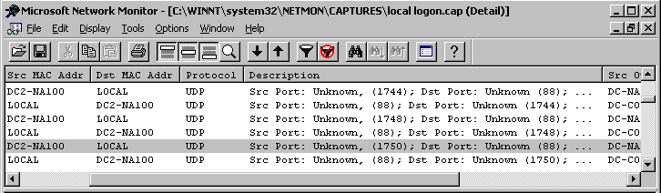

Kerberos uses port 88 on the KDC-side and a variable port on the client-side. If your Kerberos clients communicate only with KerberosV5 KDCs (Windows 2000) it’s enough to keep port 88 open on your firewall; if they communicate with KerberosV4 KDCs remember to open up port 750.
Figure 35: Network Monitor Kerberos trace

The Network Monitor trace shown in Figure 35 shows a typical Kerberos local logon trace. Notice the usage of UDP as a transport protocol, port 88 on the KDC side and a variable port (ranging from 1744 to 1750) on the client side.

Delegation of Authentication
As discussed in the section on “Kerberos features,” Windows 2000 Kerberos supports delegation of authentication. Delegation of authentication was introduced in v5 of the Kerberos protocol. Besides facilitating authentication in multi-tiered applications, this feature also improves authorization and auditing for the same type of applications.
Delegation is a mechanism that makes it possible for the KDC to issue a ticket with a network address that is different from the address of the principal that made the ticket (TGT or service ticket) request. The mechanism is based on some flag values that can be set in the “flags” field of a Kerberos ticket.
The Kerberos standard (RFC 1510) defines 4 types of flags related to delegation:

Flag | Meaning
Proxiable | Tells the TGS that a new service ticket with a different network address may be issued based on this ticket
Proxy | Indicates that the ticket is a proxy ticket
Forwardable | Tells the TGS that a new TGT with a different network address may be issued based on this TGT
Forwarded | Indicates that this ticket has been forwarded or was issued based on an authentication using a forwarded TGT
Windows 2000 currently only support the “forwardable” and “forwarded” delegation ticket flags. The table above shows that “forwardable” is a much more powerful concept than “proxiable”.
Figure 36 gives a practical example of a delegation process. Imagine we are dealing with a browser client that wants to access his Exchange mailbox crossing an Internet Information Server (this is an Outlook Web Access (OWA) example).
Figure 36: Kerberos delegation

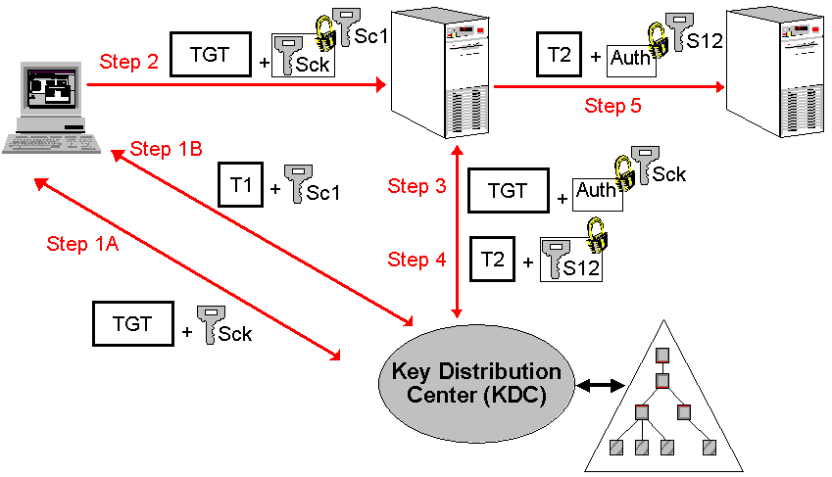

Here’s what’s happening before and during the delegation process:
- During the Authentication sequence (KRB_AS_REQ and KRB_AS_REP) the client receives a ‘Forwardable’ TGT and the associated session key Sck from the KDC. (Step 1A)
- Later on in his logon session the client accesses a resource on Server1 and obtains a ticket T1 and a session key Sc1 for Server 1 (KRB_TGS_REQ and KRB_TGS_REP) (Step 1B).
- The client then decides he wants to access his mailbox using his browser. To do this the client will forward the TGT and the associated session key Sck to Server1. To assure the confidentiality of the session key Sck it will be encrypted using the session key Sc1 the client shares with Server1. (Step 2)
- Using the client’s ‘Forwardable’ TGT Server1 can request a new ticket T2 to access Server2. The KDC will notice the request is coming from a different IP-address than the one mentioned in the TGT. (Step 3)
- Because the TGT is ‘Forwardable’ The KDC agrees to issue a new ticket. This new ticket T2 will contain the client’s identity and authorization data (PAC). Coming with the ticket is a new encrypted session key S12. (Step 4)
- Server 1 authenticates to Server2 using T2 and session key S12. Server 2 thinks he is dealing with the client although the messages are originating at Server1. (Step 5)

Kerberos Time Sensitivity
Time is a critical service in Windows 2000. As mentioned before this is due to Kerberos: Kerberos uses timestamps to protect against replay attacks.
The service responsible for time synchronization between Windows 2000 computers is the “Windows Time Synchronization Service” (W32time.exe). The time service is compliant with the Simple Network Time Protocol (SNTP) as defined in RFC 1769.
More details on the basic operation of SNTP as implemented in W32time can be found in appendix 4 of this white paper.
The following registry parameters related to W32time can be set:
- NTPServer (REG_SZ): NTP servername or IP address
- Type (REG_SZ): “NT5DS” or “NTP”
The first registry entry can be set using the “NET TIME /SETSNTP: <ntp server>” command. To query the same registry entry use “NET TIME /QUERYSNTP: <ntp server>”.

Kerberos interoperability
When discussing Kerberos interoperability in Windows 2000 we have to focus on interoperability with MIT-Kerberos and Kerberos as implemented by CyberSafe. There exist numerous MIT-Kerberos implementations for different Unix platforms. CyberSafe has Kerberos implementations for Unix, MVS and NT4 platforms. In what follows we’ll focus on authentication interoperability between Windows 2000 and a Kerberos implementation on Unix.
Our interoperability discussion can be subdivided in 3 scenarios:
- The Windows 2000 Kerberos KDC is the KDC for both Windows 2000 and Unix principals (the principals are administered from the Windows KDC). (Scenario 1)
- The Unix KDC is the KDC for both Windows 2000 and Unix principals (the principals are administered on the Unix KDC). This scenario includes no Windows 2000 domain controllers. (Scenario 2)
- A cross-realm trust-relationship is defined between a Windows 2000 domain and a Unix Kerberos realm. (A part of the principals is administered on the Windows KDC, another part is administered on the Unix KDC). (Scenario 3)
Scenario 1: Principals in Windows 2000 KDC
In this scenario the Windows 2000 administrator has to run through the following configuration steps:
- Create new accounts for the Unix hosts in the Active Directory
- Use ktpass.exe to create a keytab file. The keytab file contains the password that will be used by the Unix host to logon to the Windows 2000 domain.
- Copy the keytab file to the Unix host and merge it with the existing keytab file.
- Edit the Kerberos configuration file on the Unix host to refer to the Windows 2000 KDC.
- Create Unix accounts corresponding to the Windows 2000 accounts
The example below illustrates this scenario. A team within Compaq Professional Services set it up to provide Kerberos single-sign-on between a Compaq Tru64 platform and a Windows 2000 platform. The Windows 2000 domain controller involved hosts the KDC and the central directory (the Active Directory) containing the credentials of both Tru64 and Windows 2000 principals.
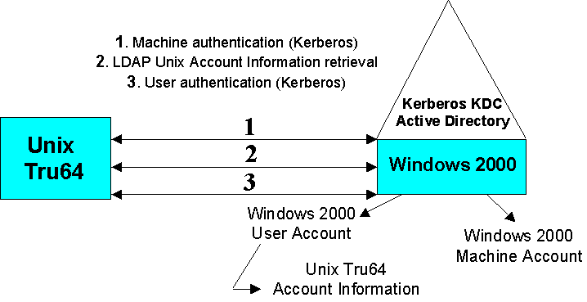

To enable the storage of Unix-specific account information in the Active Directory, the Windows 2000 Directory schema and management interface were extended. Before a user principal can logon to the Windows 2000 domain, account specific information (such as the UID and GID) is retrieved from the Active Directory using LDAP. The retrieval is secured using SASL. In the future the protocol could be extended to include the Unix account information into the ticket’s PAC.
Scenario 2: Principals in Unix KDC
Figure 37: Unix Tru64 – Windows 2000 Kerberos interoperability

This setup can only be supported in a limited way. The problem is that Windows 2000 applications that use a SID-based authentication cannot do anything with a Unix account, administered from a Unix KDC. Windows 2000 applications that use a simple name-based authentication scheme could use Unix accounts, administered from a Unix KDC. An example is a database application doing authentication using its own authorization tables.
From the moment you have an application that needs SID-based authentication you’ll need a Windows 2000 KDC. This case is explained in scenario 3.
For a Windows 2000 workstation or member server to use a Unix KDC the following has to be done:
- Create a host for the workstation in the Unix realm.
- Configure the Windows 2000 workstation or member server using ksetup.exe to let it point to the Unix KDC and realm and to set the machine password (this will automatically switch the workstation or member server to workgroup mode).
- Restart the workstation or member server and run ksetup.exe again to map local machine accounts to Unix principals.
Scenario 3: Cross-realm trust
This is probably the best interoperability solution available. In this scenario we have resources or applications requiring a SID-based authentication. This means that at least one Windows 2000 domain controller running the KDC service is needed.
If we define all user accounts in the Unix domain we create a domain layout that is very similar to the NT4 multiple domain model of account domains and resource domains. In this case the Unix domain acts as a master account domain containing all the accounts. The Windows 2000 domain acts as a resource domain, containing resources and mappings from the Unix accounts to Windows 2000 SIDs.
Although this can be a nice solution you’ll loose a lot of administrative simplicity. For example: you’ll have to define account mappings. An account mapping maps a Windows 2000 Security Identity (SID) to an alternate identity (In this case the alternate identity is an account defined in the Unix domain). The way account mappings are implemented in Windows 2000 is by adding entries to the altSecurityId attribute of a Windows 2000 account.
The setup could also become fairly complex. Think of the example where you have to link two Windows 2000 domains with one Unix domain in the middle. The key message in this interoperability-scenario is: test and test and…
To setup a cross-realm trust between a Windows 2000 domain and a Unix realm:
- Add a realm entry for the Unix realm on every Windows 2000 host (ksetup.exe)
- Setup the trust relationship by running ksetup.exe on the Windows 2000 domain controller and by adding a trust relationship in the Active Directory domains and trusts snap-in.
- Setup the trust relationship on the Unix side by adding cross-realm principals for the Windows 2000 domain.
- Create account mappings in the Active Directory between the Unix principals and Windows 2000 SIDs.
Let’s look at what happens when a Unix principal wants to access a resource hosted on a machine that is a member of a Windows 2000 domain (We’re in scenario 3, a cross-realm trust is defined between the Unix and the Windows 2000 domain):
- The Unix principal is logged on to the Unix domain; his credential cache contains a TGT for the Unix domain.
- The Unix principal wants to access resource A in the Windows 2000 domain. His local KDC refers him to the Windows 2000 KDC.
- The Windows 2000 KDC creates a new service ticket for the Unix principal to access resource A. Since the TGT used by the Unix principal contains an empty PAC, the Windows 2000 KDC will query the Active Directory for an account mapping between the Unix principal and a Windows 2000 SID. The newly issued service ticket will contain the PAC data corresponding to the Windows 2000 SID.
- Using the service ticket the Unix principal authenticates to the machine hosting resource A.
Three more remarks for application developers regarding Kerberos interoperability:
- Although Microsoft implemented the Kerberos protocol as an SSPI plug-in it supports the GSS_API token formats (as defined in RFC 1964). As a consequence a Unix application supporting GSS_API and a Win2K service can mutually authenticate using Kerberos.
- The MS Kerberos implementation is currently not interoperable with the OSF’s DCE security environment.
- Application Developers using the KRB_PRIV extension to provide data confidentiality services need to consider the U.S. export restrictions on strong encryption when implementing their application between the US and other countries. U.S. Export Laws prohibit the export of software that is using encryption technology with key-lengths higher than 56 bits. The standard MIT Kerberos V5, available on US websites for several Unix platforms, is using 56-bit keys. Windows 2000 Kerberos comes in two flavours: a version implementing 128-bit keys for data confidentiality services (KRB_PRIV), and another one implementing 56-bit keys for the same service. For authentication and integrity services Windows 2000 always uses 128-bit keys. The 128-bit key version for data confidentiality is made available via an add-on “Crypto Pack” to the retail Windows 2000 edition. This Crypto Pack is only made available to customers in the US and Canada and to organizations that are on the US export law exception list (such as banks…). Anyway: if there’s one side that supports only 56 bit keys, Kerberos will negotiate the usage of 56 bit keys for data encryption.

Logon Names
Windows 2000 users can logon to a Windows 2000 domain using an NT4-like account name or using a User Principal Name (UPN).
The concept of a UPN is an extension to the standard Kerberos Protocol. A UPN must be unique in the forest. Every user also keeps his downlevel NT4-like logon name (MS Principal Name): <domain name>\<SAM name>. The “SAM name” must be unique in the domain.
A UPN consists of a principal’s name, an @-symbol and a DNS domain name. There’s no need for the DNS domain name to correspond to the domain containing the user principal. It needs to correspond to a domain that has a trust relationship with the principal’s domain or to an alternate domain name listed in the properties of the Partitions container (part of the Configuration container) (Illustrated in Figure 39). At logon time the UPN is validated first by searching the local Active Directory Domain naming context, then the Global Catalog.
The UPN stays the same independently of what happens with the user principal after its creation. The following examples do not affect the UPN:
- Moving a user principal to another domain.
- Renaming a user principal’s NT4-like name.
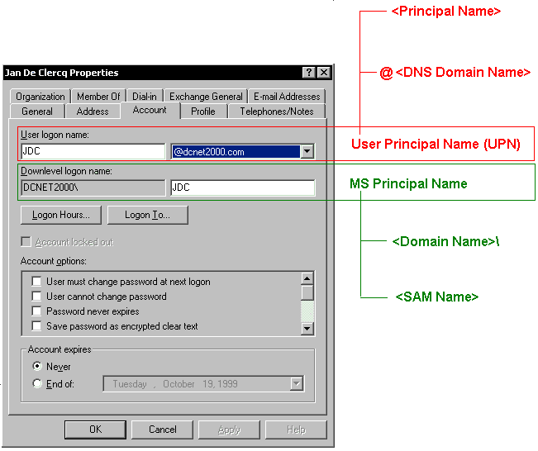

From a user’s point of view Windows 2000 UPNs enable the user to logon with his E-mail address. This can be risky from a security point-of-view: a hacker sniffing SMTP traffic, immediately catches half of the credentials.
Figure 39: Adding UPN suffixes: left: properties of root node of Active Directory Domains and Trusts; right: properties of Partitions container (ADSI edit)

Figure 38: Logon names listed in account properties of user object

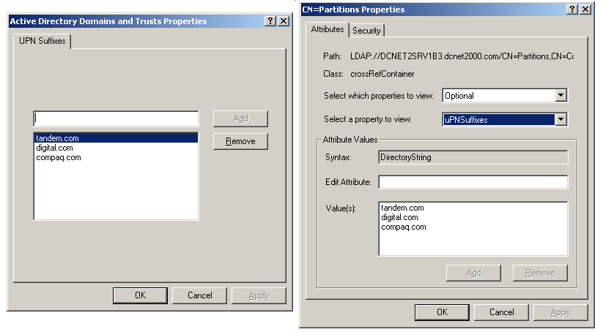

Troubleshooting Kerberos
The Windows 2000 resource kit comes with several tools that can be used to troubleshoot Kerberos. Most of them are command prompt tools:
- Netdiag.exe helps isolate networking and connectivity problems by providing a series of tests to determine the state of your network client and whether it is functional. One of the ‘NETDIAG’ tests is the Kerberos test (netdiag was named nettest before Beta 3).
- Nltest.exe can be used to test trust relationships.
- netdom.exe (netdom was named trustdom before Beta 3) is a command-line tool to manage (view, create, delete) trust relationships:
  - Two-way trust relationships between Windows 2000 domains;
  - Explicit one-way trust relationships with NT4 domains;
  - Trust relationships between a Windows 2000 domain and and an MIT-based Kerberos realm on a UNIX system.
On the GUI-side the Replication monitor and the Network monitor are worth mentioning. Using Replication monitor an administrator can not only check the replication traffic but also the number of AS and TGS requests and the FSMO roles.
Network monitor doesn’t include a parser for the Kerberos protocol but can anyway be interesting to analyze Kerberos network traffic (look for port 88).

Perhaps the most interesting tools are included in the Windows 2000 SDK:
- Using mytoken.exe a user can look into his local access token: he can see his group memberships and user rights.
- Using klist.exe one can look at the locally cached Kerberos tickets, the TGT and even purge tickets.
Figure 40: Mytoken.exe

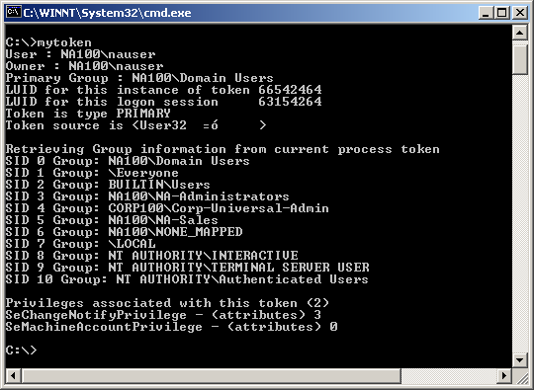

Conclusion
By implementing Kerberos in Windows 2000 Microsoft has clearly ameliorated and extended the authentication process. This article also showed that Kerberos is, mainly because of its “symmetric cryptography” roots, a typical LAN-intranet oriented authentication protocol. The inclusion of PKINIT is a first step towards the inclusion of public key-based authentication mechanisms into Kerberos and towards the widening of Kerberos‘ application area.

Appendix 1: Analyzing Kerberos Tickets
In this Appendix we’ll analyze two network logon sequences: a local logon and a network logon. In what follows we’ll look in great detail at the content of a Kerberos Ticket Granting Ticket (TGT) and a service ticket.
Key to understand the content of Kerberos TGTs and tickets are the ticket flags. The ticket flags and their meaning are explained in the table below.

BIT 1 |  | BIT 2 |  | BIT 3 |  | BIT 4
8 | N/A | 8 | Proxy (4) | 8 | Renewable (8) | 8 | N/A
4 | Forwardable (1) | 4 | May be postdated (5) | 4 | Initial (9) | 4 | Target trusted for delegation (12)
2 | Forwarded (2) | 2 | Postdated (6) | 2 | Preauthent (10) | 2 | N/A
1 | Proxiable (3) | 1 | Invalid (7) | 1 | Hardware preauthentication (11) | 1 | N/A

- Indicates to the ticket-granting server that it can issue a new ticket- granting ticket with a different network address based on the presented ticket.
- The ticket has either been forwarded or was issued based on authentication involving a forwarded ticket-granting ticket.
- Indicates to the ticket-granting server that only non- ticket-granting tickets may be issued with different network addresses.
- The ticket is a proxy.
- Indicates to the ticket-granting server that a post- dated ticket may be issued based on this ticket-granting ticket.
- end-service can check the ticket's authtime field to see when the original authentication occurred.
- The ticket is invalid.
- The ticket is renewable. If this flag is set, the time limit for renewing the ticket is set in RenewTime. A renewable ticket can be used to obtain a replacement ticket that expires at a later date.
- The ticket was issued using the AS protocol instead of being based on a ticket-granting ticket.
- Indicates that, during initial authentication, the client was authenticated by the KDC before a ticket was issued. The strength of the preauthentication method is not indicated, but is acceptable to the KDC.
- Indicates that the protocol employed for initial authentication required the use of hardware expected to be possessed solely by the named client. The hardware authentication method is selected by the KDC and the strength of the method is not indicated.
- This flag means that the target of the ticket is trusted by the directory service for delegation. Thus, clients may delegate their credentials to the server, which lets the server act as the client when talking to other services.
A ticket can contain multiple flags. The flags are added to the ticket’s properties as a hexadecimal 8-bit number, of which only the first four bits are significant. 1 bit can refer to different flags. If flags refer to the same bit-position they are added hex decimally.
The table below facilitates the addition of hexadecimal numbers. Hexadecimal A equals 8 + 2 (decimal 10); Hexadecimal D equals 8 + 4 + 1 (decimal 13).

 | 8 | 4 | 2 | 1
A | * |  | *
B | * |  | * | *
C | * | *
D | * | * |  | *
E | * | * | *
F | * | * | * | *

Some examples of typical ticket flags:
- 0x40e00000
(4) Forwardable
e = 14 = 8 + 4 + 2
(8) Renewable
(4) AS : Initial ticket
(2) PreAuth

- 0x40840000
(4) Forwardable
(8) Renewable
- Target of ticket is trusted for delegation
In the examples below we will be using the following domain layout:
- 1 parent domain corp100.com
- 2 child domains eu100.corp100.com and na100.corp100.com
Local logon example
A user defined in the na100 domain logs on to the na100 domain from machine dc2-na100 that’s also part of the na100 domain.
“klist tickets” reveals the following local ticket cache content:
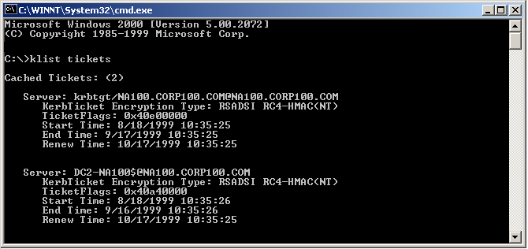

Network logon example
Figure 41: klist output for interactive logon

The same user accesses a resource located on machine dc1-eu100 in the eu100 domain.
“klist tickets” reveals the following local ticket cache content:
- 1 TGT for the na100 domain.
- 1 ticket for the local machine: dc2-na100.
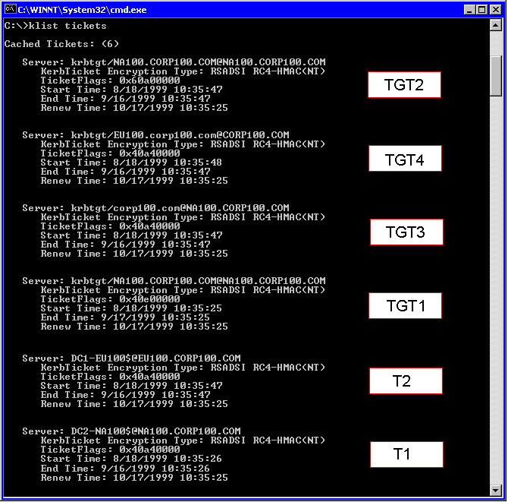

This time the cache contains 6 tickets, of which 4 are TGTs. The 4 TGTs reflect the Kerberos referral process: there’s a 1 TGT for corp100, 1 for eu100 and 2 for na100.
Figure 42: klist output for non-interactive logon in multiple domain

The tickets are for the user’s local machine (dc2-na100) and for the resource machine in the eu100 domain (dc1-eu100).
Let’s look closer at the 4 TGTs
TGT 1 for NA100
Flags: 40e
- Forwardable
e = 14 = 8 + 4 + 2
- Renewable
- AS : Initial ticket
(2) PreAuth
TGT 2 for NA100
Flags: 60a
6 = 4 + 2
(4) Forwardable
(2) Forwarded
a = 8 + 2
- Renewable
(2) PreAuth
TGT 3 for CORP100
Flags: 40a
(4) Forwardable
a = 8 + 2
- Renewable
(2) PreAuth
TGT 4 for EU100
Flags: 40a: see TGT3

Appendix 2: Kerberos Ticket and Authenticator fields
The table below lists the content of a ticket:

Encrypted? | Name | Meaning
 | Tkt-vno | Version number of the ticket format. In Kerberos v.5 it is 5.
 | Realm | Name of the realm (domain) that issued the ticket.
 | Sname | Name of the server. (Principal name)
 | Flags | Ticket options.
 | Key | Session key.
 | Crealm | Name of the client’s realm (domain).
 | Cname | Client’s name. (Principal name)
 | Transited | Lists the Kerberos realms that took part in authenticating the client to whom the ticket was issued.
 | Authtime | Time of initial authentication by the client. The KDC places a timestamp in this field when it issues a TGT. When it issues tickets based on a TGT, the KDC copies the authtime of the TGT to the authtime of the ticket.
 | Starttime | (Optional) Time after which the ticket is valid.
 | Endtime | Ticket’s expiration time.
 | Renew-till | (Optional) Maximum endtime that may be set in a ticket with a RENEWABLE flag.
 | Caddr | (Optional) One or more addresses from which the ticket can be used. If omitted, the ticket can be used from any address.
 | Authorization data | (Optional) Privilege attributes for the client. Microsoft calls this part the Privilege Attribute Certificate (PAC).
The table below lists the content of an authenticator:

Encrypted? | Name | Meaning
 | Authenticator-vno | Version number of the authenticator format. In Kerberos v.5 it is 5.
 | Crealm | Name of the realm (domain) that issued the corresponding ticket.
 | Cname | Name of the server that issued the corresponding ticket. (Principal name)
 | Cksum | (Optional) Checksum of the application data in the KRB_AP_REQ
 | Cusec | Microsecond part of the client’s timestamp
 | Ctime | Current time on client
 | Subkey | (Optional) Client’s choice for an encryption key to be used to protect an application session. If left out the session key from the ticket is used.
 | Seq-number | (Optional) Initial sequence number to be used by the KRB_PRIV or KRB_SAFE messages (protection against replay attacks)

Appendix 3: Kerberos ports

Port | Protocol | Function description
88 | UDP TCP | Kerberos V5
750 | UDP TCP | Kerberos V4 Authentication
751 | UDP TCP | Kerberos V4 Authentication
752 | UDP | Kerberos password server
753 | UDP | Kerberos user registration server
754 | TCP | Kerberos slave propagation
1109 | TCP | POP with Kerberos
2053 | TCP | Kerberos de-multiplexor
2105 | TCP | Kerberos encrypted rlogin

Appendix 4: Basic SNTP Operation
All Windows 2000 machines have W32Time installed by default. Only machines that are joined in a domain will start the W32Time service automatically.
Client Boot Checks
a. The client contacts an authenticating domain controller.
- Packets are exchanged to determine the latency of communication between the two computers.
- W32Time determines what current time should be converged to locally, (the "target" time).
b. The client adjusts the local time.
- If the target time is ahead of local time, local time is immediately set to the target time.
- If the target time is behind local time, the local clock is slowed over the next 20 minutes to align the two times, unless local time is more than 2 minutes out of synchronization, in which case the time is immediately set
Interval Checks
a. The time server client performs periodic checks.
- The client connects to the "inbound time partner" (authenticating domain controller) once each "period."
- The initial period is eight hours.
b. If the local time is off from the target time by more than two seconds:
- The interval check period is divided in half.
- This process is repeated at the next interval check until either:
  - The local and target time remain within two seconds of each other, or
  - The interval frequency is reduced to the minimum setting of 45 minutes.
- If accuracy is maintained within two seconds, the interval check period is doubled, up to a maximum period of eight hours.
Time Convergence Hierarchy
a. All client desktops nominate as their inbound time partner the authenticating domain controller (the domain controller returned by DSGetDCName()). If this domain controller becomes unavailable, the client re-issues its request for a domain controller.
b. All member servers follow the same process.
c. All domain controllers in a domain nominate the primary domain controller (PDC) Flexible Single Master Operation (FSMO) to be the inbound time partner.
d. All PDC FSMOs in the enterprise follow the hierarchy of domains in their selection of an inbound time partner.
e. The PDC FSMO at the root of the forest is authoritative, and can be manually set to synchronize with an outside time source.

Kerberos V5 is defined in RFC 1510.
IPsec (The security architecture for the Internet Protocol) is defined in RFCs 1825 through 1827.
L2TP (Layer 2 Tunneling Protocol) is defined in the Internet-draft: “draft-ietf-pppext-l2tp-14.txt”.
For more information on SSL v3 go to http://home.netscape.com/eng/ssl3/ssl-toc.html; TLS v1 is defined in RFC2246.
See the Windows 2000 section of Compaq Active Answers at http://www.compaq.com/activeanswers
More SID details are available in the Platform SDK of Windows 2000.
The Windows 2000 FSMO roles are explained in more detail in the Compaq white paper on “Active Directory Overview”.
Known as the Secure Attention Sequence (SAS)
Another key change happened to one of NT’s most important abstraction layers: The CryptoAPI is now up to Version 2. V2 includes new interfaces to deal with certificates.
GINA stands for Graphical Identification and Authentication.
You can find out which authentication package dlls are available at your machine by looking into the following registry folder: \HKEY_LOCAL_MACHINE\System\CurrentControlSet\Control\Lsa\AuthenticationPackages
“Authentication database” refers in this white paper to the same concept as “security database”
For more information on the difference between symmetric and asymmetric cryptography read the white paper “Security fundamentals as implemented in Windows 2000”.
Every Windows 2000 domain controller runs a KDC “service”.
In the early days of Windows 2000 Microsoft promised to include Kerberos support for Windows 95 and 98 in the “Directory Service Client”, an add-on for Windows 95 and 98 that can be found on the Windows 2000 Server CD.
In what follows the following are synonyms: account=principal=SID and domain=realm (this is true as long as we discuss a pure Windows 2000 environment)
Acceptable means: the resource server compares the timestamp received in Alice’s encrypted packet against the local time. If the time skew between these two timestamps is too big, the resource server will reject the authentication attempt, since a hacker could have replayed Alice’s original authentication packet.
Once more we’re talking about symmetric key cryptography.
The hash algorithm used for password hashing is MD4.
Interesting note: a standard Kerberos domain is made up of a master KDC and one or more slave KDCs. The master KDC is collocated with a read-write copy of the authentication database (single-master model). In Windows 2000 every KDC server hosts a read-write copy of the domain portion of the Active Directory (multi-master model).
Also note that the KDC consists of two subservices: an authentication service (AS) and a Ticket Granting Service (TGS). We’ll come back to this difference later on in the white paper when discussing inter-domain replication traffic.
The “quality” or the “randomness” of the session key is dependent on the quality of the random number generator of Windows 2000.
In this case the master key is derived from the workstation’s machine account password.
Remember that the session key is encrypted once with Alice’s master key and once with the resource server’s master key.
From the server’s point of view Kerberos’ symmetric key distribution is ‘stateless’.
See Kerberos Features…
For example: the L0phtcrack tool from the “Cult of The Dead Cow ”hacker group.
‘Strong’ means: less susceptible to brute-force attacks. To resist these attacks there are two possibilities: - Use longer keys (longer keys create bigger key-spaces and make it more difficult to guess the right key). - Change the keys more often, which limits the chance for brute-force attacks (in other words: limit the lifetime of the keys; this principle is often referred to as perfect forward secrecy (PFS)). The Kerberos developers have chosen for the latter.
If you do not consider this phrase it may sound silly that the KDC generates the session key and sends it out to the client to get it back from the client at a moment later in time.
The encryption of this request is not a part of the basic Kerberos protocol as defined in RFC 1510; it’s based on the extension known as “preauthentication data”. Preauthentication data will be explained later on in the text.
Remember from step 1 that the authenticator is the basic entity used for Kerberos authentication: it is the user’s ID and the current timestamp, encrypted using the session key that is shared between the 2 entities that need to authenticate to one another.
During a brute-force attack a hacker tries out different keys to decrypt a packet until he finds the right key that decrypts the packet in cleartext.
The Kerberos package will retry up to three times to contact a KDC. It initially waits ten seconds for a reply and will wait an additional ten seconds on each retry.
This shows one of the big advantages of using DNS in Windows 2000: it is easy to find the closest domain by walking the DNS tree.
See “Kerberos: the basic protocol”, on page 15 of this white paper.
The network traffic generated by the referral process is not that huge: the size of a ticket is small compared to the size of the data that are accessed and that are pulled across the network.
These are the default characteristics the trust gets when it’s created; the characteristics can be changed using the “netdom.exe” resource kit tool.
See page 46 of this white paper.
More information is available at http://www.cybersafe.com/trustbroker
The technical details behind Windows 2000 smartcard logon are explained later in this white paper.
For an update on the smart card readers that are supported in Windows 2000, check out the Windows 2000 HCL, available from the MS website.
For more information on the Global Catalog read the Compaq white paper on “Understanding Active Directory Replication”. The Global Catalog is a subset of the domain naming context that is replicated to every other domain. The discussion on the Global Catalog and universal groups is only useful in multi-domain environments.
As defined in draft-ietf-cat-kerberos-pk-init-09.txt. Although MS claims to adhere to this draft, they didn’t implement one of the required algorithms: Diffie-Hellman.
The client doesn’t need a master key anymore; however a master key is still needed for the encryption of the tickets.
It’s not clear yet whether Microsoft includes the certificate in each request. The KDC can as well query the Active Directory to get a copy of the user’s certificate.
See draft-ietf-cat-kerberos-revisions-04.txt, June 25 1999 at http://www.ietf.org.
Windows 2000 TGT are forwardable by default.
RFC 1769 is available at http://www.ietf.org/rfcs/rfc1769.txt
Registry path: HKLM\System\CurrentControlSet\Services\w32Time\Parameters
Ktpass.exe and ksetup.exe are coming with the Windows 2000 resource kit. Ktpass.exe allows an administrator to configure a UNIX computer or UNIX-based service as a security principal in the Windows 2000 Active Directory. Ksetup.exe is used to configure a Windows 2000 workstation to use a MIT-based Kerberos KDC instead of a Windows 2000 KDC.
The Unix-related schema extensions are defined in RFC2307.
The ”Users and computers” MMC snap-in.
There are other reasons why a Unix KDC cannot be used in a pure Windows 2000 environment: Unix KDCs lack RPC-support needed for SID-to-name lookups, LDAP-support for retrieving account lists…
The definition of account mappings can easily be automated.
The corresponding Windows 2000 account is sometimes referred to as a “proxy account”. A proxy account is in most cases not used for logon, but is primarily used to provide identity for a principal (defined in a non-Windows 2000 Kerberos domain) when accessing resources in a win2000 forest.
You can check your Windows 2000 version, by looking at the version description in the properties of one of the following system files: schannel.dll, rsabase.dll or ndiswan.sys.
A Windows 2000 account also has other names associated with it: the X.500 DN (Distinguished Name), the GUID, and the SID. In this paragraph we focus on names that can be used to logon to Windows 2000.
To check if a UPN is unique, check the Global Catalog.
UPNs are defined in RFC 822.
The alternate domain names are listed in the “upnsuffixes” property of the partitions container.
Tests were done on Windows 2000 RC1 (Build 2072)
Since a KDC can only issue tickets for security principals in its own domain, this is also the name of the server’s domain.
The Ticket flags are explained in detail in Appendix A of this white paper.
Since a KDC can only issue tickets for security principals in its own domain, this is also the name of the server’s domain.

