COMPAQ MICROSOFT SHAREPOINT PORTAL SERVER SOLUTION

The configuration shown below represents a Workgroup or Department sized Rapid Deployment solution for Microsoft SharePoint Portal. It is intended to be a simple, easily deployed solution that can be expanded as capacity needs increase, as shown by the Optional additional server components described later.

The target capacity for the single server system is:

- < 200 users
- < 10,000 documents stored
- < 100,000 indexed documents
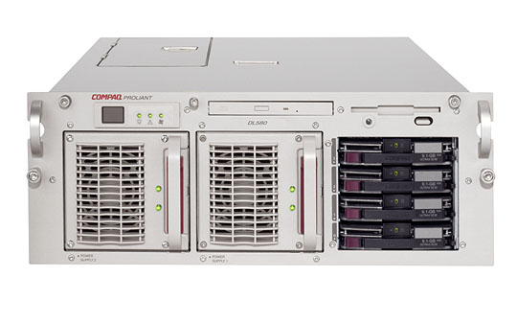

SINGLE SERVER SOLUTION

COMPAQ ProLiant DL580
2 x 700 Mhz Pentium III CPUs (upgradable to 4)
1GB main memory
SmartArray 5302/64 I/O controller
4 x 18.2GB Ultra3 SCSI disks (internal)
Dual Power Supplies

STORAGE EXPANSION CAPABILITY

COMPAQ StorageWorks 4314R (Rack mounted)
Provides an additional 14 x 36.4GB Ultra3 SCSI disks
Connected to SmartArray controller on above system
Full RAID support (RAID 0, 1, 0+1, 5)
Hot Swap capability

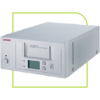

TAPE BACKUP CAPABILITY

COMPAQ 20/40 GB DAT DDS-4 8 Cassette Autoloader
8 Cassette Magazine (7 Tapes + 1 Cleaning Tape)
Up to 7 day unattended operation
Up to 16.8GB / hour capacity (at 2:1 compression)

Additional servers can be deployed as part of a solution to support increased capacity needs. Exact solution sizing and configuration will depend upon the exact workload requirements, however the examples below show typical additional server configurations. If high volume document management or crawling / indexing is anticipated, those solution components can be installed in a dedicated server.

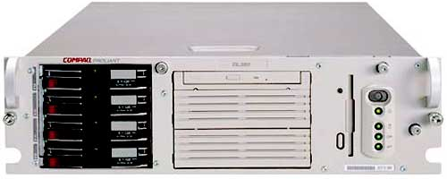

DOCUMENT MANAGEMENT SERVER

COMPAQ ProLiant DL380
1 x 800 MHz Pentium III CPU (upgradable to 2)
512MB main memory
4 x 18.2GB Ultra2 SCSI disks (internal)
Dual NICs

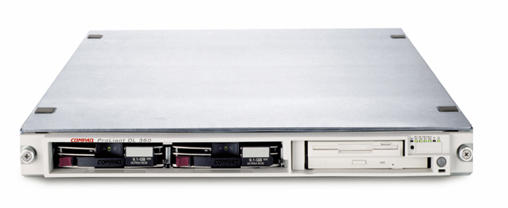

CRAWLER / INDEX / QUERY SERVER

COMPAQ ProLiant DL360
1 x 800 Mhz Pentium III CPU (upgradable to 2)
1GB main memory
2 x 18.2 GB Ultra2 SCSI disks (internal)
Dual NICs

