BIG-IP® Blade Controller: Essential Software for Blade Server and Application High Availability, Scale, Security and Performance Optimization

Introduction
Companies are looking to both hardware and software technologies to help them increase the performance and simplify the deployment of their core enterprise applications, while increasing high availability, scalability, security, performance, and management ease. The introduction of blade servers – modular, rack-optimized platforms providing greater server density and ease of physical deployment – is hardware’s answer. These ultra-dense, servers-on-a-board can be stacked and interconnected in a single chassis, providing economies of scale in computing while significantly reducing power requirements, saving space, and improving hardware management.
In order to harness their full potential – and to create a powerful computing platform for the successful delivery of enterprise applications – blade server technology will require the intelligence of blade and application control software, installed on a blade within the chassis to provide a complete solution. This white paper examines this emerging class of slimmed-down systems called blade servers, their appeal to enterprises and service providers, and why blade controller software should be considered the essential enabling technology for the successful deployment of these new systems.

What Are Blade Servers?

A blade server can be thought of as a server on a card. These ultra-dense, servers-on-a-card slide sideways into a chassis (like library books on a shelf) and can be interconnected. In turn, groups of these chassis can then be housed in a traditional server rack. The first generation of blade servers are powered to support front-end applications like web servers, firewalls, caches, DNS servers, and terminal servers. Second and third generation blade server platforms are being designed to support the greater processing needs of back-end applications, such as application servers and database servers.

BIG-IP Blade Controller – The Essential Component

The potential ROI (Return on Investment) for blade server hardware is great. However, blade servers do not eliminate the traffic management issues organizations currently face with traditional rack or pedestal servers. The only difference is that the problem now exists inside a condensed space.
The bottom line is this: If blade servers can’t properly receive or intelligently manage traffic, the size advantages and hardware management benefits of the technology become irrelevant. A simple analogy can be found with the cell phone. The cell phone has become smaller, with a greater reach, and better functionality – but if a customer is unable to get a signal, the size and functionality benefits are immaterial.
The tangible benefits provided by blade server technology depend on its ability to guarantee maximum server and application uptime, performance, and security. BIG-IP software therefore is an essential component for these systems.

What is BIG-IP?
F5 Networks’ BIG-IP Blade Controller software intelligently manages and directs traffic for all IP-based applications including web servers, application servers, caches, and firewalls running inside the blade server chassis. This ensures the reliability, performance and scalability of the blade server environment. F5’s BIG-IP Blade Controller is uniquely designed to:
- Ensure high availability of the blade servers and applications running in the environment by directing traffic to the service best able to handle the request
- Provide intelligent traffic management direction across services or applications running inside a blade server chassis system
- Enhance scalability by teaming servers into virtual pools, allowing them to appear as one
- Increase security of applications via SSL and BIG-IP’s firewall like features
- Reduce management complexities of the infrastructure
- Enable easy addition of servers and applications to scale services rapidly

Through its virtualization capabilities, BIG-IP Blade Controller serves as the unifying element that optimizes how different blade servers work together and simplifies management by allowing the customer to view them as a single device – as well as combining standard layer 2-3 networking and innovative layer 4-7 traffic management to significantly increase blade server, application, and network capacities.
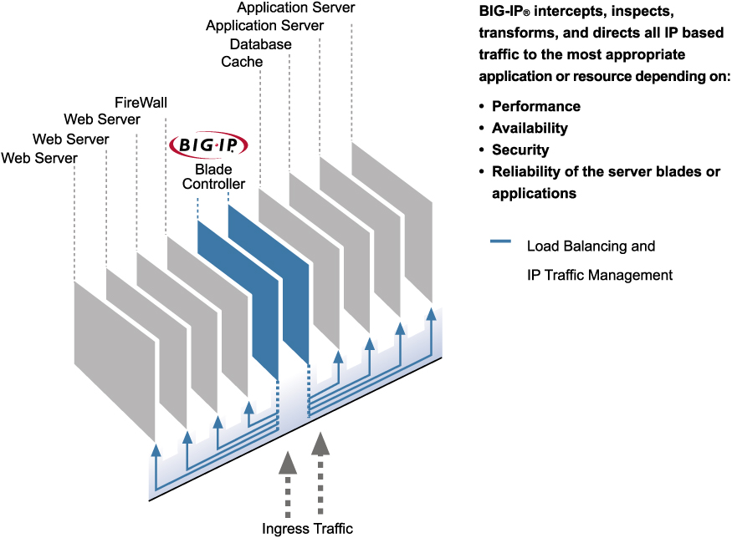

BIG-IP software is identical to the software on F5’s IP Application Switches or IP Server Appliances – only the platform is different (the software is installed on a blade within the blade server chassis). It dynamically consolidates blade server and application resources into flexible pools of resources – helping to achieve simplified management of the total system and provide scale, high availability, security and performance optimization for the applications and blade servers.

Market Adoption For Blade Servers

This emerging class of slimmed-down systems is quickly gaining momentum in the market. According to International Data Corporation (IDC), sales of Intel-based blades are expected to grow from $148 million in 2002 to $2.9 billion by 2005. All the major computing players including Hewlett-Packard have introduced blades.

Benefits of Blade Servers

There are four key benefits found with blade servers that are not found with the traditional server platforms. These benefits include 1) easier management, 2) space savings 3) power savings and 4) cost savings.

Easier Management
Blade servers are attractive to IT primarily because of their hot-pluggable/hot swappable form factor, which makes them easier to manage. The all-in-one design of blade servers provide the “four-R’s” of IT: they’re easy to reboot, re-deploy, re-assign, and re-provision. Unlike traditional rack servers, which require a lot of cabling, circuitry and other components that limit expandability, the blade server design frees IT to “rip and replace” blades – meaning the system can be expanded or contracted as required. The fact that the servers are in closer physical proximity to each other also makes them easier to manage.
Blade server chassis also include power and fan redundancy for the entire system, which means IT organizations don’t have to maintain hardware redundancy for every individual server.

Space Savings
Blade servers deliver density and smaller form factors compared to rack mount and pedestal servers. Because a business can place dozens of blades into a single chassis, they can put more horsepower into a smaller space. By deploying more servers per square foot, for example, service providers can serve up significantly more web pages per rack while driving down data center floor space costs.

Power Savings
Blade servers include various features to reduce power needs, primarily through their Ultra Low Voltage (ULV) processors. Lower power use, in turn, generates less heat and reduces cooling needs. Lower heat production also increases hardware life.

Cost Savings
When deploying more than 10 servers, blade servers are more cost effective than 1U rack servers over time due to:
- Power – up to 5x less than 1U rack servers
- Rack space – up to 7x less than 1U rack servers
- Lower administration costs by approximately 30% through:
  - Integrated management
  - Rapid deployment
  - Reduced cabling

BIG-IP Software Value-Add To Blade Servers

Despite all of their obvious hardware benefits, blade servers and the applications running on them are still essentially stand-alone units within a chassis. They have no knowledge of each other in relation to the applications, so they’re unable to deliver application high availability by themselves. That is, they appear as individual units to the outside world, so if a blade server, O/S, or application fails, users could still be directed to that resource and be adversely impacted even if there are twenty other healthy servers and applications in the chassis. Blade servers are also unable, by themselves, to optimize application performance, or provide built-in security functionality to support the applications.
Definition of BIG-IP Blade Controller software:
Through intelligent traffic management, BIG-IP serves the role of tying discreet (blade) servers together to create a flexible and powerful computing platform for the applications that are running on them.
BIG-IP software can then recognize individual server and application performance and direct IP traffic to the most optimal server or application at any given time. Additionally, the software can also authenticate users to the appropriate resources and secure a channel between client and server/application via SSL.
The importance of having the right IP traffic management software like BIG-IP installed in blade server systems can be set down in four basic laws:
- Without traffic management, blade servers function simply as separate, stand alone devices.
- BIG-IP is the enabling technology for blade servers and the applications running on them.
- BIG-IP software “virtualizes” the individual blade servers – allowing them to operate as a functional whole.
- Virtualization harnesses the power of each server blade, making the whole greater than the sum of the parts.

BIG-IP Blade Controller Software: Summary Benefits

BIG-IP Blade Controller software delivers the following benefits for enterprises and service providers adapting blade server technology. BIG-IP software:
- Intercepts, Inspects (layers 2 to 7), Transforms and Directs all IP-based traffic to the correct server blade resource within the chassis, based on capacity, performance, or customer-defined business criteria.
- Supports SSL acceleration, offloading this processing-intensive function from other server blades – increasing application performance.
- Ensures high availability, reliability, security, and scalability for web applications and services running on server blades.
- Allows for horizontal scaling of applications through the purchase of additional server blades.
- Increases the overall savings realized by dense-server solutions.

Problem/Solution Scenarios

Server blades contain obvious benefits addressing the hardware component of computing but what about the applications and the network? How can an enterprise or service provider integrate the hardware solution more seamlessly into the overall application and network architecture so that the full potential of server blades can be realized? The answer: BIG-IP Blade Controller.
In order to better understand how BIG-IP accomplishes this, it’s important to first understand some of the more fundamental computing problems within the enterprise, server blades, and how BIG-IP solves them:
1. The Problem of Discrete Computing
All servers, including server blades, are discrete individual units within a data center environment. The benefits of discrete computing – and especially of server blades – is that it enables significant hardware economies of scale.
The applications running on these servers are also separate components within this environment. The problem with discrete computing, when examined in the context of both the server and the application, is that it can require a lot of personnel to manage and doesn’t address the application high availability and scaling needs of an enterprise. Server blades and their architecture address the hardware element, but nearly all web applications and their component parts are deployed redundantly for high availability, scale, and performance needs. This causes a problem: how do you effectively tie all redundant resources (hardware and applications) together to support web application deployments without incurring more resource and management overhead?
Discrete computing, if it is not unified, also reduces the cost efficiency of the overall computing environment because a customer will not be taking full advantage of the aggregate processing power available for their applications.
The Solution for Discrete Computing
BIG-IP software presents multiple resources, both servers and applications, as one for a unified server blade ecosystem. The number of resources that can be unified is virtually unlimited. This functionality is accomplished through the use of Virtual Servers, Virtual IPs, Pools of resources, and the Dynamic Load-Balancing of these resources. These capabilities, when factored with BIG-IP’s rich application and server health monitoring, completely support the web application architecture – ensuring high availability, scale, security, performance and simplified management.

2. The Problem of Inefficient Resource Use
Inefficiencies are always felt, but are especially heightened in tough economic times. Inefficiencies can be found in the use of hardware, applications, personnel, and the management of these resources. Server blades help to address several aspects of these inefficiencies but the problems they address are specific to hardware, not the total application environment. To overcome this problem, customers need total system solutions that factor in hardware, applications, personnel, and management.
The Solution To Inefficient Resource Use
Blade servers condense and combine the hardware elements of an Internet infrastructure. BIG-IP, combined with blade servers, unifying and harness the complete power of these systems and maximize the use of both the server and application resources. The result is better use of personnel and simplified management. Instead of attempting to manage hundreds of discrete units, customers can manage their blade and application resources as one system.

3. The Problem of Heterogeneous Environments
Enterprises have always had different systems and applications to accomplish different tasks. Although they may have “standardized” on a particular vendor, they either have legacy solutions or adopted new ones outside of their primary vendor to fulfill a specific need. These vendors also frequently develop proprietary solutions, adopt different standards, or adopt the same standard but in a different manner. As a result, heterogeneous environments exist, making it difficult for enterprises to “tie” all the various systems and applications together in order to simplify their management and leverage their combined capability.
Despite the compelling value proposition of server blades, there is still a common concern and potential obstacle for the server blade market - a lack of common standards across all vendors. This is not a new problem but it does force the question: which vendor does the enterprise choose? What if they choose incorrectly? Will they lose that investment or can they make it work regardless of how their infrastructure gets built out?

The Solution For Heterogeneous Environments
BIG-IP’s dynamic teaming of servers and applications extends not only to server blades but all server systems and any type of IP-based application traffic. So BIG-IP not only unifies the server blade ecosystem, but the heterogeneous ecosystem of a typical enterprise as well. BIG-IP software runs on both the HP ProLiant BL line and the BH line of blade servers. In addition, F5’s IP appliances and application switches can support both blade and standard server farm environments.
Regardless of how BIG-IP is delivered – blade controller software, IP application controller, or IP application switch – the result is the same – maximum scalability, reliability, security and performance across all systems and applications. F5 can deliver:
- Software inside the blade server chassis
- Appliances or switches external to the blade server chassis
F5 also offers products for wide-area traffic management, caching, and content distribution – all linked together through a standards-based interface, called iControl, to create a complete and integrated network infrastructure.

4. The Problem of Provisioning Services
Bringing new services (a combination of the hardware, network, and application) online rapidly and reliably has always been a challenge. This requires tight coordination between network, system, and application personnel and requires that the enterprise create an infrastructure capable of accomplishing this. Without this capability, business-critical services and applications are frequently delayed, cost more than necessary, or are delivered with errors. Server blades address the hardware component of rapid provisioning with their “hot pluggable” design and come integrated with software provisioning tools. To overcome this problem completely, the network needs to be a key consideration as well.

The Solution For Provisioning Services
Supporting rapid and effective provisioning from a networking perspective takes two angles. First, the network or traffic management solution needs to be aware of back-end performance and have the flexibility to adapt. BIG-IP, with its unique dynamic server allocation load-balancing algorithm, can bring pre-positioned applications online automatically if user-defined thresholds are met.
Secondly, BIG-IP’s iControl interface, the open API based on SOAP/XML, can receive instructions from an external or third party provisioning application. Several blade server vendors have either already delivered this type of integration with BIG-IP or are working on efforts to do so. This provides the capability for an application to tell BIG-IP that a new service is available and to automatically add it to the pool of available resources to respond to client requests.
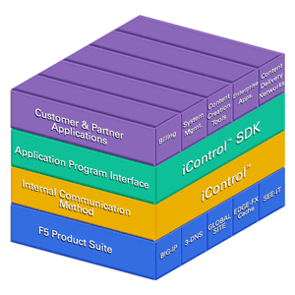
The iControl interface enables a tightly integrated product suite available for total control of Internet traffic and content deployment/delivery.
BIG-IP eases the maintenance and troubleshooting of blade servers. When a failed or poorly performing server and application is identified, it can be quickly removed from the BIG-IP pool of resources and repaired without interrupting service to that application. This results in reduced downtime and ensures high service availability while significantly reducing the total cost of manual maintenance and operations of web applications and services.

5. The Problem of IP Management and Traffic direction
In an environment where an enterprise can have hundreds of discreet servers with dozens of different applications running, the problem of effectively managing all IP addresses as a single resource for those applications and having a simplified method to horizontally scale is a challenge. Server blades exacerbate this problem because they encourage horizontal scaling. This type of environment creates the problem of how to effectively direct or failover IP traffic to the correct server and application based upon the type of request, business, and / or performance criteria.
The Solution To IP Management and Traffic Direction
BIG-IP represents many individual servers as a single virtual server while using dynamic load balancing algorithms, flexible rules, and deep application/server health monitoring to intelligently direct traffic to the optimal individual server at any given point in time. BIG-IP also has extensive fail over capabilities that ensure a down server or application doesn’t affect the user experience.

6. The Problem of Application Availability, Scale, and Performance
Applications are never perfectly designed; they have bugs and exist in environments with too many variables that affect their performance, scale, and availability. Unfortunately, these variables are nearly impossible to anticipate. When applications don’t run well, are not available, or can’t scale, the result is decreased end-user satisfaction and an increase in support costs.
The Solution For Application Availability, Scale, and Performance
The solution for this problem is usually accomplished through server and application redundancy. To overcome the unforeseeable limitations of applications, to effectively scale them and remove as many single points of failure from the environment, redundancy is a common practice. This practice will be commonplace within the blade server environment because the majority of applications deployed on these platforms will be web or IP-based applications. BIG-IP has always solved this problem through its advanced load-balancing algorithms, flexible rule sets, deep health monitoring and application persistence modes.

7. The Problem of Closed Systems
This problem is similar to the heterogeneous environment problem; too many systems and applications are closed and make it difficult to integrate disparate elements. If systems and applications are not designed to either interoperate or integrate easily with one another, it is next to impossible or very costly to attempt to integrate them to get more benefit out of the total infrastructure.
The Solution for Closed Systems
F5’s iControl architecture (see figure above) is a completely open and standards based application programming interface (API) and software development kit (SDK). The standard used is SOAP/XML. Because BIG-IP is the essential unifying layer between the client, the blade servers, and the applications – its openness means that enterprises or their application vendors can easily interface, integrate and extend the capabilities of the total system solution (BIG-IP, blade servers, and applications). In essence, any authenticated third party application or device can interface with anyone of F5’s products, including BIG-IP. Nearly anything that can be done manually through an F5 Graphical User Interface (GUI) or Command Line Interface (CLI) can now be done automatically through the iControl interface.

8. The Problem of Application Security
Security is the number one concern for all enterprises. Given the web enabling of enterprise applications, security takes on new dimensions because of the sensitivity of the information, the distributed nature of applications, their broadening accessibility, and the fact that application traffic frequently traverses the public Internet. If an enterprise has hundreds of discreet servers that are distributed, all running several dozen applications, being accessed by internal and external users, how can they effectively control this environment to ensure security?
The Solution for Ensuring Application Security
Security must be implemented at every tier within an application architecture and enterprise security is only as good as its weakest link. BIG-IP is one of the essential components supporting application security on blade servers. BIG-IP itself is hardened and only allows specific types of traffic to flow through. In addition, BIG-IP Blade Controller software also incorporates SSL acceleration. This allows customers to effectively manage enterprise applications being delivered over SSL, and provide advanced inspection for intelligent traffic management. The result is greater performance and a lower cost for implementing secure applications. BIG-IP is unique in that it has deep certificate support and header transformation for client authentication, and advanced filtering capabilities to prevent DOS, Synflood, Nimbda, and CodeRed types of attacks.

Summary
BIG-IP software is the enabling technology for the emerging class of systems called blade servers.
Itself integrated on a blade server, BIG-IP software it is uniquely designed to provide high availability and intelligent traffic management/direction across services or applications running inside a blade server chassis – lowering overall cost of ownership, reducing management complexities of the infrastructure, making efficient use of IT capital, and ensuring 24/7 uptime for web applications and services.
BIG-IP, through its virtualization capabilities, serves as the unifying element that optimizes how the different blades work together and simplifies management by allowing the customer to view them as a single device –-as well as combining standard layer 2-3 networking and innovative layer 4-7 traffic management to significantly increase blade server application and network capacity.
No matter how BIG-IP is delivered – through blade server software, IP application controller, or an IP application switch – enterprises and service providers receive an award-winning, market-leading IP-traffic management solution to intelligently and successfully deliver their core applications and services.

