May 1998

Compaq Computer Corporation
Contents
Overview 3
The Telecommunications Market 4
Network-Based Solutions 4
Customer Interaction Center–Based Solutions 5
Enterprise-Based Solutions 5
Trends in the Telecommunications Industry 5
Compaq and the Telecommunications Marketplace 6
Telecommunications Market
Structure 6
Solutions for the New Era 7
Service providers 7
Customer Interaction Center 8
Enterprise 9
Supporting Technologies 9
E2000 Architecture Initiative 9
Microsoft Windows NT Server Clustering 10
NonStop SQL for Windows NT
Server 11
Windows NT Server–based N-series IN Platform 11
NonStop Clusters 11
Open Standard Compaq ProLiant Servers 12
Fault-Tolerant UNIX System Hardware 12
NonStop Kernel for Fault-Tolerant Hardware 12
Why Compaq? 13
Market Leadership 13
Technological Innovation 13
Roadmap for Success 14
Best-of-Class Partnerships 15
Conclusion 16

Compaq: Leading the Telecommunications Market

Telecommunications is one of the most dynamic sectors of the business world. Existing and new telecommunications operators are finding real value developing new services at a lower cost of entry to address competitive pressures while boosting profits. With double-digit market-wide growth projected to exceed US$70 billion by the end of the century, the potential for Telecommunications products and services is expanding as never before.
From desktop to NonStop® solutions, Compaq Computer Corporation, along with its Tandem subsidiary, is playing a major role in this growing field as the new global telecommunications market leader. With Compaq’s leadership in standards-based computing and Tandem’s unmatched expertise in fault-tolerant solutions for the telecommunications industry, Compaq now delivers an impressive range of open, reliable solutions and technologies that enable communications companies to succeed in the global marketplace. Whether in the network, at the edge of the network, or in the enterprise, Compaq leads the industry in highly scalable, fault-tolerant technologies that meet the needs of customers running complex applications in demanding environments.
This white paper provides a framework for understanding Compaq’s role in the telecommunications market and how our products, services, and partnerships help our customers excel across the network, enterprise, and customer interaction center markets.

Notice
The information in this publication is subject to change without notice.
Compaq Computer Corporation shall not be liable for technical or editorial errors or omissions contained herein, nor for incidental or consequential damages resulting from the furnishing, performance, or use of this material.
This publication does not constitute an endorsement of the product or products that were tested. The configuration or configurations tested or described may or may not be the only available solution. This test is not a determination of product quality or correctness, nor does it ensure compliance with any federal, state, or local requirements. Compaq does not warrant products other than its own strictly as stated in Compaq product warranties.
Compaq, Compaq Insight Manager, ProLiant, registered United States Patent and Trademark Office.
Tandem, Himalaya, Integrity, iTP NetACD, NonStop-UX, and ServerNet are trademarks or registered trademarks of Tandem Computers Incorporated in the United States and/or other countries.
Other product names mentioned herein may be trademarks and/or registered trademarks of their respective companies.
©1998 Compaq Computer Corporation. All rights reserved. Printed in the U.S.A.
Microsoft and Windows NT are trademarks and/or registered trademarks of Microsoft Corporation. SCO and UnixWare are registered trademarks or trademarks of The Santa Cruz Operation, Inc. in the U.S.A. and other countries. UNIX is a registered trademark in the United States and other countries, licensed exclusively through X/Open Ltd.

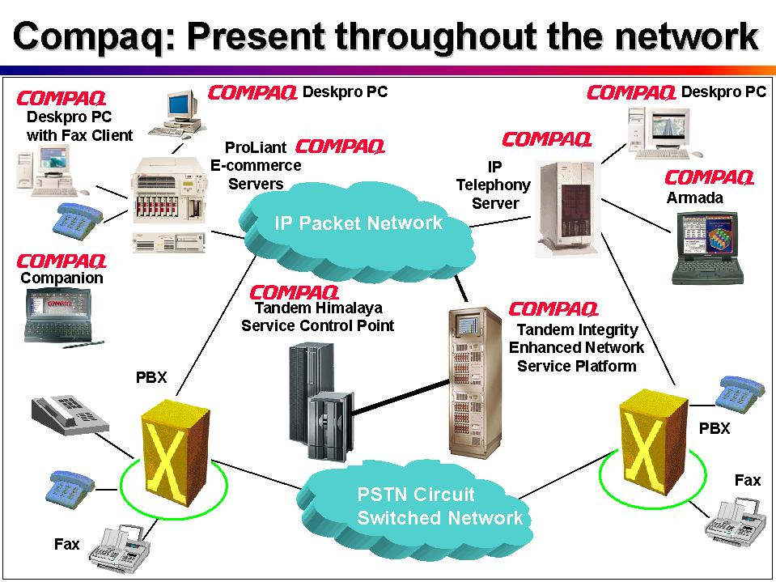
Overview
Compaq is the new global telecommunications market leader as well as a proven leader in technology innovation. Through close collaboration with strategic partners, Compaq offers a comprehensive choice of products and solutions that address customer requirements in the telecommunications network, enterprise, and customer interaction center markets.

With a history of achieving leadership in every market entered, Compaq is the worldwide leader in server sales and the leading Microsoft® Windows NT® workstation vendor worldwide. Compaq leads the PC market worldwide, shipping more than 10 million PCs and servers in 1997—40 percent more than the nearest competitor.
Compaq plays a major role in delivering robust transaction processing solutions and services that enable leading telecommunications and networking companies to generate new revenue-producing services for their customers. Compaq, through its Tandem subsidiary, is the largest supplier of deployed Service Control Points (SCP) in the world. Tandem’s IS-41 Home Location Registers serve more than 15 million subscribers. In fact all of the world’s 30 largest communications providers rely on Compaq systems ranging from the desktop to the most scalable, business-critical data centers.
These companies value Compaq’s delivery of industry-standard hardware and software at an unbeatable price with unrivaled performance. In addition, Compaq engineers have developed options especially suited to the telecommunications network operating environment, such as DC power supplies. These allow deployment of leading standards-based solutions within the telephone company central office.

The Telecommunications Market
The telecommunications industry has been growing in both complexity and competitiveness as a result of deregulation, aggressive acquisitions, globalization, convergence, and new players entering the market. New enabling technologies are also dramatically affecting the competitive landscape.
- Deregulation, at both the national and international levels, including the 1996 US Telecommunications Act which removed most market entry barriers, as well as European telecommunications directives to open up EC markets to foreign competition.
- New players entering, including competitive local exchange carriers, cable operators, internet service providers, utilities, and wireless carriers, who are all increasingly in a position to challenge local and long distance service incumbents.
- Unprecedented growth of the Internet opens up tumultuous opportunities—and challenges—to telecommunications providers
- Innovative technology is distributing network intelligence away from centralized and proprietary switches—enabling cost savings through improved automation and performance
- Increasing digitization of content makes transport via data networks more economically attractive, opening the door to value-added information processing services
- Convergence of voice and data allows Information Technology (IT) departments to increase productivity and decrease costs by installing a single infrastructure using standards-based systems to support both traditional IT and telecommunications functions at a lower total cost of ownership
- New suppliers such as Compaq are using their market strengths to offer competitive open, standards-based equipment at various price/performance thresholds to run telecom-related software applications
As market requirements dictate increasing network complexity, much of the intelligence and functionality within networks is migrating away from proprietary switches to switch adjuncts hosted on open standard servers. These servers support a range of voice and data applications for a variety of solution areas.

Network-Based Solutions
Within the increasingly competitive network environment, service providers face two important challenges: They need to build flexible network infrastructure that can accommodate growing demand for new services. They also need to build high-performance internal operations to support business applications.

Customer Interaction Center–Based Solutions
Customer interaction centers, or call centers, are taking on new importance as companies try to provide first-rate customer service and conduct telesales. The advent of toll-free number portability in the early 1990s and various technological improvements in customer interaction center hardware platforms, coupled with increasingly sophisticated applications, has spurred industry growth in excess of 20 percent per year over the past five years. This growth is certain to continue, if not increase, in the years ahead.
The number of customer interaction centers with fewer than 500 seats is increasing at an even greater rate, spurred in large part by advanced information technologies that efficiently manage the direction of calls. As the benefits of open, standards-based platforms for computer telephony integration (CTI) become more evident, end-user enterprise and service provider customers are replacing proprietary telecommunications equipment with reliable, low-cost, industry-standard servers.

Enterprise-Based Solutions
As with many segments of the customer interaction center market, enterprise customers are discovering the low total-cost-of-ownership advantages of open-standard platforms. These systems are running voice, fax, and unified messaging applications—vital components of many businesses—as well as back office, switching, and customer interaction center systems.
Enterprise customers have traditionally relied on basic call-routing and voice-mail solutions to handle the bulk of their internal and external voice and data traffic. As they begin to adopt an open network architecture, they rely more on advanced intelligent network elements and peripherals, and on the Internet protocol to handle growing levels of voice and data traffic.
Enterprise networks of the future will include sophisticated intelligent network–enabled platforms and applications capable of managing and integrating extensive voice and data links, in addition to fax and unified messaging services, voice mail, and voice response solutions.

Trends in the Telecommunications Industry
The telecommunications industry is undergoing change in ways that parallel developments a decade ago in the computing industry. The dominance of proprietary mainframe computers was eroded by the price/performance attributes and improved functionality of open standard computer servers and clients. Similarly, the dominance of proprietary call processing systems, such as PBXs and central office switches, is starting to be eroded by open standard computer servers enabled with Computer Telephony Integration components. Vendors now offer solutions within specialized horizontal markets, ranging from the platform and components business to the application and management software business.
Increasing competition due to deregulation, the entrance of new players, rising customer demands, new competitors, and technological advances, are all exerting pressure on the telecom infrastructure market. Certain segments of this market require the rapid deployment of new features and functionality. As a result, they are migrating to open standard off-switch platforms. This opens up new opportunities for Compaq to compete with best-in-class solutions across a broad product range.

Compaq and the Telecommunications Marketplace
Compaq has developed a framework to help customers determine what products and services they require.

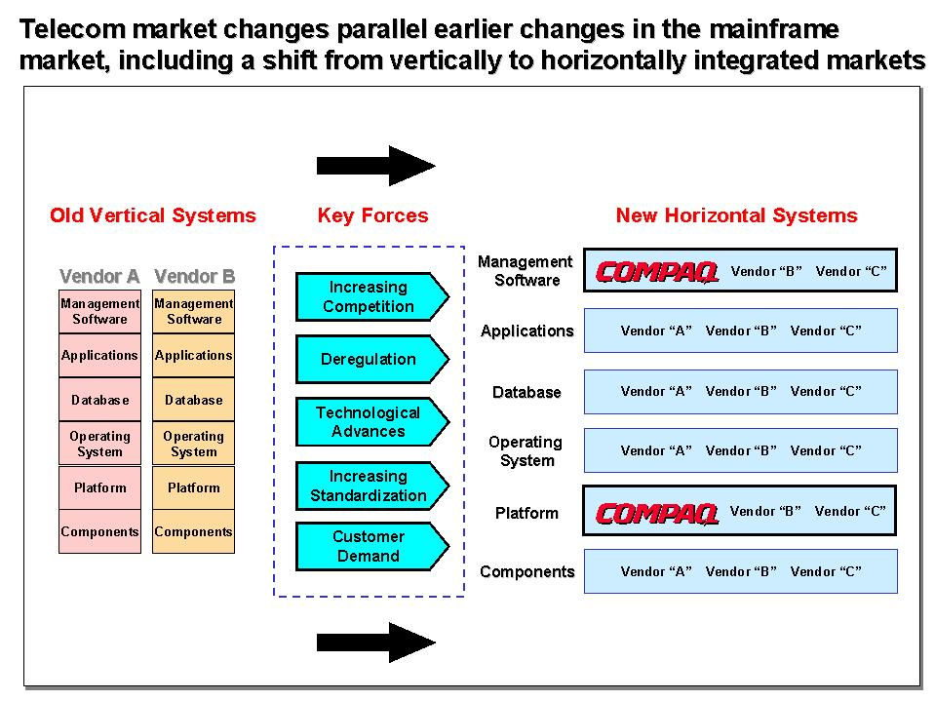

Telecommunications Market Structure
The infrastructure for the telecommunications market consists of several overlapping and interdependent networks, ranging from residential and enterprise-based facilities, to local, long distance, and wireless networks. These are operated either by traditional telecommunications companies or by more recent entrants to these markets. All of these markets, moreover, are linked by voice and data networks, and include both Internet and intranet connectivity.
Compaq is poised to meet the needs of customers as they grow in complexity and the intelligence and functionality migrates away from proprietary network switches to open standard servers in switch adjuncts. Compaq ProLiant servers will become the industry standard for operating voice or data applications at the customer premise or in customer interaction centers, or servers running billing and network management applications within telco and PTT networks.

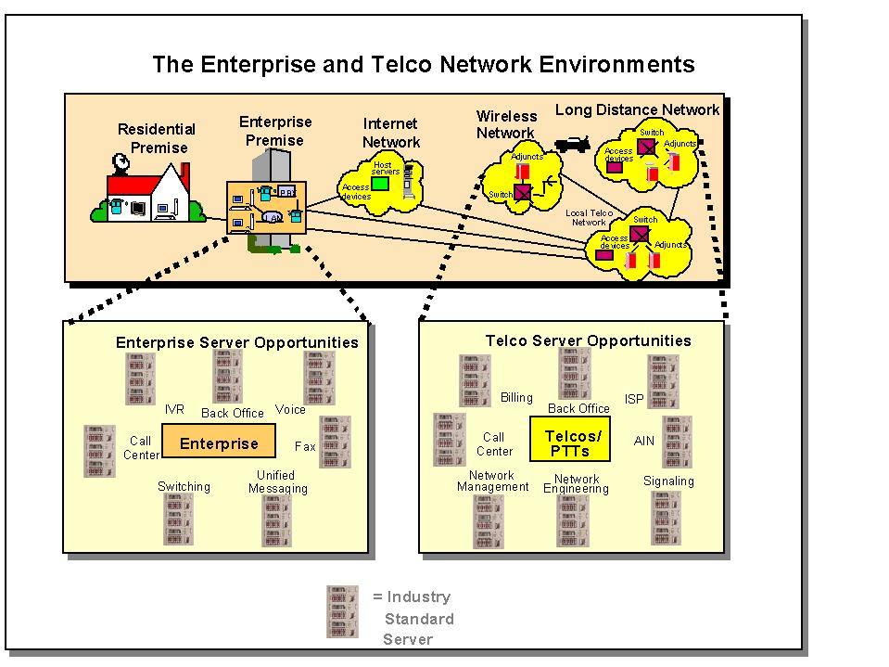
Solutions for the New Era
Compaq is an industry leader in defining the technology and standards that will provide highly-available, low cost computing capacity to the telecommunications markets of the future. Compaq has undertaken multiple initiatives to bring clustering technologies to the market, thereby ensuring that telecommunications customers receive ever improving price/performance benefits, thus enabling them to provide more services while increasing profits.

Service providers
Within the network environment, Compaq and its partners provide comprehensive solutions for both enhanced network services and business support services.

Enhanced Network Services
Compaq and its partners offer architecture and technologies for intelligent network (IN) services, enhanced services, multimedia services, and gateways. Number services, mobility management and fraud prevention makes use of an intelligent network (IN) architecture to meet the evolving needs of network operators.
Compaq’s off-switch, fault-tolerant and high availability, solutions decouple the development of new services from that of the network switch itself, enabling a wider range of differentiated service development and deployment choices. Compaq solutions are also “network neutral” supporting both IS-41 and GSM standards worldwide.
Central to these offerings are the Himalaya®, Integrity®, and Windows NT based intelligent network servers, both of which provide extremely reliable service control point (SCP) functionality for IN-based applications. These include number translation services, virtual private networks, and calling card and credit card validation systems. Additionally, Compaq’s Tandem subsidiary along with partners has developed IN components that include intelligent peripherals (IPs), service creation, and service nodes.

Business Support Services
Compaq is leading the market in creating innovative BSS solutions that offer carriers a competitive edge in the market through increased customer value and satisfaction. Compaq’s offerings provide a high-performance infrastructure for internal operations, including transaction processing, large databases, and services such as order entry, directory assistance, electronic white and yellow pages, billing, collections, account management and provisioning, customer services, customer interaction centers, telemarketing, and emergency services.
In the area of service management, Compaq’s customer care solutions range from interactive voice response systems to fully-integrated customer interaction centers to the Tandem Convergence Enterprise Architecture (CEA), an end-to-end convergence billing and customer care architecture. These solutions facilitate customer orders for new services and provide access to billing information. Through use of scalable, high-performance systems, large volumes of transactions can be handled.

Back Office
Back office business management services, such as financial accounting, collections, and risk management, use decision support systems running on NonStop Himalaya servers operating the NonStop SQL database software. Compaq ProLiant servers and desktops also play an important role in meeting the internal information technology network needs of telecommunications companies. Compaq and its partners offer mediation and integration tools to connect new and legacy systems through a common interface. Lastly, in the area of network management, Compaq provides solutions to handle alarm, event collection, fault analysis, reporting, line testing, and network provisioning.

Customer Interaction Center
Call centers are becoming “customer interaction centers,” handling inbound calls and communicating with customers via e-mail, fax, the World Wide Web, and even video. Working through partners such as Genesys Telecommunications Laboratories, Inc., Compaq delivers hardware and software solutions tailored to the needs of mission-critical customer interaction center solutions running on open, industry-standard servers.
These solutions provide powerful features such as network call routing, computer telephony integration, advanced intelligent routing, blended inbound and outbound capabilities, and real-time reporting that enable telecommunications companies to not only increase the productivity of their own call centers but increase revenues by reselling these services to other enterprises.
Compaq customers trust the quality and reliability of ProLiant servers to protect their applications and data. In addition, open, scaleable CTI applications and framework from Genesys and support from key integrators allow customers to easily and rapidly deploy CTI-enabled applications in their customer interaction centers.
Compaq offers the Call Application Manager (CAM) through the Tandem subsidiary. CAM links applications on NonStop servers with telephone switches—either stand-alone automatic call distributors (ACDs) or ACDs integrated with PBXs. The continuous availability and superior data integrity of NonStop servers and software make the CAM platform ideally suited for customer interaction center applications.
NonStop servers operate continuously through hardware or software failures, — even during earthquakes. They network with virtually any database to enhance customer interaction center agent access to information. Whether handling 100 calls per hour or 100,000, the high-volume transaction processing capability keeps pace with peak activity. The iTP™ NetACD™ solution links the customer interaction center with the Internet. Using “frame-pop” technology, agents can instantly communicate with customers during their web transaction via voice, video, or data.

Enterprise
Customers who are deploying telecommunications solutions within the enterprise are discovering the advantages of flexible open systems. They are increasingly demanding solutions that leverage a wide choice of vendors and applications at the lowest possible cost. These systems are capable of being quickly and easily adapted to rapidly changing business requirements.
Vendor interoperability is a traditional Compaq value. In the enterprise telecommunications market, Compaq is leading the industry by working with Dialogic Communications Corp. to guarantee seamless interoperability and to provide a single management interface for Dialogic voice cards and Compaq ProLiant servers.
Customers can deploy the same standards-based platforms they use with their IT infrastructure for larger, more demanding telecommunications applications.

Supporting Technologies
Compaq is an industry leader in defining the technology and standards that will provide highly-available, low-cost computing capacity to the telecommunications markets of the future. Compaq has undertaken multiple initiatives to bring clustering technologies to the market, thereby ensuring that telecommunications customers receive ever improving price/performance benefits—a critical requirement for providing more services while increasing profits.

E2000 Architecture Initiative
Compaq's recently announced E2000 Architecture delivers the availability, scalability, and flexibility that IT managers need to implement business-critical enterprise applications, including telecommunications. Just as Compaq did in the late 1980s with industry-standard symmetric multiprocessing (SMP) servers, the E2000 platform architecture will rally the industry around standards-based computing and garner support from leading industry partners like Microsoft, Intel, Oracle, and SAP.
Compaq and partners seek to extend the capabilities of today's standards-based systems to address the full spectrum of scalability and availability requirements in the enterprise. The modularity and standard nature of this architecture enables Compaq to rapidly integrate new industry-standard technology advances, such as next-generation Intel based 2-, 4- and 8-processor SMP servers, 64-bit Merced-based SMP servers, Fiber Channel storage, and high-speed interconnects such as ServerNet® technology.

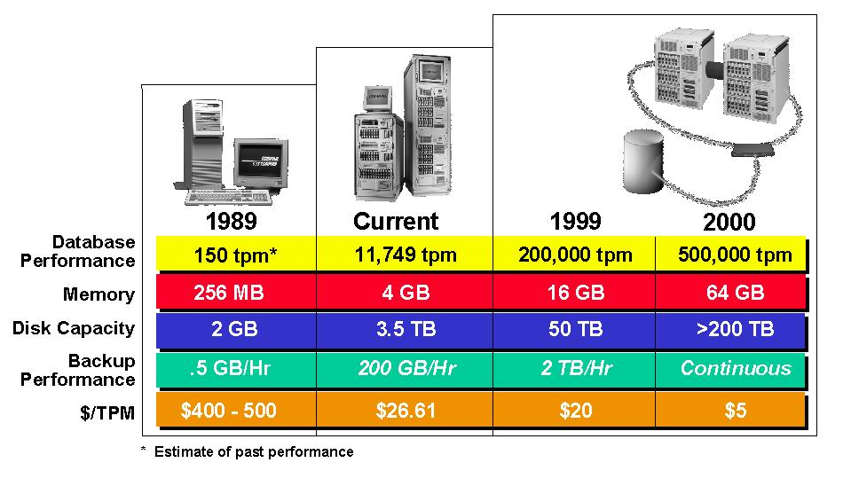
Microsoft Windows NT Server Clustering
Clusters are groups of servers (and their associated storage subsystems) networked together for enhanced availability, for performance scalability, and/or for improved management capabilities. For compute environments using Microsoft Windows NT, Compaq provides a choice of clustering platforms.
Compaq Recovery Server Option (RSO) is a 2-server (or 2-“node”) high availability clustering solution which can operate as either and active-standby or active-active configuration. RSO software continually monitors the entire hardware and software configuration. In the event of error or failure of any component, RSO automatically detects the failure and automatically “fails over” the workload from the failed node to the other node in the cluster, where applications are re-started and users are reconnected and once again return to full productive use. As of May, 1998, there are over 11,000 Compaq RSO clusters installed worldwide, in a wide range of industries and in all geographies.
Compaq also offers clusters based on Microsoft’s cluster management software, Microsoft Cluster Server (MSCS), which is a component part of Windows NT Enterprise Edition. Currently supporting two nodes, MSCS provides sophisticated cluster management facilities. In the event of hardware or software failure anywhere in the configuration, MSCS automatically detects the failure and automatically invokes recovery sequences, including the failover of applications to the other node in the cluster, where applications are restarted, allowing users to return to fully productive work.

NonStop SQL for Windows NT Server
NonStop SQL for Windows NT server is a parallel, scalable, massively extensible enterprise relational database management system. The core relational database engine has been designed using object-oriented technology and includes architectural features that easily support new data formats as they emerge.
Compaq’s Tandem subsidiary has been a leader in clustering technology for more than 20 years, and much of that technology has been ported by Tandem to the Windows NT Server operating system and the NonStop SQL database product. Because the database is optimized for clustered environments, it delivers linear performance improvements as companies add nodes to the Windows NT Server cluster. Although database access occurs across separate nodes in the cluster, NonStop SQL is managed as if it were a single database on a single machine.

Windows NT Server–based N-series IN Platform
The Tandem N-series intelligent network service (INS) platform is designed for entry-level SCP, IP, service node (SN), and CTI applications running on industry-standard Compaq ProLiant servers. It allows wireless and wireline service providers to introduce cost-effective new services on a trial basis and then easily increase system capacity as the number of subscribers and business revenue grows. The N-series supports a wide range of Signaling System 7 (SS7)–based applications such as authentication center (AC), prepaid calling card services, toll-free services, and location tracking. It offers multiple configuration options for tailoring network requirements to program budgets and enables carriers to cost-effectively and reliably manage smaller capacity networks.

NonStop Clusters
Compaq offers a powerful UNIX® system–based clustering product for telecommunications applications. NonStop Clusters uses ServerNet technology to deliver 10 times the availability of other high-availability computer systems at half the price. NonStop Clusters is a highly scalable clustered operating environment that enables a group of UNIX system–based Compaq ProLiant servers to operate as a single, reliable computing resource. It is the first clustering product to offer true single system image (SSI) capability.
This feature presents a cluster of nodes as if it were one system, greatly improving manageability and simplifying application development. The SSI capability allows transparent access to all cluster resources such as shared memory, semaphores, and pipes. Highly integrated and optimized to run with the SCO® UnixWare® 2.1 operating system, NonStop Clusters’ SSI also allows applications to migrate among nodes without disruption. Early adopters of this technology include Wildfire, an intelligent electronic assistant, and Interact Incorporated, a prepaid debit card solution.

Open Standard Compaq ProLiant Servers
Industry standard Compaq Proliant servers continue to lead the market in technological innovation and price/performance, as well as market share. By deploying Intel-based Compaq Proliant Servers, carriers can capture significant price/performance advantages over the highly specialized hardware and operating systems they have traditionally deployed. Clustered Compaq ProLiant Servers are well suited for deployment in the PSTN - offering flexibility, scalability, availability, and manageability, with no single point of failure, to integrate smoothly into rapidly changing networks. Compaq is an industry leader in supporting the development of cost effective software clustering solutions based on both SCO UnixWare and Microsoft Windows NT Server.
Compaq’s broad portfolio of high availability hardware, software and services allow customers to tailor their clustering solutions to the performance, capacity, availability, and budget requirements of each particular application environment. Compaq also leads the industry in defining standards like Hot Plug PCI to increase the availability of Open Standard Servers. Many Compaq Proliant servers have redundant hardware features built right into the platform, including features such as redundant hot swap power supplies and fans, PCI Hot Plug I/O slots and redundant processor power modules. Compaq ProLiant servers are now more easily deployed in telco central offices with the introduction of -48V DC power supplies.

Fault-Tolerant UNIX System Hardware
Compaq’s high-performance Tandem Integrity S4000 server family offers telecommunications providers and commercial businesses - the industry's most extensive range of reliable and scalable servers based on the UNIX operating system. At the heart of Integrity S4000 servers is Tandem's ServerNet architecture, a breakthrough technology that offers a high-performance interconnect between processors and I/O devices—for building scalable systems with the highest availability, the highest data integrity, and the most flexible range of configuration choices. The Tandem NonStop-UX operating system provides enhanced data integrity features, a highly robust and reliable kernel, and sophisticated diagnostic and maintenance facilities. These special features support the fault-tolerant hardware of Integrity S4000 servers.

NonStop Kernel for Fault-Tolerant Hardware
NonStop Himalaya S-series servers run the NonStop Kernel operating system combined with Tandem's revolutionary ServerNet interconnect architecture and the latest RISC processing to provide breakthrough I/O bandwidth, and unlimited scalability. Designed to meet the needs of a new generation of applications—multimedia, video-on-demand, electronic commerce, decision support, and others—S-series servers handle complex transactions and rich data types while maintaining all the benefits of the NonStop Kernel operating system: continuous availability, data integrity, distributed transaction processing and database, open networking, and security.
The commercial version of the Himalaya S-series server is enhanced with middleware to add IN capabilities such as SS7 termination, processing, telecommunications network management interfaces and reports, and telecommunications equipment hardening features. In addition to the highest level of fault-tolerance, scalability, and reliability, key benefits of the new ServerNet technology–enabled SCP include a significant boost in both throughput and bandwidth, and a significant reduction of the footprint.

Why Compaq?
Compaq and its partners offer a comprehensive choice of platforms and solutions to address requirements from the network to the enterprise.

Market Leadership
A committed supplier to the telecommunications industry, Compaq is the choice for many leading service providers, including all of the top 30 global telecommunications providers. For instance, BT and AT&T trust Compaq for the deployment of key business productivity solutions. SBC and Deutsche Telecom rely on Compaq servers for critical customer interaction centers. Wireless carriers throughout the world use Compaq Mobility Management systems, including the largest operators in the United States, Canada, and the United Kingdom. In fact, most cellular roaming calls in the United States are processed on Compaq fault-tolerant platforms. Compaq equipment also generates the majority of U.S. monthly cable TV bills.
Compaq leads the world in the production of servers and in the manufacture of PCs for consumers, small and medium-sized businesses, and large enterprises. Its market leadership in both commercial and consumer markets gives Compaq the ability to influence a broad mix of customers. Compaq created the Intel-based server market in 1989 and maintains a greater market share than all the next four largest vendors combined. It has shipped well over a million servers to date.

Technological Innovation
Compaq is on the forefront of developing high-impact integrated solutions for next generation payment processing, security, and customer care infrastructure. Through use of innovative and patented technology developed by Compaq and the Tandem subsidiary, Compaq platforms provide telecommunications companies with several key benefits:
Continuous availability, through use of patented fault-tolerant hardware and software capabilities. Tandem was one of the pioneers of fault tolerance for commercial applications with the introduction of the first commercial parallel processing system.
Data integrity, through unique capabilities that protect against data loss or corruption in any circumstance, ensuring complete and continuous accuracy of billing data and customer information.
Scalability, through server solutions that can grow in either small or large increments, by adding processing modules without having to interrupt service.
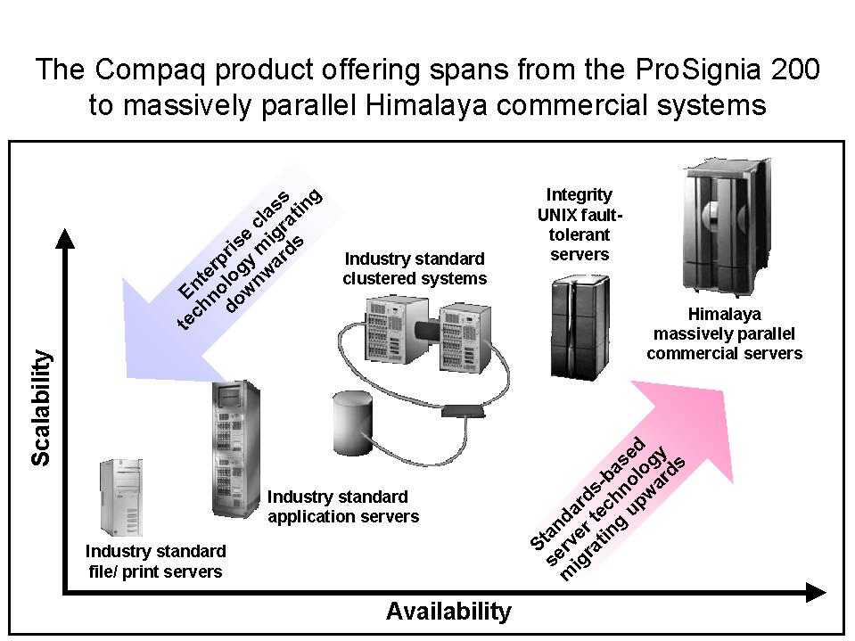
High performance, through use of multiple processors working in parallel to handle massive amounts of data at speeds far exceeding conventional computers. This configuration provides the performance required by network applications, complex database queries, multimedia applications, and a growing number of portable and distributed devices.

In addition to industry leadership in platforms, Compaq offers industry-standard solutions that can be planned, deployed, and operated with the minimum cost and risk possible. As the industry moves towards distributed enterprise solutions based on industry standard servers, service providers who implement solutions are faced with the challenges of compressed time intervals to roll-out new solutions with fewer internal resources available. Customers are offered easier implementation through the services of Systems Integrators.

Roadmap for Success
In addition to a portfolio of products dedicated to the telecommunications market, Compaq serves the market with a dedicated field organization and telecommunications centers of excellence located throughout the world.
Compaq’s enterprise solutions for telecommunications are delivered as complete solutions, including integrated software, services, support, and hardware delivered by Compaq partners. These solutions can be customized to fit the divergent requirements of the end customer. Compaq partners can help customers reduce the time, cost, and risk of solution implementation through the use of solution enabler tools developed specifically to speed planning, deployment, and operation.
Compaq relies on its efficient manufacturing processes, superior partnerships with “Best of Class” Independent Software Vendors (ISVs), switching equipment vendors and telecommunications network providers, plus its position as market leader, to deliver value to customers.

Best-of-Class Partnerships
To ensure that its telecommunications solutions meet a full range of customer needs, Compaq has developed superior partnerships with industry leaders, best-of-class independent software vendors (ISVs), switching equipment vendors, and telecommunications network providers—all of whom rely on the ease-of-use, reliability and manageability of Compaq servers to satisfy a broad range of requirements. Compaq’s volume partner model and strategic alliances with “best-of-class” partners such as Microsoft, Intel, and Oracle enables Compaq to set market standards.
- Compaq and Microsoft have had a strong relationship for more than a decade. The Frontline Partnership program expands joint efforts to accelerate the development of new technology and underscores a commitment to cooperative engineering, customer support, joint training, excellence in marketing, and dedication to customer satisfaction. Compaq and Microsoft personnel demonstrate joint solutions to thousands of customers in demonstration facilities throughout the world, in corporate briefing centers, and in proof-of-concept lab facilities. These factors help Compaq and Microsoft deliver the best overall performance and value in the industry.
- Compaq and Intel continue to work closely to develop leading solutions spanning the breadth of the industry from home computing to the rapidly growing enterprise computing marketplace.
- Compaq and Oracle have joined forces to develop low-cost, high-performance, fault-tolerant departmental database solutions that can be confidently deployed by customers wherever they are needed.
Compaq also serves the telecommunications market through partnerships with best-of-class ISVs, network equipment manufacturers, and consultants. Compaq’s competence centers offer ISVs the means to certify and optimize their software for maximum performance on Compaq servers.
- Compaq is the preferred Microsoft Windows NT server provider to Genesys, a leading customer interaction center solution developer. The partnership offers integrated, state-of-the-art computer-telephony platforms. .
- Compaq solutions are used by Wildfire exclusively, a leading electronic assistant solution, for product development and customer deployments, resulting in safe and reliable enhanced services for wireless and wireline networks.
- Lucent’s decision to standardize its Internet Telephony Server (ITS) solution on ProLiant servers is based on Compaq’s long-standing position as the industry leader of open, industry-standard server solutions. Lucent recognized that Compaq ProLiant servers provide compatible and sturdy platforms that meet growing customer needs for leading telecommunications applications.
- Compaq partners with Portal to offer a billing and customer care system for ISPs and Internet telephony service providers. The solution allows real-time registration, tracking, management, and billing of subscribers.
- Compaq offers competitive customer care and service management solutions through partnerships with Volt Delta, CAP, MARS, Cable Data, and GTE.
- Tandem’s Convergence Enterprise Architecture (CEA) allows service providers to simultaneously support business functions for two or more types of communications networks with one integrated and scalable system. CEA enables providers to give their customers a single point of contact for all of their service needs. CEA partners currently include Microsoft, Daleen Technologies, Opus Telecom, Kanbay, and Global Telemanagement.
- Through strategic partnerships with companies such as AG Communication Systems, Sema Group Telecom, Brite Voice Systems, Vicorp, SCC, and Signalsoft, Tandem offers world-class enhanced network services to the telecommunications industry. Services such as ACRE, short messaging, prepaid, E911, and location-based services are available on the NonStop Himalaya and/or Integrity intelligent network servers.

Conclusion
New realities are shaping the telecommunications marketplace as the balance of power tilts increasingly in favor of customers. Service providers are faced with the growing demand for new and improved services and enhanced customer control, and the added pressures of new and existing players. Customers, both large and small, need to create or purchase services for themselves through the use of intelligent networks.
The combination of simplified operating environments, sophisticated partner software, and open standard platforms makes this possible; they enable the rapid development and deployment of unique and personalized services. As the barriers between traditional telephony, the Internet, and enterprise computing erode, and as telecom services are distributed across multiple intelligent nodes, these services will increasingly need to be controlled and administered through the Internet or via corporate intranets.
Compaq is driving change in the telecommunications market and promoting the adoption of open-standard platforms. As the leading computing company, Compaq is dedicated to providing the products and services that telecommunication service providers and enterprises will need to compete in this rapidly evolving environment

